Founded in 1843

VILLAGE OF ONTONAGON

315 Quartz Street
Ontonagon, Michigan 49953
Phone: 906-884-2305 Fax: 906-884-4369
TDD: 1-800-649-3777
Website: www.villageofontonagon.org

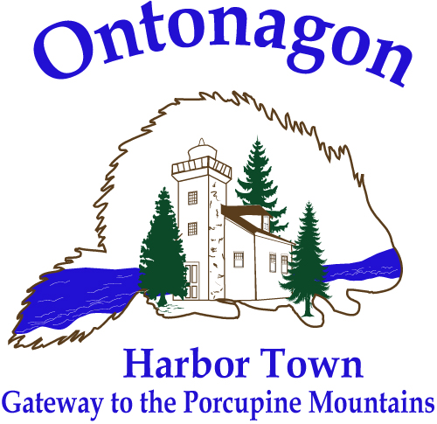

AGENDA
VILLAGE COUNCIL MEETING
MONDAY – JULY 28, 2025
5:00 P.M. - 315 QUARTZ ST.

FINANCE COMMITTEE MEETS AT 4:30 P.M.

- PLEDGE OF ALLEGIANCE

- CALL TO ORDER – ROLL CALL

- PUBLIC COMMENT (Five Minute Limit Per Individual on Agenda and Non-Agenda Items)

- APPROVAL OF CONSENT AGENDA: Finance Committee July 14, 2025; Infrastructure Committee Meeting July 16, 2025; Planning Commission June 18, 2025, Marina Commission June 19, 2025; Housing Commission June 17, 2025.

- APPROVAL OF AGENDA

- APPROVAL OF BILLS

- APPROVAL OF COUNCIL MINUTES: February 24, 2025, July 14, 2025

- REPORTS:
  - Financial Report

- UNFINISHED BUSINESS
  - MERS Updates
  - Request to purchase Village property (Community Development)
  - OASD Bus Garage Lease (Community Development)
  - Steel Street Request (Planning Committee)
  - Signature Cards
  - CTE Building Water Service Request (Infrastructure Committee)
  - Ontonagon Street Right Of Way Request

- NEW BUSINESS
  - GEI - DPW Garage Floor Replacement Project Bid Award Recommendation
  - Ruotsala Payment Application #6
  - Infrastructure Recommendations (DDA & Food Truck Rally)

- ANNOUNCEMENTS – OTHER COUNCIL BUSINESS

- ADJOURNMENT

Pamela Coey
President

Sarah Hopper
President Pro-Tem

William DuPont
Village Manager

Wendy Pence
Village Clerk

TRUSTEES

Lyle Perry
Mike Rebholz
Debra Seid
Dorothy Sharkey
Matt Wiesen

The Village of Ontonagon is an equal opportunity provider and employer. Complaints of discrimination should be sent to:
USDA, Director, Office of Civil Rights, Washington, DC 20250-9410 .

