Founded in 1843

COMMUNITY DEVELOPMENT COMMITTEE

315 Quartz Street
Ontonagon, Michigan 49953
Phone: 906-884-2305 Fax: 906-884-4369
TDD: 1-800-649-3777

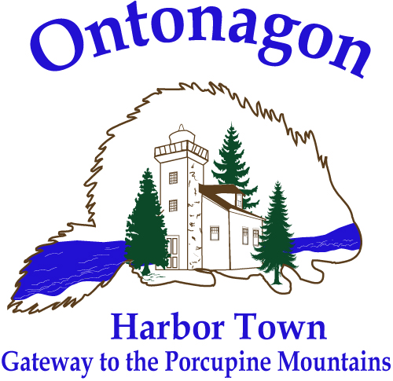

COMMUNITY DEVELOPMENT COMMITTEE
Wednesday, July 23, 2025
Village Council Chambers
1:00 P.M.

The mission of the Village of Ontonagon Recreation Commission is to create a recreational environment in the Village that enhances the quality of life of all persons, of all ages, of all abilities, and of all interests for the physical and emotional well-being of its citizens and visitors.

