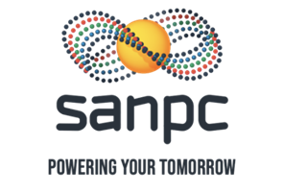

AGENDA FOR THE SANPC BOARD SPECIAL MEETING TO BE HELD ON THE 17th JULY 2026 AT 10H00, VIA MS TEAMS

Item | Points for Discussion | Action By | Submissions
 | OPENING AND WELCOME | Chairperson
 | Apologies | All | Verbal
 | Declaration of Interest | All | Verbal
 | ADOPTION OF AGENDA | Chairperson
 | COMMITTEE REPORT TO BOARD
 | BARC REPORT (16 July 2026) | BARC Chair | Submission
 | MATTERS FOR APPROVAL
 | Risk Adjusted Plan | CEO | Submission
 | Igas Loan Instrument | CEO | Submission
 | Working Capital Funding | CEO | Submission
 | Avedia Loan Repayment | CEO | Submission
 | MATTERS FOR NOTING / DISCUSSION | Chairperson
5.1. | Trading Update – stood down | CEO | Submission
 | IN-COMMITTEE SESSION
 | Board Assessment Report- stood down | Directors only | Submission
 | CLOSURE | Chairperson

