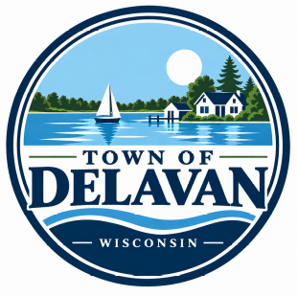
5621 Town Hall Road
Delavan, Wisconsin 53115
(262) 728-3471 FAX (262) 728-3473
Email clerk@townofdelavan.com
Office Hours: M – F, 8:30 AM – 4:30 PM

OFFICIAL NOTICE
The Town of Delavan Fire & Rescue Committee will hold its monthly Meeting on Thursday, November 5th, 2026 at 4:30 PM at Fire Station #1, 5698 Town Hall Rd., Delavan WI 53115.
- Call to order/Roll Call
- Declaration of quorum for doing business
- Approval of the Agenda
- Approval of the minutes of Fire & Rescue Committee meeting August 8th , 2026
- Communications:
  - None
- Comments and Suggestions of Citizens present regarding Items on the Agenda (Comments limited to 3 minutes please)
- New Business:
  - Discussion/possible recommendation: Review of current overtime procedures and alternative options
    - Discussion to include Town labor attorney, Kyle Gulya, by Zoom
- Old Business:
  - Discussion/possible recommendation: F&R Reports
  - Discussion/possible recommendation: Improving EMS response times for outlying Town residents and boundary review
  - Discussion/possible recommendation: Personnel Update
  - Discussion/possible recommendation: Geneva Township follow up
  - Discussion/possible recommendation: Retaining current tower and ladder truck
- Monthly Bills: Review and Approve
- Comments and Suggestions from Citizens present regarding items not on the agenda (Comments limited to 3 minutes please)
- Date of Next Meeting: Thursday, December 3rd, 2026 , 5:00pm at Fire Station #1 OR potentially postpone one month
- Adjournment

Date: November 4th, 2026
Committee Members:
Bill Thummel – Chair Jeff Flitcroft - Assistant Fire Chief
Mary Knipper – Co-Chair Mike Burns - Citizen Member
Jamie Jarosz - Fire Chief Mary Bores– Citizen Member
Michael Petkoff - EMS

“**NOTE: A quorum of the members of the Town Board who are not also Committee members may be in attendance to gather information and participate in discussion about an issue over which they have decision making ability. This may constitute a meeting of the Town Board pursuant to State ex. Re. Badke v. Greenfield Village Board 173 Wis. 2d 553, 494 NoW.2d 408 (1993), and must be noticed as such even though the Town Board will take no formal action at this meeting. This meeting must be noticed appropriately and is intended to comply with the requirements of Badke and the Wisconsin Open Meetings Law.”
Any person who has a qualifying disability as defined by the American with Disabilities act that requires the meeting or the materials at the meeting to be in an accessible location or format must contact the Town of Delavan, 5621 Town Hall Road, Delavan Wisconsin at least twenty –four hours prior to the commencement of the meeting so that necessary arrangements can be made to accommodate the request.
Legally posted at: Town Hall, www.townofdelavan.com
Courtesy postings at the following businesses: Bank First, Lakefront Mobil, Maxi One, and Piggly Wiggly.

The Town of Delavan is an Equal Opportunity Employer

