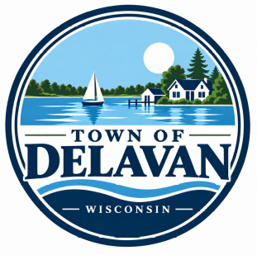
5621 Town Hall Road
Delavan, Wisconsin 53115
(262) 728-3471 FAX (262) 728-3473
Email clerk@townofdelavan.com
Office Hours: M – F, 8:30 AM – 4:30 PM

Park and Tourism Committee Agenda
Tuesday, November 3, 2026, at 4:30pm Town Hall

- Call to Order
- Roll Call
- Declaration of quorum for doing business
- Approval of the agenda
- Approval of minutes of the October meeting
- Comments and suggestions of citizens present regarding items on the agenda. Comments are limited to 3 minutes.
- Communications
- FOP would like a large pier constructed to accommodate boats that would like to park and enjoy the park, to have a weigh station for fishing tournaments, and to park the police boat.
- FOP would like the town to consider planting several arborvitaes along the driveway where cars park just to the north/east of WE.
- Payment of monthly bills/ fee waiver requests
- Comments and suggestions of citizens present. Please limit comments to 3 min.
- Date of next meeting Tuesday, Dec 1, 2026.
- Adjournment

“**NOTE: A quorum of the members of the Town Board who are not also Committee members may be in attendance to gather information and participate in discussion about an issue over which they have decision making ability. This may constitute a meeting of the Town Board pursuant to State ex. Re. Badke v. Greenfield Village Board 173 Wis. 2d 553, 494 NoW.2d 408 (1993), and must be noticed as such even though the Town Board will take no formal action at this meeting. This meeting must be noticed appropriately and is intended to comply with the requirements of Badke and the Wisconsin Open Meetings Law.”
Any person who has a qualifying disability as defined by the American with Disabilities act that requires the meeting or the materials at the meeting to be in an accessible location or format must contact the Town of Delavan, 5621 Town Hall Road, Delavan Wisconsin at least twenty –four hours prior to the commencement of the meeting so that necessary arrangements can be made to accommodate the request.
Legally posted at: Town Hall, www.townofdelavan.com
Courtesy postings at the following businesses: Bank First, Lakefront Mobil, Maxi One, and Piggly Wiggly.

