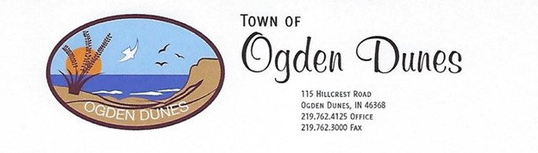
AGENDA
OGDEN DUNES TOWN COUNCIL MEETING
August 3, 2025, 7:00 p.m. Cheryl Tarpo Community Eoom

Call to order
Pledge of Allegiance
Roll Call

Approval of town meeting minutes
Approval of claims

DEPARTMENT REPORTS BOARD & COMMITTEE

Police Department Access Ogden Dunes General Code review
Building Department Animal Committee Historical Society
Street/Water Department Beach Nourishment Home Association
BZA (Board of Zoning) Parks & Rec
Budget and Finance Planning Commission
Community Fund Town Beautification
Environmental Advisory Recognition Committee
Women’s Club

OLD BUSINESS

- Happy 5-year Anniversary to our Chief and Building Commissioner, Jeremy. It has been exciting and good for everyone!
- Additional Recap of storm impact on town services and budget Bernadette, John Hannon
- Additional Street Department update Mike Lanovich, John Hannon
- Addition update police vehicles, repairs, Frontier and NIPSCO wires, Jeremy Ogden
- Website Update: Scott Kingan
- Town Hall Conference Room Refresh Project, Bernadette
- Access 2, Project David Snyder
- Beach stairs Scott Kingan
- Central Rock Project update – no news
- Insurance Refund- Amy Parry
- Update Community Crossings Grant, Amy Parry

NEW BUSINESS

- Cleveland Cliffs Dredge Permit Scott Kingan
- Presentation regarding NIH Research regarding the effects of environmental pollution on health of communities near steel mills. – Allan Halline
- Request for monthly use of Community Room as part of the NIH study - Allan Haline
- Julia Klingensmith Insurance Coverage – Berandette Slawinski
- Town Insurance Coverage ScottKIngan, Bernadette Slawinski
- Multi Hazard Mitigation Planning Meeting-August 27.
- Government Updates (State, Local)
- Reggae Party _ August 15, Tamarack Beach, 7 – 10 p.m. BYO Food and Beverage
- Gary Air Show Weekend August 21 -23
- Watch for rip currents and beach closing warnings. Always call NIPSCO if you have a power outage to allow them to know your status. Follow weather warnings. Stay Safe and enjoy the rest of the summer.
RESIDENT REMARKS COUNCIL REMARKS MOTION TO ADJOURN

Town of Ogden Dunes is inviting you to a scheduled Zoom meeting.

Join Zoom Meeting
https://us06web.zoom.us/j/85871936340?pwd=BrVPBT7VkGtHfjUU0U8jdIboDGnDvE.1

Meeting chat link
https://us06web.zoom.us/launch/jc/85871936340

View meeting insights
https://us06web.zoom.us/launch/edl?muid=bcae6cc1-198d-421c-9d01-a45803324de4

Meeting ID: 858 7193 6340
Passcode: 265585

One tap mobile
+13092053325,,85871936340#,,,,*265585# US
+13126266799,,85871936340#,,,,*265585# US (Chicago)

