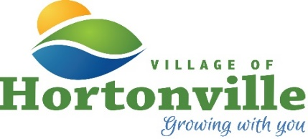

NOTICE OF A POSSIBLE QUORUM

In compliance with the State of Wisconsin Open Meetings Law requirements, public notice is hereby given that members and a possible quorum of the Village Board members along with Village staff will potentially attend the Informational Hearing on the Reconstruction of Main Street and its potential impacts on downtown businesses.

Thursday, June 11, 2026
6:30 p.m.
Municipal Services Center
531 N Nash Street

No formal Village action will take place at this meeting.

Posted: June 8, 2026
Jane Booth, WCMC

Village Clerk-Treasurer

