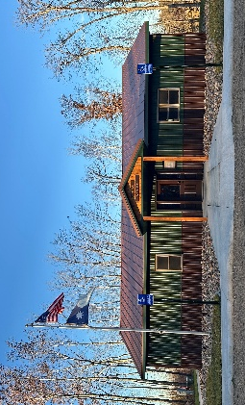
HIRAM TOWNSHIP
5895 – 36th Street N.W.
Akeley, MN 56433
Hiram Township Regular Meeting Agenda
June 9, 2026

- Call to Order
- Pledge of Allegiance
- Approve Meeting Minutes of the May 12, 2026
- Treasurer’s Report
- Clerk/ Treasurer Reconciliation
- Old Business
  - Notification to MPL and any other public utilities about utility work being done in Hiram township
  - Sale of old town hall
  - .gov website
  - Forseman Point Drive up-date
  - Storage shed up-date
  - White board damage; return and replace
  - Town hall rental policy
- New Business
  - Woodland Drive Lake Access
  - H1 Ron Bray Advisory Section 9
  - Highway Department – Traffic counts on June 29 on Hiram 1 (52nd Ave NW) with one north of Ford Dr and one south of Ford Dr
  - Road vacate petition; Derek Penner
  - Weed Id project
  - Primary election, August 11, 2026 – need to reschedule Aug board meeting
  - Treasurer search
- Supervisor’s Reports
- Clerk’s Report
- Citizen comments
- Claims for May 2026
- Other:
- Adjournment

