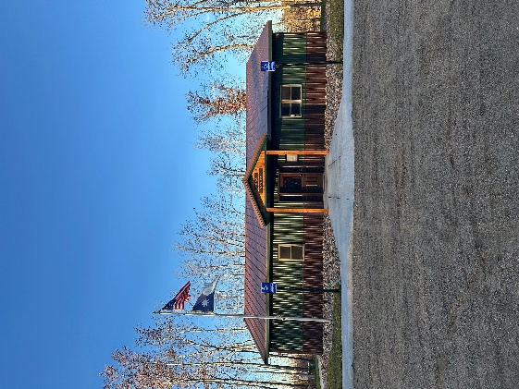
HIRAM TOWNSHIP
5895 – 36th Street N.W.
Akeley, MN 56433
Hiram Township Regular Meeting Agenda
May 12, 2026

- Call to Order
- Pledge of Allegiance
- Approve Meeting Minutes of the April 14, 2026
- Treasurer’s Report
- Clerk/ Treasurer Reconciliation
- Old Business
  - Mike Schmitt - Video Conference OWL equipment training
  - Annie Knight - Conservation Easement on township 40
  - Sourcewell Grant final report
  - Mowing contract
  - Sale of Old Town Hall up-date
  - Forseman Point Drive up-date
- New Business
  - Notification to MPL and any other public utilities about utility work being done in Hiram township
  - Derek Penner (Iron Lane road vacation)
  - Treasurer resignation
- Supervisor’s Reports
- Clerk’s Report
- Citizen comments
- Claims for April 2026
- Other:
- Adjournment

