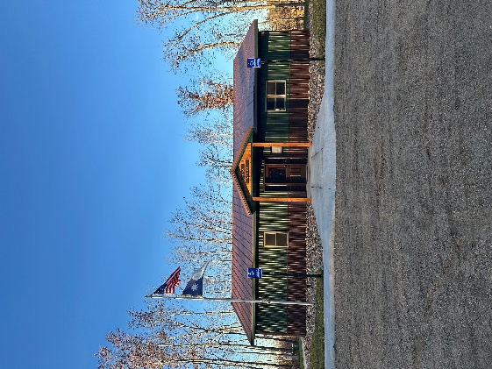
HIRAM TOWNSHIP
5895 – 36th Street N.W.
Akeley, MN 56433
Hiram Township Regular Meeting Agenda
April 14, 2026

- Call to Order
- Pledge of Allegiance
- Approve Meeting Minutes of the March 10, 2026
- Treasurer’s Report
- Clerk/ Treasurer Reconciliation
- Old Business
  - Sale of old town hall
  - .gov
  - Storage shed
  - Forseman Point Drive Up-date
- New Business
  - Mike Schmitt TV and damaged white board donation
  - Set Roads Inspection Meeting Dates
  - Weed Inspector Training (05/15/26, WAC)
  - Mowing contract
  - Sourcewell Grant final report
  - Video Conference OWL equipment training
  - Conservation Easement on township 40
- Supervisor’s Reports
- Clerk’s Report
- Citizen comments
- Claims for March 2026
- Other:
- Adjournment

