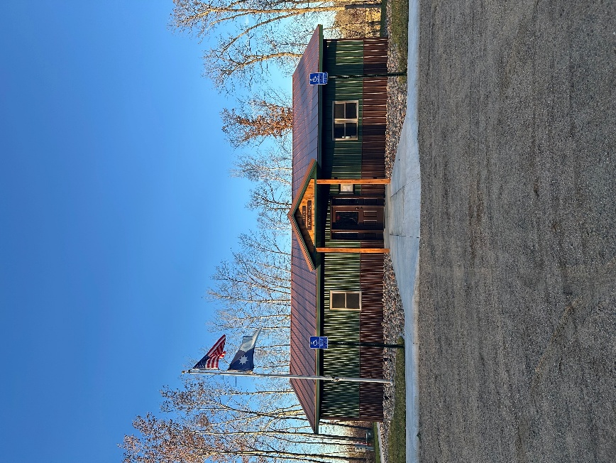
HIRAM TOWNSHIP
5895 – 36th STREET N.W.
AKELEY, MN 56433
HIRAM TOWNSHIP MEETING MINUTES
March 10, 2026

Regular scheduled meeting of the month was called to order on Tuesday, March 10, 2026 at 6:00pm.

Present: Jim McGill (via Zoom), Dave Morris, Jim Zierhut, Shelly Ganz and Carla Baker

Guest: Jon Bohn, Dennis Abbott, Rick Boeckman, Terry Cook, Pat Moran

M/S/P: McGill/ Morris to approve regular Township Meeting Minutes from February 10, 2026. Motion carried.

TREASURER’S MONTHLY REPORT:
M/S/P: McGill/ Zierhut to approve Annual Treasurer’s Report as presented: Beginning $483,236.06, Receipts of $23,391.58, Expenses of $51,265.75, CD Adjustment of -$77.28, $452,697.88. Motion carried.

Clerk & Treasurer reconciliation tabled to give update next meeting.

OLD BUSINESS
M/S/P: Morris/ Zierhut to approve retaining Pat Moran for his services to sell the Old Town Hall for the listing price of $67,500. Motion carried.
M/S/P: McGill/ Morris Supervisor Zierhut to execute the listing document in Supervisor McGill’s physical absence. Motion carried.

Further discussions on the storage shed and the Board agreed to purchase from the Amish. Details regarding transition to .gov website and email are to be tabled next month. The Board discussed items to be added to the Town Hall rental policy and setting up figures by April.

M/S/P: McGill/ Morris to approve Forseman Point Drive Resolution with a couple of amendments to the words used. Motion carried.

NEW BUSINESS
Supervisor Zierhut to do more research on Ditch mowing, as well as talks on whether weed spraying is the best alternative for the township. All three supervisors are planning to attend the Weed Inspector Training on May 15 at the WAC. Shelly and Carla to look into submitting the SLFRF closeout. The Board also discussed issues experienced when having deliveries using the Akeley post office. It was determined that it is best to deliver small items to the PO Box in Hackensack and big items to be coordinated through Supervisor Zierhut or Jon Bohn. The Board was reminded of the following events like Board of Appeals which is on April 14 at 2:00pm and election filings starting May 19.

M/S/P: Zierhut/ McGill to approve donation requests as follows: $300 each for Cass County Fair, Cass County Historical Society, Senior Leech Lakers, Support within Reach, $1,000 for Hackensack Lakeside. And $2,000 for Faith in Action. Motion carried.

M/S/P: McGill/Morris to approve 2027 Levy as follows: General Fund at $80,000, Road & Bridge at $240,000, Fire at $50,000, EMS at $12,000 for a total of $382,000. Motion carried.

M/S/P: McGill/ Morris to provide Jon Bohn and Jim Etzel employee life insurance at $80 annual premium. Motion carried.

SUPERVISORS REPORTS

Supervisor Zierhut: Shared insights on the CCAT event

CLERK’S REPORT
Received an email from Derek Penner regarding a road vacation and requested to be added to the May agenda.

CLAIMS:
M/S/P: McGill/ Morris to approve the claims as presented 18 checks 6896-6913, three electronic funds transfer for a total of $12,594.13. Supervisor Zierhut to sign checks in Supervisor McGill’s physical absence. Motion carried.

M/S/P: McGill/ Zierhut to adjourn meeting at 7:52pm. Motion carried.

