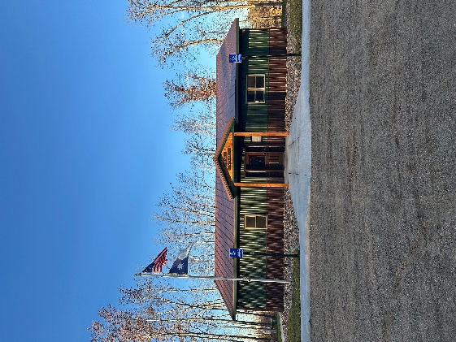
HIRAM TOWNSHIP
5895 – 36th Street N.W.
AKELEY, MN 56433
Hiram Township Regular Meeting Agenda
March 10, 2026

- Call to Order
- Pledge of Allegiance
- Approve Meeting Minutes of the February 10, 2026
- Treasurer’s Report
- Clerk/ Treasurer Reconciliation
- Old Business
  - Pat Moran - Sale of old town hall
  - Storage Shed
  - .gov/ website
  - Town Hall rental policy
  - Forseman Point Drive Resolution
- New Business
  - Ditch mowing
  - Weed spraying
  - Donation requests
  - Weed Inspector Training (05/15/26, WAC)
  - Sourcewell Spring Launch: Learn Series
  - SLFRF Close out (02/16/26 email)
  - Zip code delivery issue
  - 2027 Levy
  - Employee Life Insurance
  - Board of Appeals
  - Election updates
- Supervisor’s Reports
- Clerk’s Report
- Citizen comments
- Claims for February 2026
- Other:
- Adjournment

