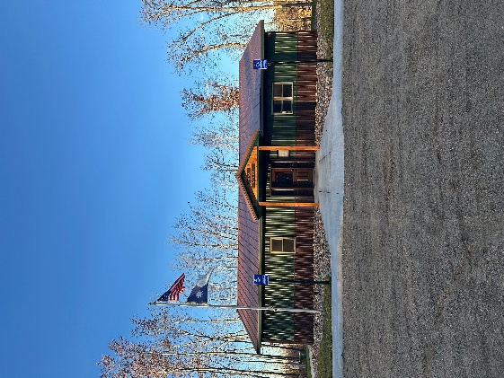
HIRAM TOWNSHIP
5895 – 36th Street N.W.
AKELEY, MN 56433
Hiram Township Regular Meeting Agenda
February 10, 2026

- Call to Order
- Pledge of Allegiance
- Approve Meeting Minutes of the January 13, 2026
- Treasurer 2025 Annual Report
- Clerk/ Treasurer Reconciliation
- Old Business
  - Website
  - .gov
  - Sale of old town hall
  - Town Hall Rental Policy
  - Storage building
  - Office furnishings & OWL update
  - Minimum Maintenance Road Resolution
- New Business
  - Donation Requests
  - Board of Appeals; date/ time
  - Spring Short Courses
  - Internet update and options
  - 26 Fire/ Ems Agreement
  - Election update
- Supervisor’s Reports
  - Report from Supervisor James Zierhut – Crack filling estimate from Ty Andrews
- Clerk’s Report
- Citizen comments
- Claims for January, 2026
- Other:
- Adjournment

