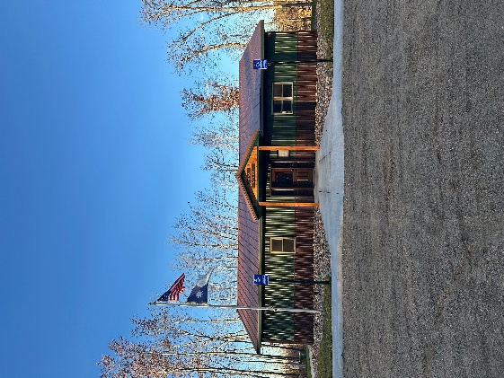
HIRAM TOWNSHIP
5895 – 36th Street N.W.
AKELEY, MN 56433
Hiram Township Regular Meeting Agenda
December 9, 2025

- Call to Order:
- Pledge of Allegiance:
- Approve Meeting Minutes of the November 11, 2025.
- Treasurer Report for November, 2025.
- Report from Chair Jim McGill
- Report from Supervisor James Zierhut
- Report from Supervisor Dave Morris
- Claims for November, 2025.
- Additional items for discussion: Cannabis resolution form
- Correspondence:
- Adjournment

