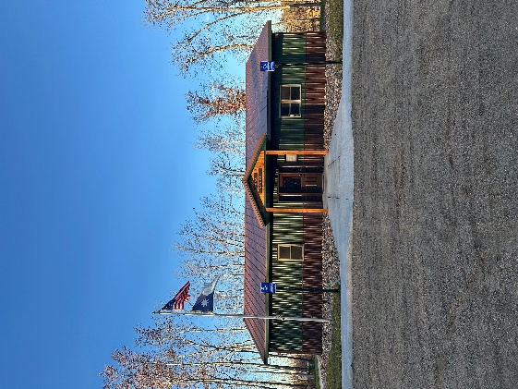
HIRAM TOWNSHIP
5895 – 36th Street N.W.
AKELEY, MN 56433
Hiram Township Regular Meeting Agenda
November 11, 2025

- Call to Order:
- Pledge of Allegiance:
- Moment of silence in honor of Veteran’s Day.
- Approve Meeting Minutes of the October 14, 2025.
- Treasurer Report for October, 2025.
- Report from Chair Jim McGill
- Report from Supervisor James Zierhut – Peterson rocks
- Report from Supervisor Dave Morris – Julie Maag (Whispering Pines Lane)
- Claims for October, 2025.
- Additional items for discussion: Foreseman Point Drive Proposal, Banning guns on premises, OWL install quote
- Correspondence:
- Adjournment

