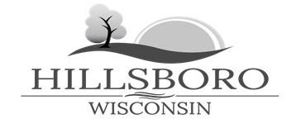
____________________________________________________________________________________
NOTICE
CITY COUNCIL MEETING AGENDA
Monday, May 19th, 2025 – 7:00 p.m.
HILLSBORO CITY HALL
123 Mechanic Street

Order of Business

- Call to Order and Pledge of Allegiance
- Proper Public Notice
- Roll Call
- Approval of Meeting Minutes
  - April 21st, 2025 — City Council Meeting
  - April 28th, 2025 — Special City Council Meeting

Committee Reports and Business
- Action on Monthly Bills— 4/3/25-5/7/2025
- Action on City of Hillsboro Audit Recommendations
- Action on Ordinance #02-2025 — Establishing Council/ Mayor Compensation
- Action on Resolution #03-2025— Employee Handbook Adoption
- Action on Resolution #04-2025 — A Resolution Opposing the Inclusion of Bump Outs
- Action on Special Park Use Permit — Albert Field Memorial Park, Vande Hei
- Action on Sidewalk Use Permit — Let’s Shine Coffee

- Adjournment

