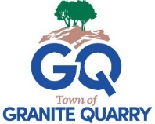
TOWN OF GRANITE QUARRY
Events Committee
Regular Meeting Agenda
May 13, 2026
6:00 p.m.

Identify Meeting Chair

Call to Order Volunteer Chair

- Approval of Agenda

- Approval of Minutes April 8, 2026

Old Business

- Discussion Arts in the Park Debrief

Member and Staff debrief

- Discussion Fish for Fun - Spring

Fish For Fun Saturday, June 6th 9am-12pm

Who will be available?

- Discussion Granite Fest ‘26

Discuss council direction on Granite Fest ’26 with Civic Park renovations beginning soon.

New Business

Adjourn

Next Meeting will be Wednesday, May 13, 2026, at 6:00 p.m. at Town Hall.

