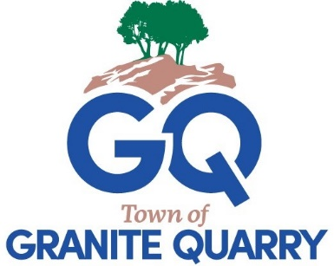
TOWN OF GRANITE QUARRY
TOWN COUNCIL
REGULAR MEETING
Monday, April 13, 2026
6:00 p.m.
Red- Mayor’s Notes
Call to Order
Moment of Silence
Pledge of Allegiance

- Approval of Agenda
ACTION REQUESTED: Motion to approve the agenda as presented/amended.

- Approval of Consent Agenda
  - Approval of the Minutes
    - Regular Meeting Minutes March 9, 2026
    - Closed Session March 9, 2026 (handout)
    - Strategic Planning Minutes March 12, 2026
    - Closed Session March 12, 2026 (handout)
  - Departmental Reports (Reports in Board packet)
  - Financial Reports (Reports in Board packet)
  - Resolution in Opposition to Limiting Local Authority on Property Tax
ACTION REQUESTED: Motion to approve the consent agenda as presented/amended.

- Public Comments
(All comments are limited to 3 minutes. No sharing of minutes with other residents.)

- Town Manager Update (Report in Board packet)

- Public Hearing Ordinance Amendment for Minimum Housing Scope
  - Staff Summary
  - Public Hearing
1) Open Public Hearing
a. Please ask anyone speaking in favor to come forward.
b. Please ask anyone opposed to come forward to speak.
2) Close Public Hearing
  - Council Discussion and Decision
ACTION REQUESTED: Motion to adopt Ordinance 2026-04-13 to amend the text of the Code of Ordinances regarding the Minimum Housing Scope.
Please restate the motion.
Old Business None
New Business
- Agreement FY26 FD Staffing Grant
The Granite Quarry Fire Department has been awarded a Fire Department Staffing Grant for FY26 in the amount of $10,000 by Rowan County Board of Commissioners.

ACTION REQUESTED: Motion to approve the FY26 Fire Department Staffing grant agreement and accept the $10,000 grant.
Please restate the motion.

- Ordinance Amendment Civic Park Project CPO 2023-01
ACTION REQUESTED: Motion to accept additional funds and amend Capital Project Ordinance 2023-01.
Please restate the motion.

- Voting Delegate NCLM Board of Directors
ACTION REQUESTED: Motion to appoint _______ as the Council’s NCLM voting delegate to submit the Council’s vote for NCLM 2026 Board of Directors.
Please restate the motion.

- Agreement Civic Park SRU Utility Easement
ACTION REQUESTED: Motion to …
Please restate the motion

- Proclamations
  - Child Abuse Prevention Month April
  - Teacher Appreciation Week May 4-8
  - Nurses Week May 6-12

- Council Comments

- Announcements and Date Reminders
- Thursday April 16 7:30 a.m. Power in Partnership Breakfast
- Thursday April 16 6:00 p.m. Rowan Municipal Association Dinner
- Wednesday April 22 5:30 p.m. CRMPO TAC
- Saturday April 25 1:00 p.m. Arts in the Park
- Monday May 4 6:00 p.m. Planning Board
- Monday May 4 6:15 p.m. Board of Adjustment
- Tuesday May 5 City Vision Conference
- Wednesday May 6 City Vision Conference
- Thursday May 7 City Vision Conference

Adjourn

