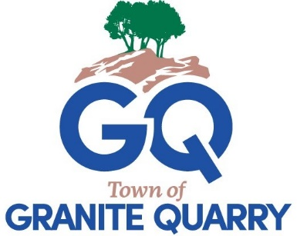
TOWN OF GRANITE QUARRY
TOWN COUNCIL
REGULAR MEETING
Monday, March 9, 2026
6:00 p.m.

Call to Order
Moment of Silence
Pledge of Allegiance

- Approval of Agenda

- Approval of Consent Agenda
  - Approval of the Minutes
    - Special Meeting Minutes January 27, 2026 & February 6, 2026
    - Closed Session January 27, 2026 (handout)
    - Closed Session February 6, 2026 (handout)
    - Regular Meeting February 9, 2026
  - Departmental Reports
  - Financial Reports

- Public Comments
(All comments are limited to 3 minutes. No sharing of minutes with other residents.)

- Town Manager Update

Old Business None

New Business
- Donation Request Granite Quarry 125th Anniversary Committee
ACTION REQUESTED: Motion to donate the requested $4,000 to the Granite Quarry 125th Anniversary Committee from Contingency for the 125th Anniversary events to be held in April 2026.

- Budget Amendment Granite Quarry 125th Anniversary Event Funds
ACTION REQUESTED: Motion to approve Budget Amendment #7 as presented.

- Agreement Interlocal Agreement for Faith Police Services
ACTION REQUESTED: Motion to approve the interlocal agreement to provide law enforcement services to the Town of Faith as presented.

- Proclamation Celebrating the 125th Anniversary of Granite Quarry

- Council Comments

- Announcements and Date Reminders
- Wednesday March 11 5:00 p.m. Centralina Executive Board
- Wednesday March 11 5:30 p.m. Community Appearance Comm.
- Wednesday March 11 6:00 p.m. Events Committee
- Thursday March 12 1:00 p.m. Strategic Planning Meeting
- Tuesday March 17 6:00 p.m. Gardening 101 Class
- Thursday March 19 7:30 a.m. Power in Partnership Breakfast
- Saturday March 21 9:00 a.m. Resident Mulch Giveaway
- Wednesday March 25 5:30 p.m. CRMPO TAC
- Friday April 3 Good Friday – Town Offices Closed
- Saturday April 4 1:00 p.m. Easter Parade & Community Egg Hunt
- Monday April 6 6:00 p.m. Planning Board
- Monday April 6 6:15 p.m. Board of Adjustment
- Wednesday April 8 5:00 p.m. Centralina Executive Board
- Wednesday April 8 5:30 p.m. Community Appearance Comm.
- Wednesday April 8 6:00 p.m. Events Committee
- Thursday April 9 10:00 a.m. Budget Workshop
- Saturday April 11 2:00 p.m. 125th Anniversary Event

- Closed Session TM Mid-Year Evaluation
ACTION REQUESTED: Motion to go into closed session pursuant to N.C. General Statutes Section 143-318.11(a)(6) to consider performance of an individual public employee.

ACTION REQUESTED: Motion to return to open session.

Adjourn

