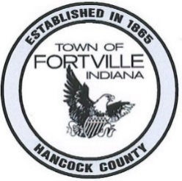

Fortville Advisory Plan Commission

Fortville Town Hall, 714 E. Broadway St., Fortville, IN 46040

THE PLAN COMMISSION MEETING SCHEDULED FOR
TUESDAY, JULY 28th, 2026
IS CANCELLED
AS THERE ARE NO ITEMS FOR DISCUSSION.

THANK YOU!

