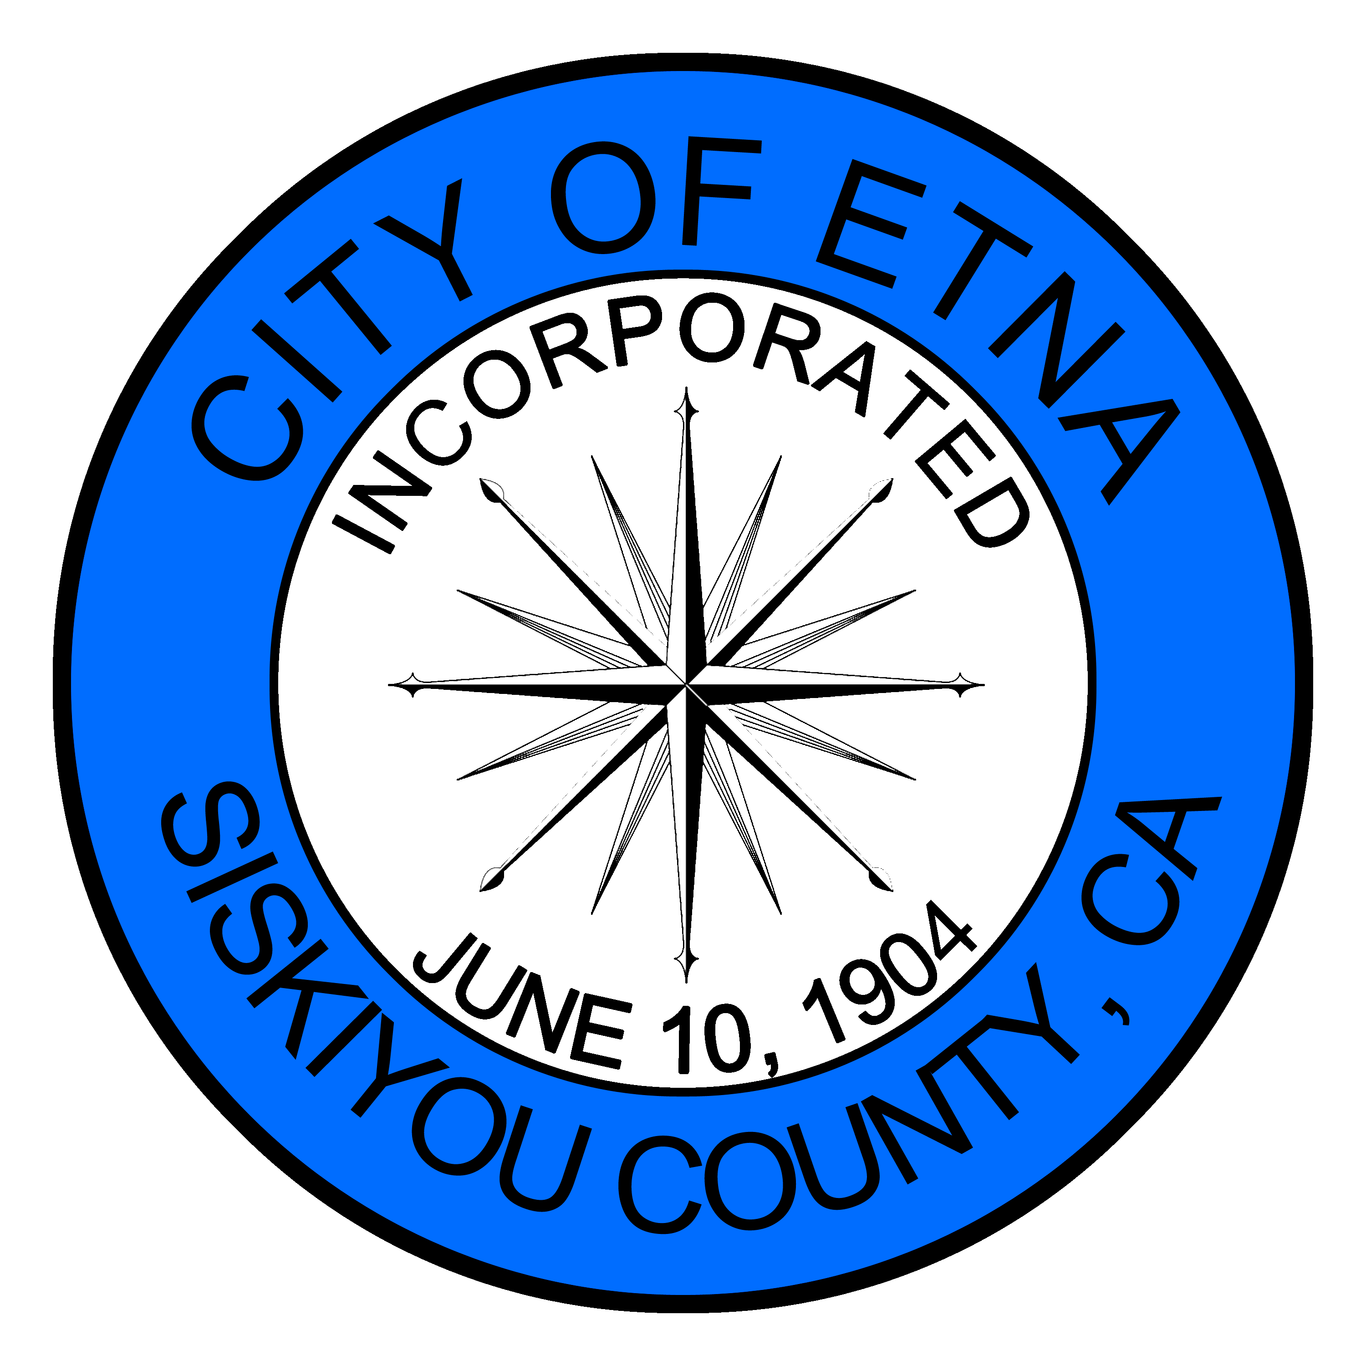
AGENDA FOR THE SPECIAL MEETING OF THE ETNA CITY COUNCIL

DATE OF THE MEETING: June 1, 2026
TIME OF THE MEETING: 6:00 pm
PLACE OF THE MEETING: 442 Main Street Etna, CA

- Call to Order
- Pledge of Allegiance
- Roll Call
- Public Comment – Agenda Items Only – Public participation during a special meeting is limited to those items listed on the agenda.
- CURRENT BUSINESS:
  - Discuss/Approve Rescinding 2026-2029 Fort Jones Police Contract Approved on May 26, 2026
  - Discuss/Approve Amending 2025-2026 Fort Jones Police Contract Price to $TBD
- CLOSED SESSION: The City Council will recess to Closed Session to discuss the below item(s). At the conclusion of the Closed Session, Open Session will reconvene and the reportable action, if any, will be announced. Announcement of any action taken by the City Council in Closed Session required by the Ralph M. Brown Act (Government Code §54950 et. Seq.)
  - Public Employment – Appointment (Pursuant to Government Code §54957)
      - City Administrator/Manager
- CITY COUNCIL STATEMENTS AND REQUESTS
- ADJOURNMENT

Zoom Teleconference Information:
Phone: 1-669-444-9171 US Meeting ID: 829 0203 8109
https://us06web.zoom.us/launch/jc/82902038109
The City of Etna does not discriminate based on disability in the admissions or access to, or treatment of or employment in, its programs or activities. Disability-related aids or services, including printed information in alternate formats, to enable persons with disabilities to participate in public meetings are available. If any accommodations are needed, please contact Pamela Eastlick at 530-467-5256 p.eastlick@etnaca.gov. Requests should be made as soon as possible but recommended between three days to one week prior to the scheduled meeting.

