City of High Shoals
Regular City Council Meeting
August 11, 2026

- Call to Order: Mayor PJ Rathbone called the meeting to order at 6:30 pm. Denese Cook, Dennis Cash, Bo Rhyne, Kathy Rhyne, Bobby Vassey, and Tim Eidson were in attendance.
- Invocation
- Pledge of Allegiance
- Approval of Agenda: Motion to approve the agenda made by Denese Cook, seconded by Bo Rhyne. All in favor.
- Approval of Minutes: Motion to approve the minutes of July 2026 made by Dennis Cash, seconded by Tim Eidson, all approved.
Citizens’ comments/concerns: The City of High Shoals City Council offers citizens the opportunity for public expression pursuant to NCGS 160A-81.1. Comments are limited to 3–5 minutes per speaker. No citizen signed up to speak.
Good of the Order: Time set aside for members to offer comments or observations about the organization and its work without formal motion.
- Trash Truck is in for repair for the valve body assembly.
- We should hear from the state for funding for a new trash truck by September 1st
- Last week Tim drove one trash truck, and the Mayor drove another trash truck to get the route completed.
- Kathy Rhyne reported that though it is outside of city limits, water is pooling badly in front of the new fire department at Miles Road. Dennis said they were out there working on it earlier that day.
- Kathy also asked what happened to all of the military banners. The crew had to locate more rods/poles to install the remaining banners on the bridge, also, the crew is behind due to the weather and trash truck issues for the past two months.
- Denese asked if we should look into hiring another employee for the outside crew.
- Dennis asked if we could get the state to put speed bumps in on Dayton Road.
- Tim suggested we look into tree trimming on Holly Ridge Road.

VI. Departmental Reports:
- Police Report-Gaston County—Chief Matt Johnson said that starting in October, they are switching up how they divide the county. Captain Parsons will be our Point of Contact and the Chief over our area.
- Financial-Dennis Cash
    - CHECKING 1: $117,085.06
    - CHECKING 2: $ 7,850.78
    - CAP MGMT: $273,222.50
    - TOTAL: $ 398,158.34
- Cemetery-Denese Cook—The grass had gotten knee high, though the cemetery looks great now. Had someone complained about a broken trinket; however, told them there was nothing the city could do, especially considering trinkets aren’t permitted.
- Water/Sewer-Bo Rhyne—There may be a leak on River Street at the wall; though it could be seepage from the rain we’ve gotten recently.
- Streets/Maintenance/Sanitation-Kathy Rhyne –Has been covered under the Good of the Order.
- Parks/Recreation-Bobby Vassey
    - Yard of the Month:– 108 River Street---Kelly Beach
- Vehicles- Tim Eidson—Linkage in one of the stand-up mowers broke. It is at James River for repair.
- Administration/Mayor Report-PJ Rathbone—Ongoing issues at Autumn Ridge concerning the fire hydrants, water leaks on the homeowner’s side. We’re going to schedule a meeting with True Homes for Friday to discuss a solution.
- New Business:
  - Resolution for CDBG Revitalization—Motion to approve the CDBG revitalization resolution made by Denese Cook, seconded by Bobby Vassey. All in favor.
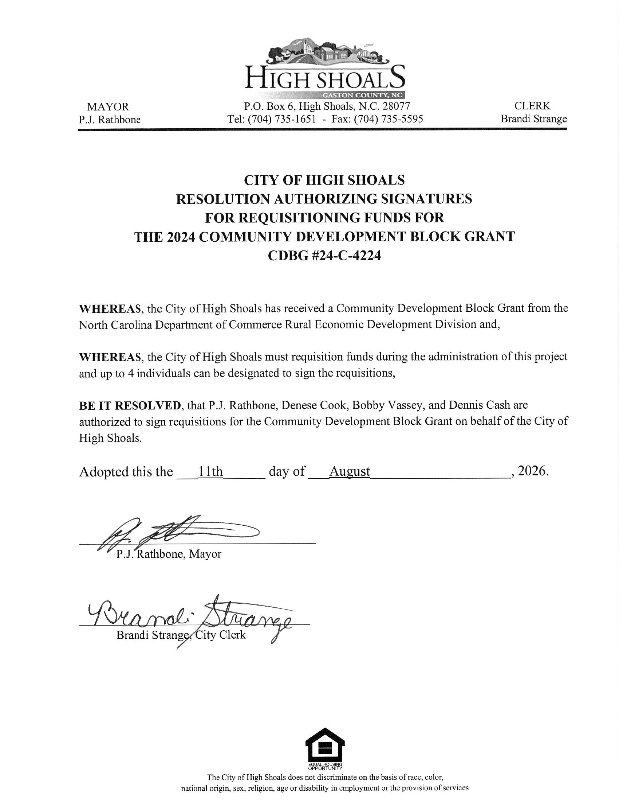

- Motion to Recess for August 25th 6:30 pm Public Hearing: Motion to recess made Denese Cook, seconded by Bobby Vassey. All in favor.

