City of High Shoals
Regular City Council Meeting
July 14, 2026
- Call to Order: Mayor PJ Rathbone called the July council meeting to order at 6:31 pm. In attendance are the following: Tim Eidson, Kathy Rhyne, Bobby Vassey, Bo Rhyne, Denese Cook, Dennis Cash, and PJ Rathbone.
- Invocation
- Pledge of Allegiance
- Approval of Agenda: Motion to approve the agenda made by Denese Cook, seconded by Bo Rhyne. All in favor.
- Approval of Minutes: Motion to approve the minutes from June 2026 approved by Bo Rhyne, seconded by Dennis Cash. All in favor.
Citizens’ comments/concerns: The City of High Shoals City Council offers citizens the opportunity for public expression pursuant to NCGS 160A-81.1. Comments are limited to 3–5 minutes per speaker.
Ms. Diane signed up to speak about the gold car with no license plate, and there are two families living under the bridge. The policeman said to call the emergency number. Judy spoke up and said that she had called the non-emergency number about a man at her house at night, beating on her door, and no policeman came to her house at all.
A gentleman requested and asked for someone to have a permanent policeman on the grounds. The policeman suggested a separate contract to have a substation in the city.
Good of the Order: Time set aside for members to offer comments or observations about the organization and its work without formal motion. It has been hot; Jerry has been sick for four days. He had some stomach issues, possibly dehydration, the ER gave him fluids after 3 days. Denese mentioned that the city’s float was the nicest, and it was nominated as the “picture float” and the state & local officials took pictures in front of our float, since it was the most patriotic. December 13th at 2 pm is the Christmas parade.

VI. Departmental Reports:

- Police Report-Gaston County
- Financial-Dennis Cash
    - CHECKING 1: $110,946.40
    - Powell Bill funds: $ 10,121.42
    - CAP MGMT: $272,081.12
    - TOTAL: $393,148.94
- Cemetery-Denese Cook-Nothing to report
- Water/Sewer-Bo Rhyne-Nothing to report
- Streets/Maintenance/Sanitation-Kathy Rhyne-The trash truck had a hydraulic line busted, taken to the shop, repaired, and got as much done as they could.
  - Kathy Rhyne requested the military banners be put up. Make sure they’re dried out before they get stored, so they don’t mildew.
- Parks/Recreation-Bobby Vassey
    - Yard of the Month:– 100 Thompkins St –Seth Rollins
- Vehicles- Tim Eidson
- Administration/Mayor Report-PJ Rathbone
  - Mill Property-Phase II-Fall Timeline—Phase II assessment is funded through Centralina and when we finish this, the EPA Brownsfield will keep moving forward. Now that we are in these phases, Centralina has been pushing through the timelines to get things completed.
  - Fire Station Appraisal Report: We have gotten the appraisal report back, we are waiting for the RFP for three banks to come back for financing options, then we will have to go through the LGC.
  - W. Virginia Crew-Helene/River Cleanup: There is a work crew that is coming into the area to clean up the creeks, rivers, of all the trees and such to prevent future flooding from Helene. They have requested to use the concrete pad and will put a fence around the pad, and mulch and remove the mulching. He wanted to clean up the entire site; however, since it’s a Brownfield site, they cannot disturb any soil. The Holly Ridge creek is included as well. The creek behind Cherry St. houses will be removed as well.
    - The hydrants haven’t had the correct valves put on in the housing development as of yesterday.
- New Business:
  - Discussion/Action CDBG Water Line – Council Approval to allow us to meet with Long & Sons Utility Co., LLC and enter into contract.
    - The recommended bid is for the water line on River Street, Long & Sons. The lines are replacing exactly what’s there. Steve suggested meeting with them first, they’re stationed in Simpsonville, SC, Thrasher Group has met with them, but the state has not much information on them. If they are ok with the processes here in NC, this council needs to decide if we move in to the contract with them, if they’re not and would like to withdraw their bid, can we move forward to move on to the next lowest bidder (Two-Brothers) who did the work of the other lines & understand the process in NC.
      - Motion made to go into contract if they understand the rules made by Dennis Cash, seconded by Bo Rhyne. All in favor.
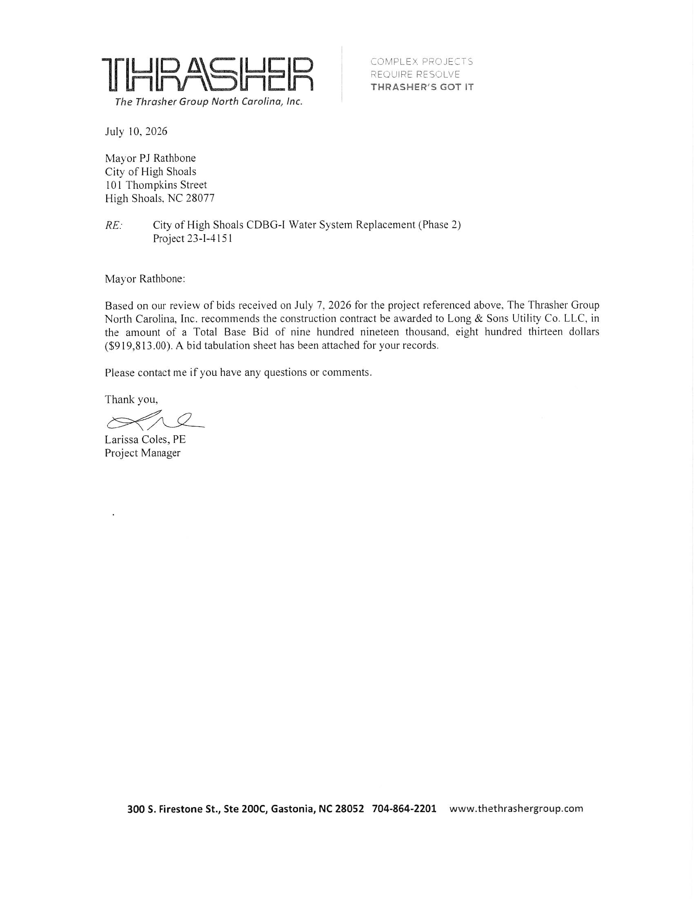
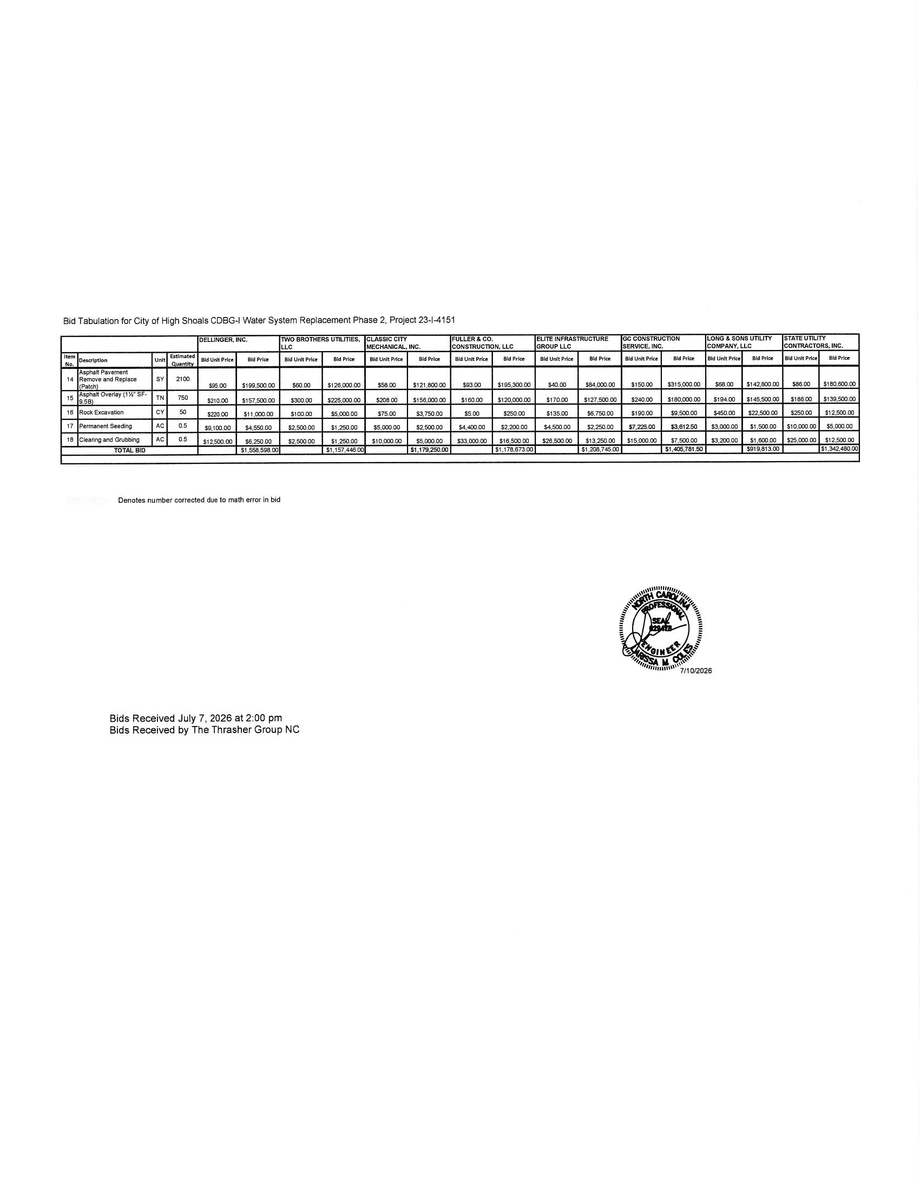
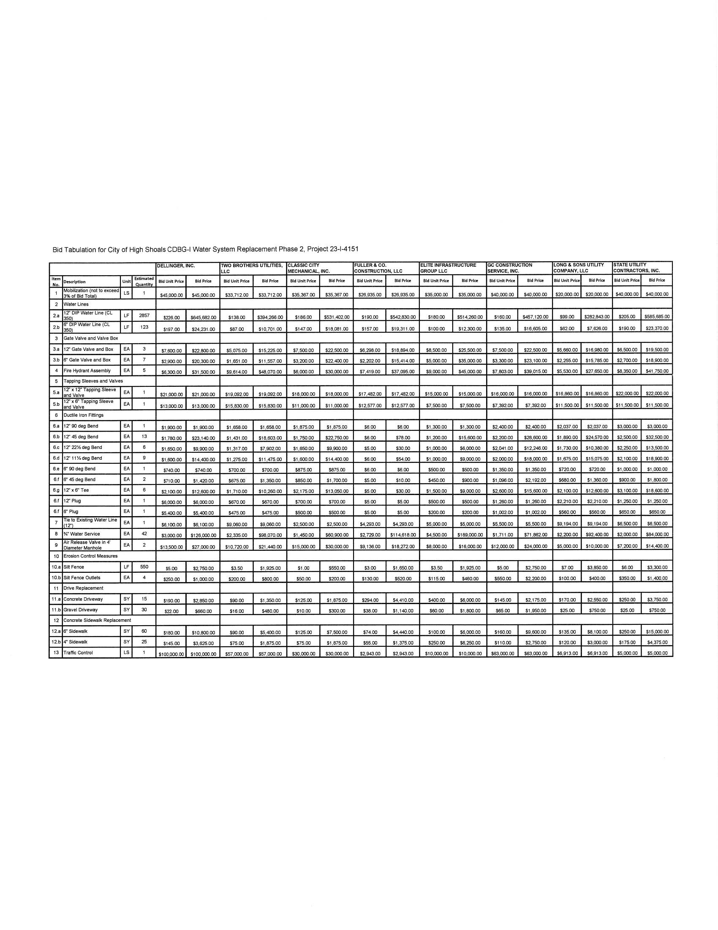

  - Discussion/Action—Plan for an event in the park -late summer/early fall
    - Fall Festival on October 31st 5:30 -Trunk-r-Treat, 7:00 band

- Motion to Adjourn: Motion to adjourn made by Denese Cook, seconded by Bo Rhyne. All in favor.

