City of High Shoals
Regular City Council Meeting
June 9, 2026
- Call to Order: Mayor PJ Rathbone called the meeting to order at 6:32 pm. In attendance are the following council members: Tim Eidson, Kathy Rhyne, Bobby Vassey, Denese Cook, and PJ Rathbone. Dennis Cash was away on a fire call, Bo Rhyne showed up at 6:42.
- Invocation
- Pledge of Allegiance
- Approval of Agenda- Motion to approve Kathy Rhyne, seconded by Bobby Vassey, all in favor.
- Approval of Minutes- Motion to approve made by Denese Cook, seconded by Bobby Vassey, all in favor.
Citizens’ comments/concerns: The City of High Shoals City Council offers citizens the opportunity for public expression pursuant to NCGS 160A-81.1. Comments are limited to 3–5 minutes per speaker.
- Motion to approve the April 13th meeting minutes was tabled at the previous meeting, motion to approve those minutes made by Denese Cook, seconded by Bobby Vassey.
Mark Lanphier, EMS chief for Gaston County, apologized for the actions of EMS. Would like to do better in the future.

Judy spoke about houses being finished and returning to Ms. Taylor’s house. Her plumbing is messed up and has been addressed to the workers; however, they’re refusing to fix it. Ms. Taylor has been also trying to have the air conditioner fixed as well. She was directed to contact Steve since he’s the grant administrator. Second issue is the young couple who were caught in the act in the Post Office Saturday night. Must be locked at 7 pm on Saturday. Ms. Hulit asked about the grants for housing revitalization this round, we must have a re-sign up.

Good of the Order: Time set aside for members to offer comments or observations about the organization and its work without formal motion.

VI. Departmental Reports:
- Police Report-Gaston County
- Financial-Dennis Cash
    - CHECKING 1: $105,488.46
    - CHECKING 2: $ 12,391.89
    - CAP MGMT: $271,288.29
    - TOTAL: $389,168.64
- Cemetery-Denese Cook: Nothing to report
- Water/Sewer-Bo Rhyne Nothing to report
- Streets/Maintenance/Sanitation-Kathy Rhyne
  - Sanitation got a late start; the route will be finished in the morning. Issues with the little truck, got it back, hydraulic line ruptured.
  - Still looking into the new truck for financing
- Parks/Recreation-Bobby Vassey
    - Yard of the Month:– 200 Cherry St. Diane Hulit
- Vehicles- Tim Eidson
- Administration/Mayor Report-PJ Rathbone
  - We’re working through the mill property – until we get caught up, we won’t be able to go in to start cleaning up. Still working on Phase II assessment things.
Council Comments / Announcements

- Public Hearing: Budget Hearing—Proposed FY 2026/2027 Budget
Motion to open Public Hearing—Motion to open public hearing made by Kathy Rhyne, seconded by Bobby Vassey. All in favor.
  - Purpose: To receive public comments regarding the proposed FY 26/27 Budget.
  - Public Comments to be accepted during the hearing.
    - No comments made
Motion to Close Public Hearing—Motion to close public hearing made by Kathy Rhyne, seconded by Bobby Vassey. All in favor.

- New Business:

- Adoption of FY 2026-2027 Budget Ordinance
Motion to approve Budget Ordinance for 2026/2027 made by Kathy Rhyne, seconded by Bo Rhyne. All in favor.

- Christmas Parade date & float options https://www.clinesfloats.com/christmasfloats/
Sunday, December 13 at 2pm, Cocoa with Santa on Saturday, December 12th at 6pm

- Consider Assessment of Nuisance Abatement Costs and Authorization to File Lien – 413 N. Lincoln Street
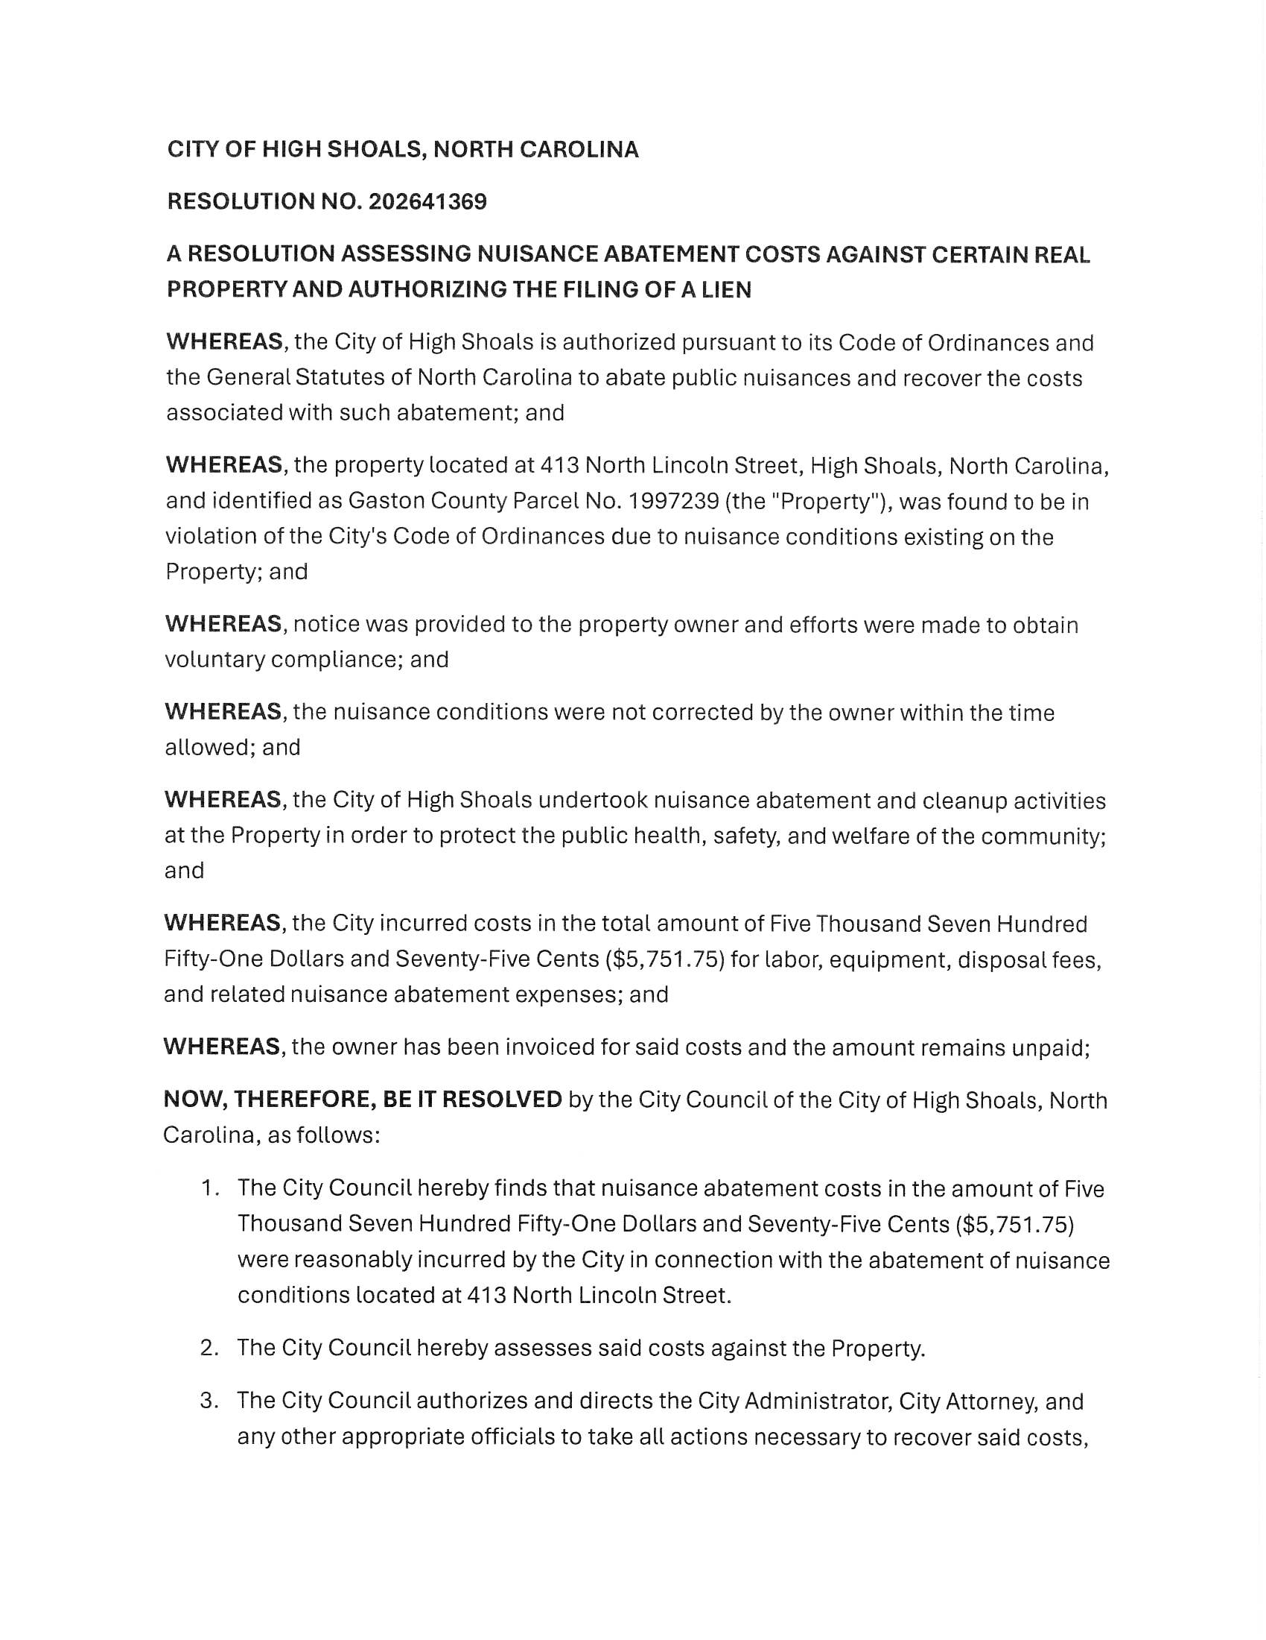
Motion to approve made by Denese Cook, seconded by Bo Rhyne. All in favor.
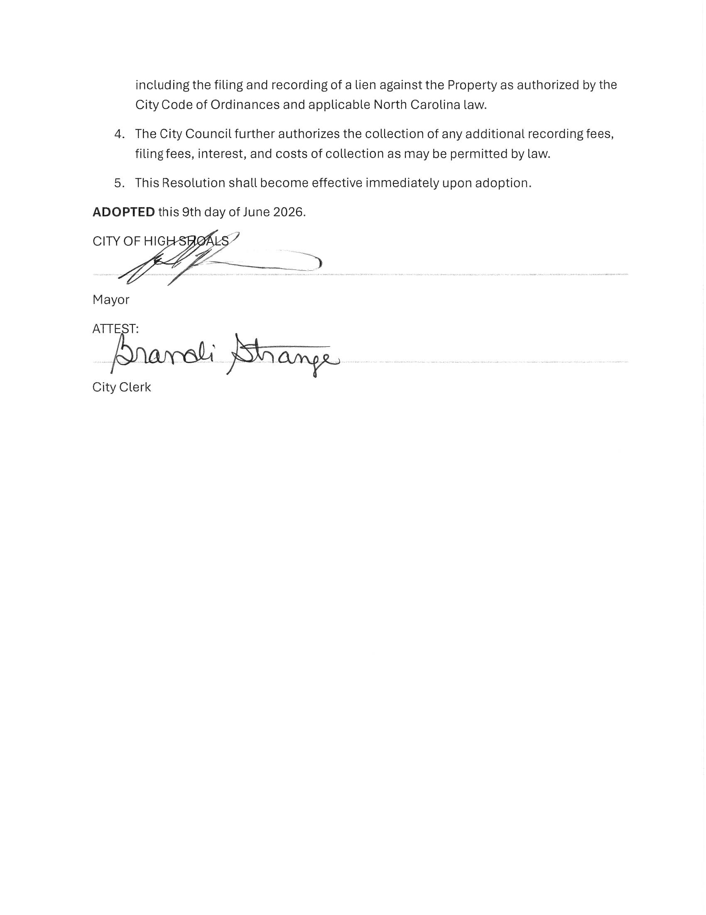
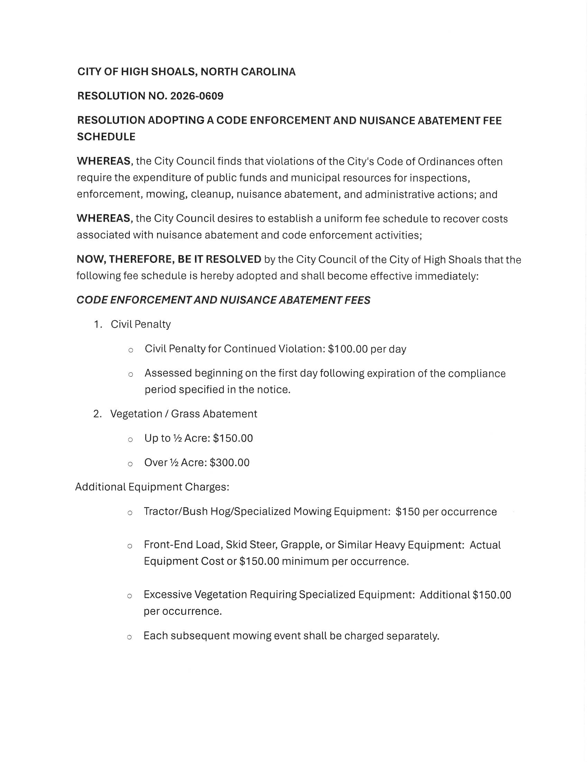
- Adjust Code Enforcement fees for repeat offenders & taller grass—Resolution
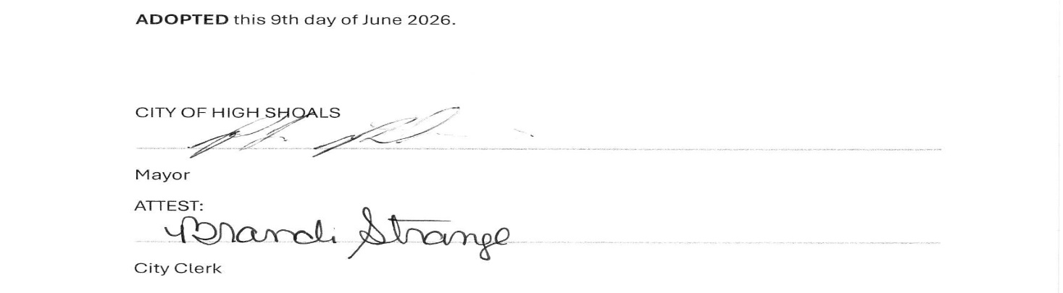
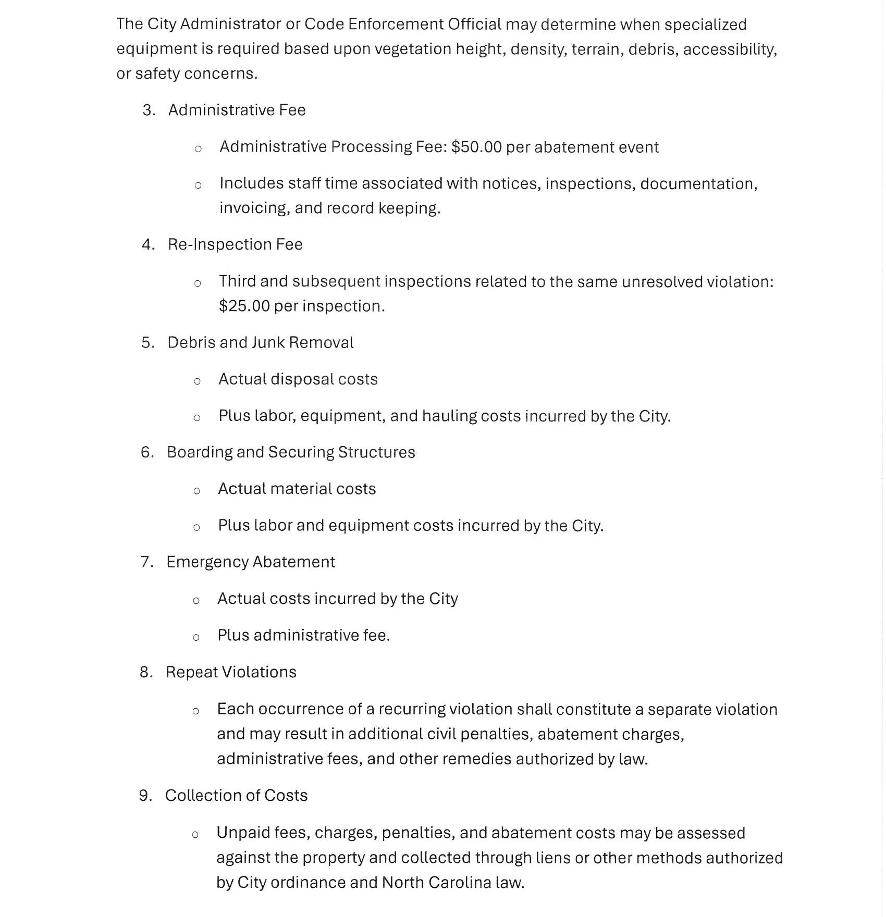
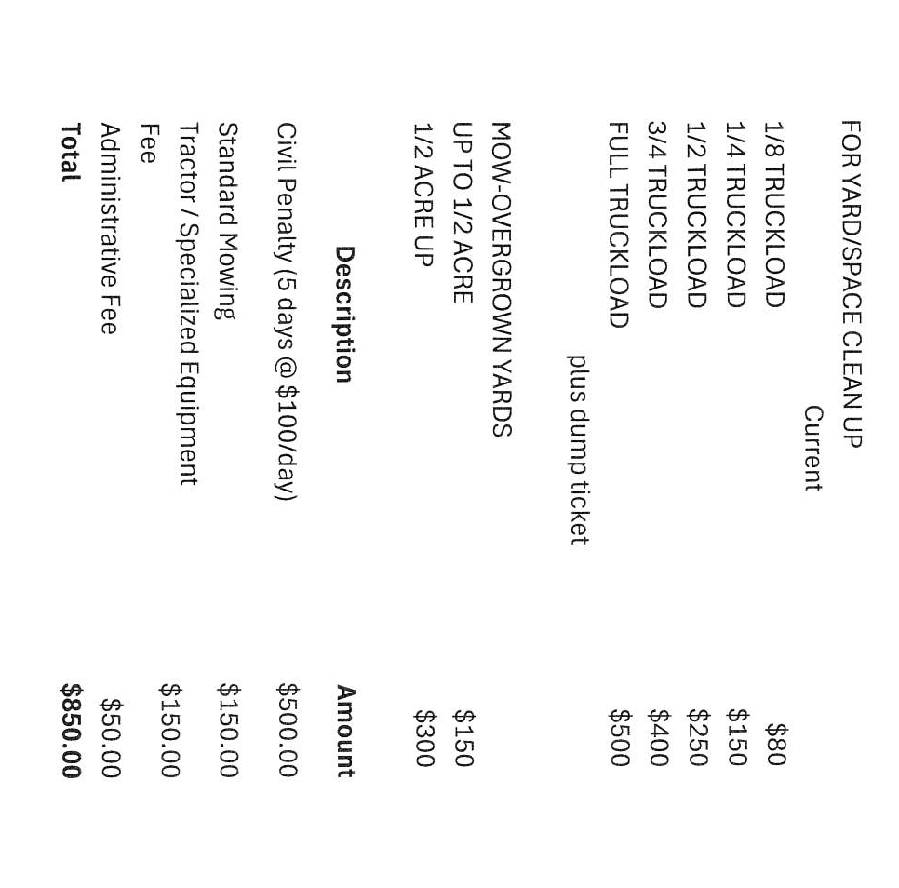
Motion to approve made by Denese Cook, seconded by Tim Eidson, all in favor.

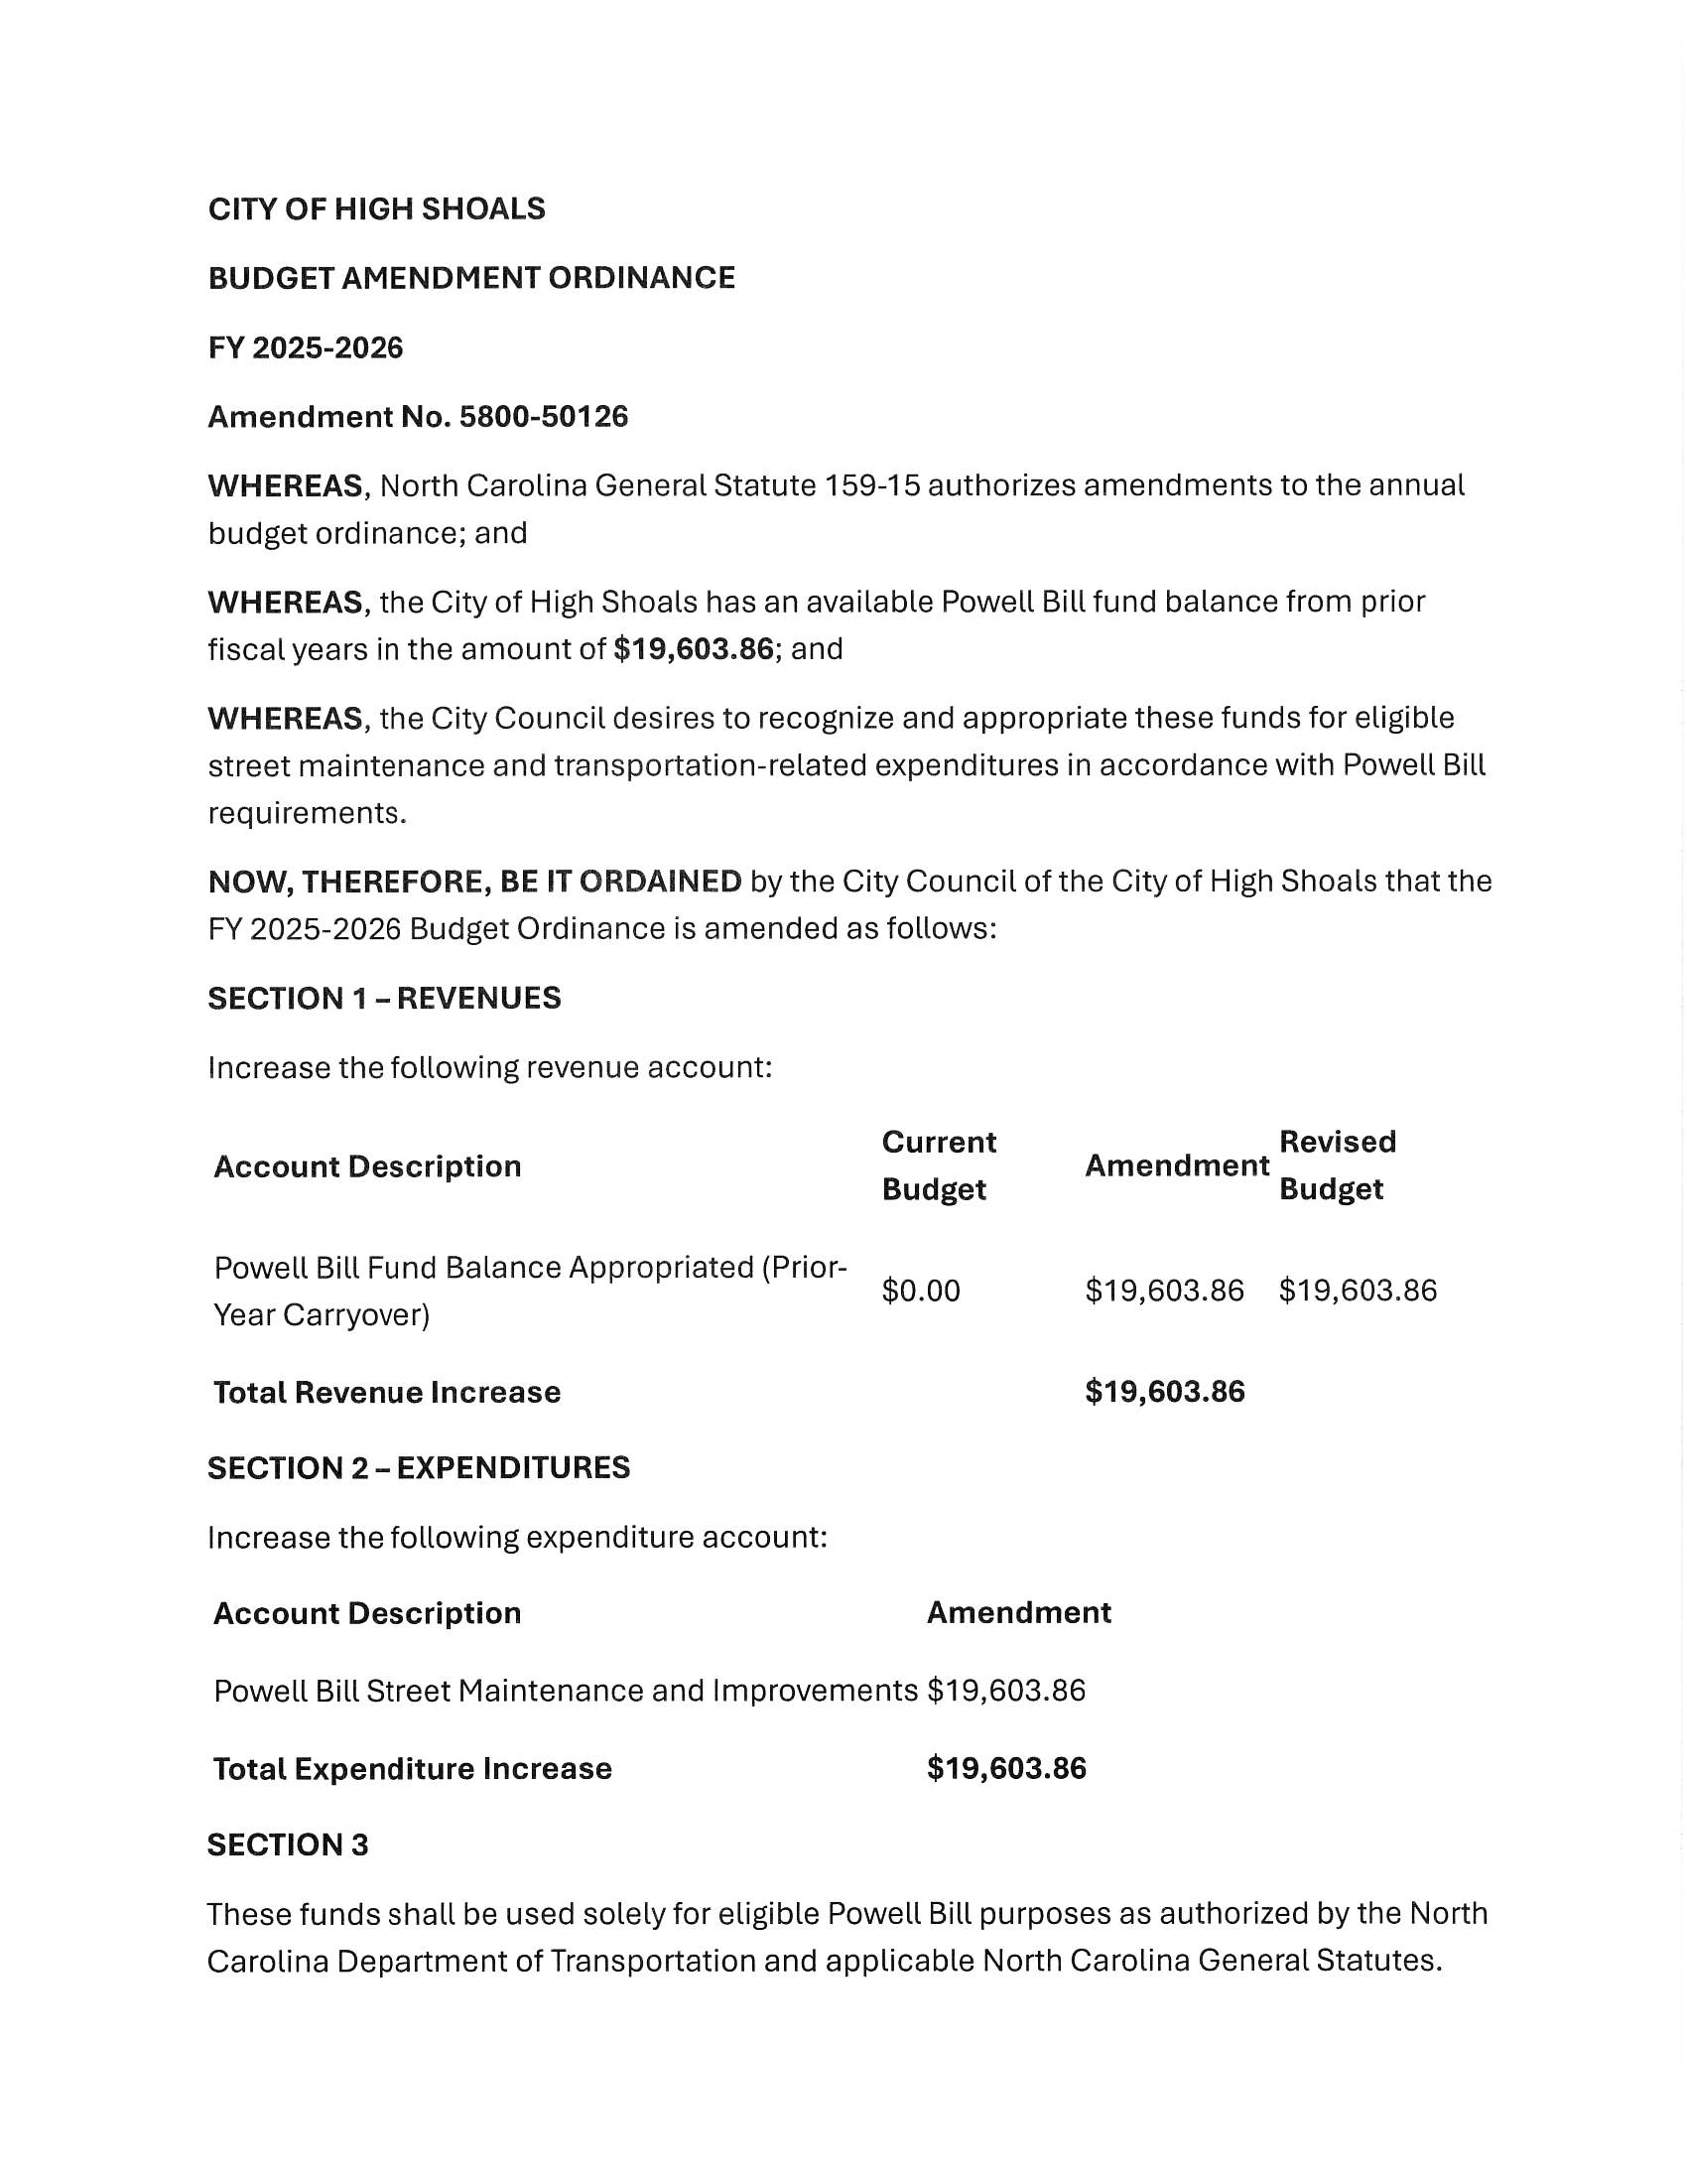
- Budget Amendments: Sanitation & Powell Bill
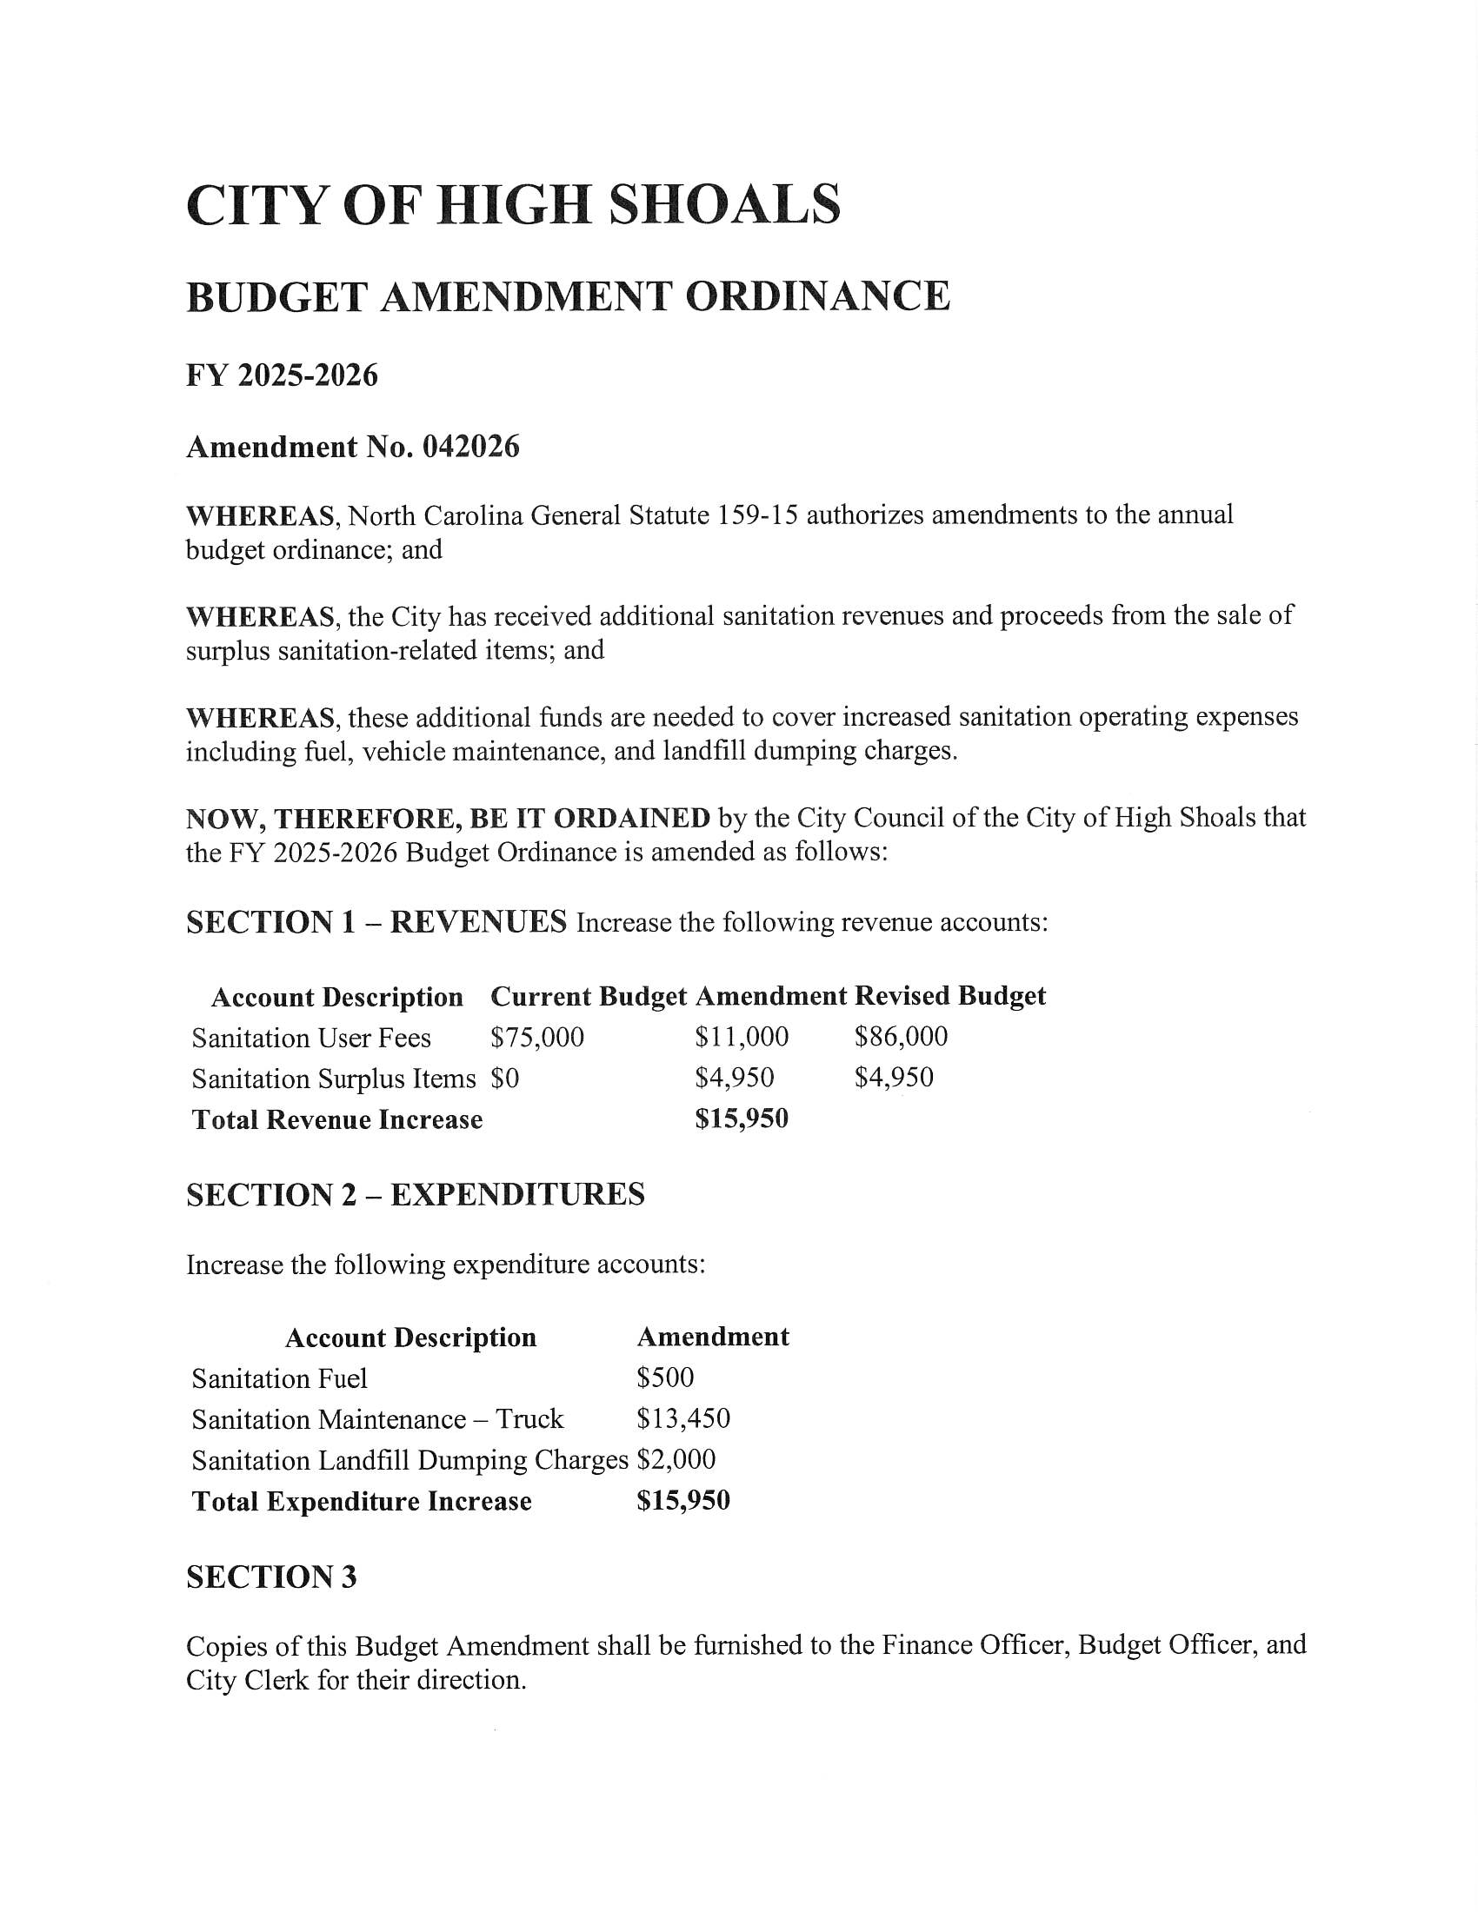
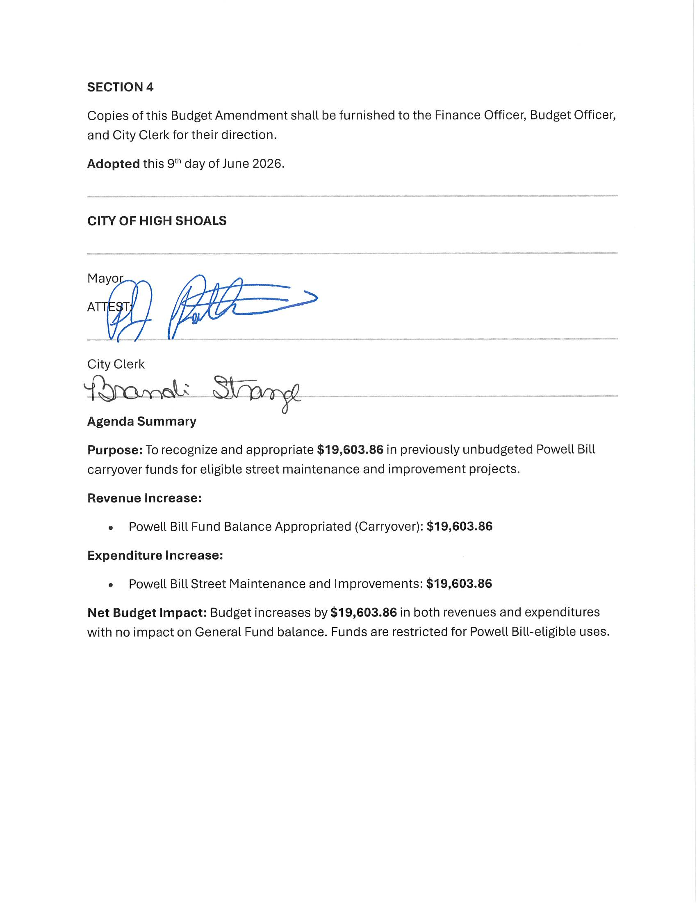

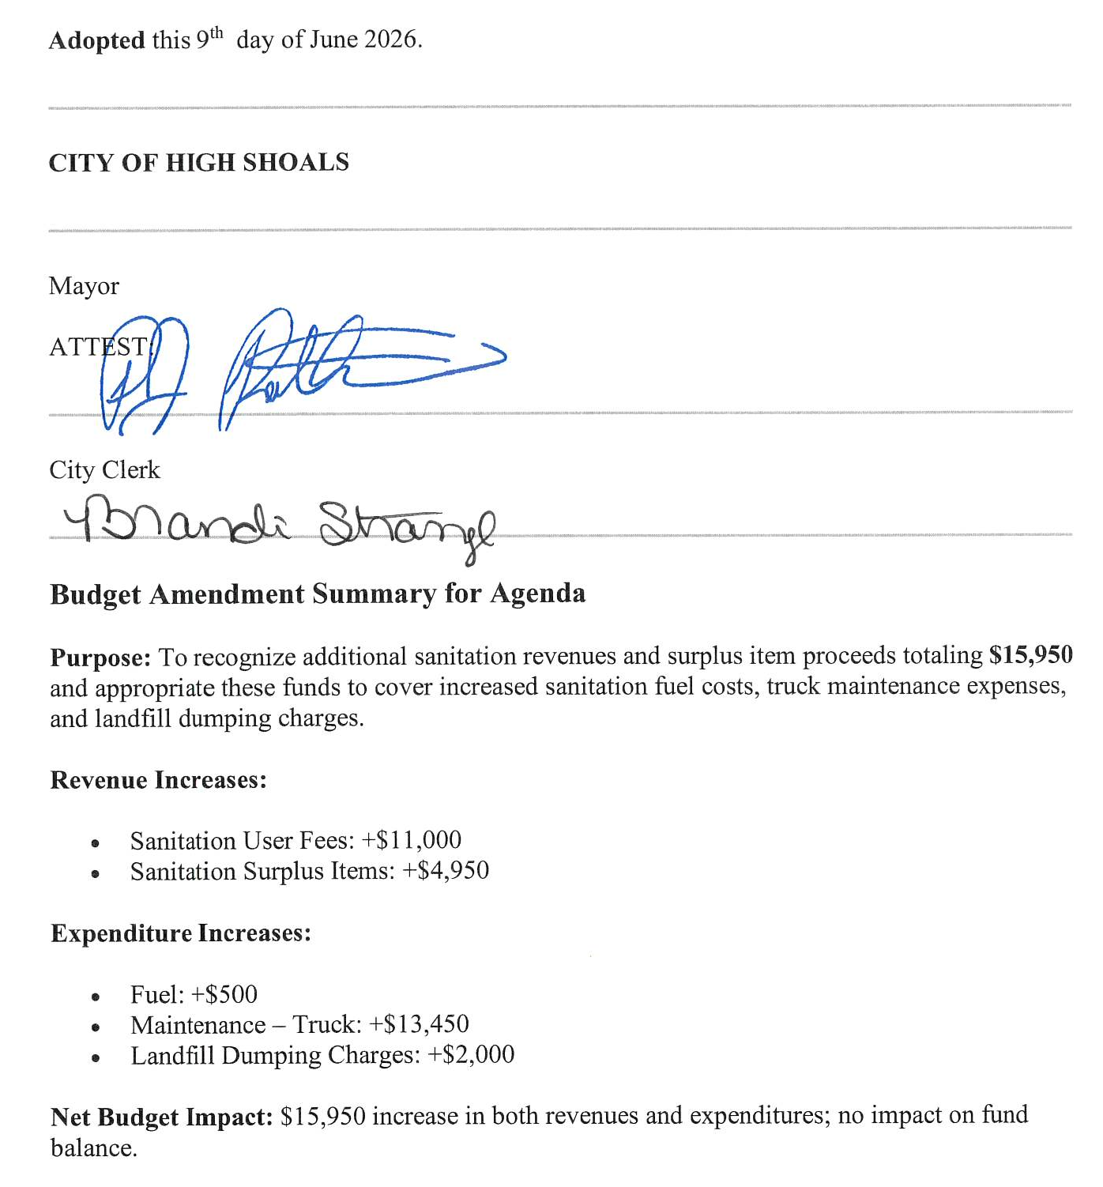 Motion to approve budget adjustments made by Kathy Rhyne, seconded by Bobby Vassey. All in favor.

- Motion to Adjourn: Motion to approve made by Denese Cook, seconded by Kathy Rhyne. All in favor.

