City of High Shoals
Regular City Council Meeting
May 12, 2026

- Call to Order: Mayor PJ Rathbone called the May 12, 2026 meeting to order at 6:30 pm. In attendance were the following council members: Denese Cook, Dennis Cash, Bobby Vassey and Bo Rhyne were in attendance. Tim Eidson and Kathy Rhyne were absent.
- Invocation
- Pledge of Allegiance
- Approval of Agenda
- Motion to approve the agenda made by Denese Cook, seconded by Bobby Vassey. All in favor.
Approval of Minutes
- Motion to approve the April 8, 2026 meeting minutes made by Dennis Cash, seconded by Bobby Vassey. All in favor.

Citizens’ comments/concerns: The City of High Shoals offers citizens the opportunity for Public Expression issues per NCGS 160A-81.1 (limited to 3-5 minutes per speaker). NONE

Good of the Order: This is a time set aside for members to offer comments or observations (without formal motion) about the organization and its work. The good of the order is also the time to offer resolution to bring disciplinary charges against a member for the offenses committed outside a meeting. Denese Cook asked if any Council members had been contacted by citizens about the new water and sewer rates.
The Mayor reminded everyone that the countywide 4th of July Parade would take place on July 4, 2026 in the Town of Dallas and that the City of High Shoals will have a float in the parade.
- Departmental Reports:
- Police Report-Gaston County
- Financial – Dennis Cash
- CHECKING 1: $116,103.50
- CHECKING 2: $ 15,012.32
- CAP MGMT: $270,474.13
- TOTAL: $401,589.95
- Cemetery - Denese Cook reported no issues.
- Water/Sewer – Bo Rhyne
- Bo Rhyne reported no issues. The Mayor reported that the Dallas water line along US Highway 321-a had been bored under the river.
- Streets/Maintenance/Sanitation – The Mayor stated that he is getting estimates for cutting trees in right of ways.
- Parks/Recreation – Bobby Vassey reported:
- Yard of the Month - 1552 Autumn Banks Way
- Aaron Thomas
- Vehicles – The Mayor reported for Tim Eidson that the check engine light has been coming on in the garbage truck and they the staff will checking it out.
- Administration/Mayor Report – PJ Rathbone
- Mill Property Phase II - Mayor Rathbone stated that the NC Department of Environmental Quality and the Centralina Council of Governments had informed him that the City could clean off any debris at the Mill Property that is on concrete pads. The City cannot do anything that disturbs the soil on the property.
- Fire Station / Public Works – The Mayor reported that he has had talks with banks about purchasing the fire department building. He also reported that the purchase and loan must be approved by the Local Government Commission.
- The Mayor distributed a form for each Council member to sign amending the fund balance in the City’s water and sewer fund.
PUBLIC HEARING: Purpose: CDBG-Revitalization Funds Request: Formal Program amendment requesting an additional $225,000 to add a new activity called Neighborhood Facilities.
- Motion to Open Public Hearing: Dennis Cash made a motion to go into public hearing. Bo Rhyne seconded. All approved.
Mayor Rathbone asked Steve Austin to discuss the application. Mr. Austin stated that this is a required public hearing for the City to request an additional $225,000 in Community Development Block Grant (CDBG) funds for the City’s current Neighborhood Revitalization Grant #222-C-4125. He stated that a public hearing and a formal project amendment request are required whenever a local government adds a new activity to a current grant program. Specifically, the City is requesting the additional funds for the installation of a columbarium in the High Shoals Cemetery. The columbarium would include approximately 120 niches for the interment of ashes. He stated that Brandi Strange had been contacting companies that provide columbarium for cost estimates. He also reported that he had contacted the NC Department of Commerce to verify that this is an eligible CDBG activity and was told yes. The project qualifies because the City has an areawide (citywide) low and moderate income rate of 76.2%. He stated that any program income derived from the sales of the niches would have to accounted for and used only for other CDBG eligible activities. The public hearing has been duly advertised, and the amendment application would be submitted in June 2026 after the Council has adopted the minutes of this public hearing.
- Formal Action to close Public Hearing: Denese Cook made a motion to close the public hearing, Bobby Vassey seconded. All approved.
- Approval of attached resolution. Denese Cook made a motion to approve the attached resolution authorizing the Mayor to submit the CDBG amendment application on
- behalf of the City. Bobby Vassey seconded the motion. All approved.
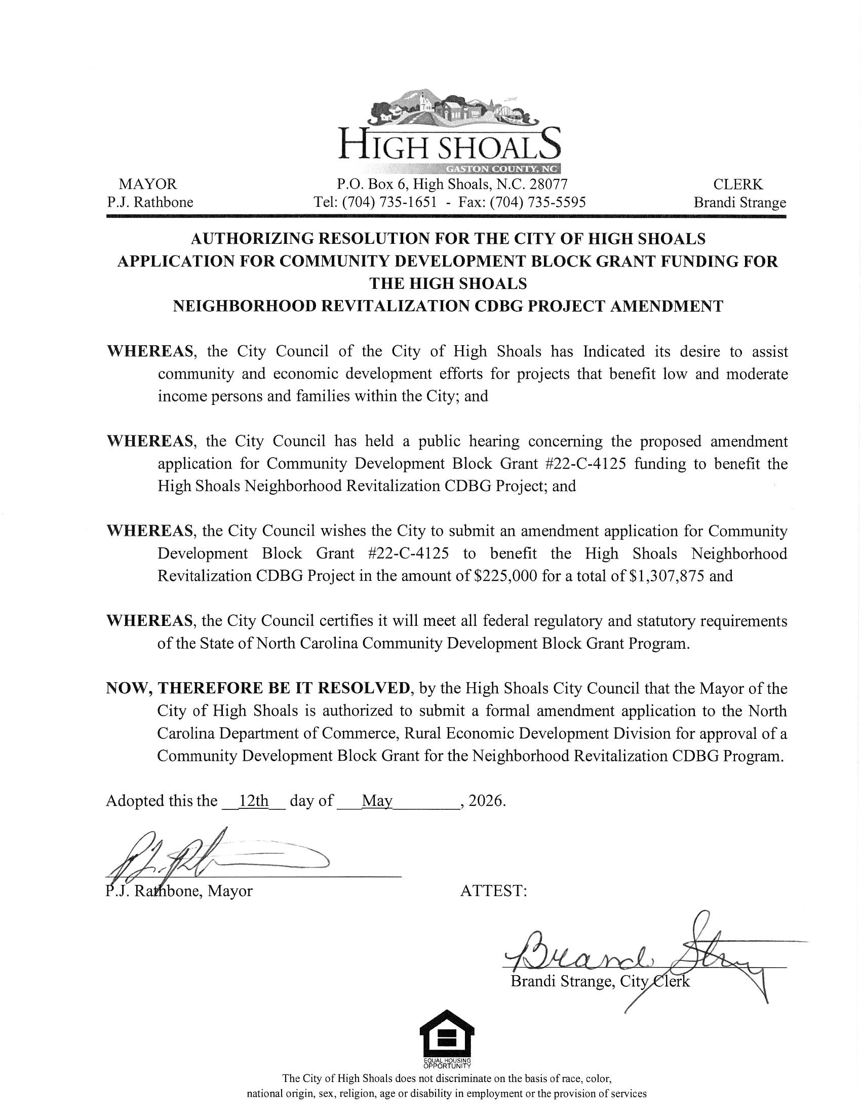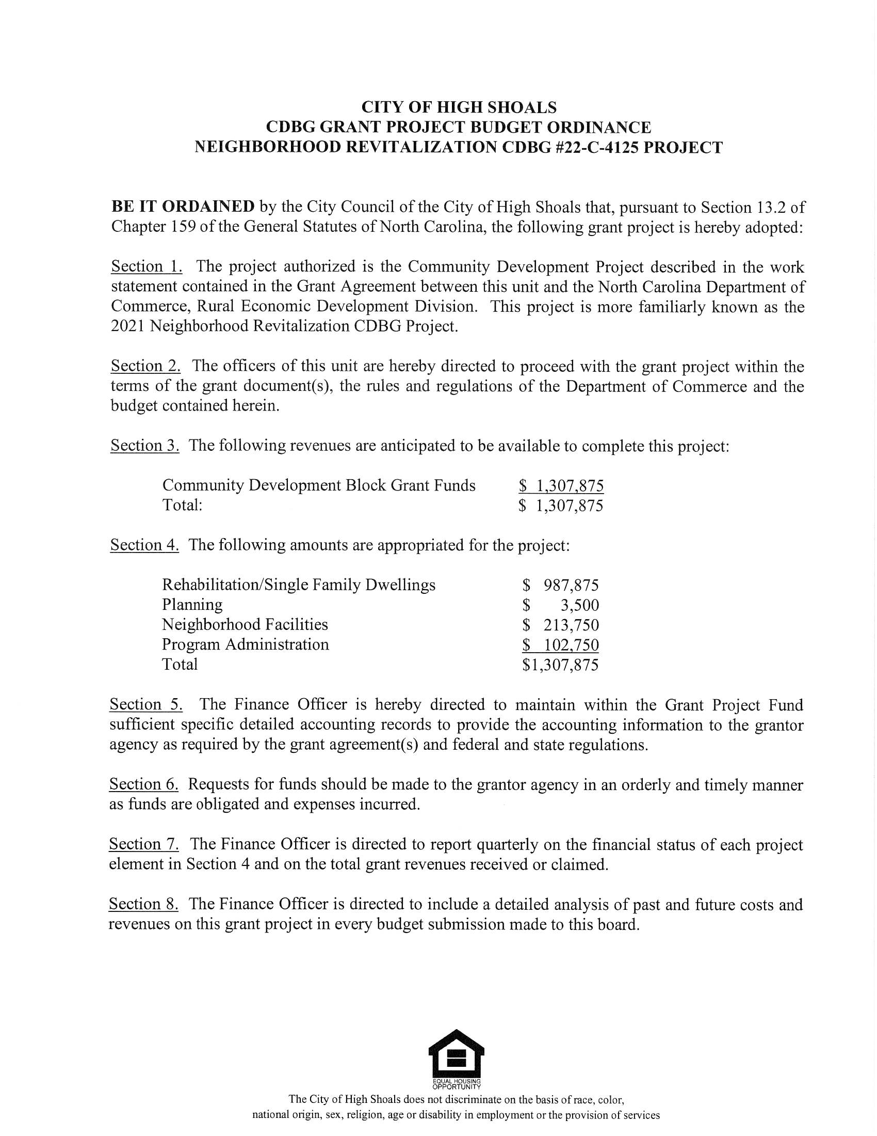
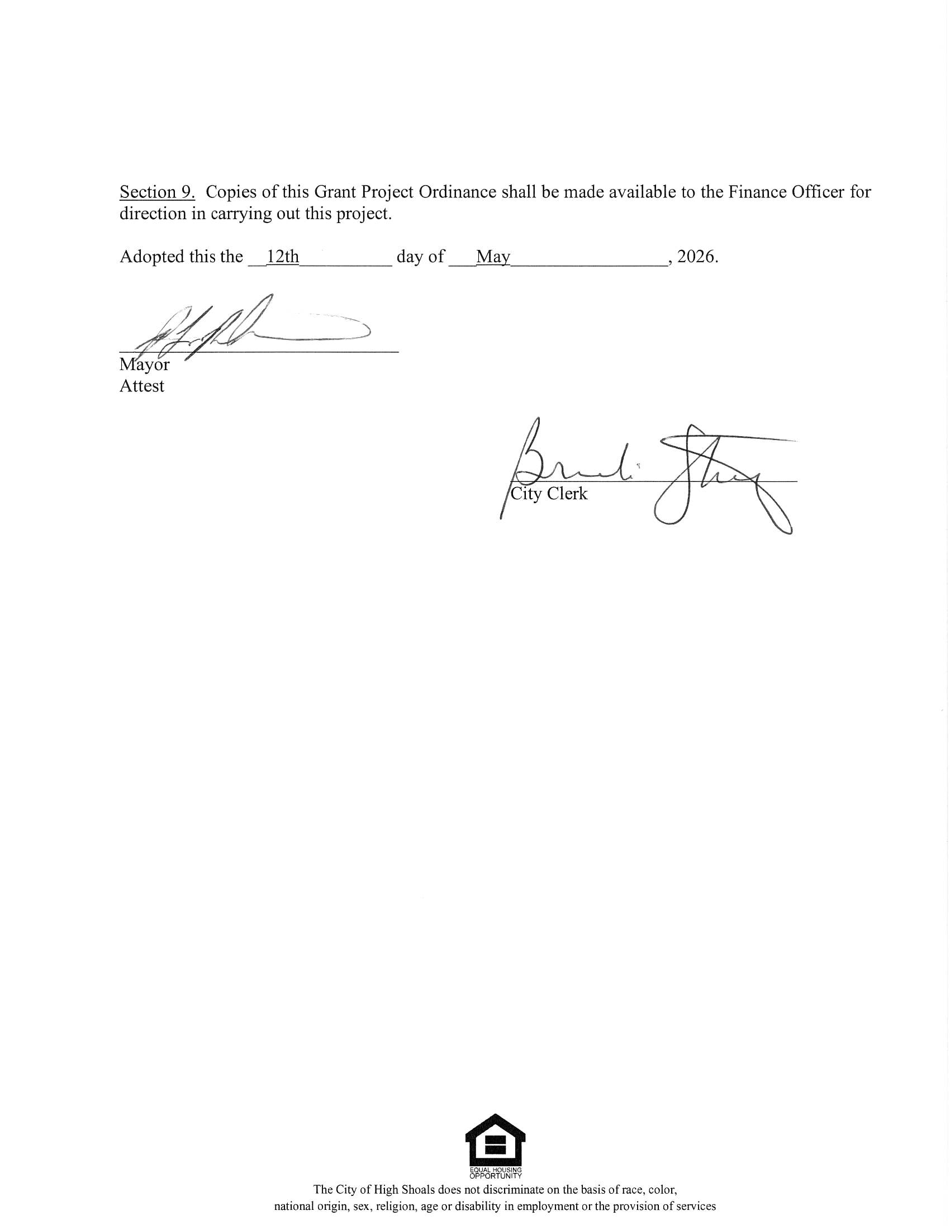

Unfinished Business:
Surplus Equipment
Large Trash Truck – The Mayor asked for a motion to declare the large trash truck as surplus and to list it for sale on the Gov Deals website. Dennis Cash made the motion and Bobby Vassey seconded. All approved.
New Business
• No-conflict Statement (Fire Department)
• Conflict of Interest Resolution
The Mayor stated the attached resolution is required for the purchase of the fire department building and property. It states that Fire Chief Dennis Cash must recuse himself during any City Council discussions regarding the City’s purchase of the fire department building and property. Denese Cook moved to approve the conflict-of-interest resolution, Bobby Vassey seconded. All approved.

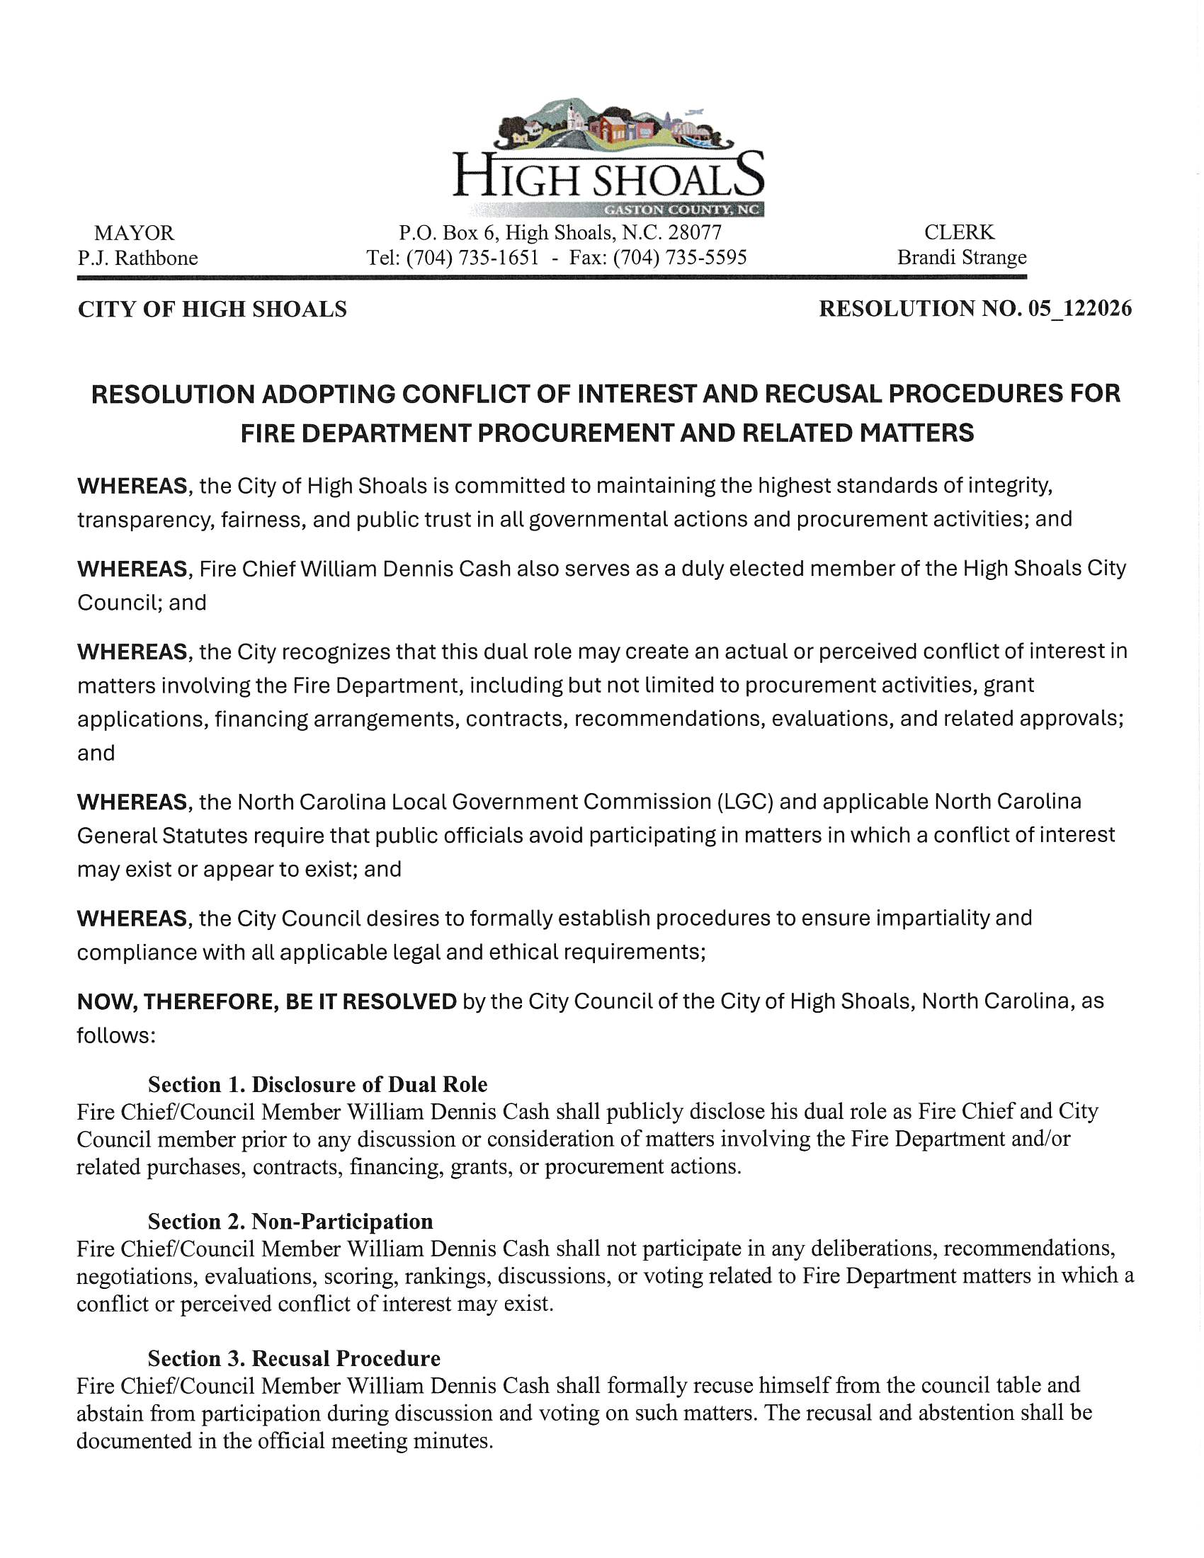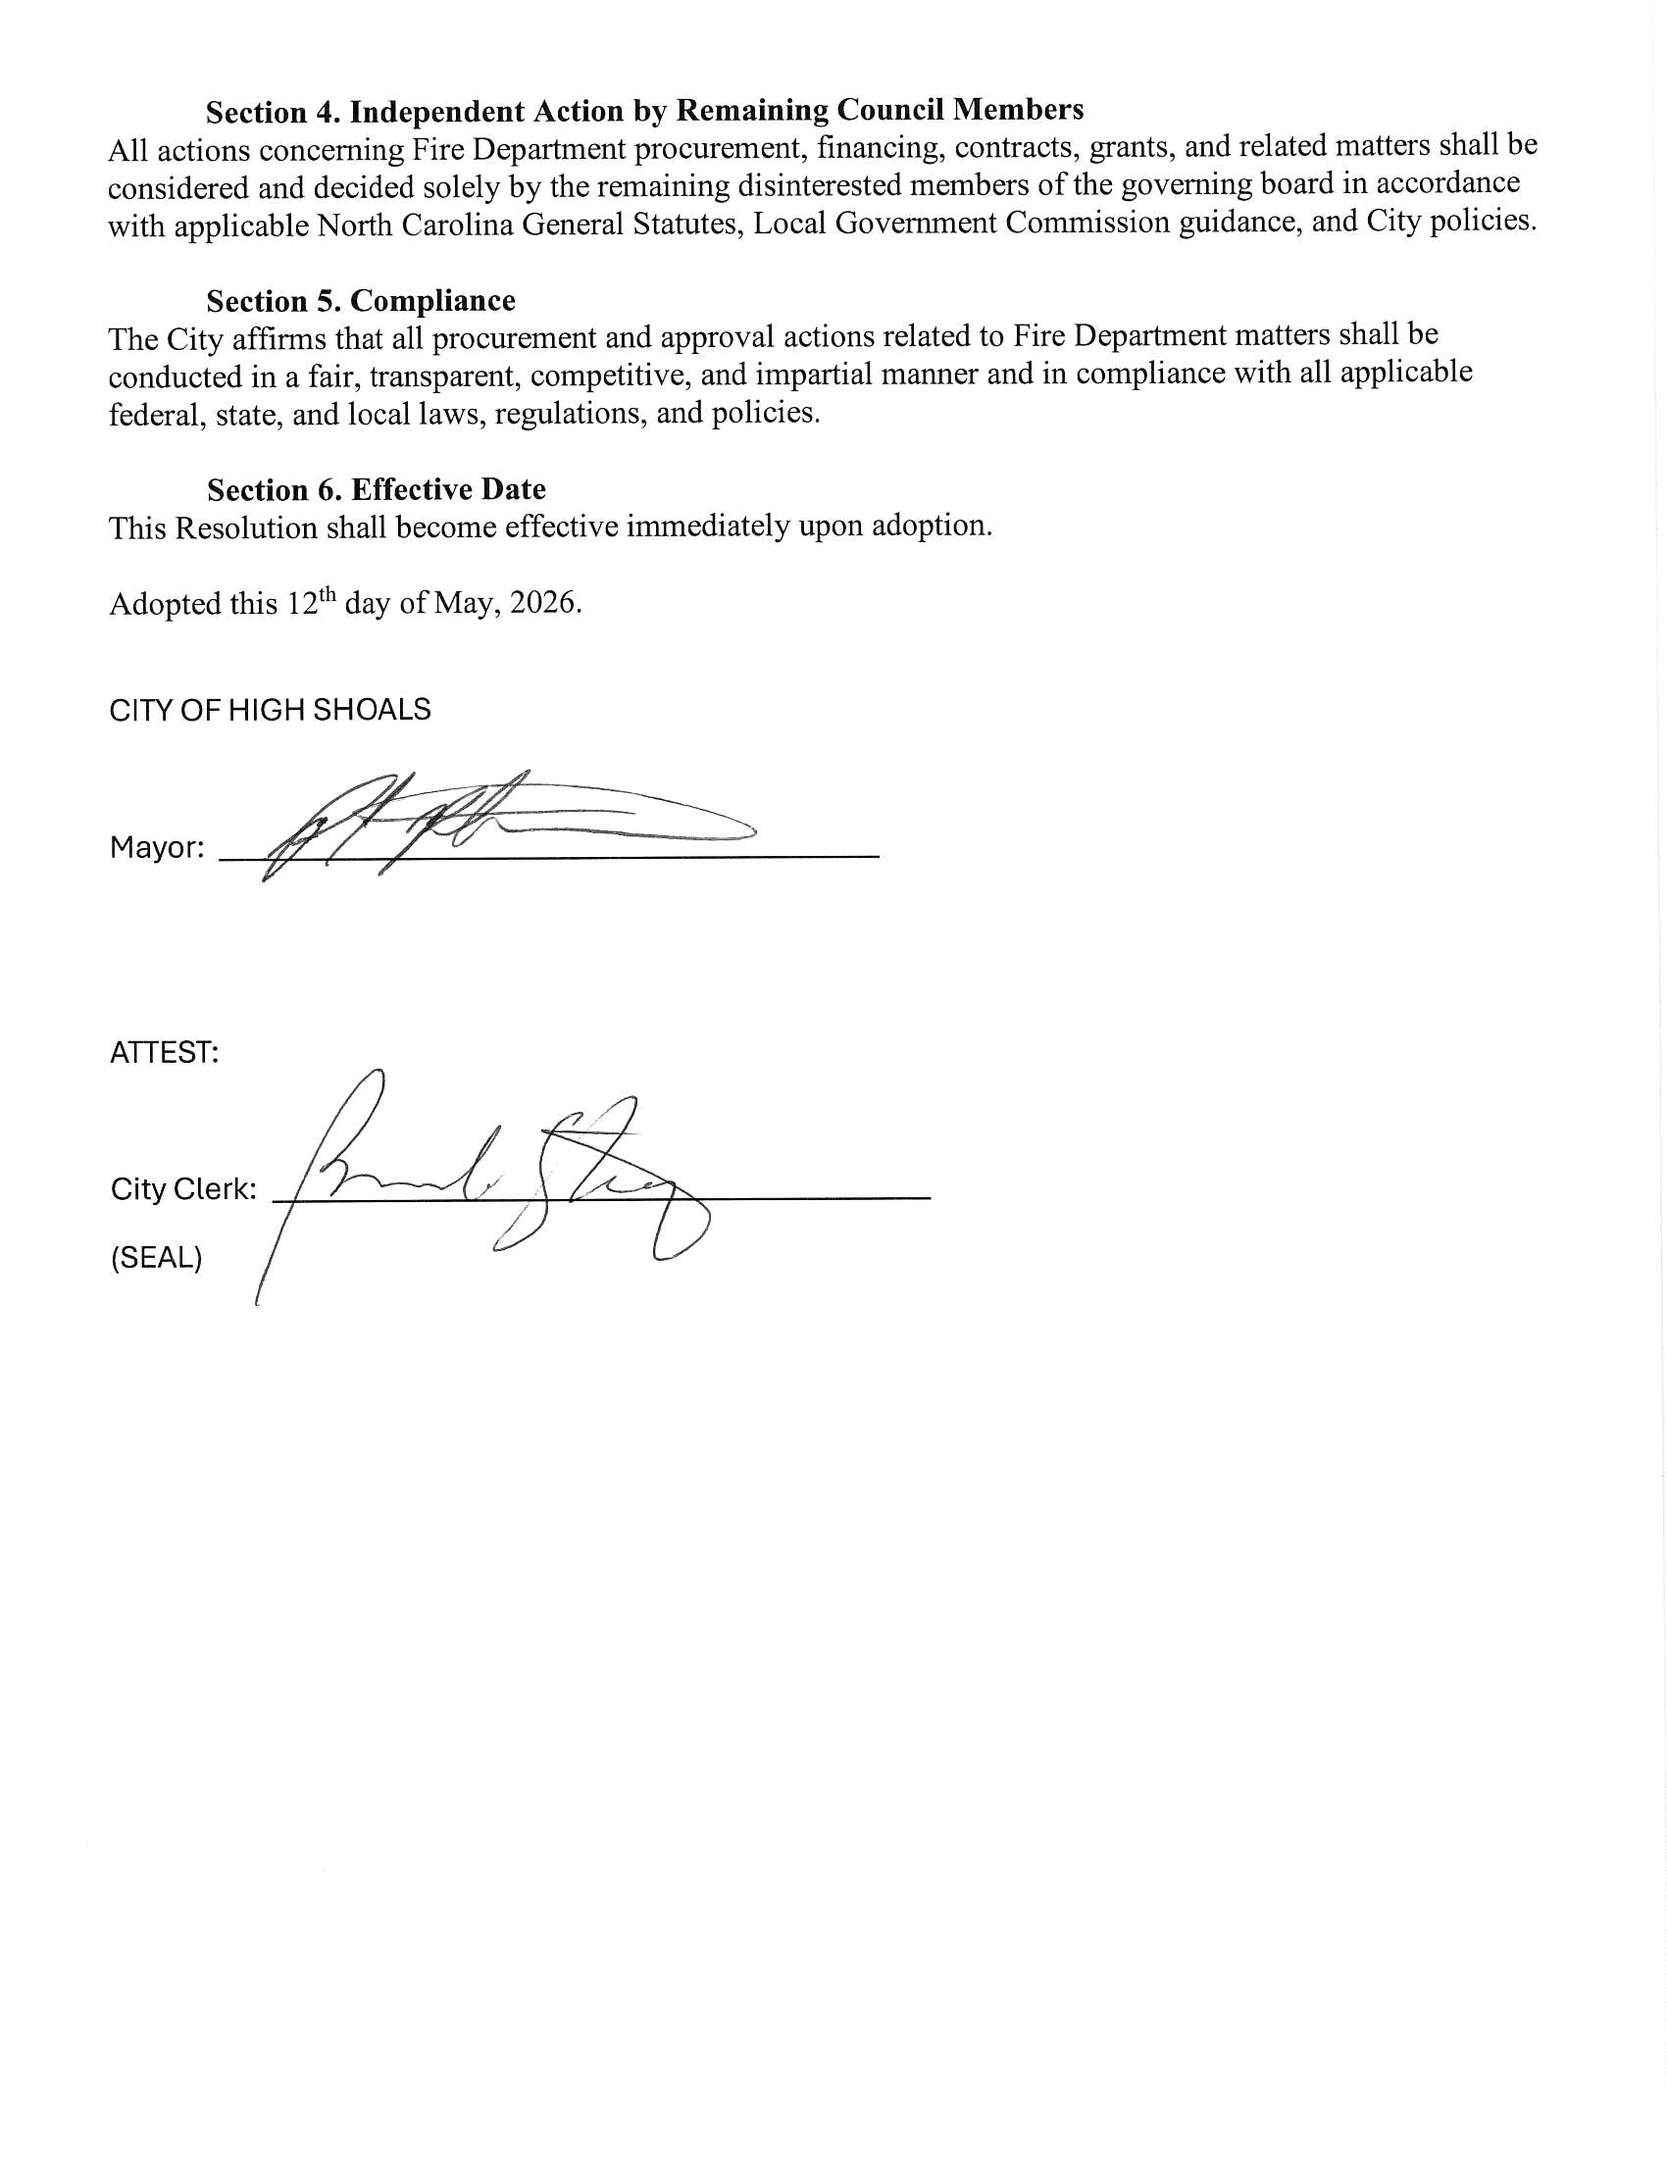
Motion to Adjourn. Denese Cook made a motion to adjourn. Bobby Vassey seconded. All approved.

