City of High Shoals
Regular Council Meeting
June 10, 2025
- Call to Order
  - Mayor PJ Rathbone called the meeting to order at 6:30 pm. In attendance are the following council members: Tim Eidson, Kathy Rhyne, Bobby Vassey, Bo Rhyne, Denese Cook, Dennis Cash and Mayor PJ Rathbone.
- Invocation
- Pledge of Allegiance
- Approval of Agenda
  - Motion to approve the agenda made by Dennis Cash, seconded by Bobby Vassey. All in favor.
- Approval of Minutes
  - Motion to approve minutes made by Kathy Rhyne, seconded by Denese Cook. All in favor.
Citizens’ comments/concerns: The City of High Shoals Council offers citizens the opportunity for Public Expression issues per NCGS 160A-81.1 (limited to 3-5 minutes per speaker).
Brian no longer works for us, but Brian had a massive heart attack yesterday and is on a ventilator. I’d like to ask to keep him in your prayers. He is still on a ventilator and coded eight times since being put on a ventilator. Residents on North Street is having a massive issue with a neighbor parking and blocking the road. The policeman requested to have a picture taken of the issue, this way we can write a citation off the picture. It speeds the process up, this works as evidence. They’ll identify whom took the picture.
Good of the Order: This is a time set aside for members to offer comments or observations (without formal motion) about the organization and its work. The good of the order is also the time to offer resolution to bring disciplinary charges against a member for the offenses committed outside a meeting.

PUBLIC HEARING—BUDGET FY 2025/2026--

The motion to open public hearing made by Kathy Rhyne, seconded by Denese Cook. All in favor.
Any comments? No one spoke. If you are curious the budget is available at any time.
Motion to close the public hearing made by Dennis Cash, seconded by Kathy Rhyne. All in favor.

- Departmental Reports:
- Police Report-Gaston County
    - Videos and pictures will be greatly appreciated.
    - Only arrest was for the breaking and entering of the park restrooms, arrested the following day on Frye Street.
    - Five non-emergency calls for officers to call back.
    - Special checks are the park, cemetery, city hall, and Frye St.
    - One domestic disturbance at Lincoln Terrace
- Financial-Dennis Cash
    - CHECKING 1: $352,667.06
    - CHECKING 2: $ 11,125.06
    - SAVINGS: $161,200.39
    - CAP MGMT: $ 51,669.50
    - TOTAL: $576,662.01
- Cemetery-Denese Cook—NO comments
- Water/Sewer-Bo Rhyne
    - Water leak on River Street
    - We had a visit from DEQ compliance inspection on May 23rd. They found a manhole on River Street with an obstruction which was rectified. There is some liquid coming out of the ground at Hardin Road but it has been identified as ground water. But we received a clean bill of health from DEQ for compliance.

- Streets/Maintenance/Sanitation-Kathy Rhyne
  - Streets and Maintenance—PJ received a concern from Dayton Road. The vegetation has grown out a bit and you can’t see the cars coming from the left-hand side. It is the state issue, and we’ll call the state to see if they can come trim it down.
  - The Sanitation route was not completed today but will be finished tomorrow. Will need to go back to the shop.

  - Parks/Recreation-Bobby Vassey
    - Yard of the Month:– 216 Old Hardin Rd.
          - Jenny Jarrell
The concert in the park was relaxed, with a decent turn out. The bands were great and got along really well.
- Vehicles- Tim Eidson
    - Trash truck we discussed.

- Administration/Mayor Report-PJ Rathbone
    - Update on the Mill Property—We’re still pushing a rope to get to the next phase of the assessment process. The letter we received from Dennis about fire suppression cuts away one of the tests they were wanting us to do. We met with them this morning and they have a finance person who is going to look for funding for that piece, we may have to float a bit of it when we get some numbers. The Royster family is ready to get the city to take the land. There is enough paperwork and contamination records to clear us of the liabilities except for the clean-up. The Royster family has agreed if we provide them with a real estate appraisal and they will turn the land over. I’ve met with an appraiser who has worked with contaminated land. There is a square in the property that does belong to Duke Energy where the transformer was located.

- New Business:
- Discussion/Action: Resolution to back State bill for Carolina Thread Trail
  - Motion to adopt the Resolution made by Kathy Rhyne, seconded by Bo Rhyne, all in favor.
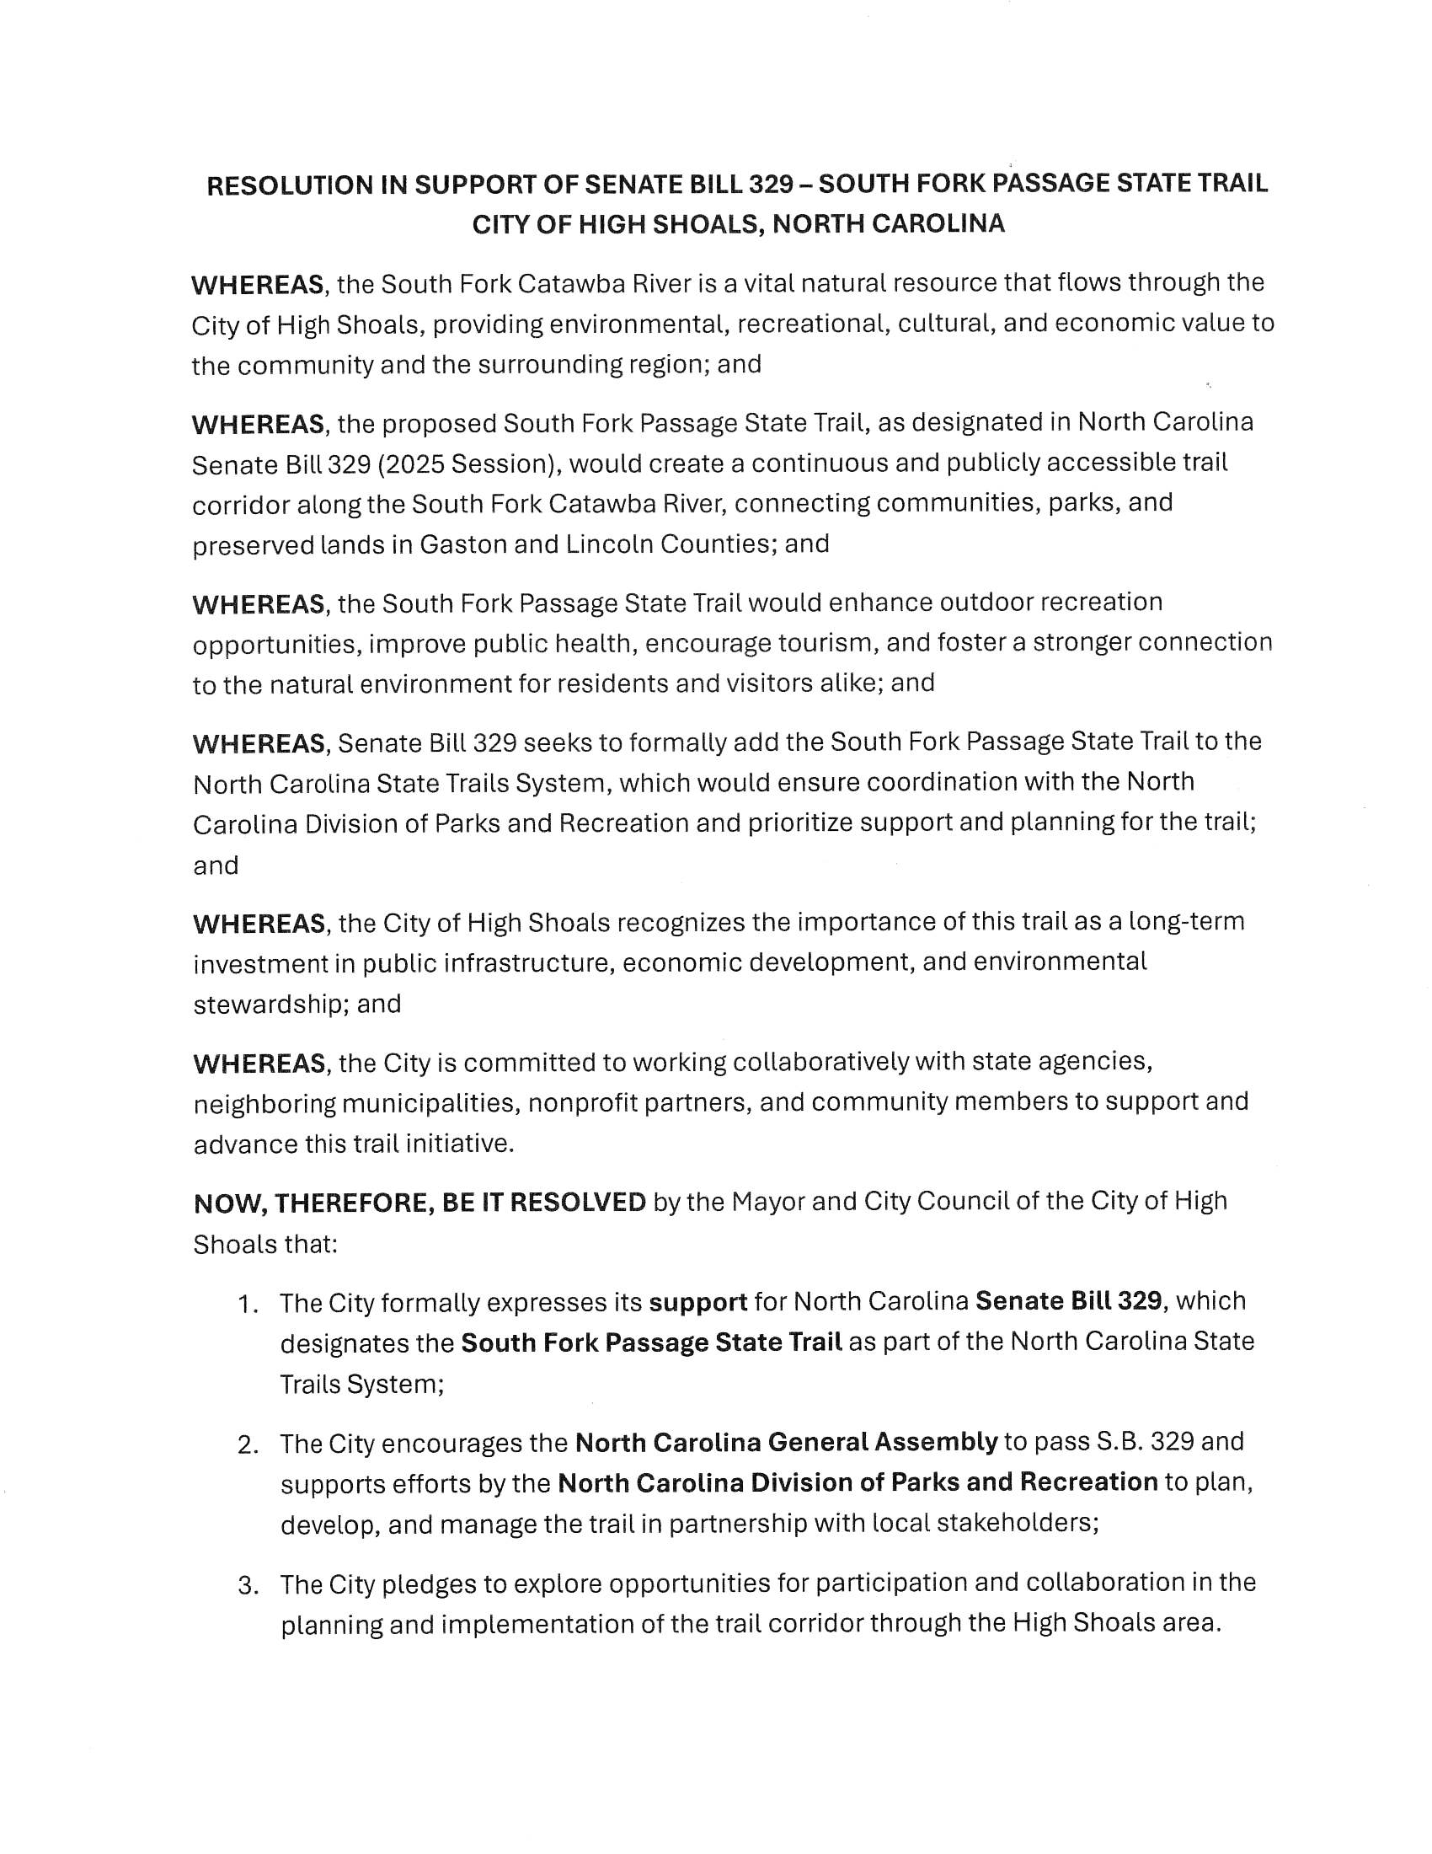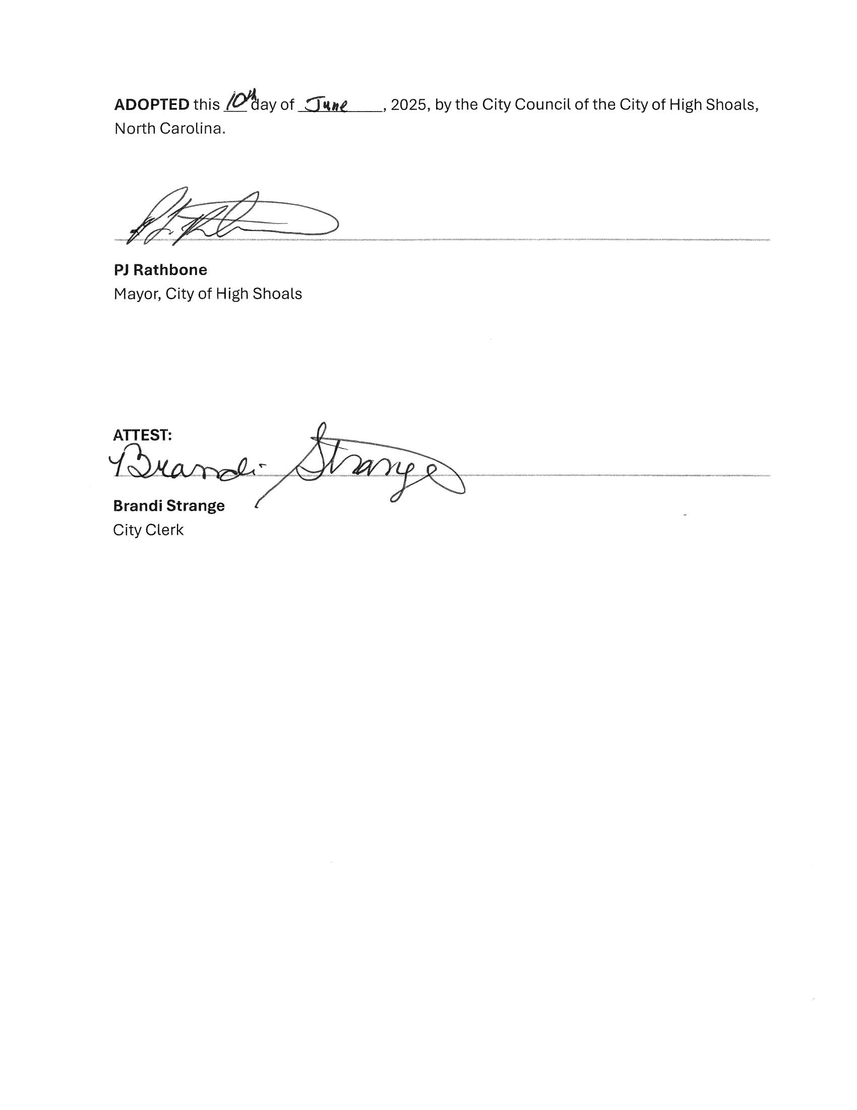
- Discussion/Action: Contract to Audit Accounts-Eddie Carrick, CPA
  - Motion to approve the contract made by Dennis Cash, seconded by Bo Rhyne. All in favor.
- Action: Motion to Recess and reconvene on June 24th at 6:30 pm for budget approval made by Kathy Rhyne, seconded by Denese Cook. All in favor.
Mayor PJ Rathbone called to order the recessed meeting from June 10th, reconvening on June 24th, 2025 at 6:30 pm. In attendance were the following council members: Dennis Cash, Denese Cook, Bo Rhyne, Kathy Rhyne, Tim Eidson, and Mayor, PJ Rathbone. Bobby Vassey was not in attendance.
  - Motion was made by Kathy Rhyne to come out of recess, seconded by Denese Cook, motion carried.
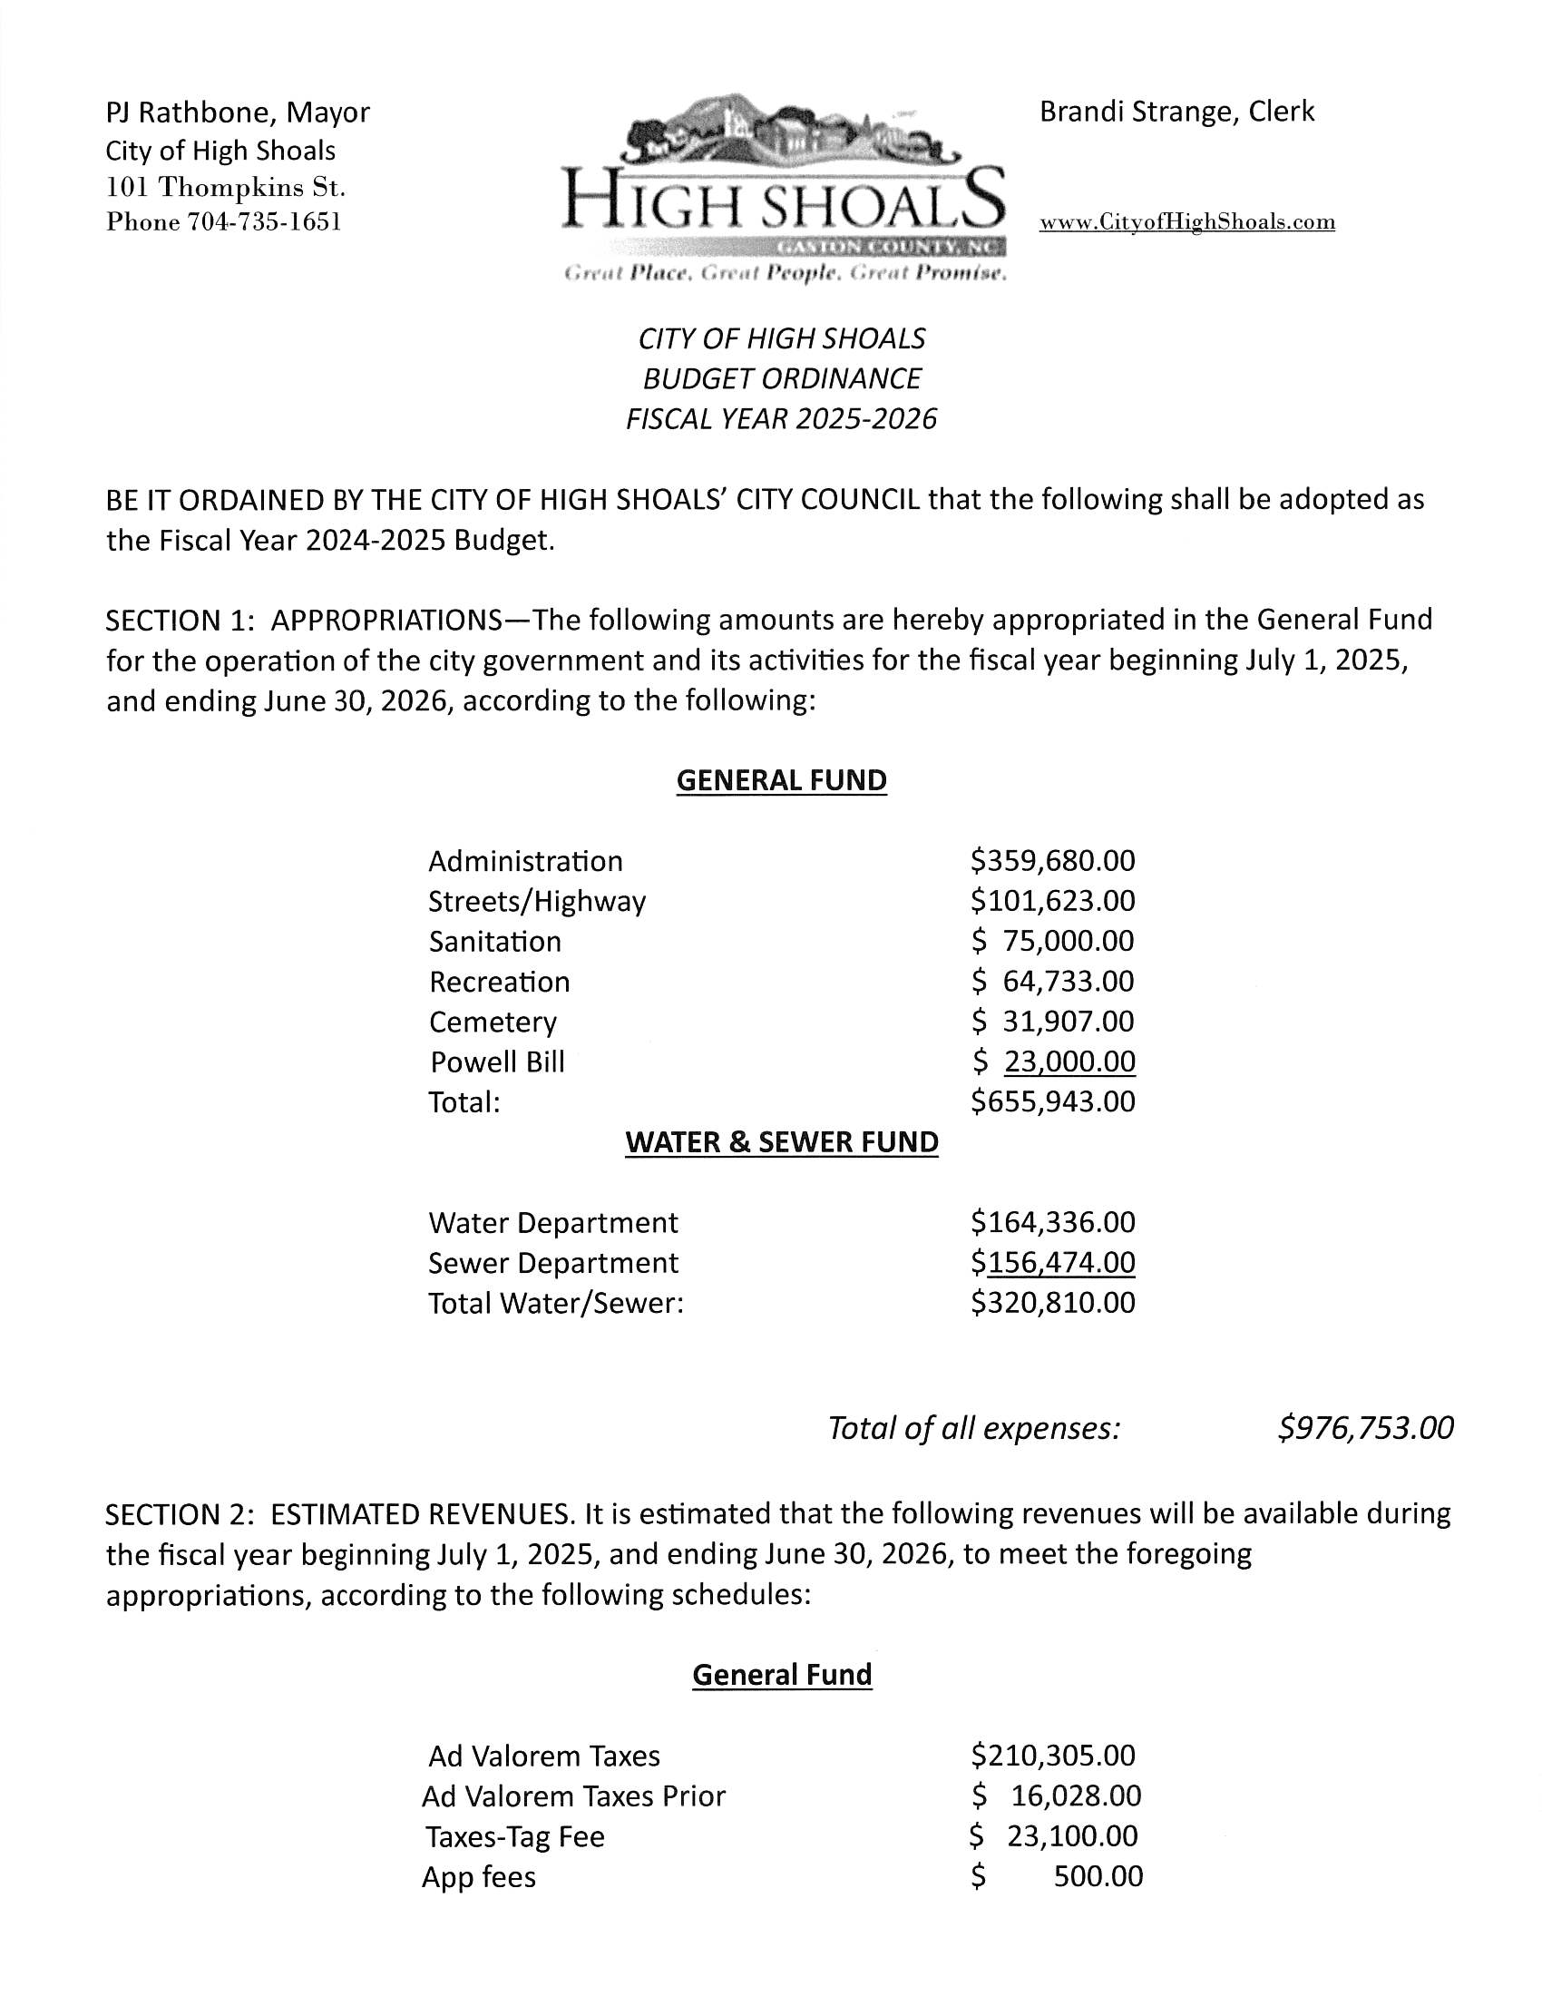
  - Motion to approve proposed 2025/2026 budget made by Kathy Rhyne, seconded by Bo Rhyne, all in favor.
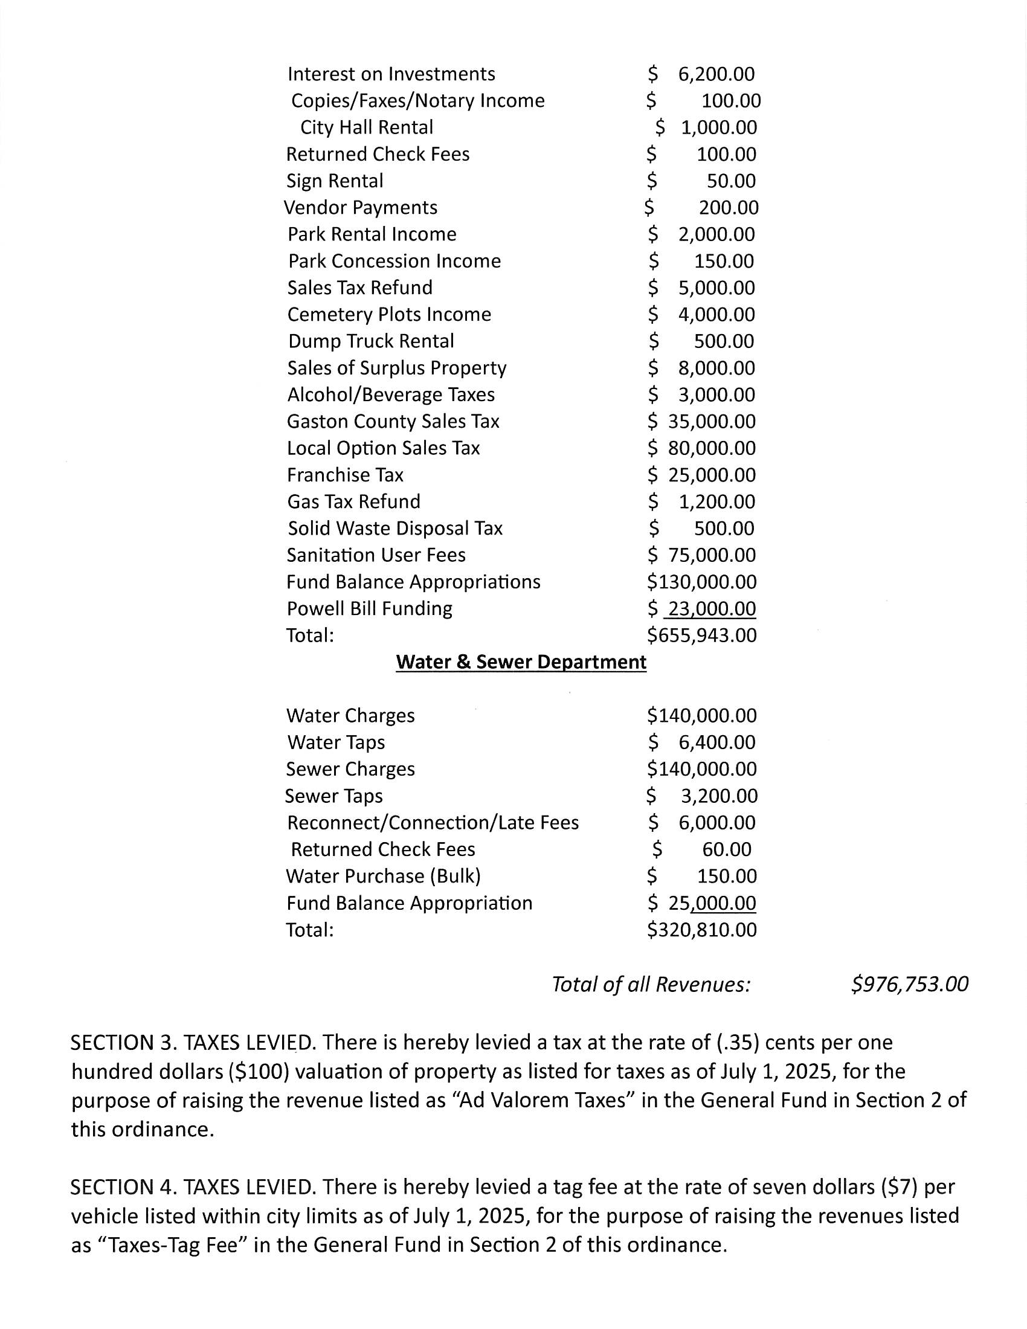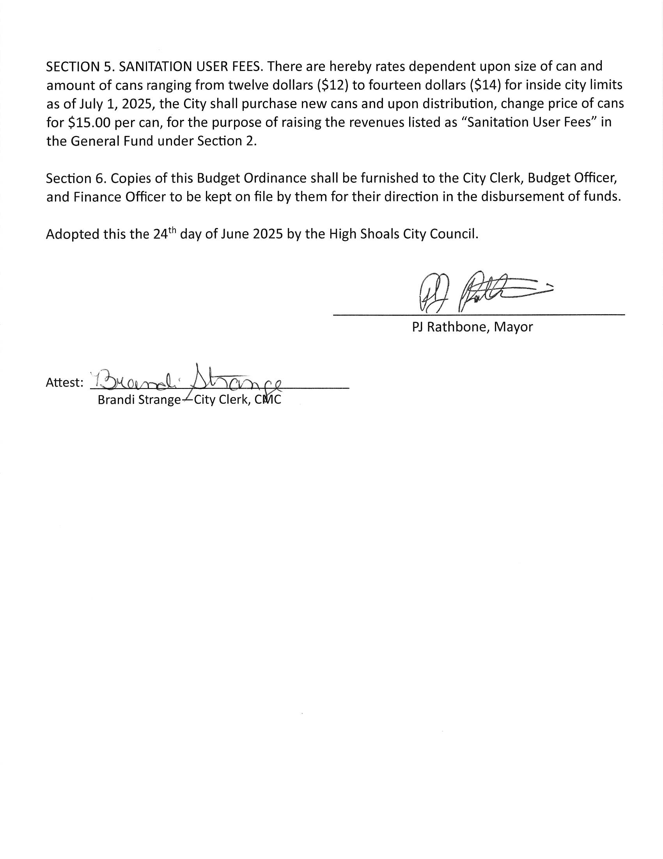
  - Motion to adjourn the meeting made by Kathy Rhyne, seconded by Denese Cook. All in favor.

