May 2025

Meeting minutes
Call to Order
Invocation
Pledge of Allegiance

Approval of Agenda
PJ proposed adding a closed session for employees at the end of the agenda under N.C. Gen. Stat. § 143-318.11(a)(6). Denese made a motion to approve this addition, seconded by Dennis Cash. Motion carried unanimously.
- Denese motioned to approve the agenda with amendments; Dennis Cash seconded the motion, which was unanimously approved.

Approval of Minutes
Motion: Dennis Cash moved to approve, seconded by Bo Rhyne. Motion carried unanimously.

Citizens' Comments/Concerns

Good of the Order: (This is a time set aside for members to offer comments or observations (without formal motion) about the organization and its work. The good of the order is also the time to offer resolution to bring disciplinary charges against a member for the offenses committed outside a meeting.)
The council inquired about the maintenance of Royster's grass. PJ assured that the matter had been resolved.

Departmental Reports

Police Report-Gaston County

Financial - Dennis Cash
Dennis presented the status of the checking account, reporting a balance of $363,679.60.

Cemetery-Denese Cook
Denese reported that someone had dumped items in the back of the cemetery, including a flag, trap shingles, and other materials. It was initially thought to have occurred on Saturday night, but the exact timing was unclear. The dumped items were located at the bottom part of the cemetery.

Water/Sewer-Bo Rhyne
- A water leak on High Street was addressed by Mr. Eidson.
- A minor leak present on River Street.

Streets/Maintenance/Sanitation-Kathy Rhyne
Issues reported with the small trash truck. The driver's side rear tire was slick and needed replacement. Additionally, the tipper is leaking again, despite being fixed the previous week. It was noted that the hydraulic system might be the cause of the problem, as it stops working when lifted halfway.
A resident had reported their trash can being missed for two consecutive weeks. The first week was attributed to paving work near the location. To address this issue, it was decided to swap out the resident's can with a spare one to ensure proper service.

Parks/Recreation-Bobby Vassey
- Yard of the Month: 201 School Street - Awarded to Angel Hildebrand
- Upcoming Event: A concert with two bands and karaoke option scheduled for next Saturday in the park.

Vehicles- Tim Eidson
- The large trash truck has failed to meet inspection standards, currently in the shop being repaired and brought to DOT standards.

Administration/Mayor Report-PJ Rathbone
The mayor thanked the council for their support during the previous month, which had been chaotic for them.

New Business

Discussion/Action: Resolution DWI
The council discussed a resolution related to DWI (Driving While Intoxicated). It was clarified that this was not about driving while intoxicated but rather about the Department of Water Infrastructure.
Steve Austin explained that there was a new payment system for drawing down funds from the grant. The process would remain similar, with council members signing paperwork, but the submission would now be through an online platform. The resolution required authorization for the mayor or town manager to be the authorized submitter of these requests. It was noted that the mayor pro tem, Dennis, would need to sign the resolution due to regulations preventing the mayor from authorizing themselves.
Resolution Approval: The motion to approve the resolution was introduced by Member Dennis Cash and duly seconded by Member Bo Rhyne. The motion received unanimous consent. 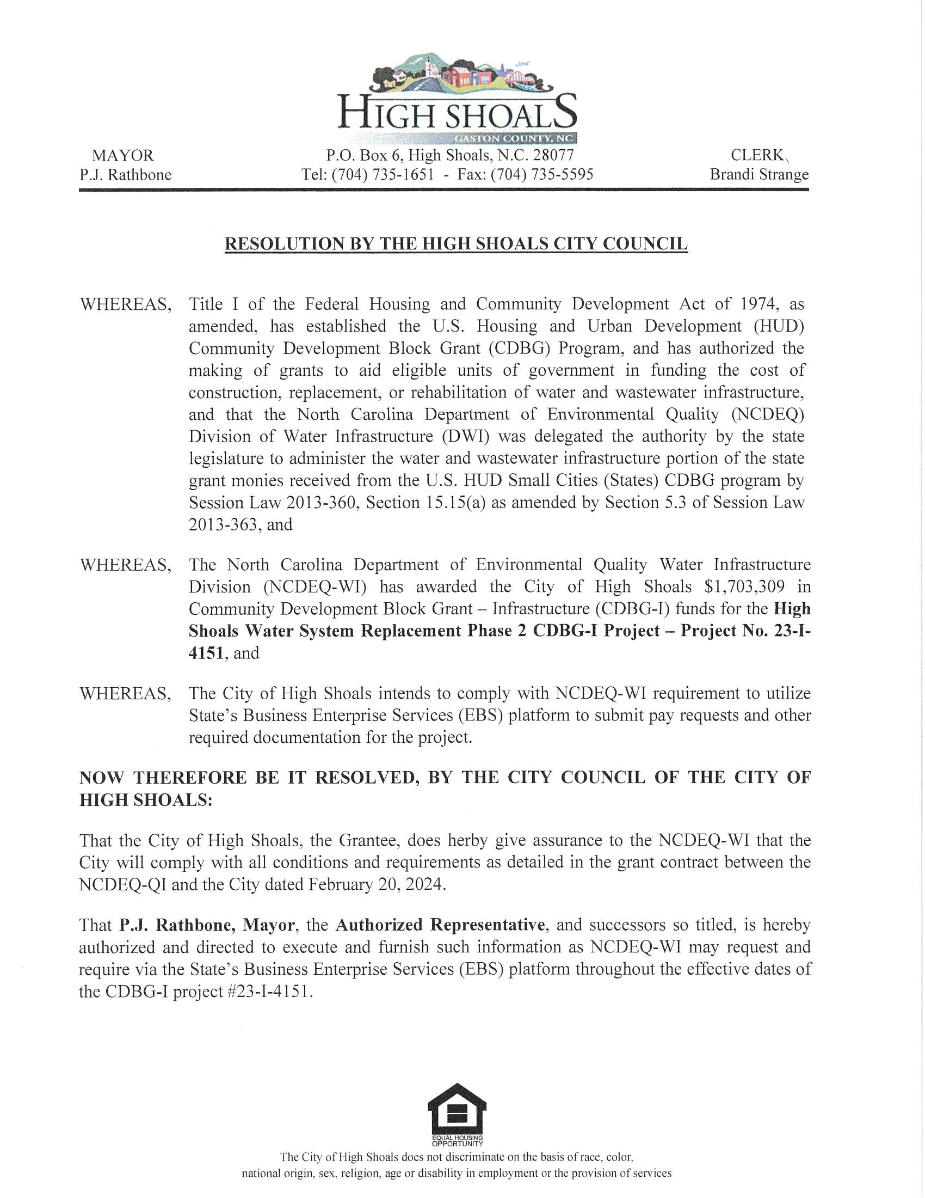
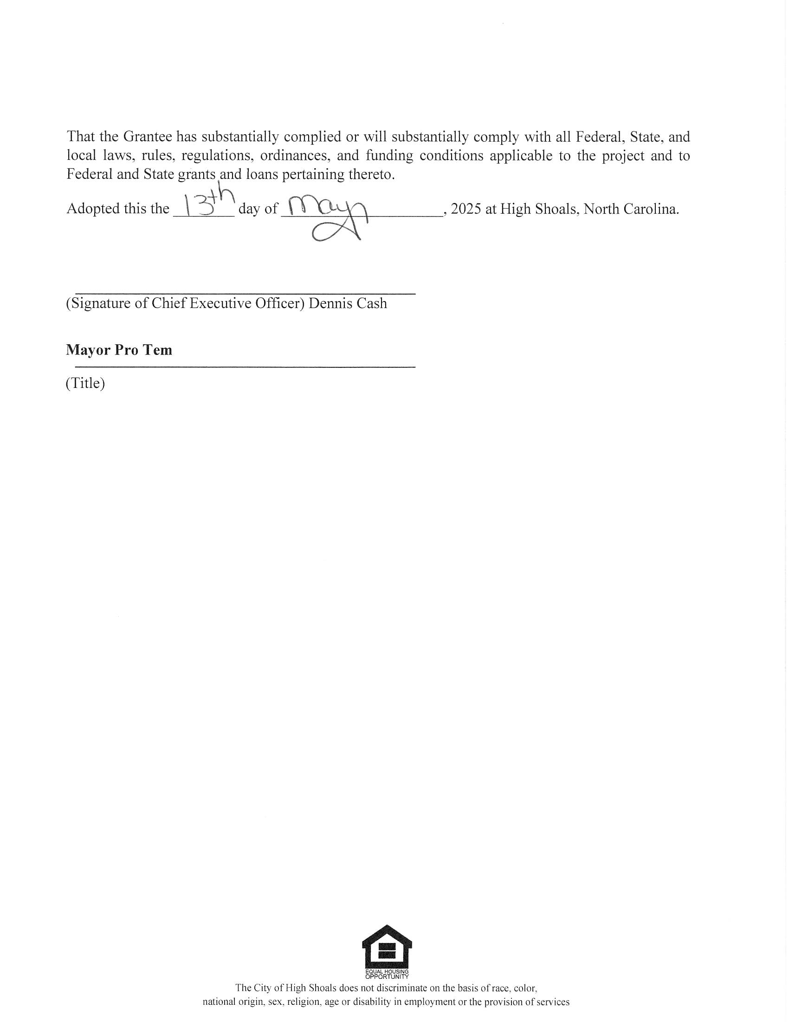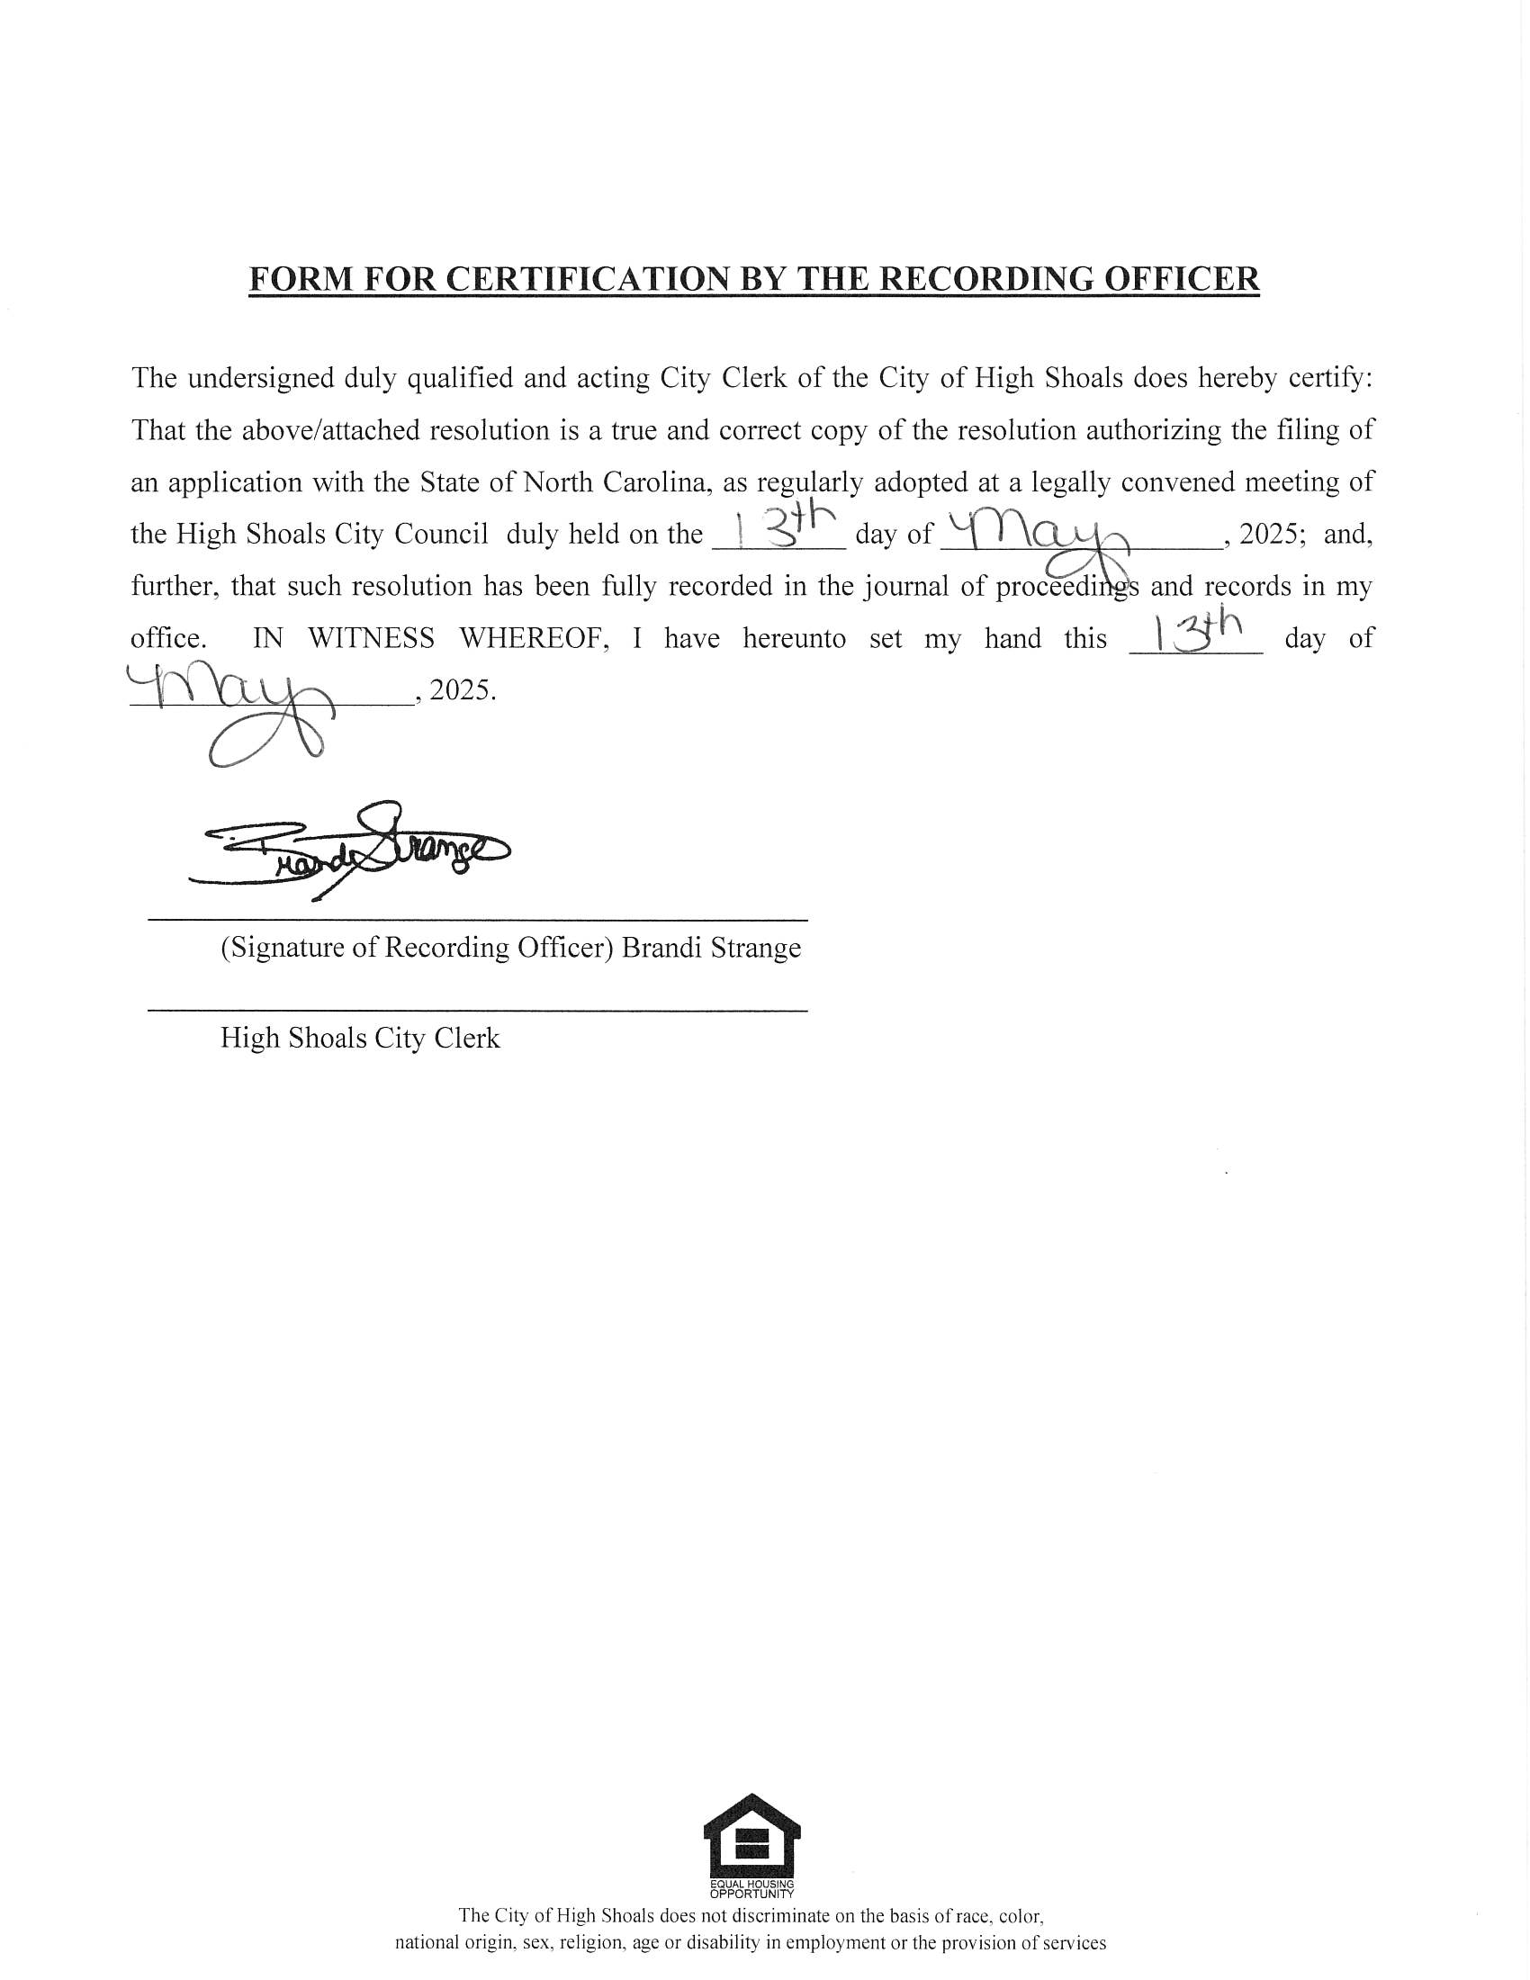

Discussion/Action: Ordinance (minimum housing)
The council discussed implementing a minimum housing code ordinance for the City of High Shoals. This ordinance would allow the city to act on housing issues without waiting for county intervention. Key points discussed included:
- The need for three officers to execute minimum housing standards.
- The ability to issue orders for demolition directly from the city.
- The ordinance being governed by North Carolina general statutes.
- The potential for partnership with the fire department for controlled burns of condemned properties.
- The need to budget for associated costs in the upcoming fiscal year.
- The process of placing liens on properties for recovery of demolition costs.
It was decided that the ordinance would be reviewed by the city attorney before becoming official.
Dennis Cash moved the motion for approval, which was seconded by Bo Rhyne. The motion was passed with unanimous approval.
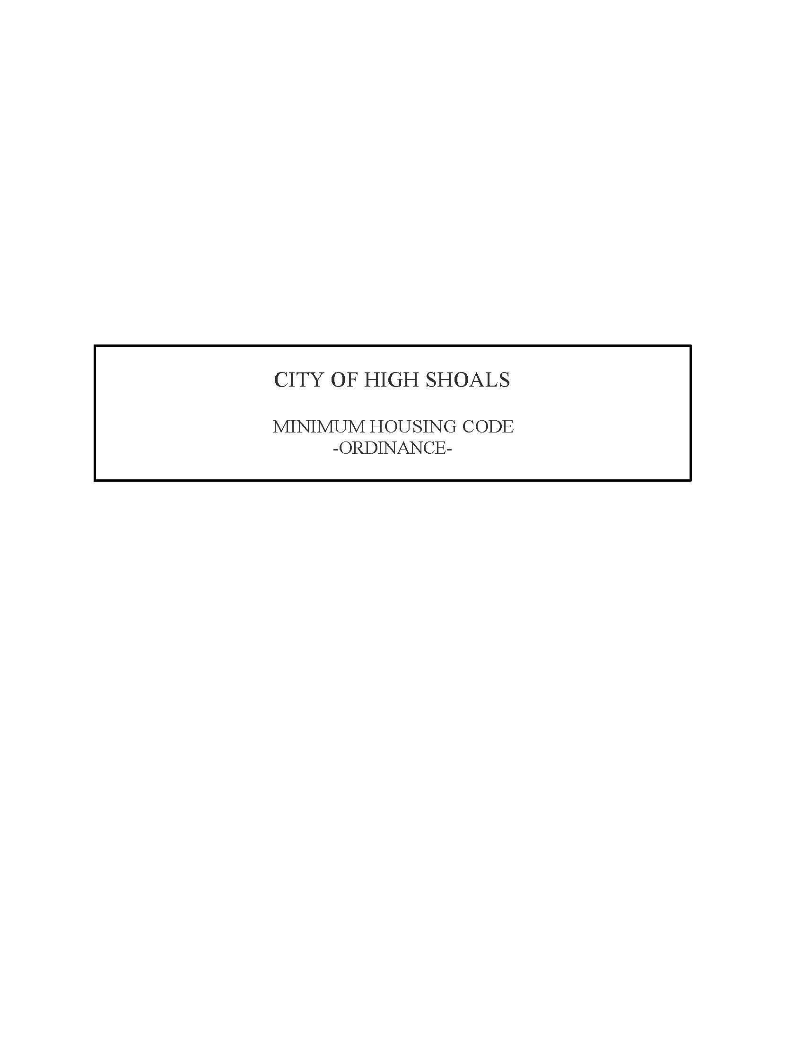
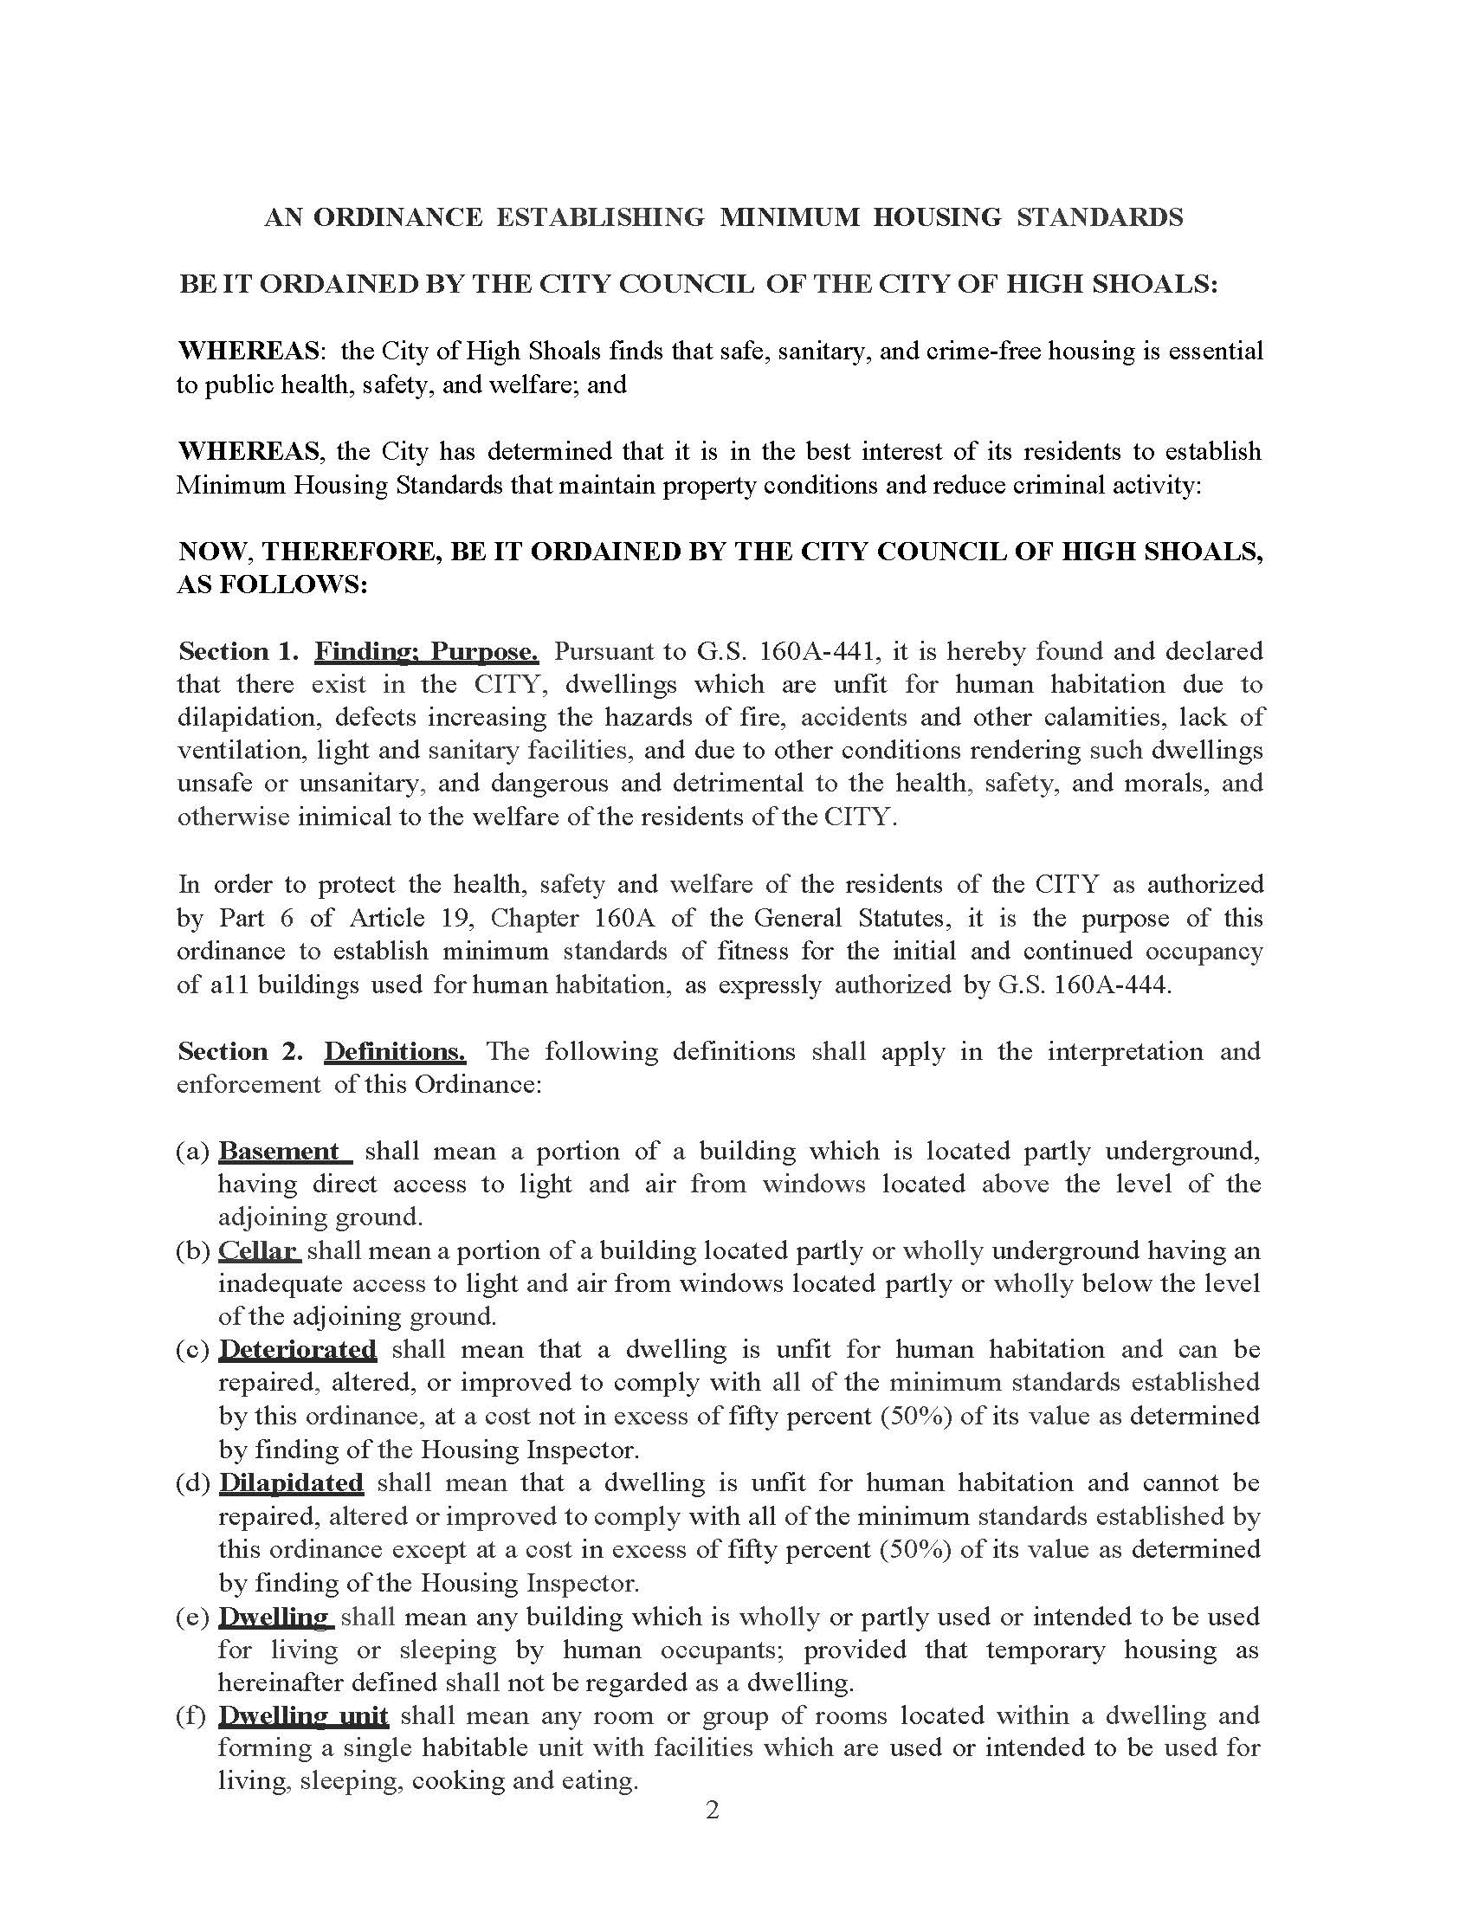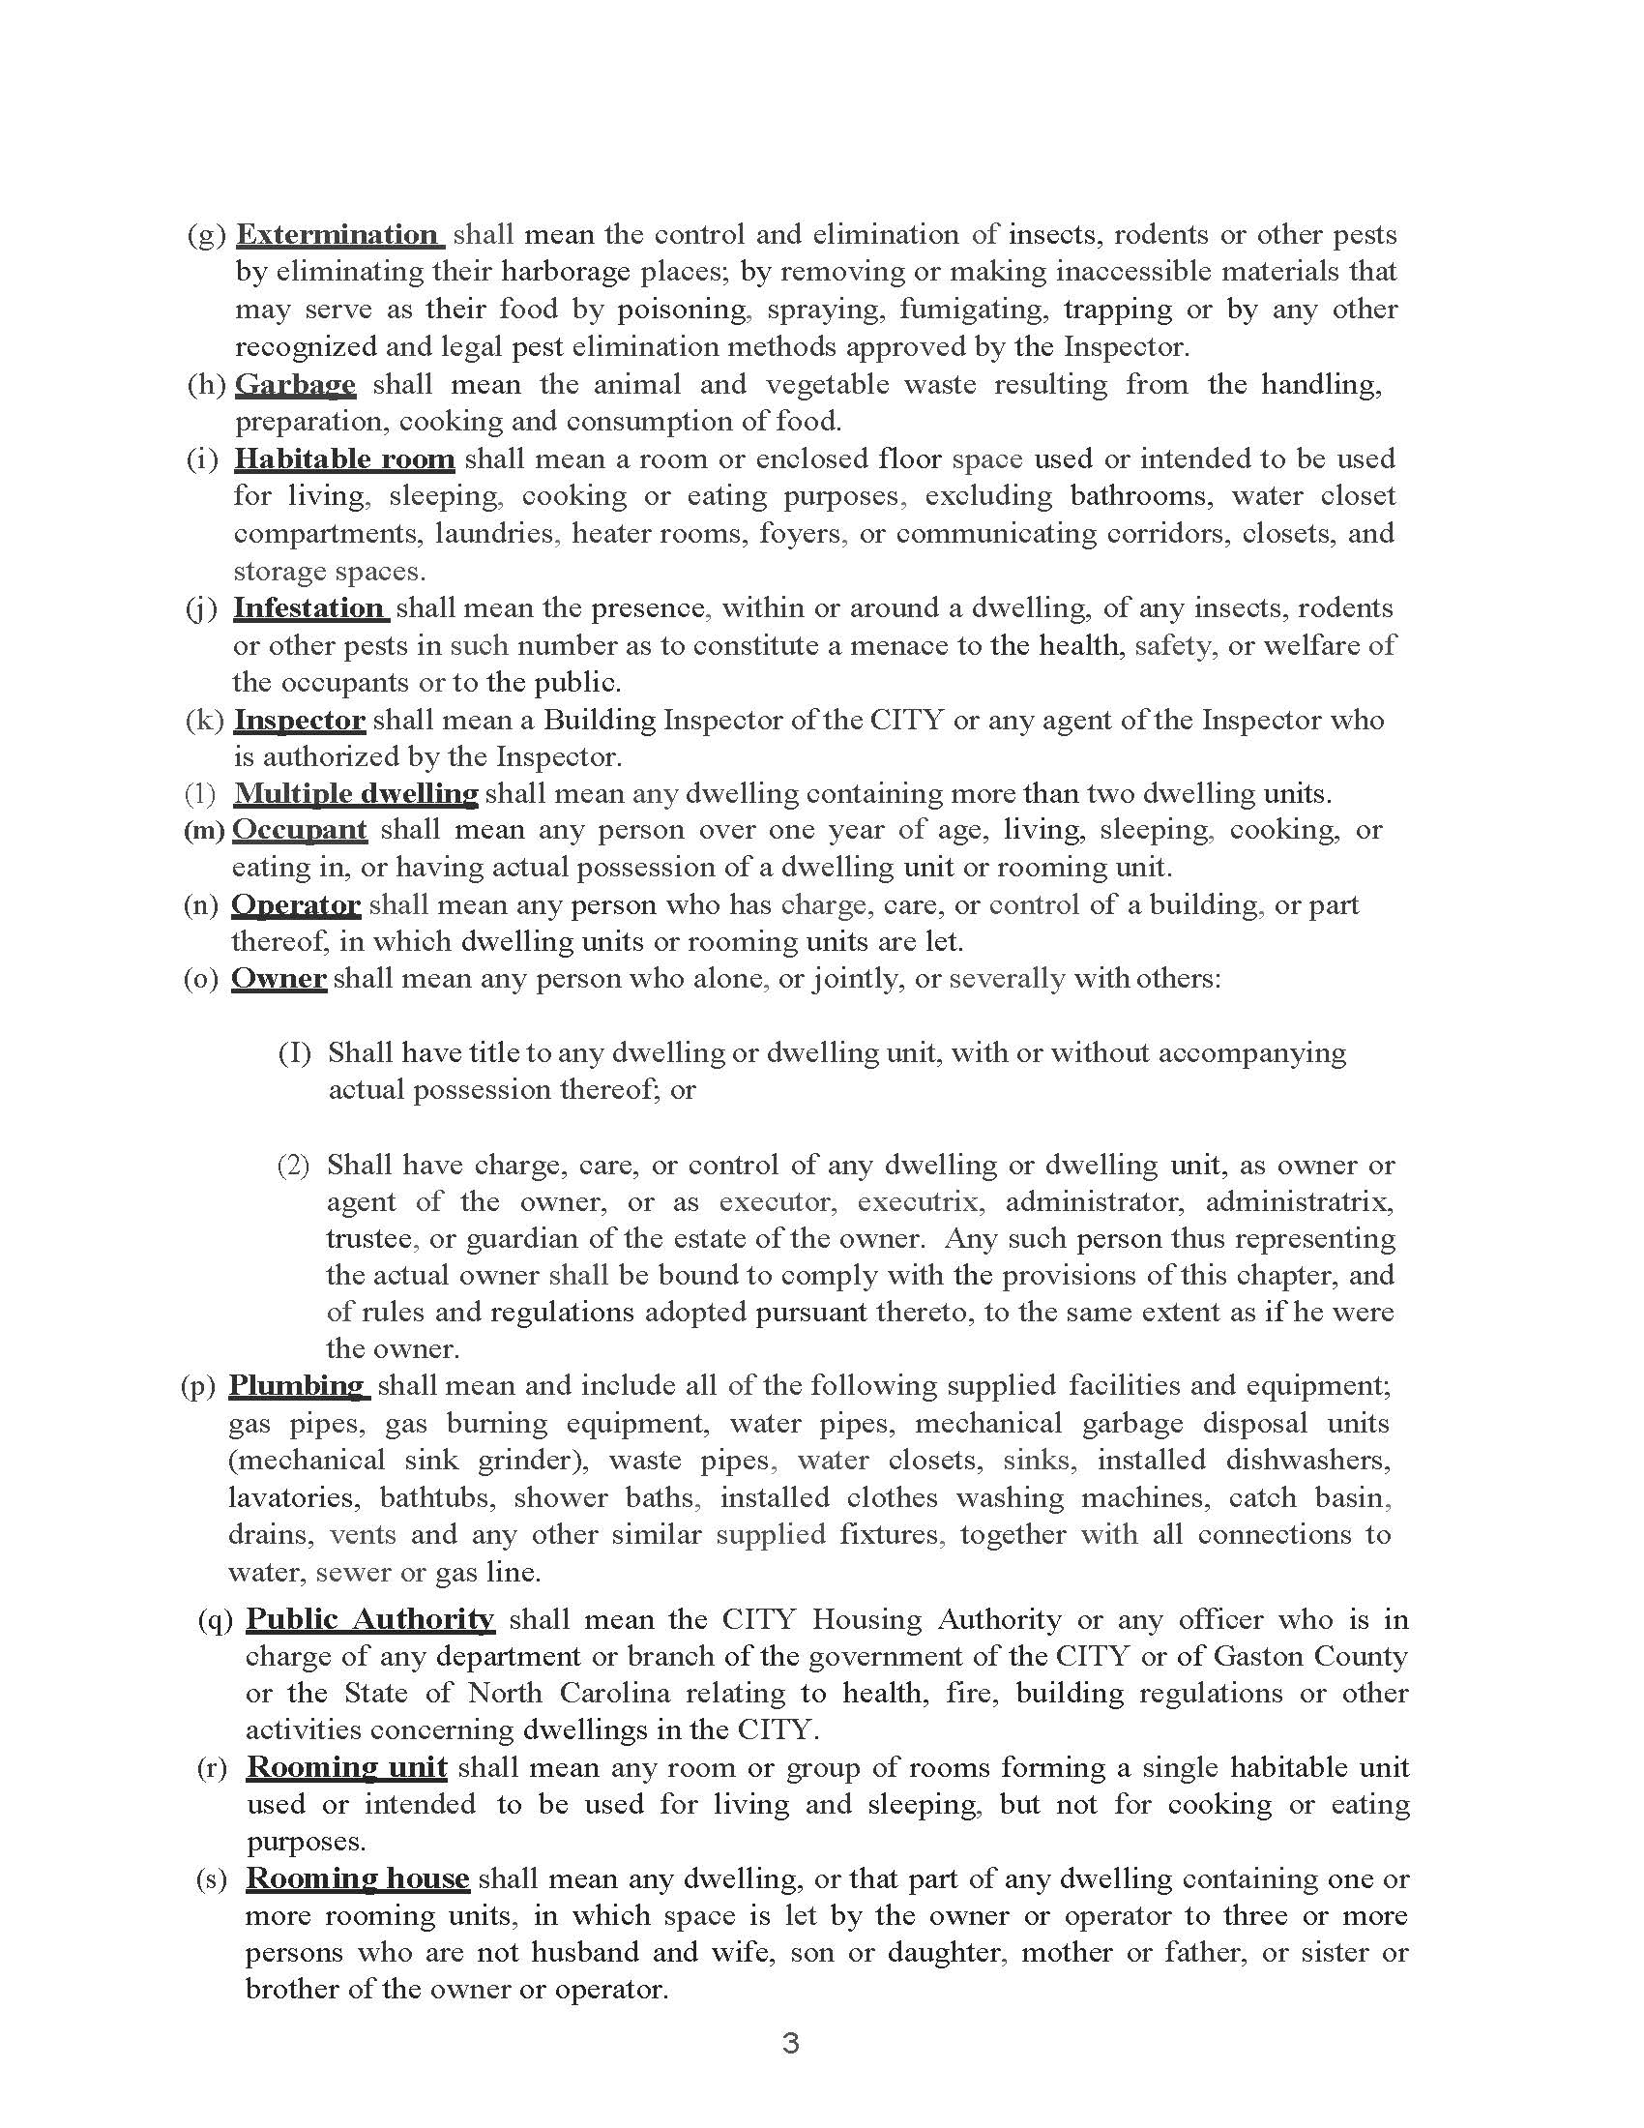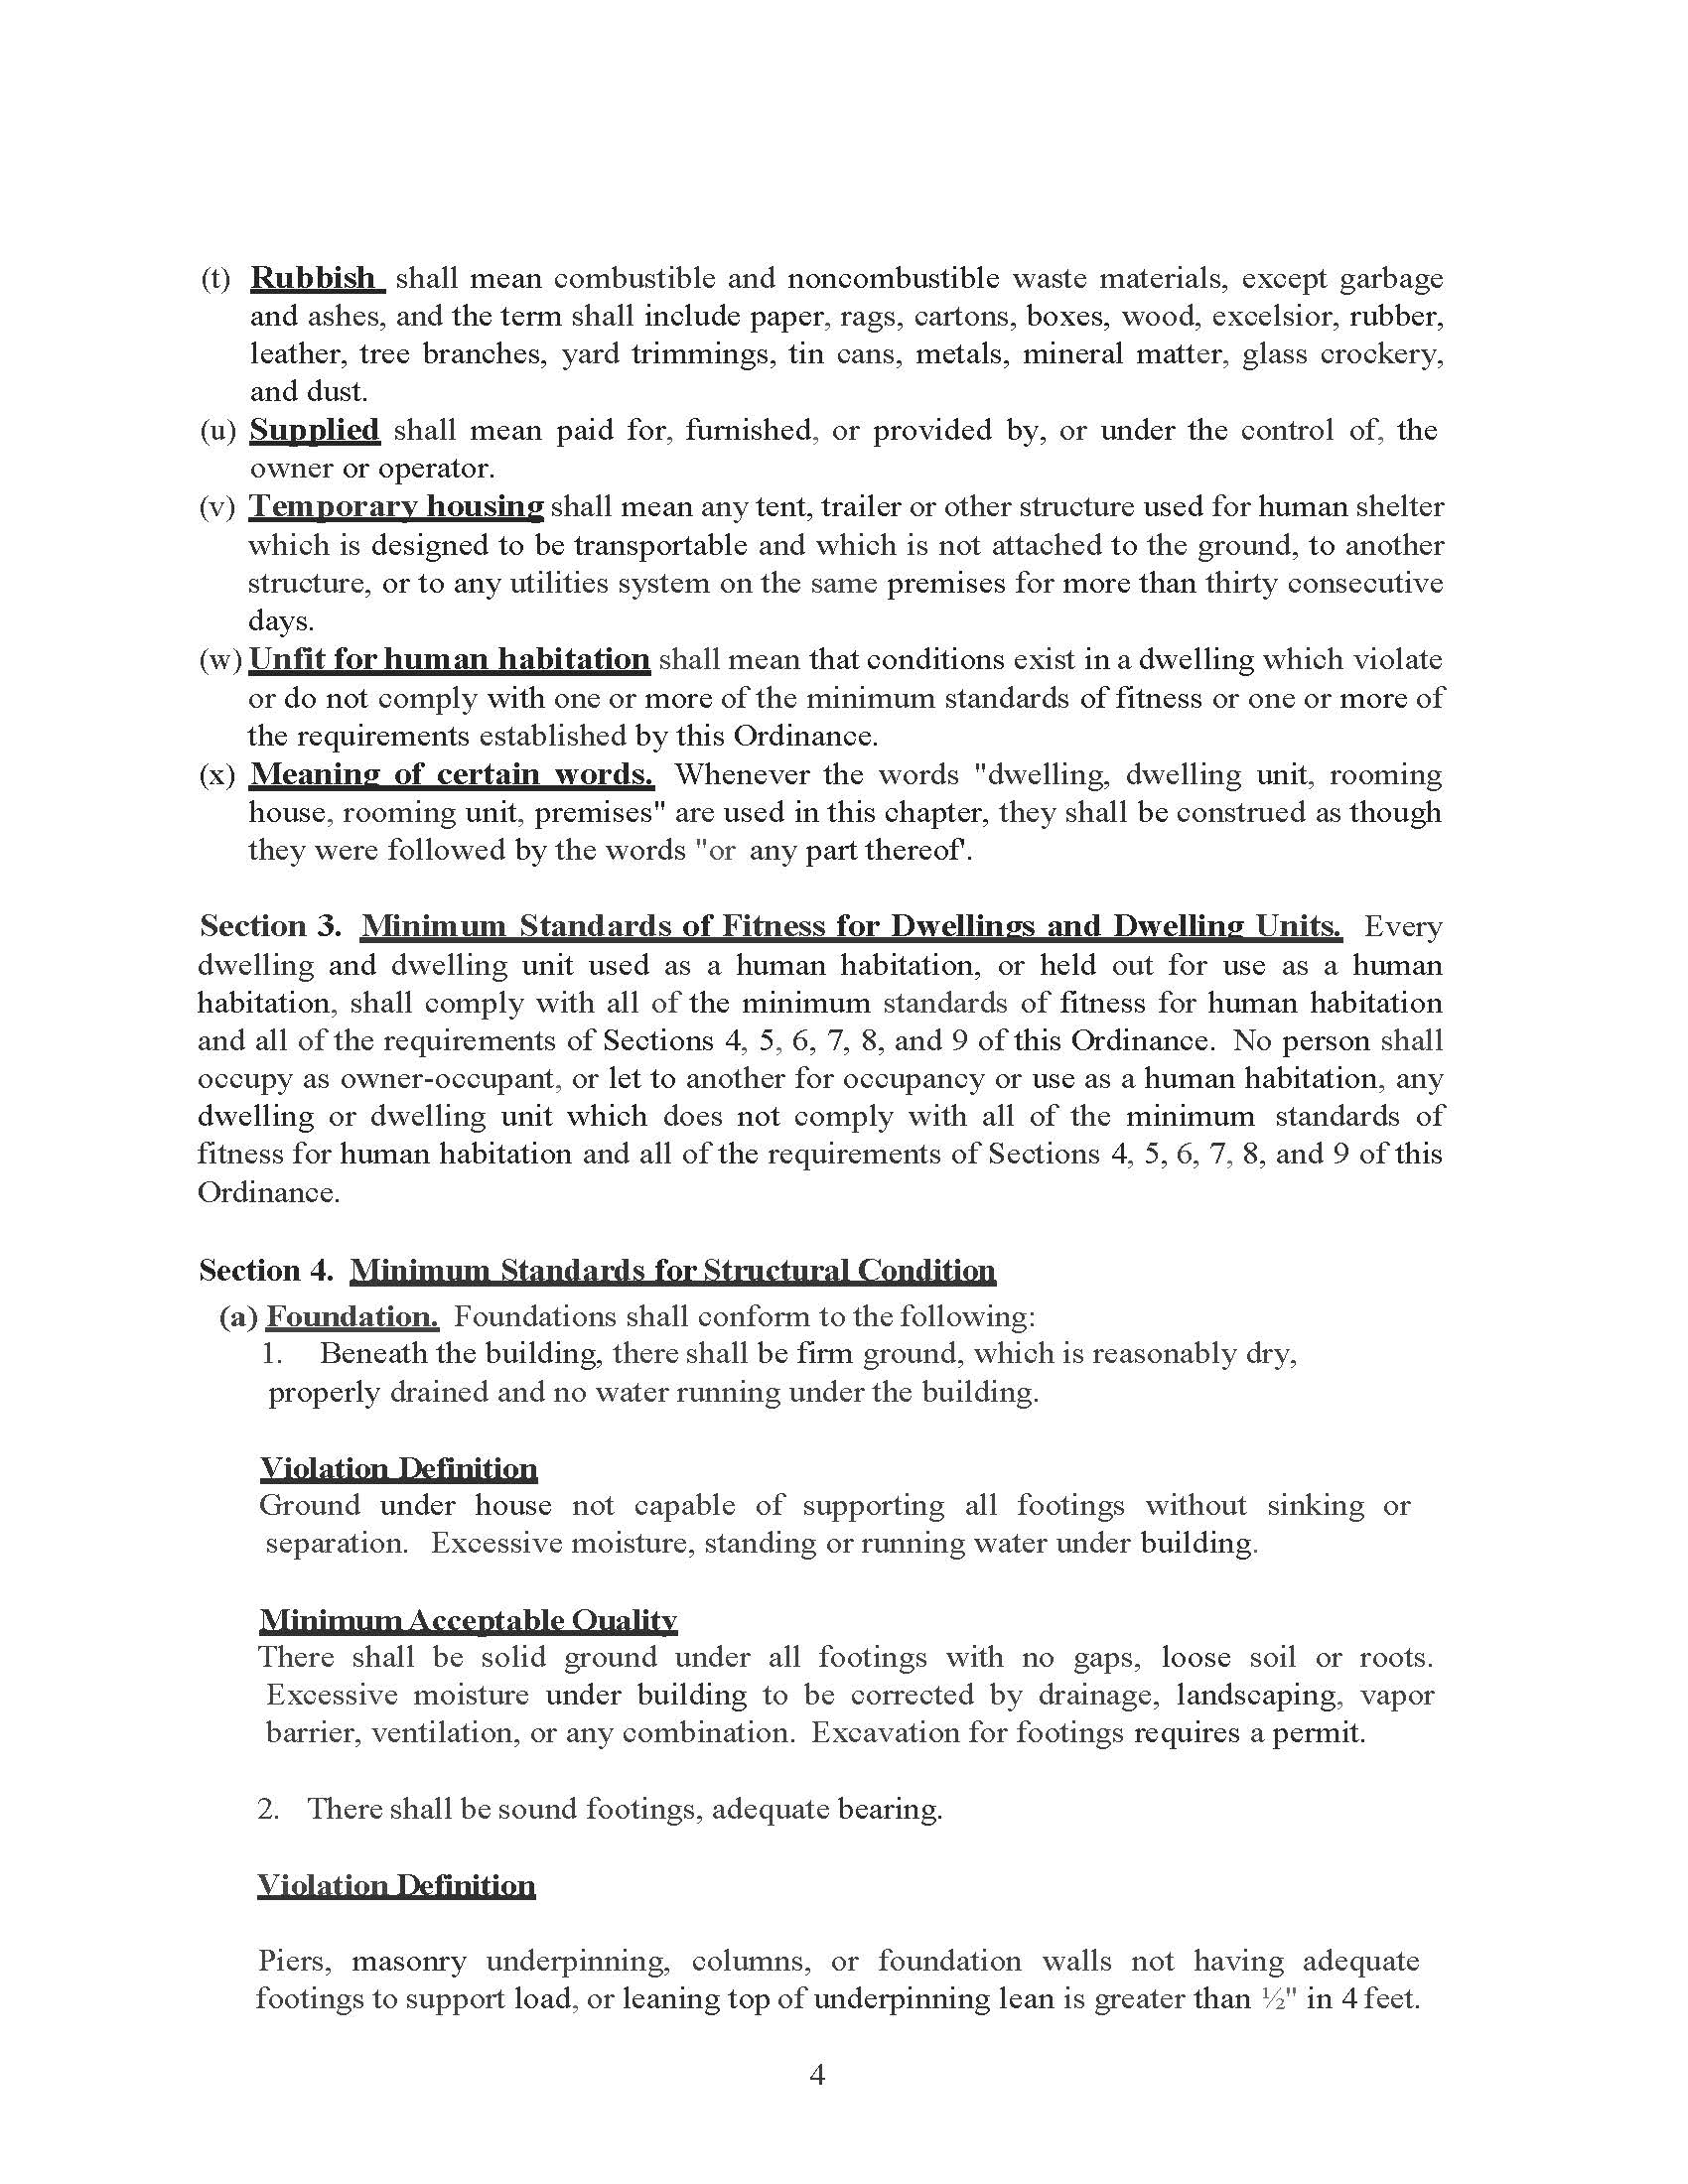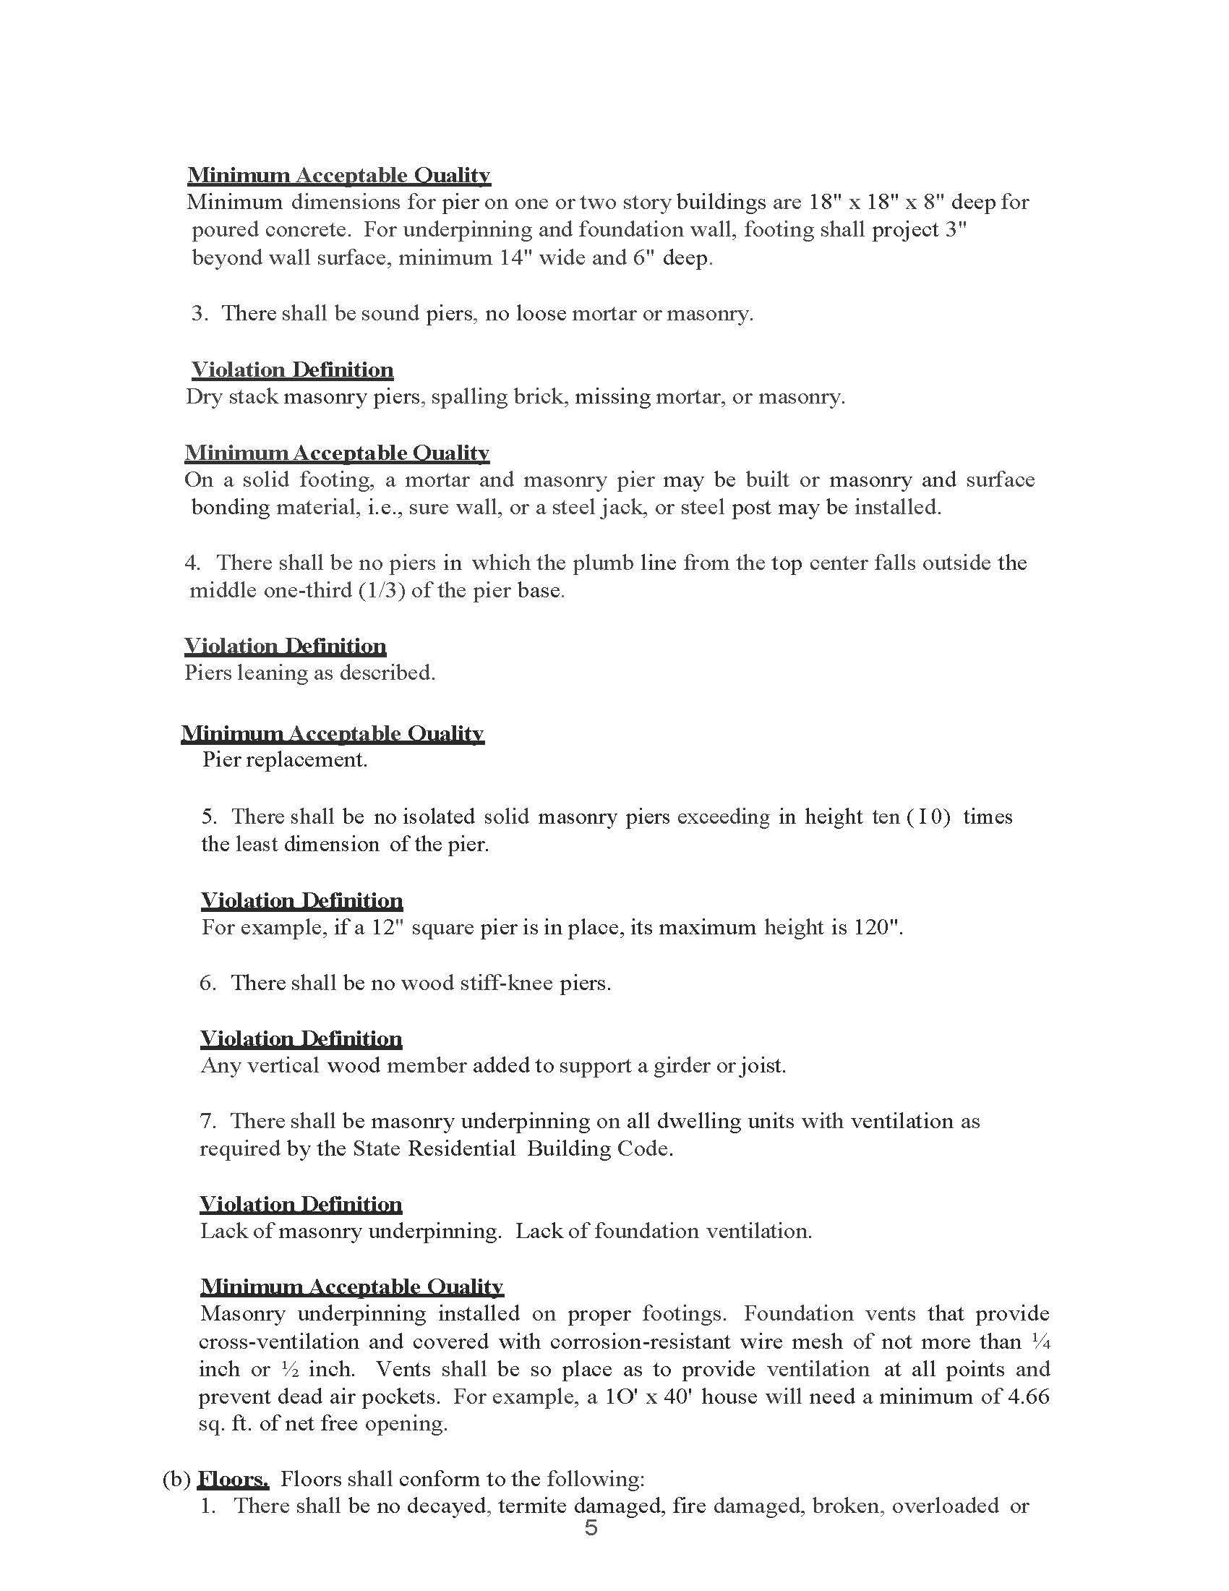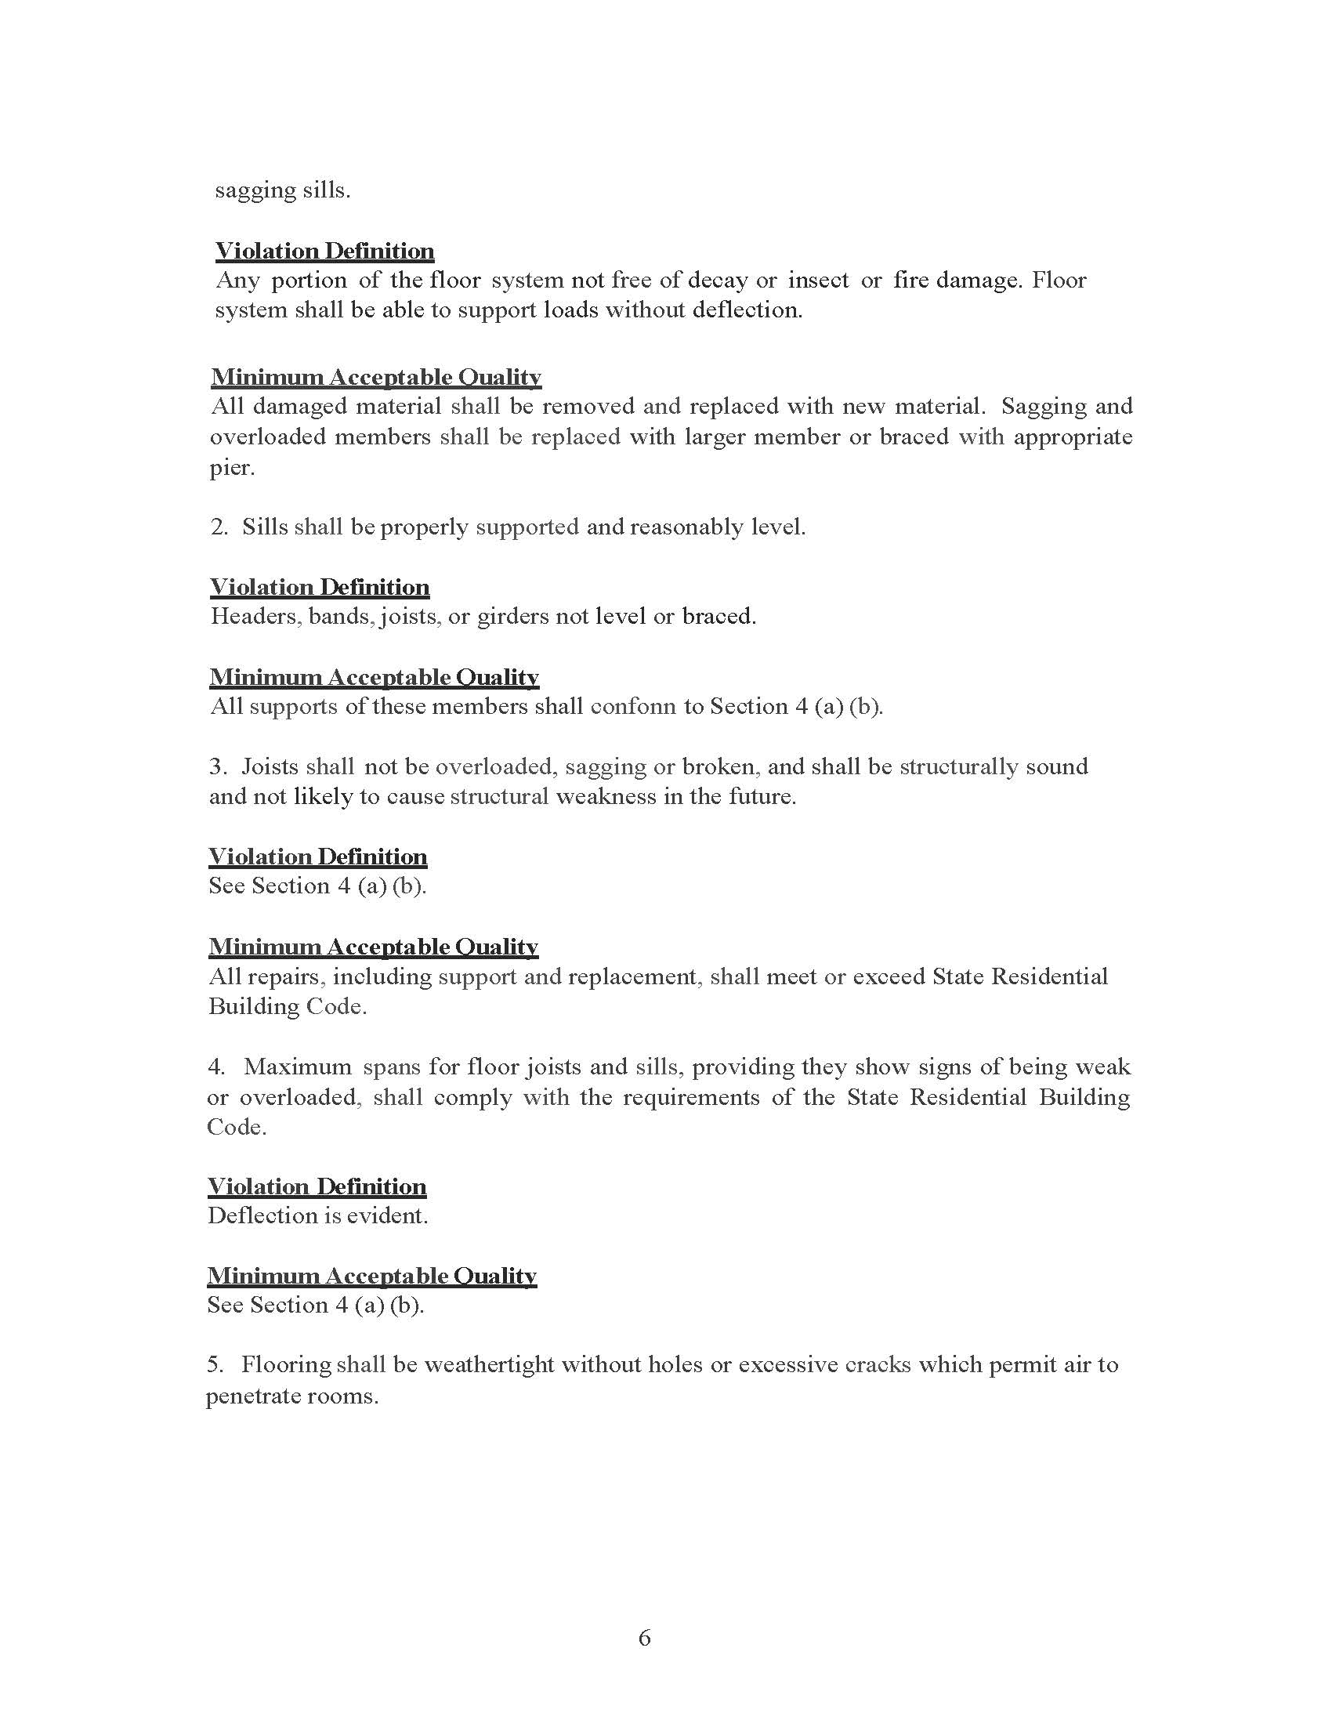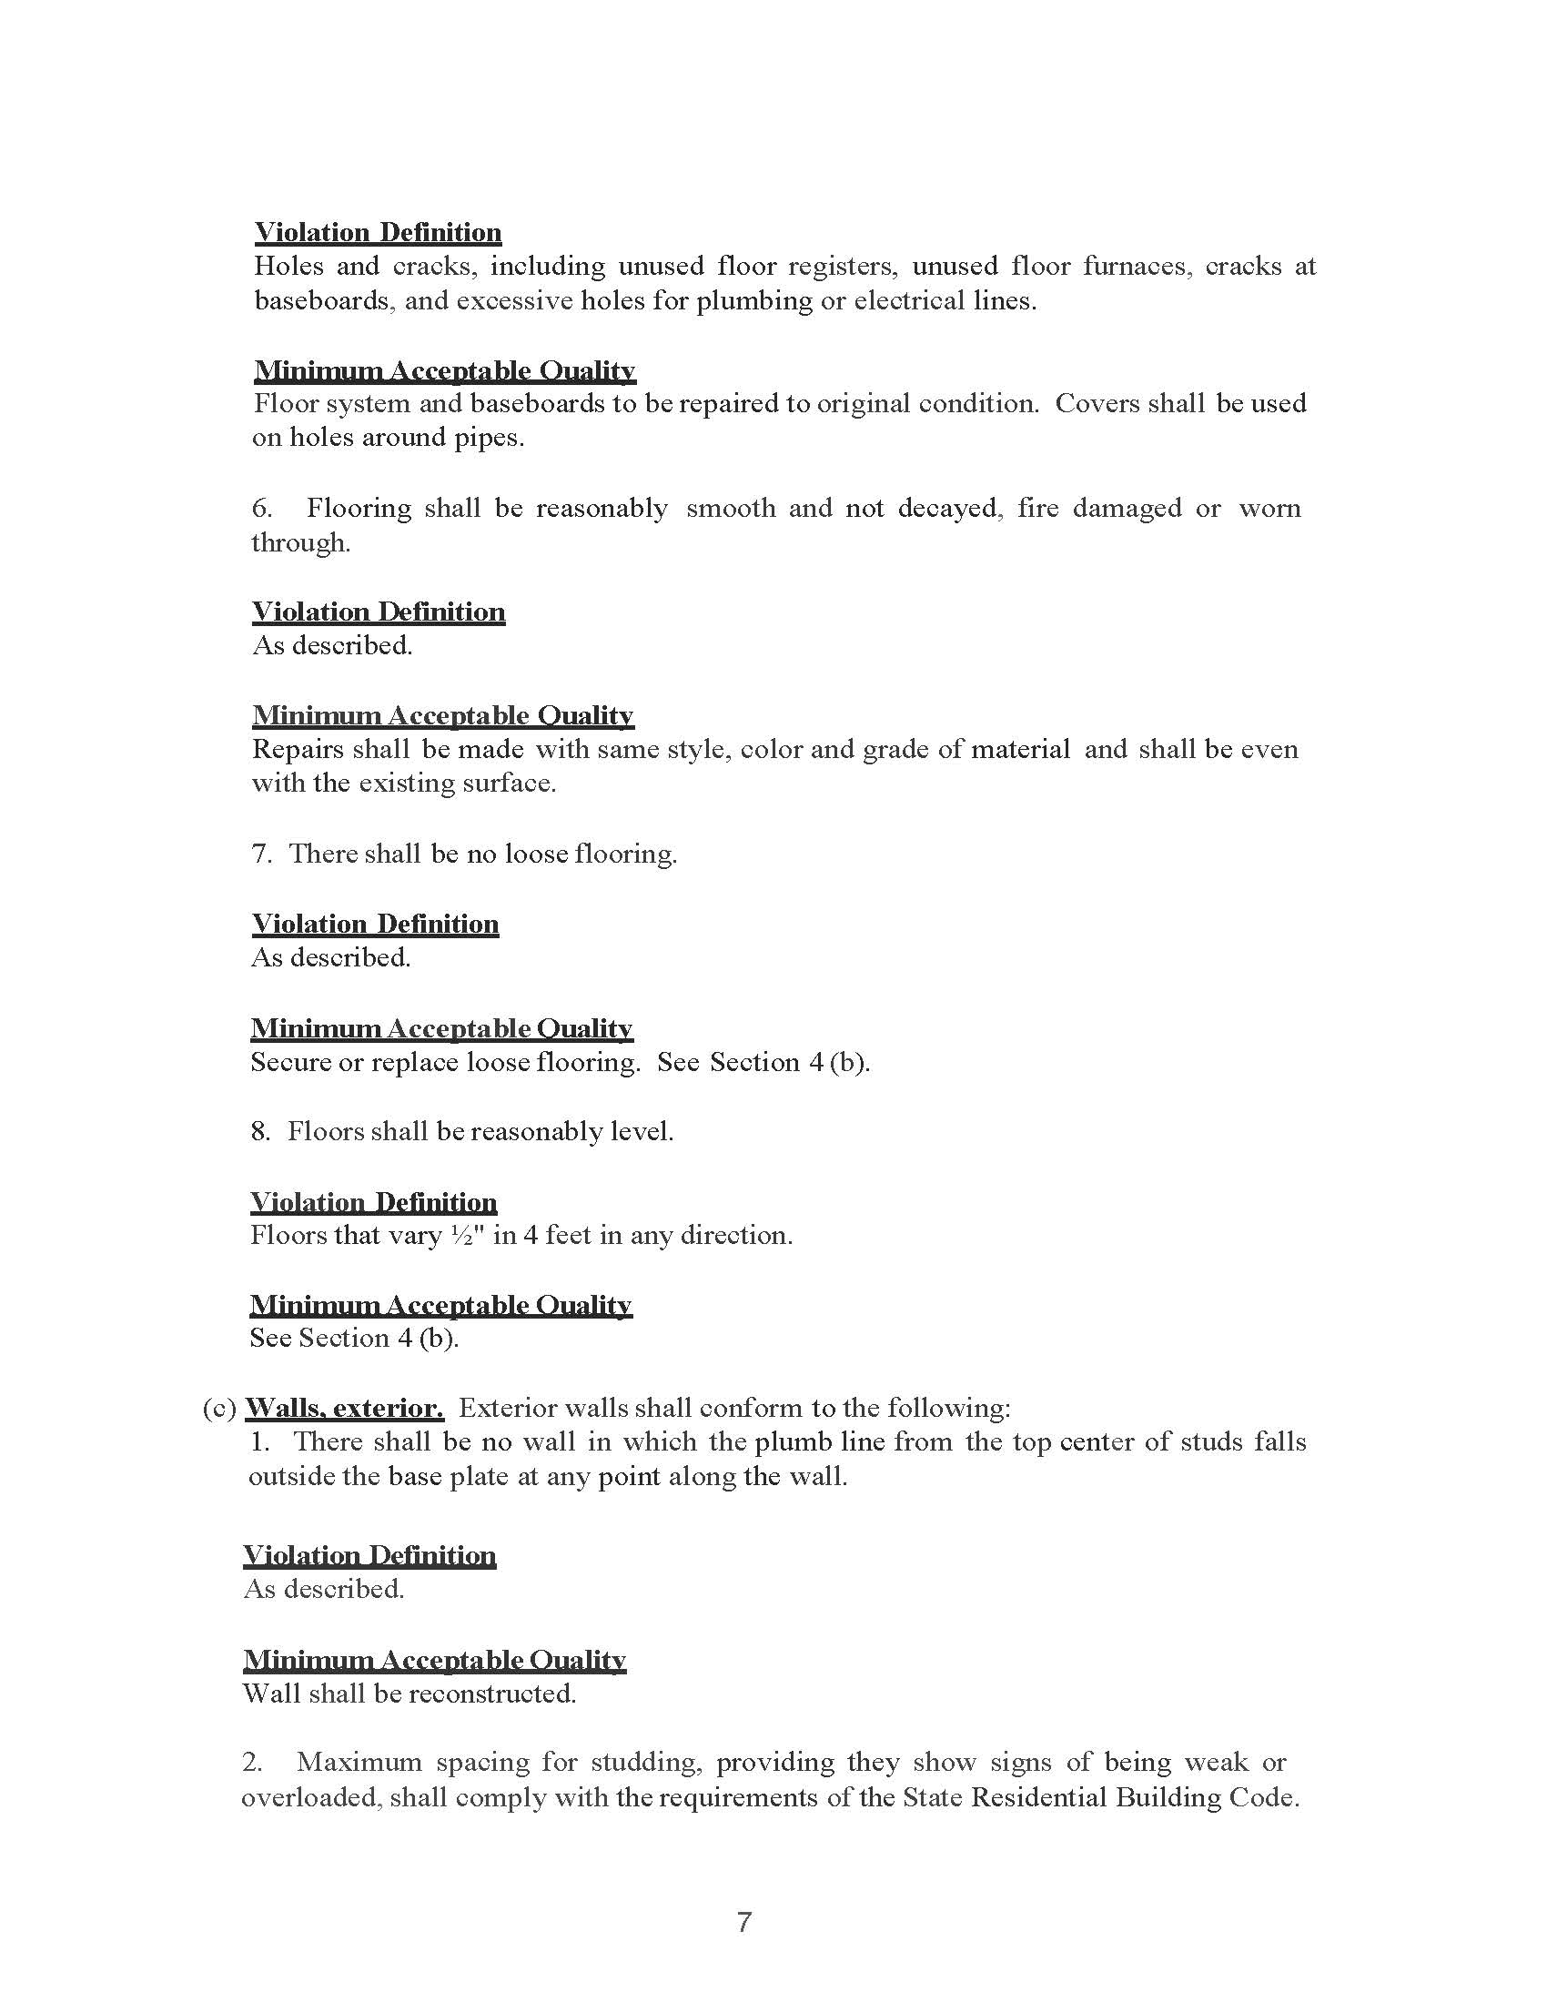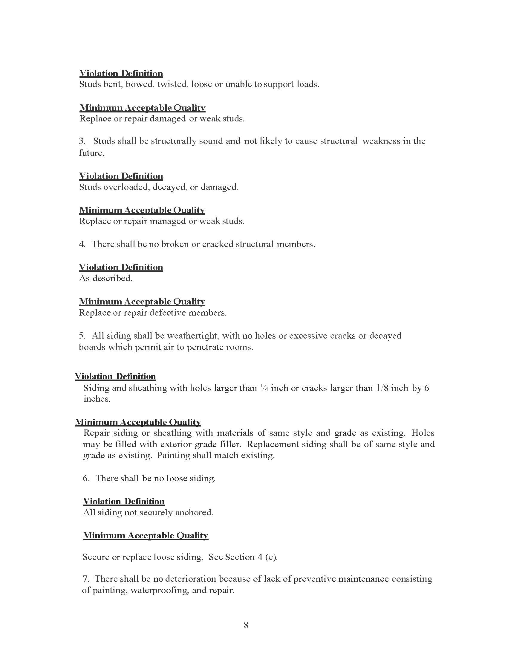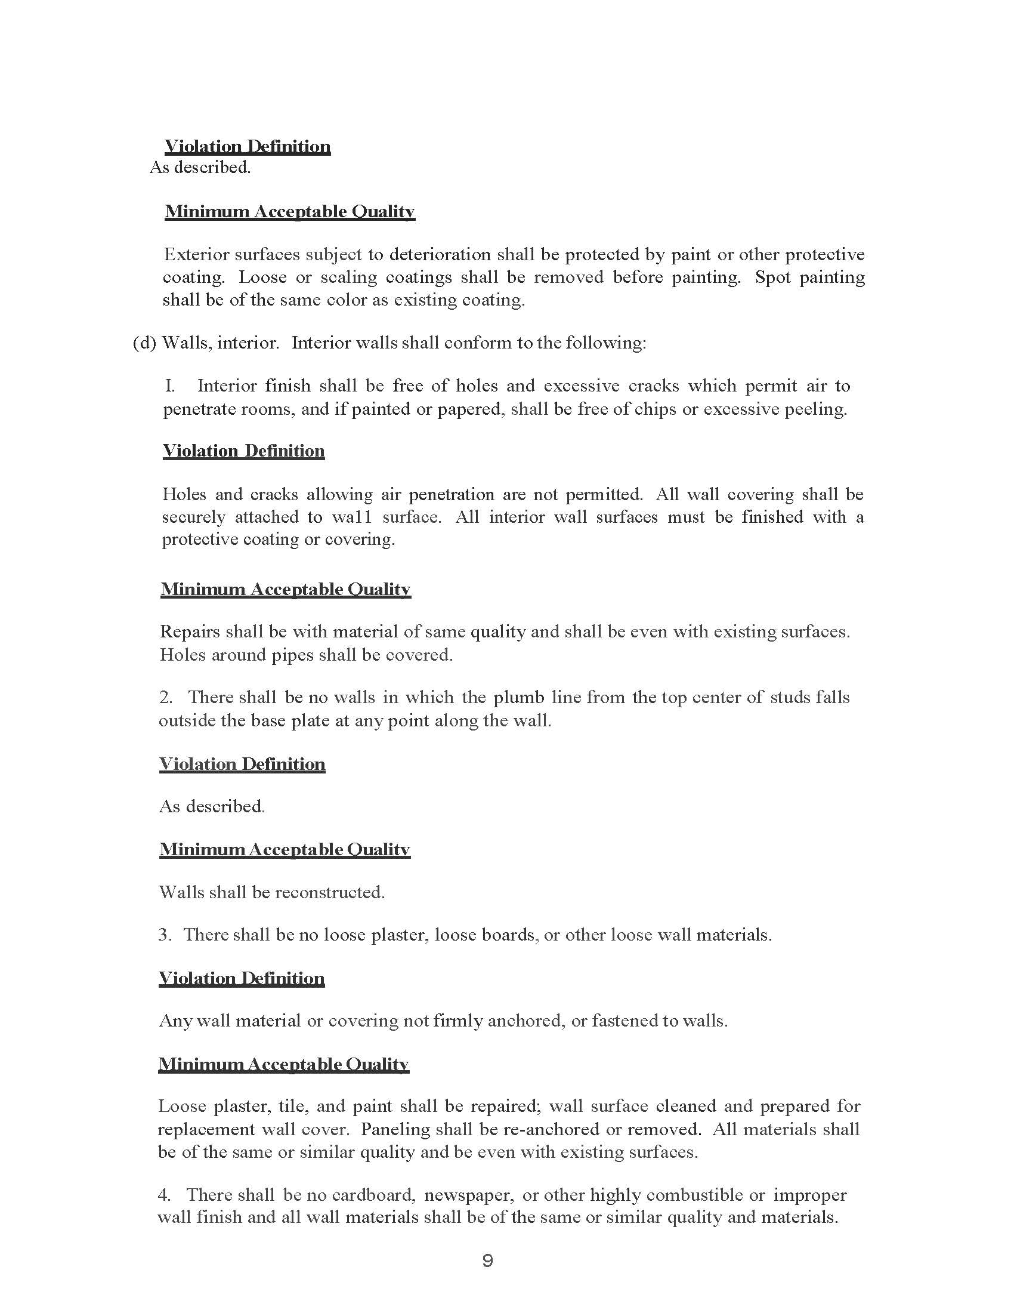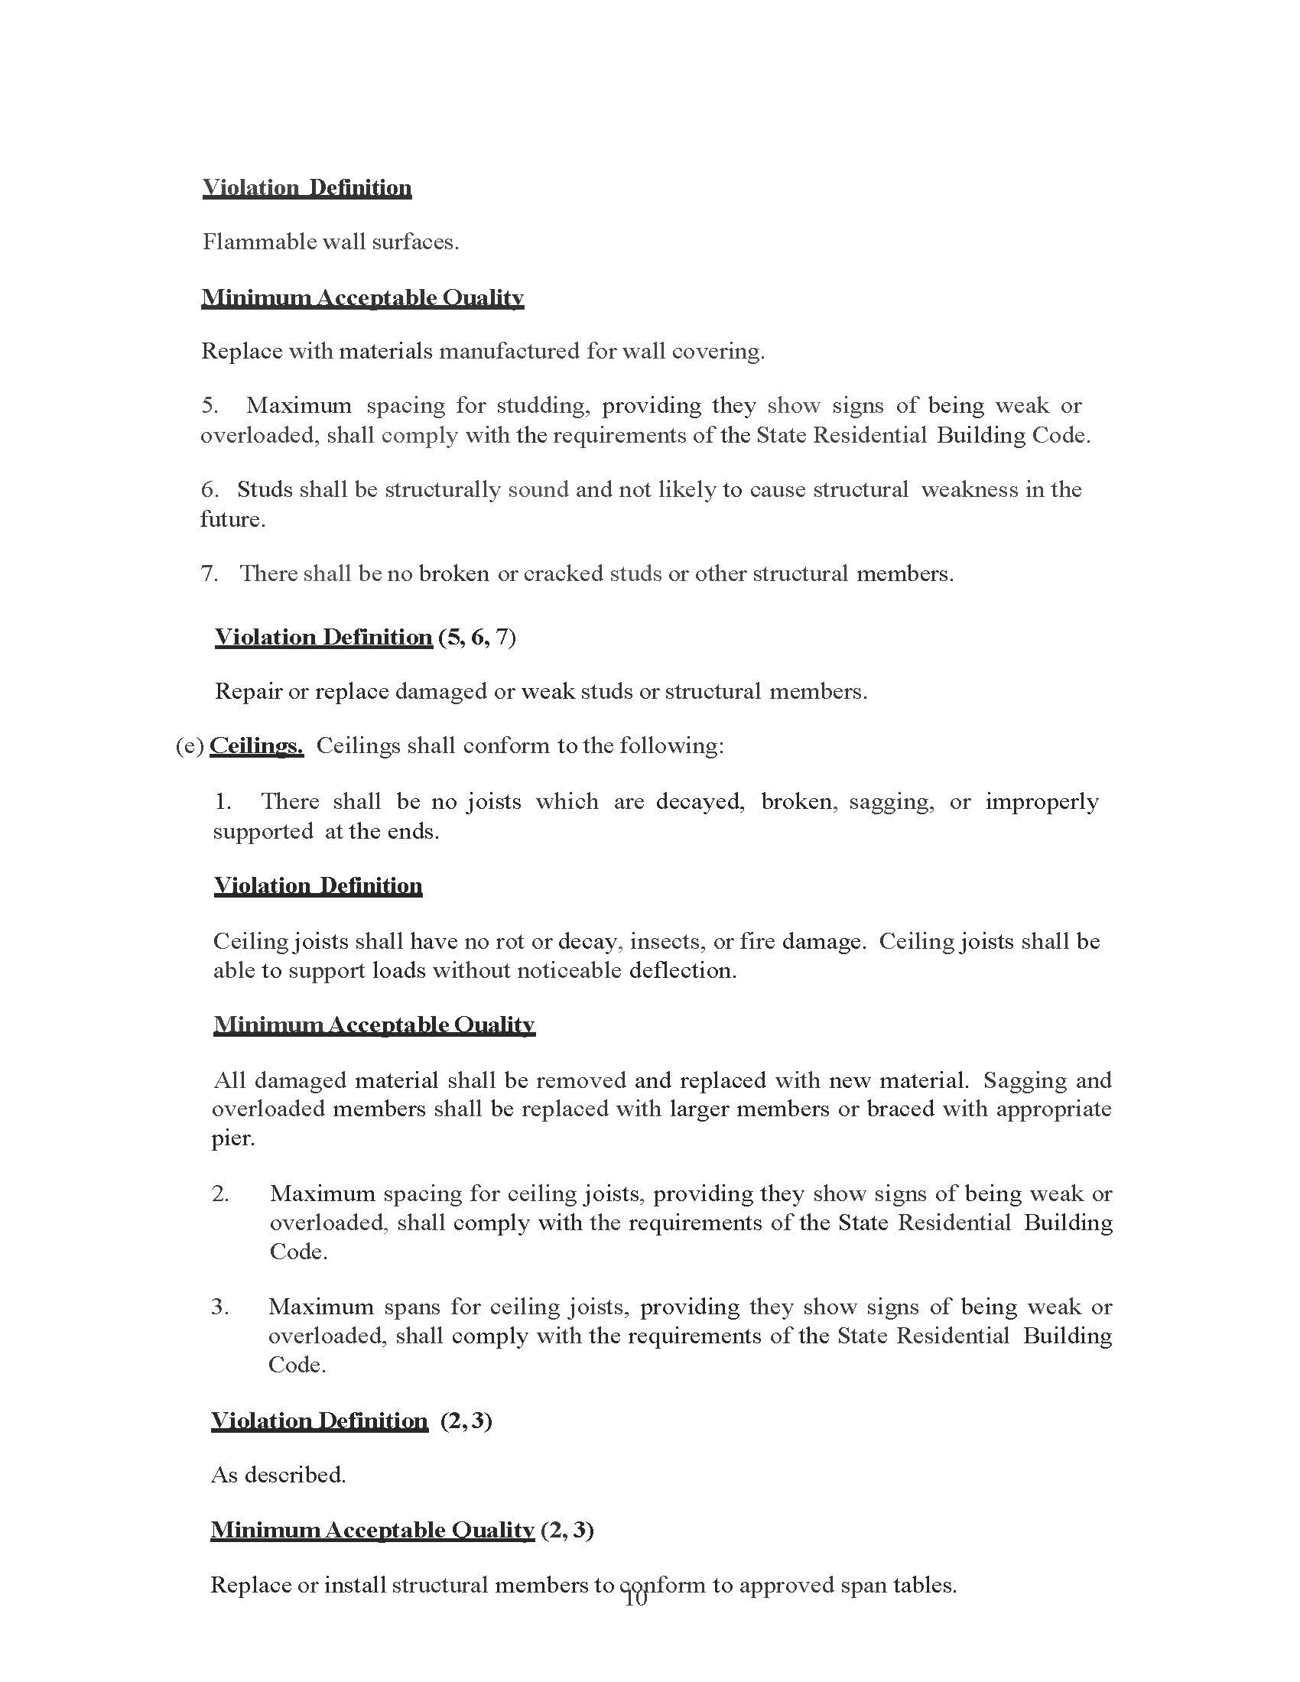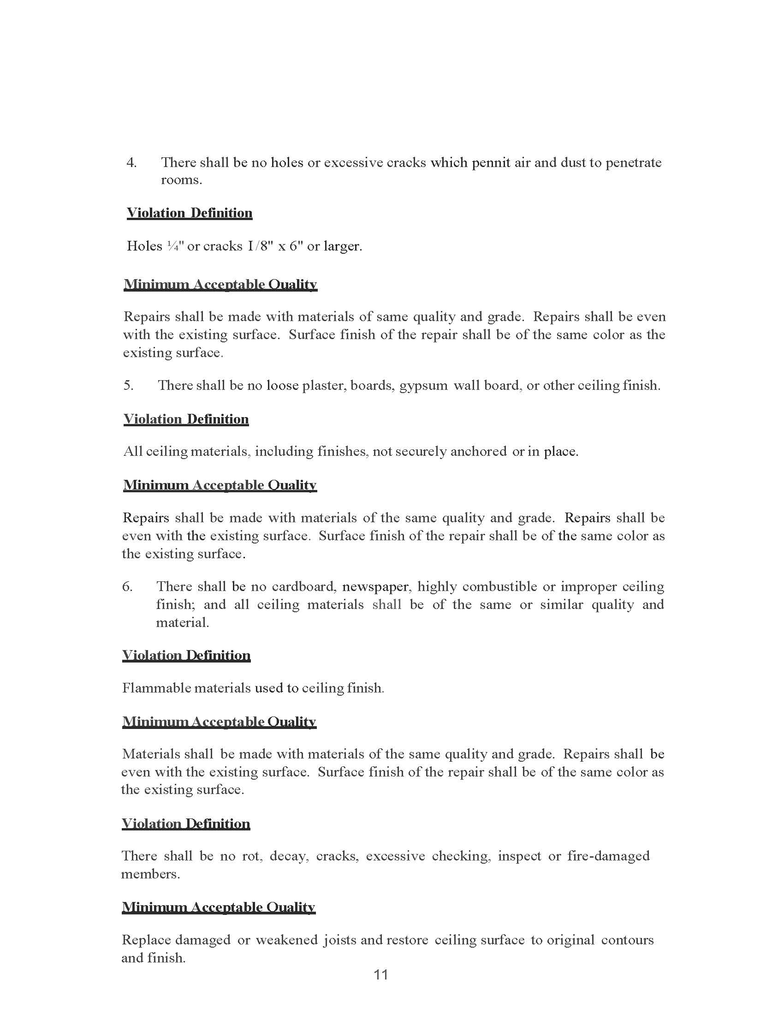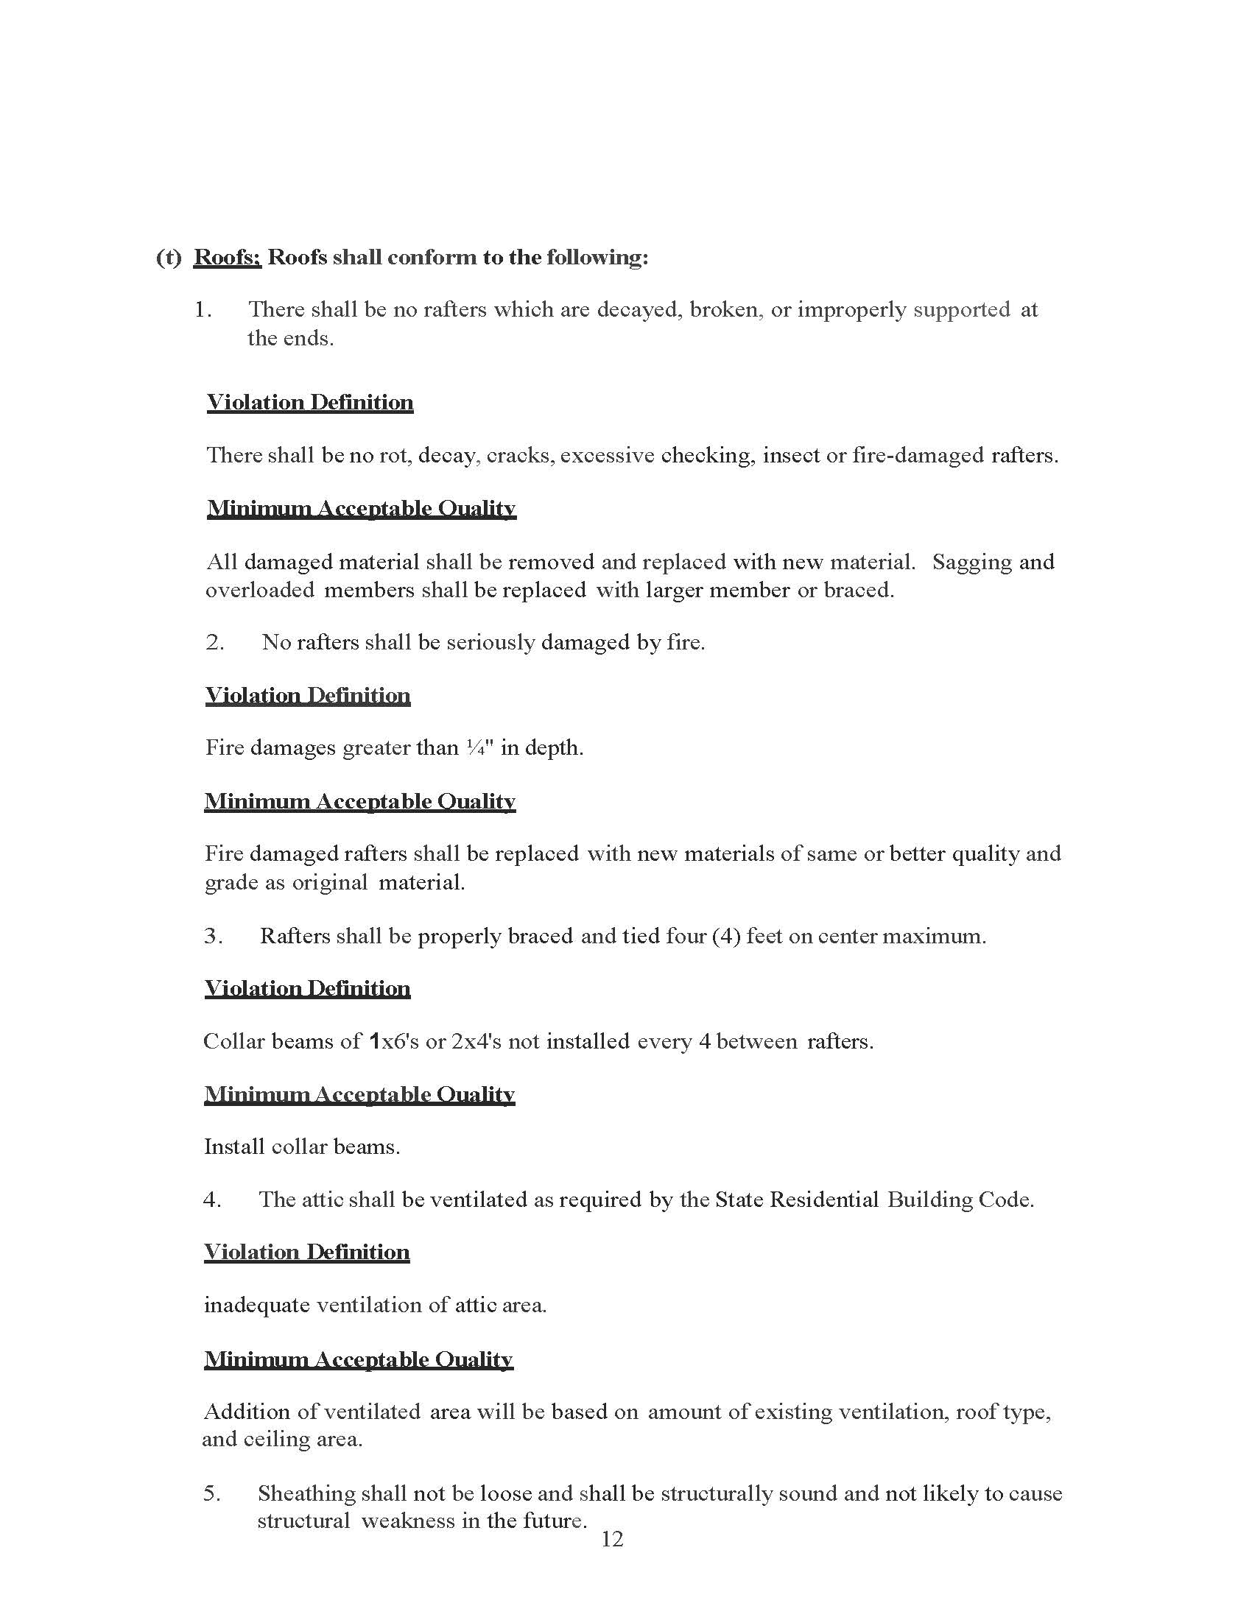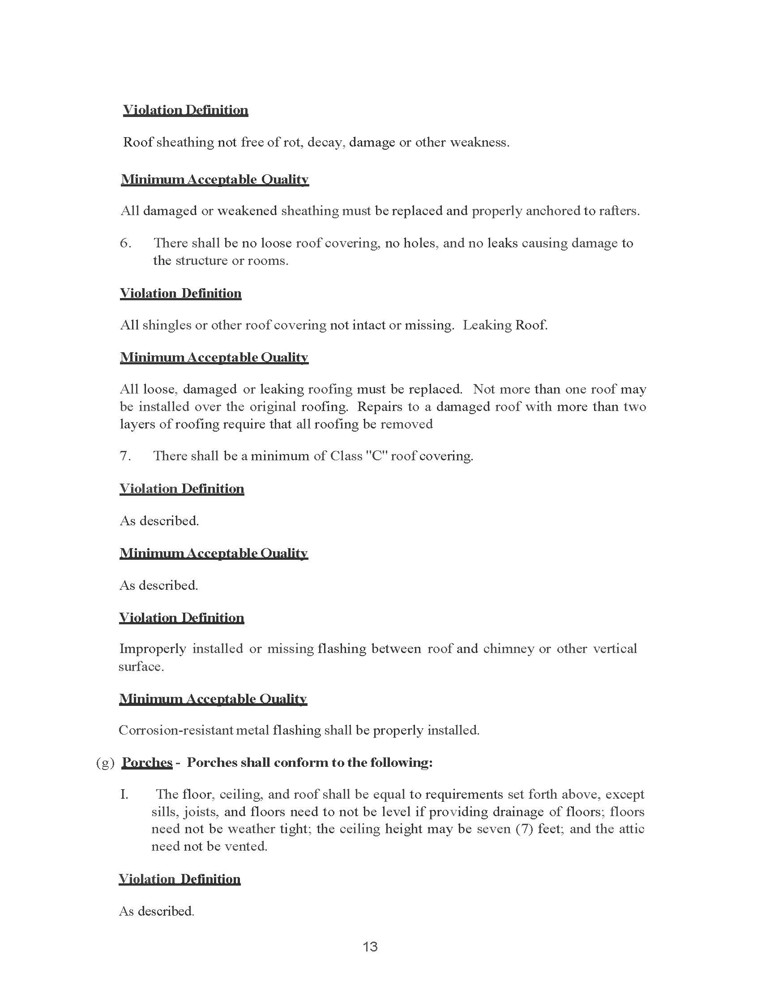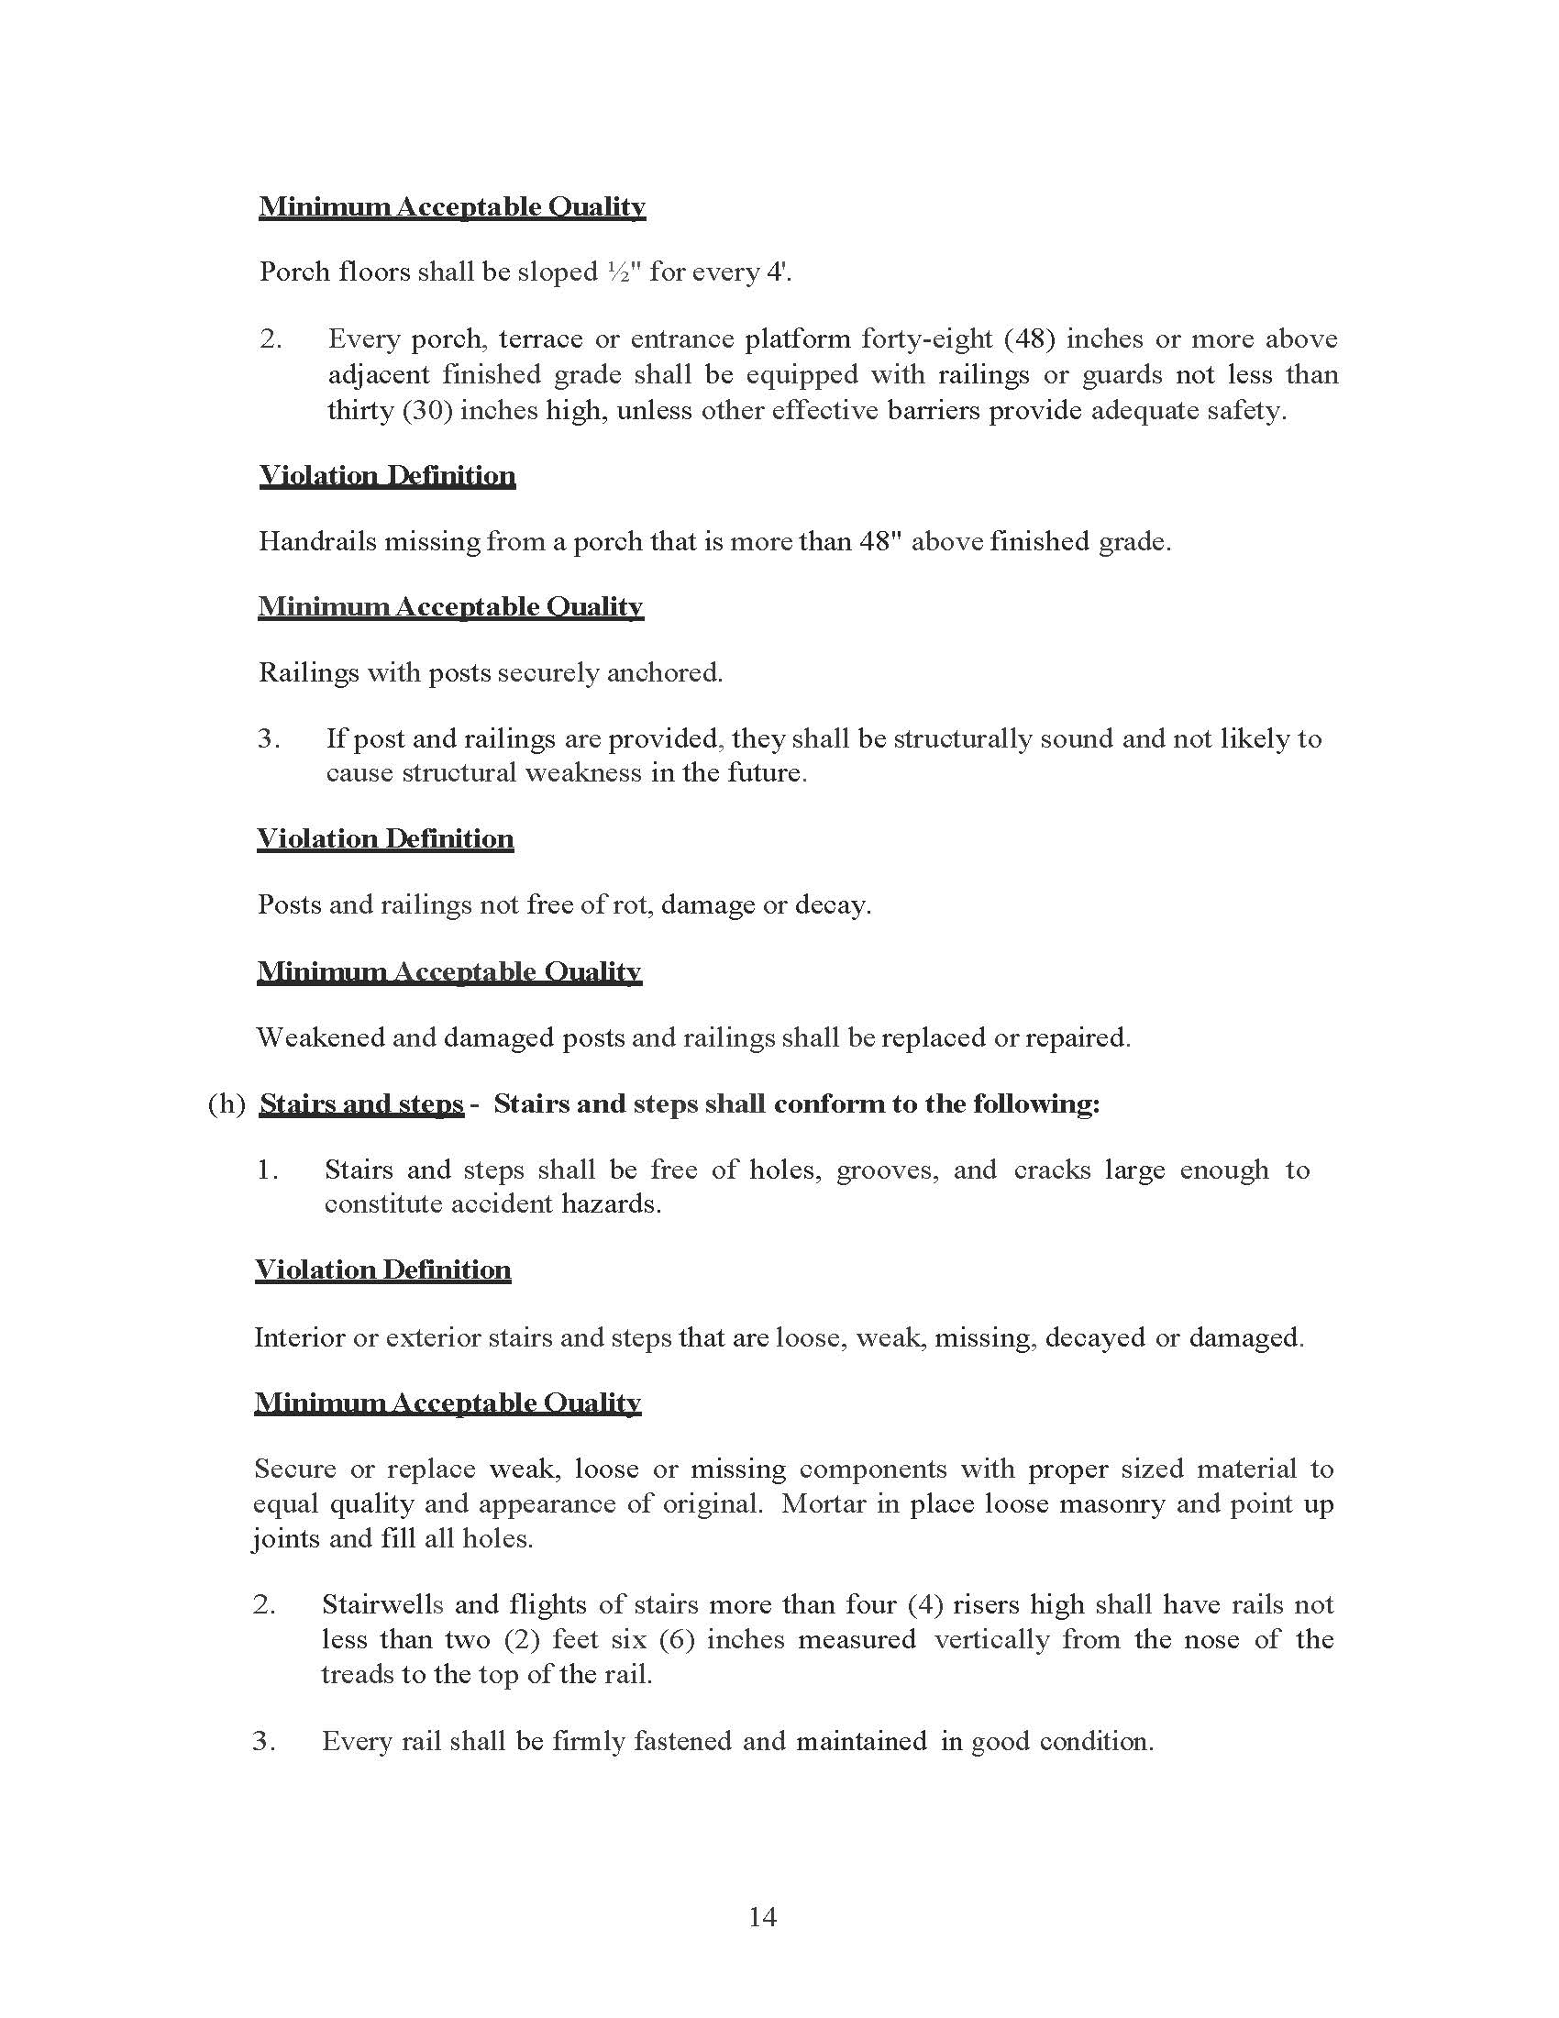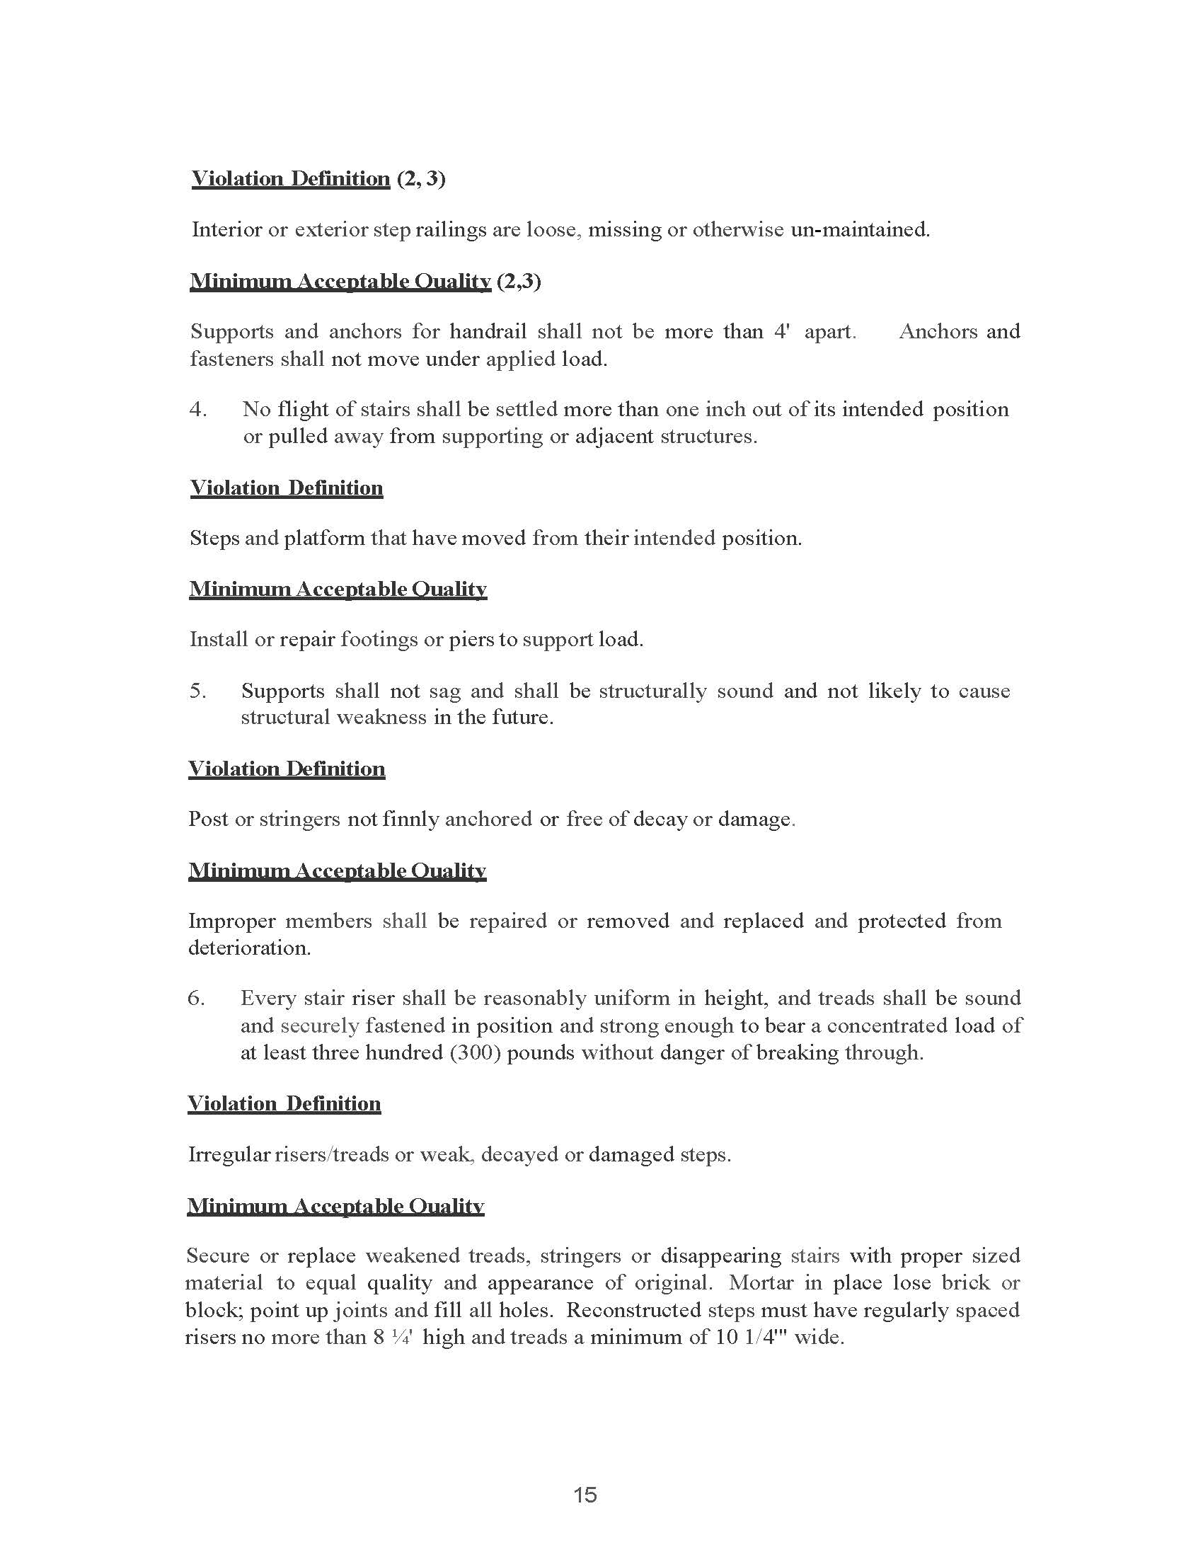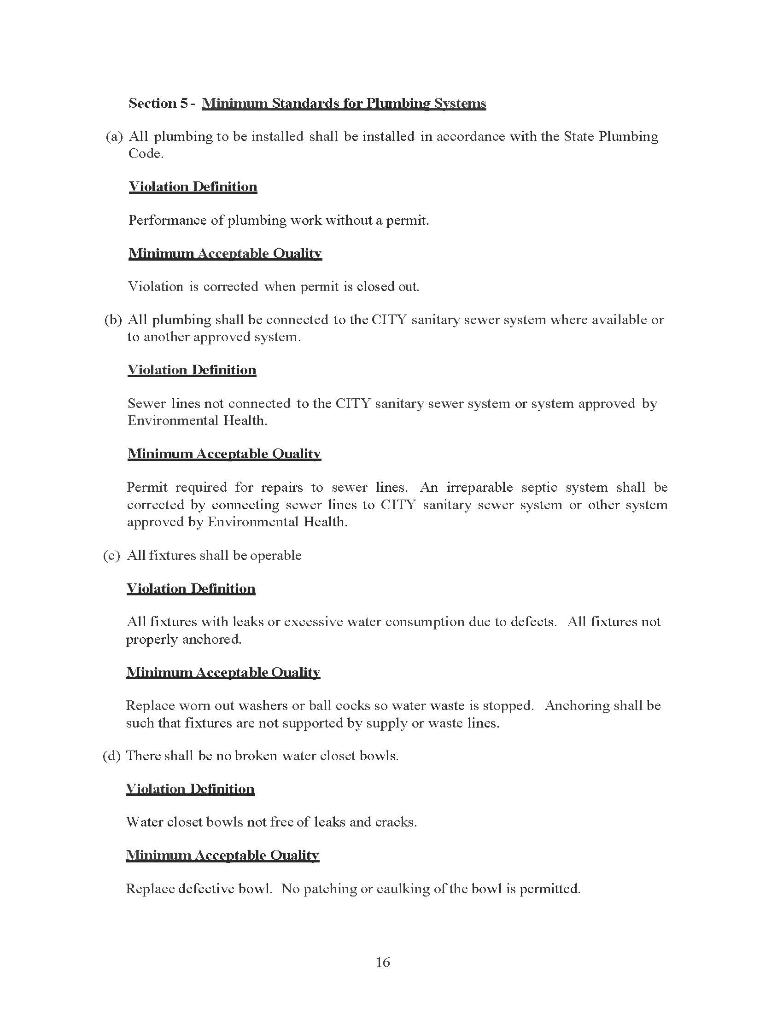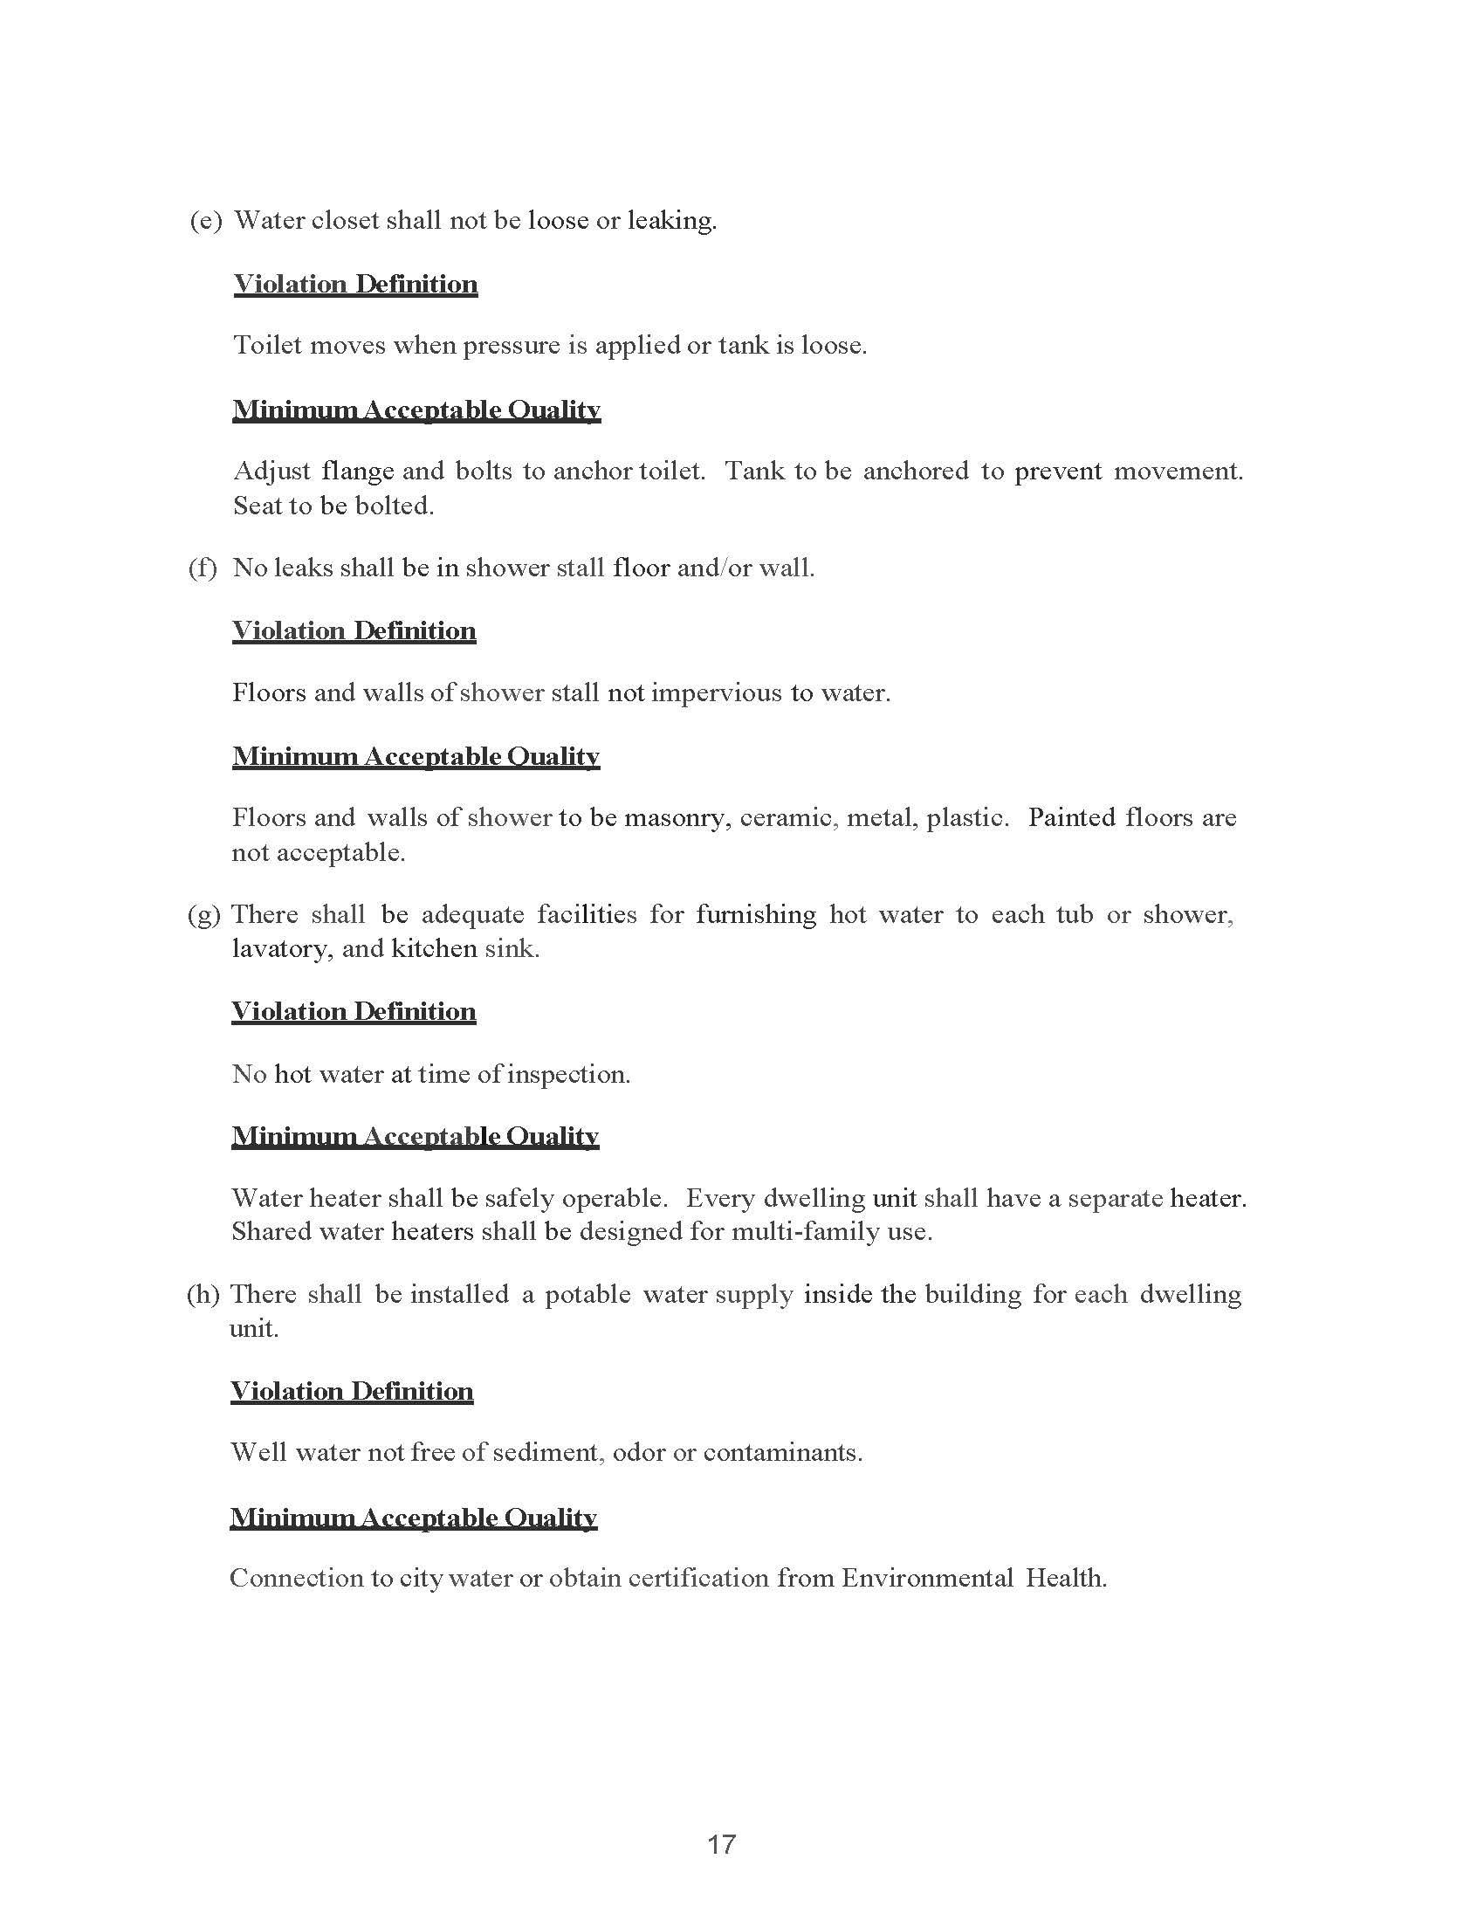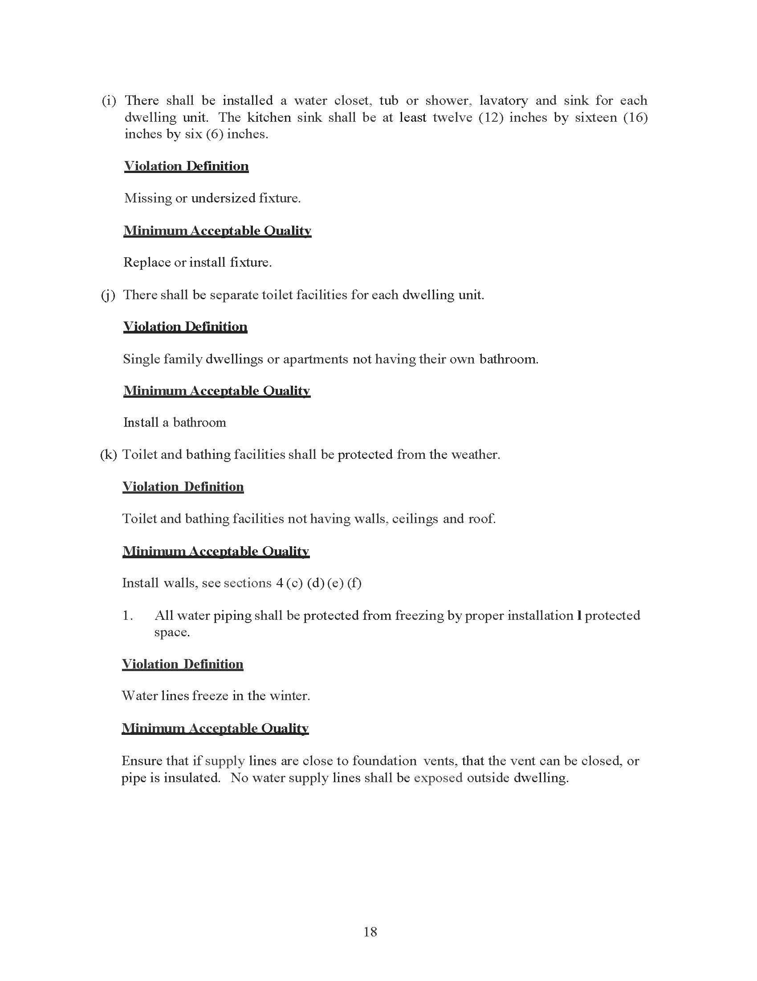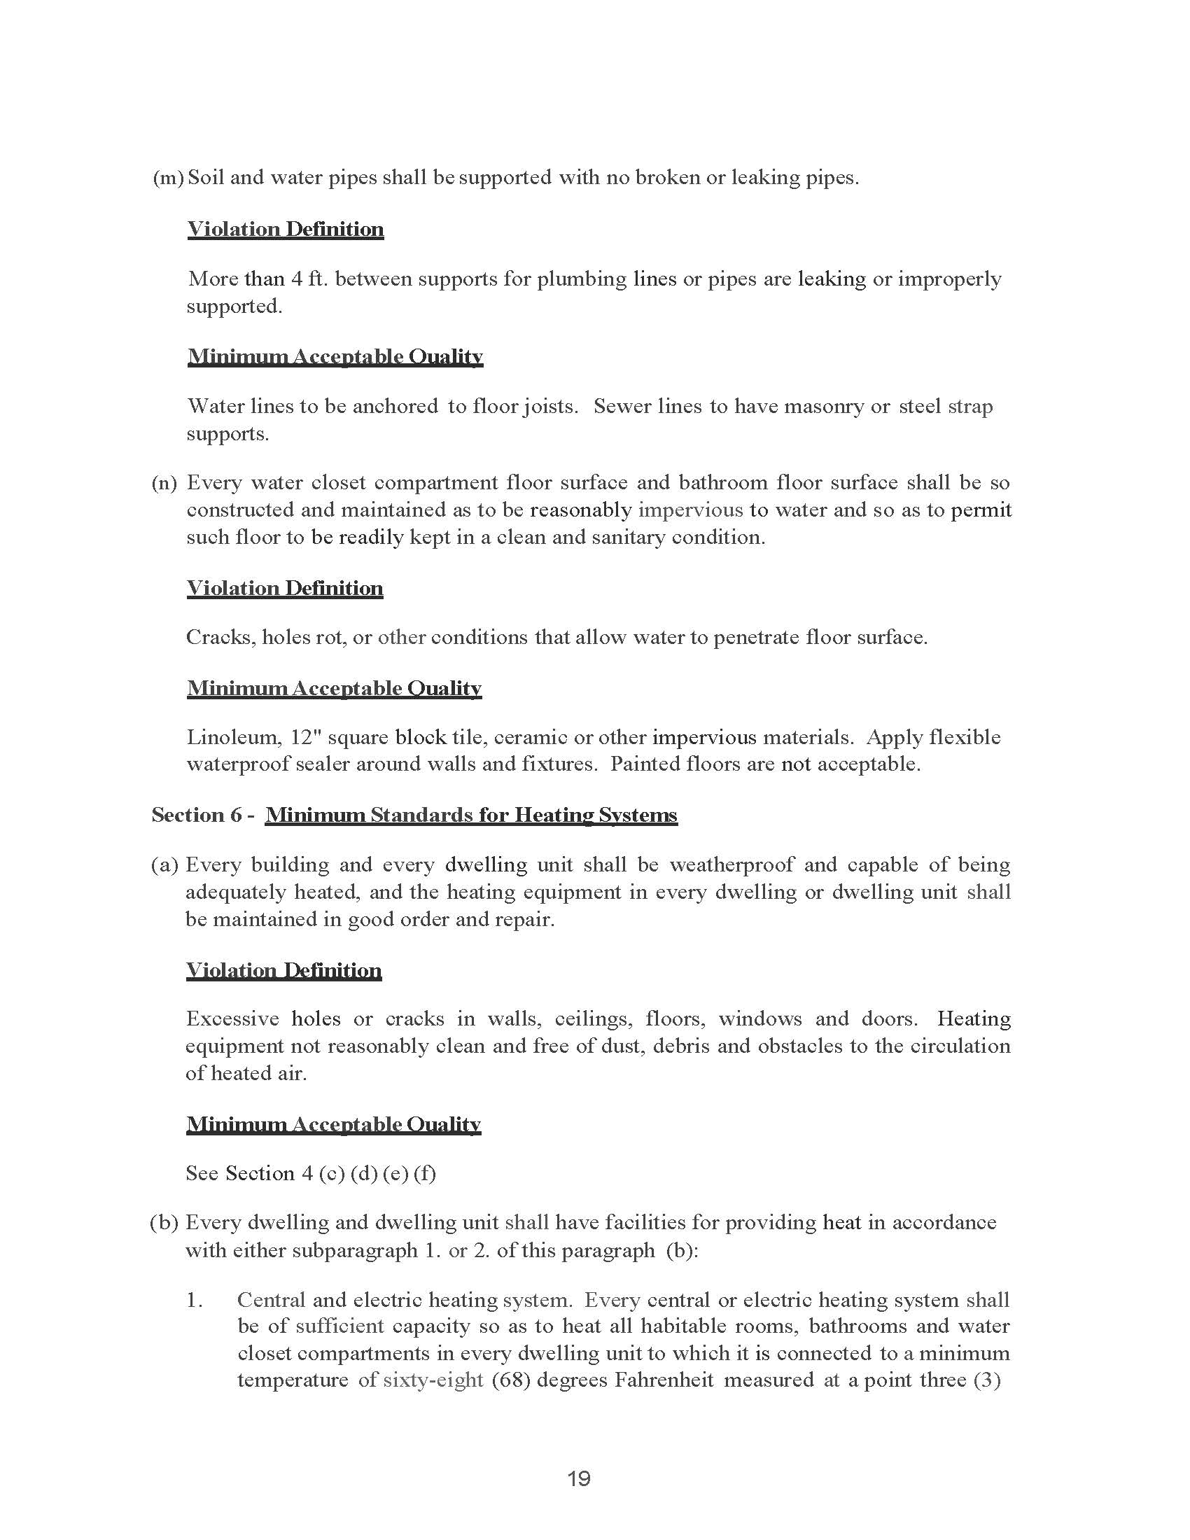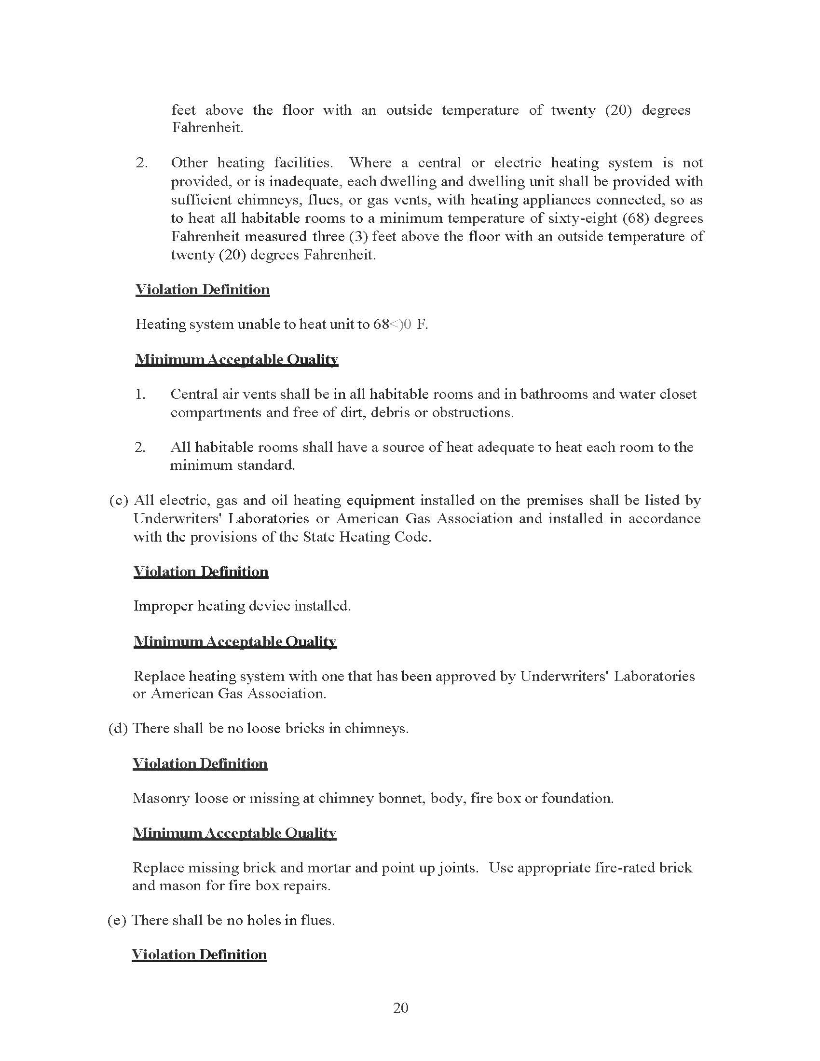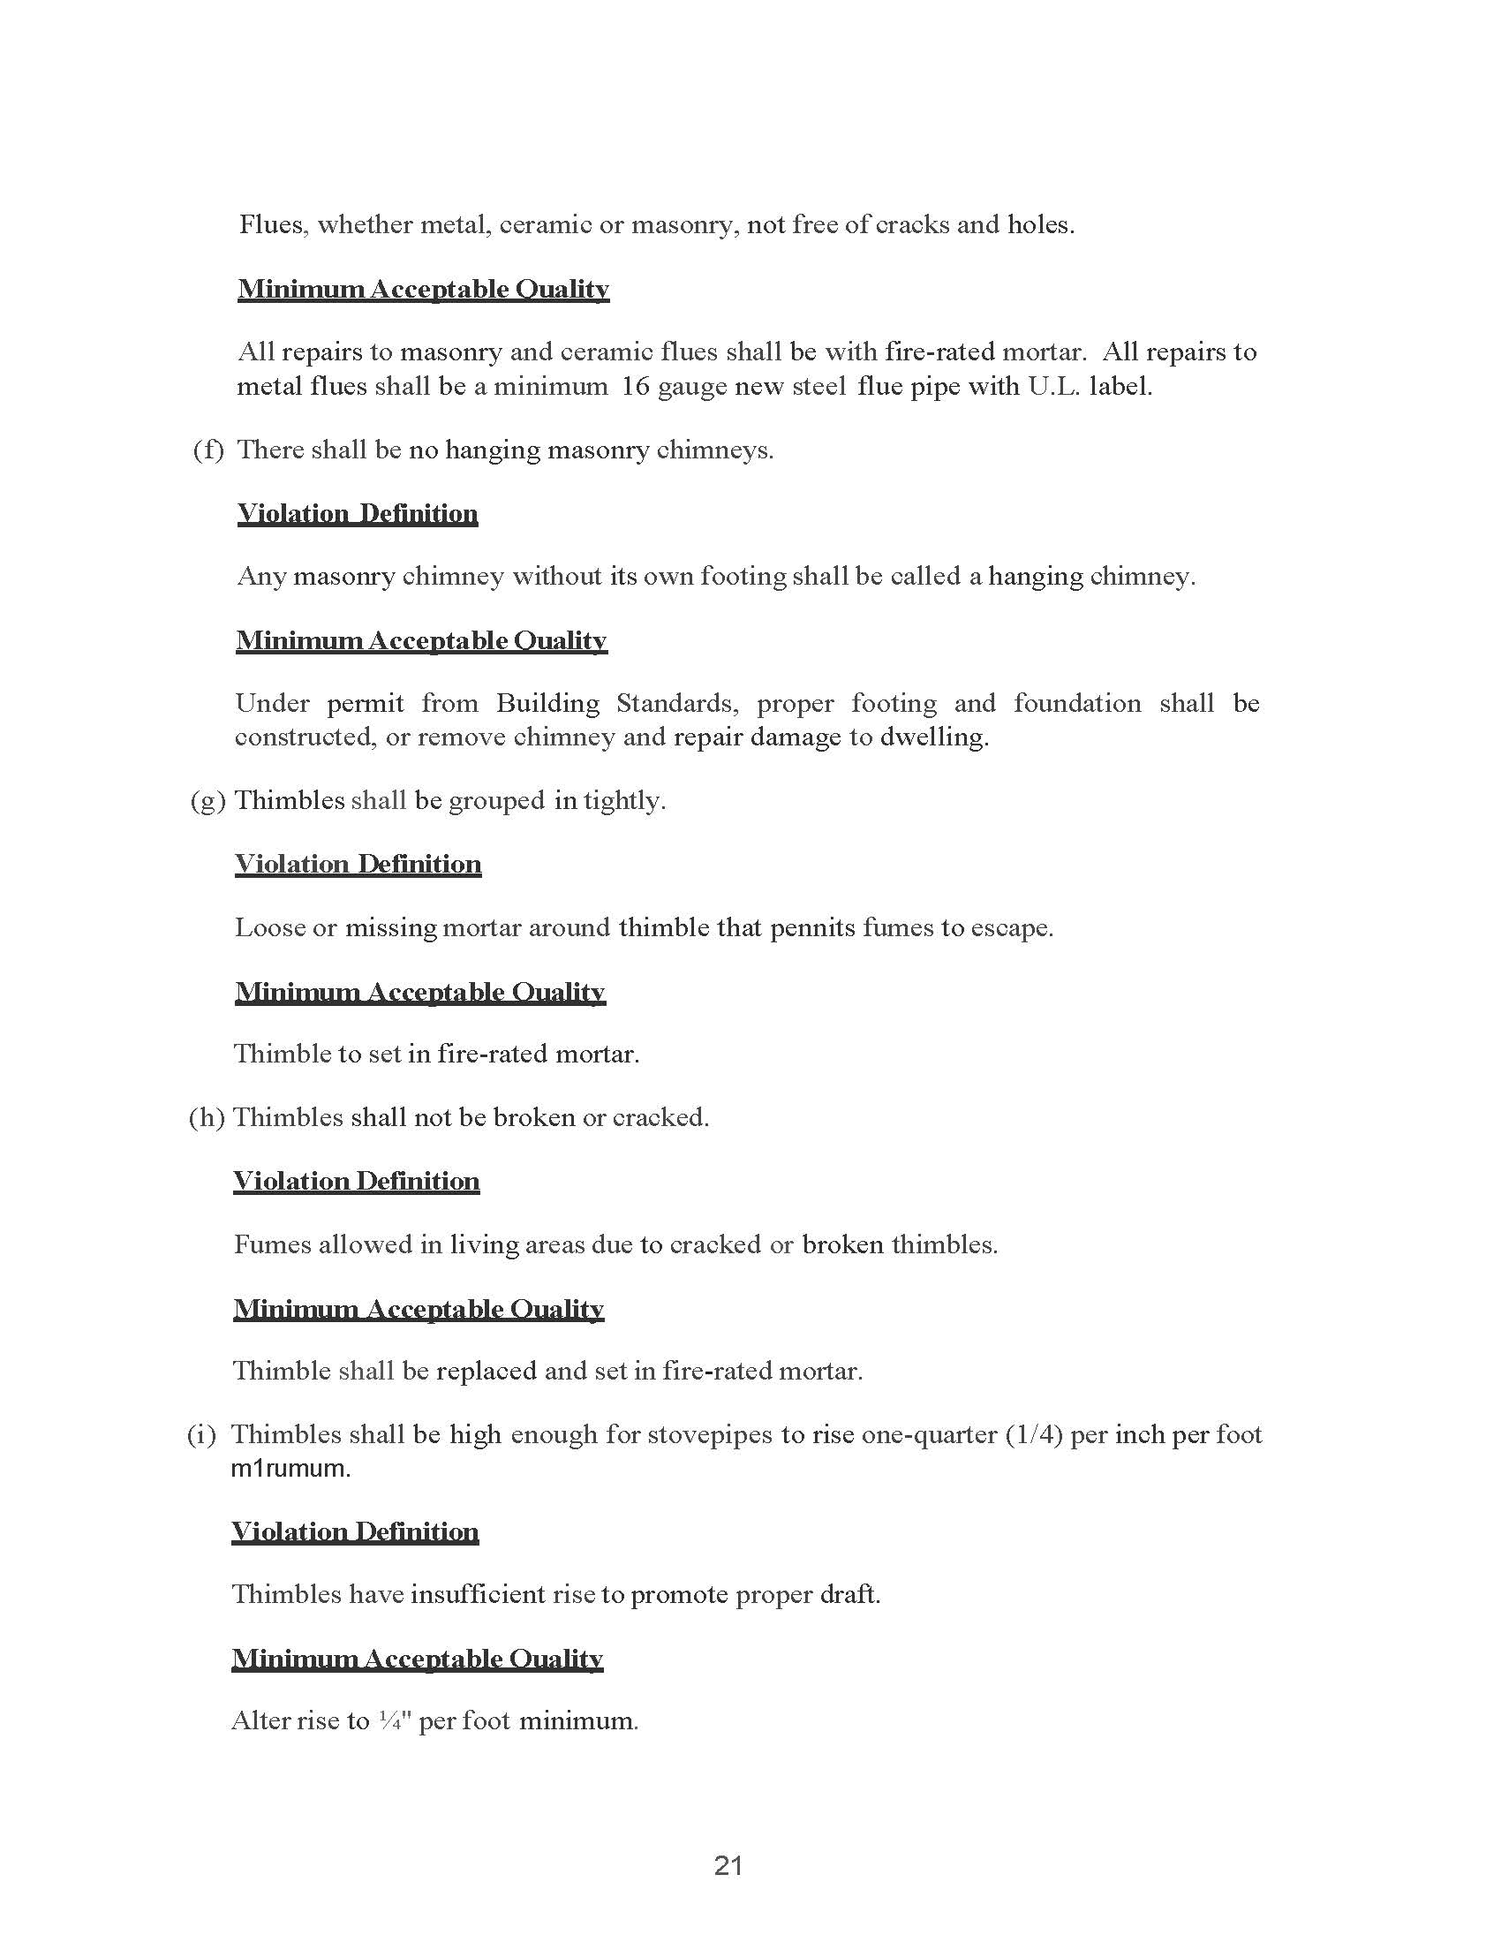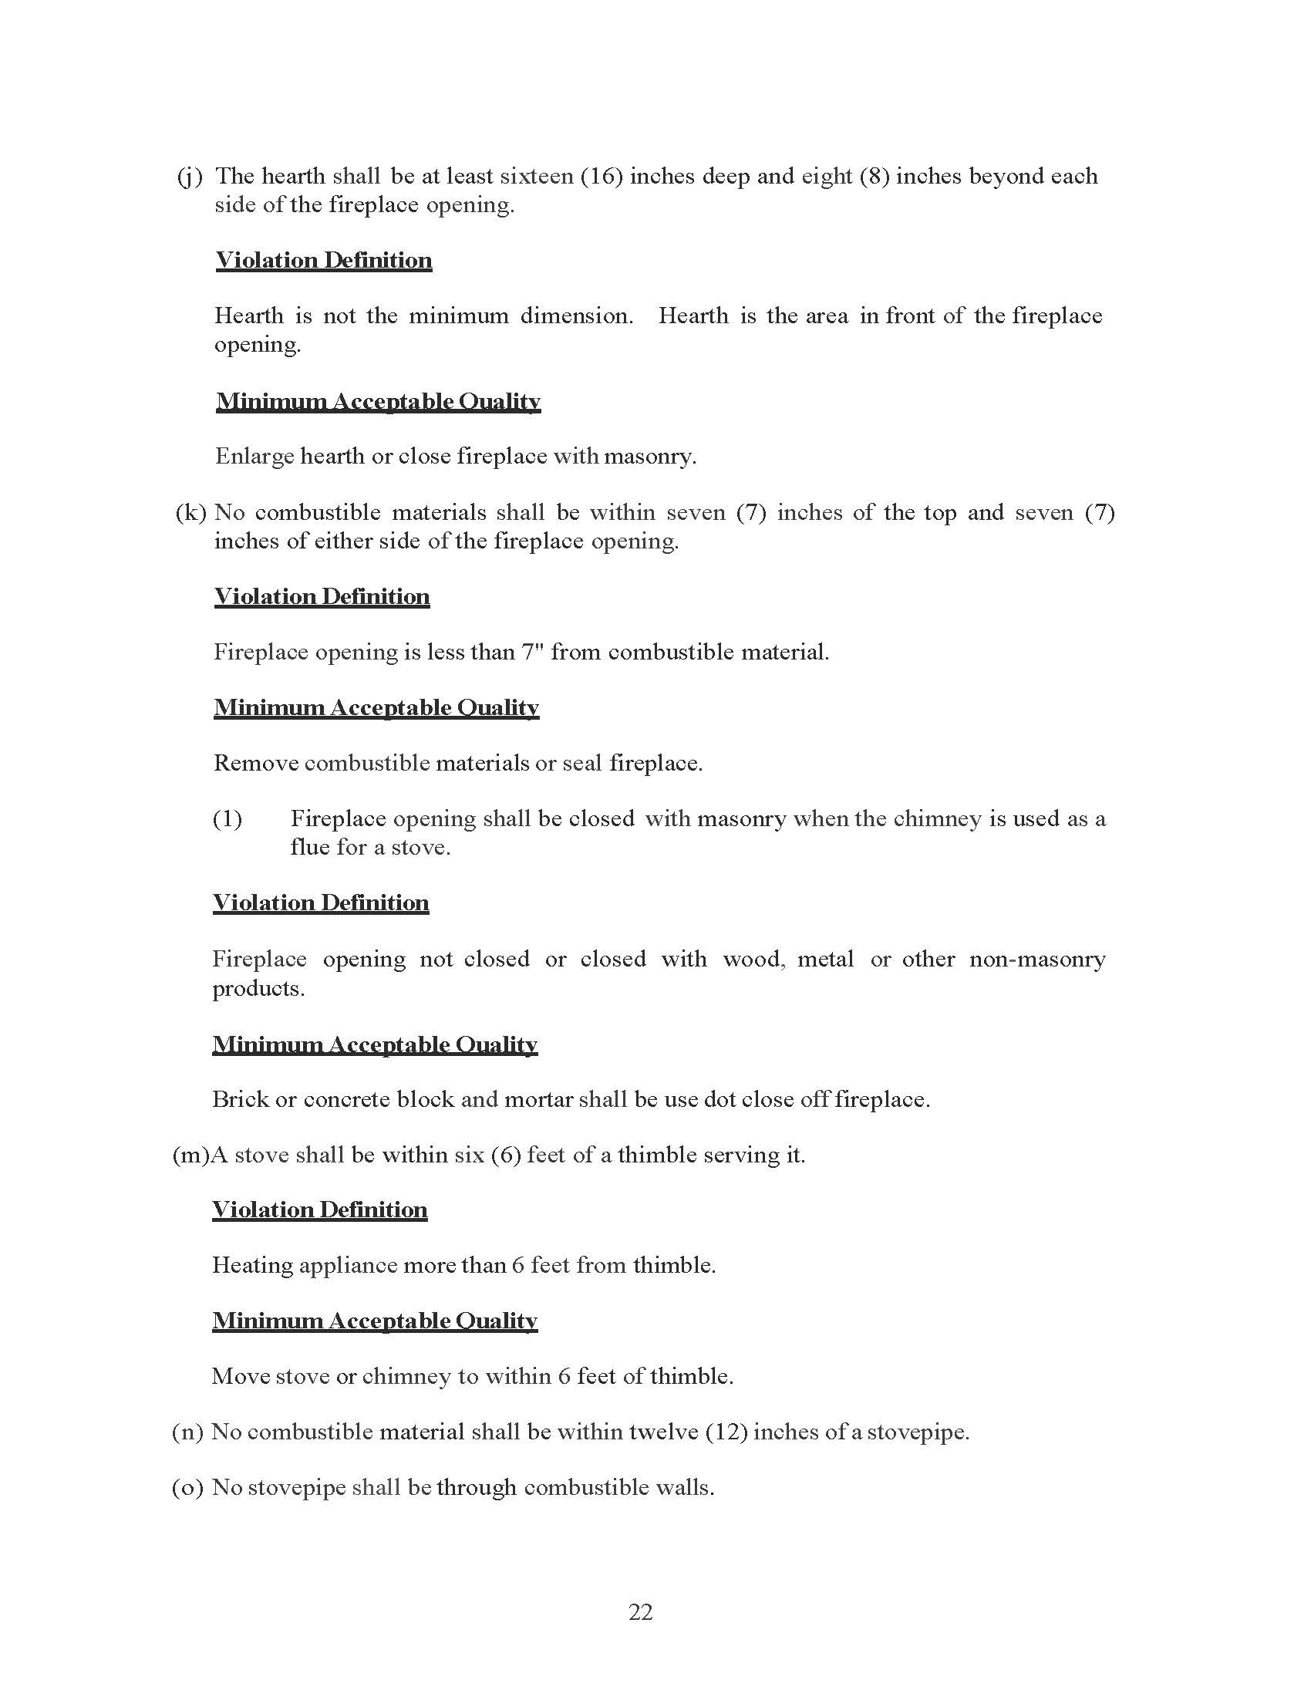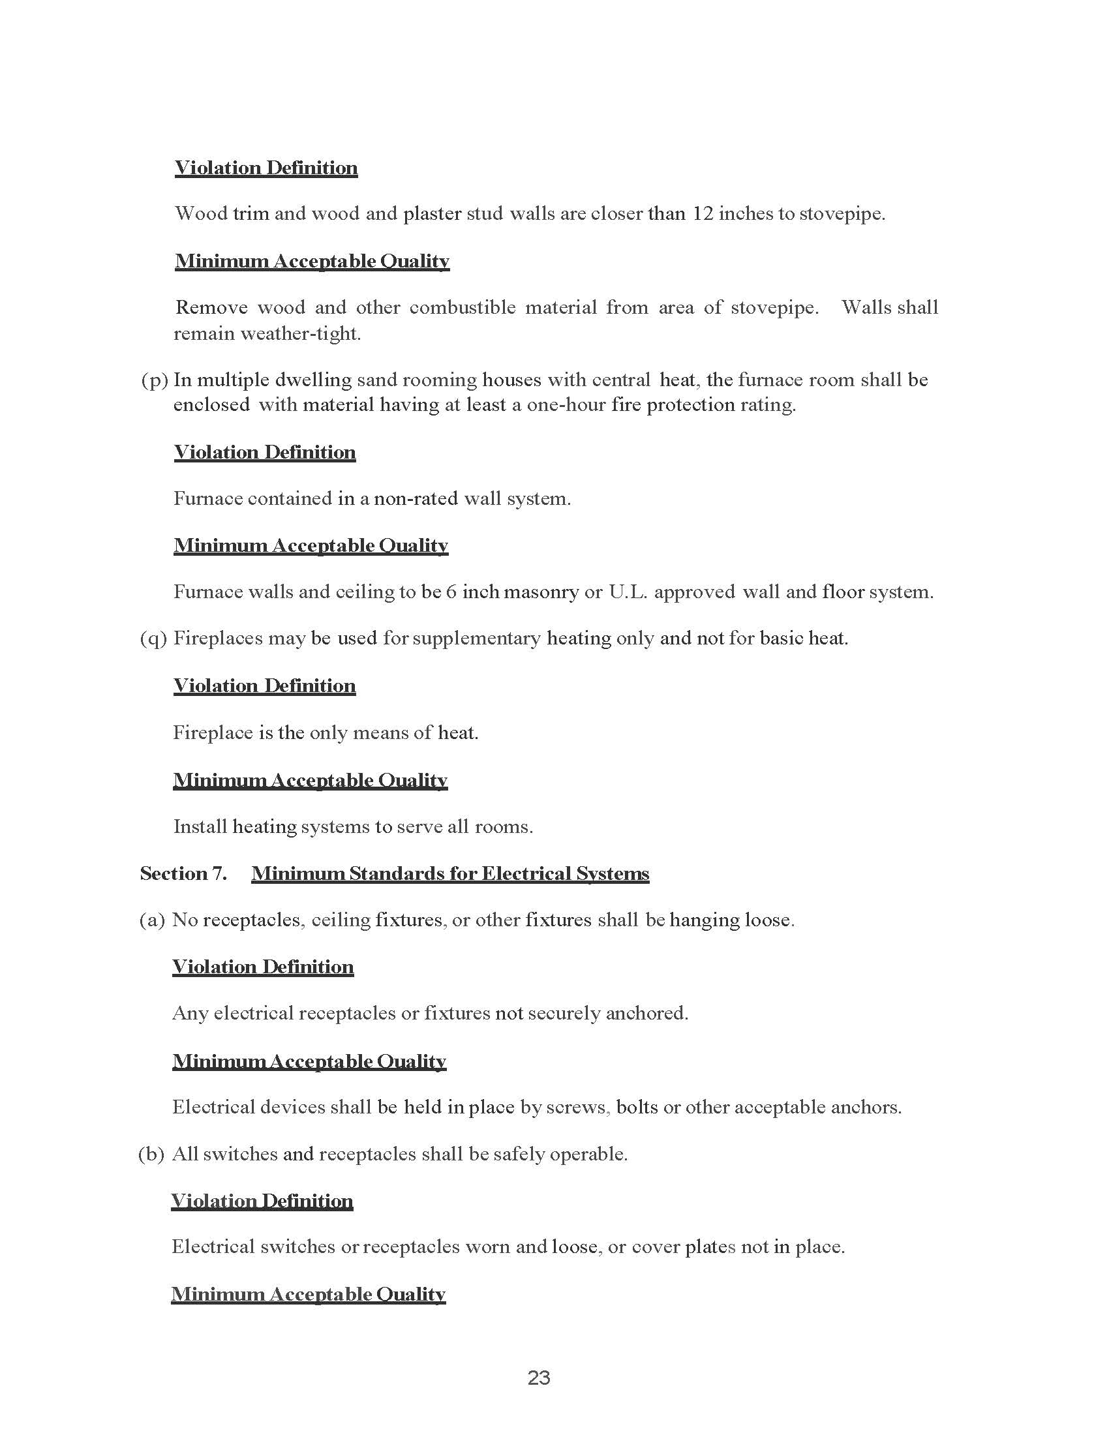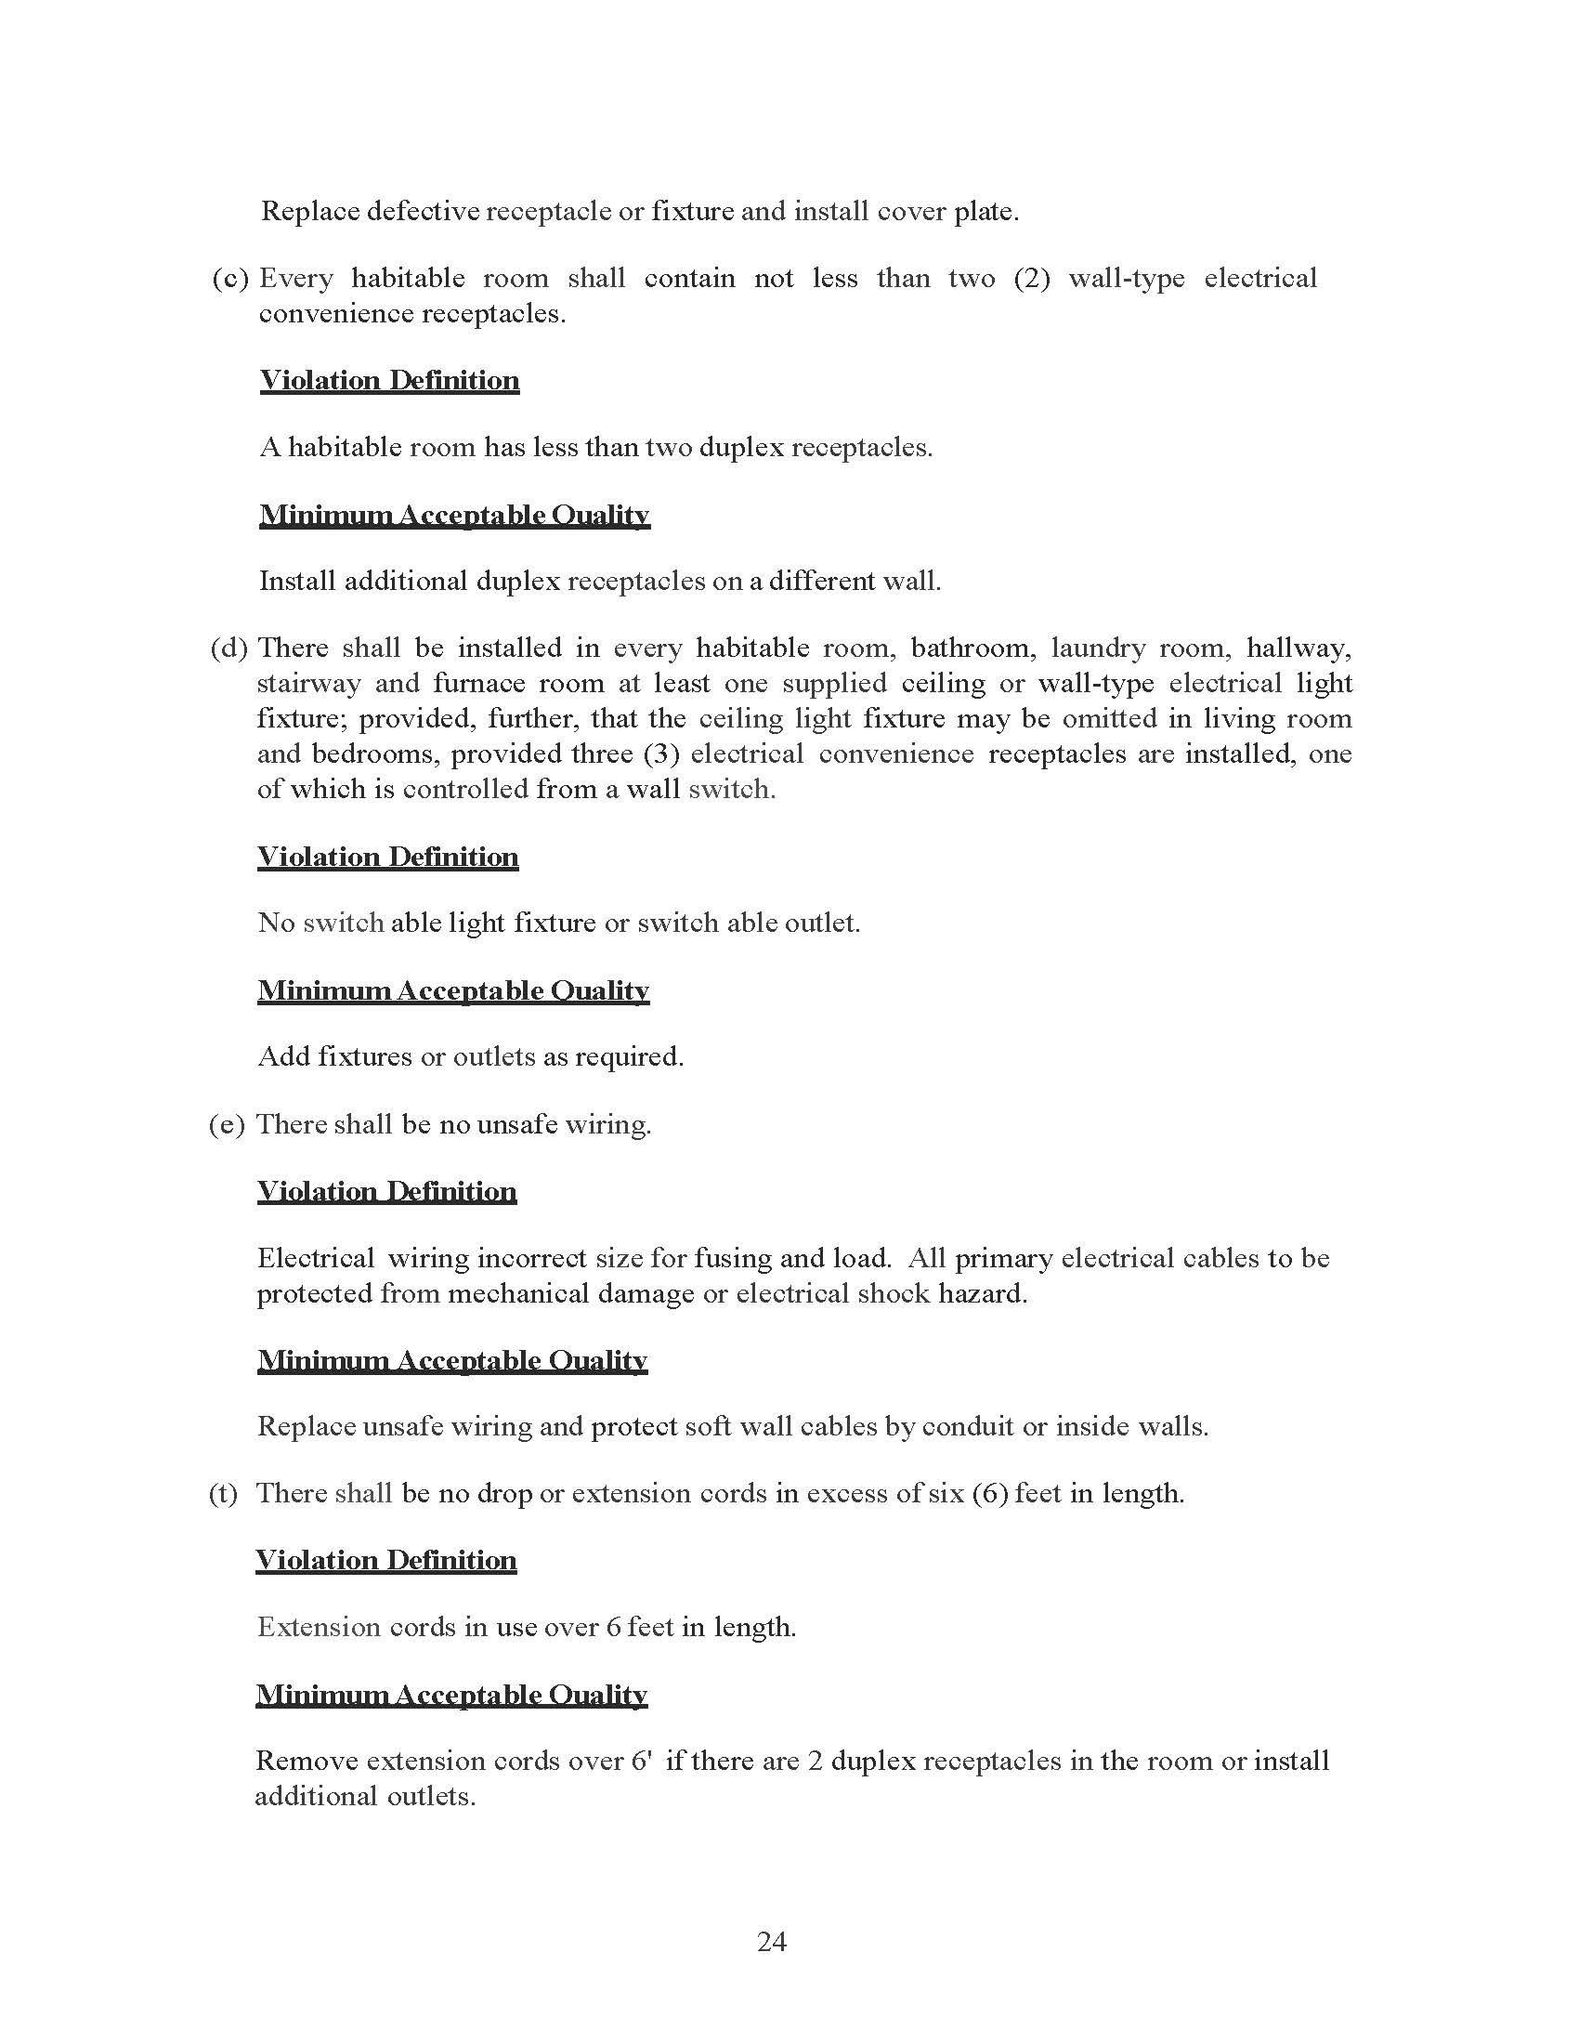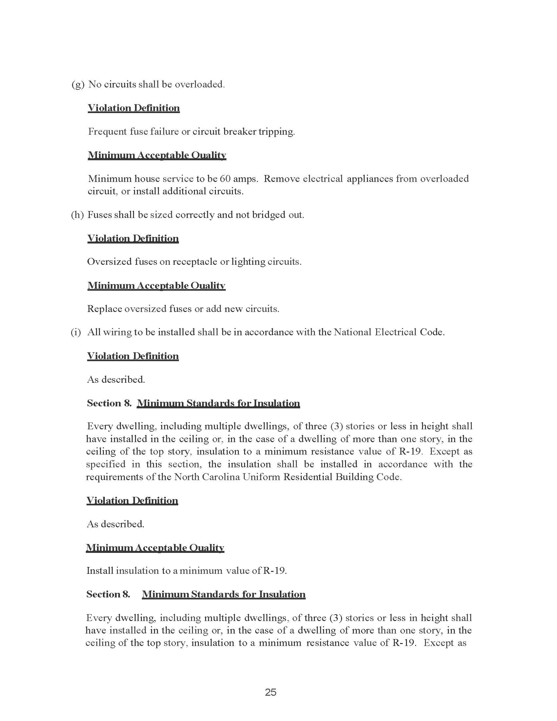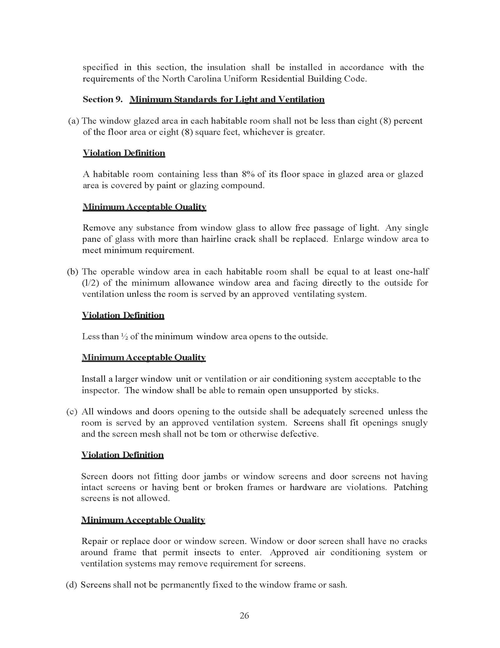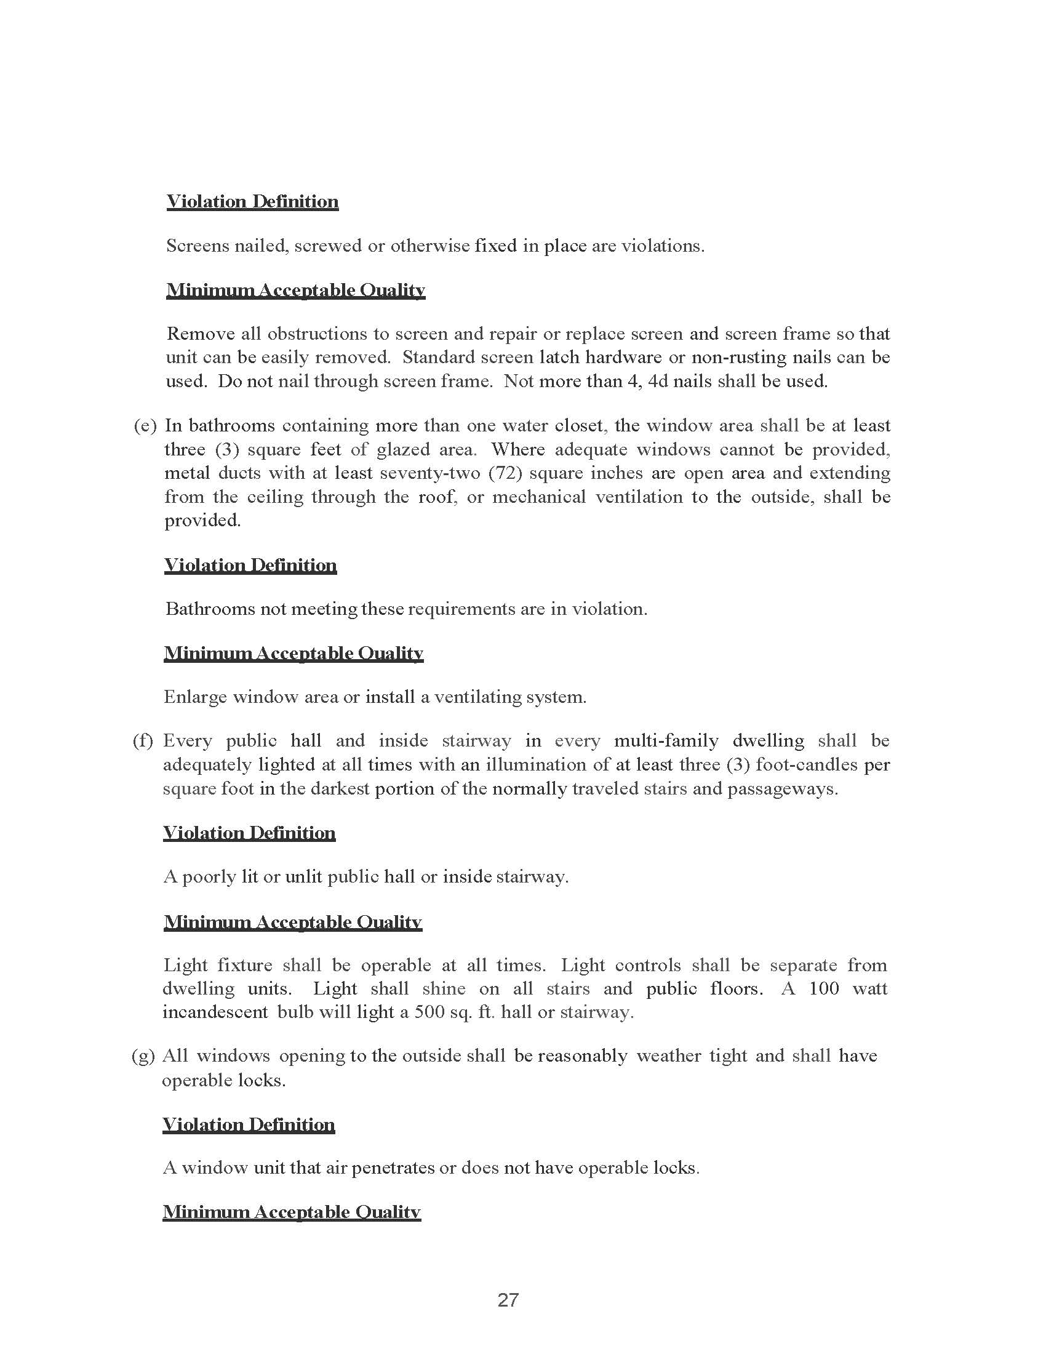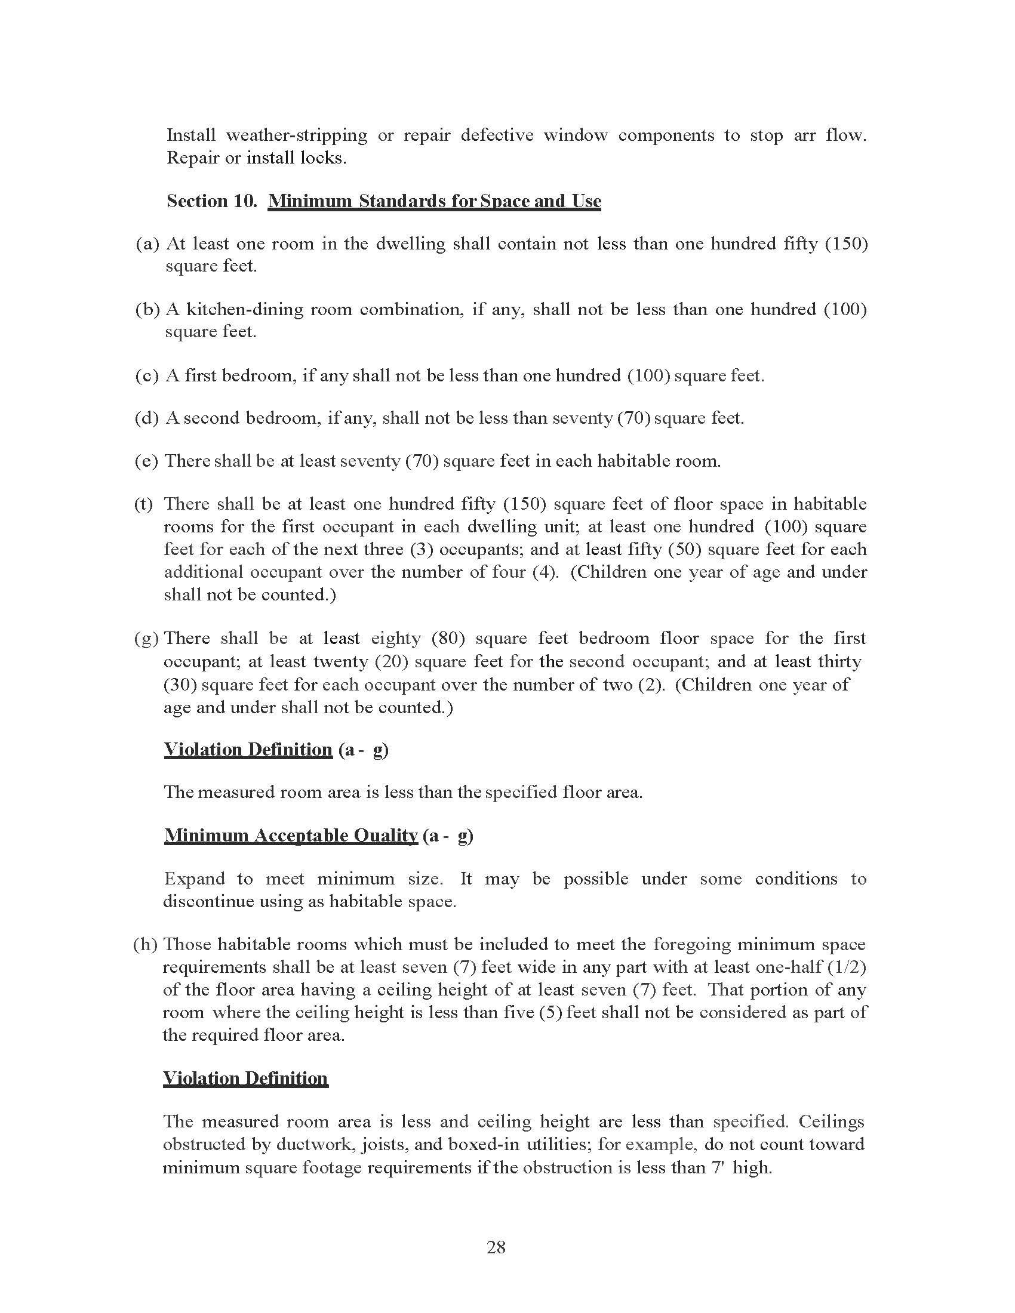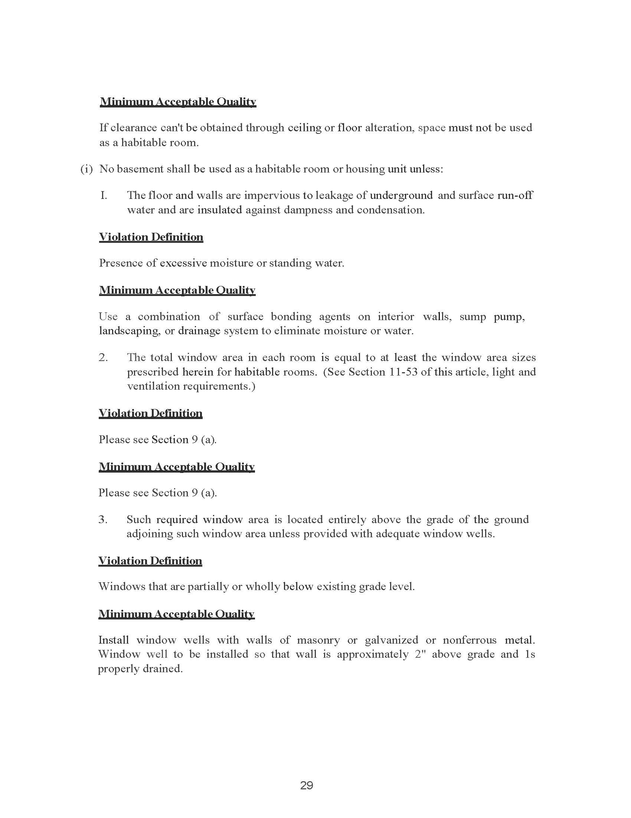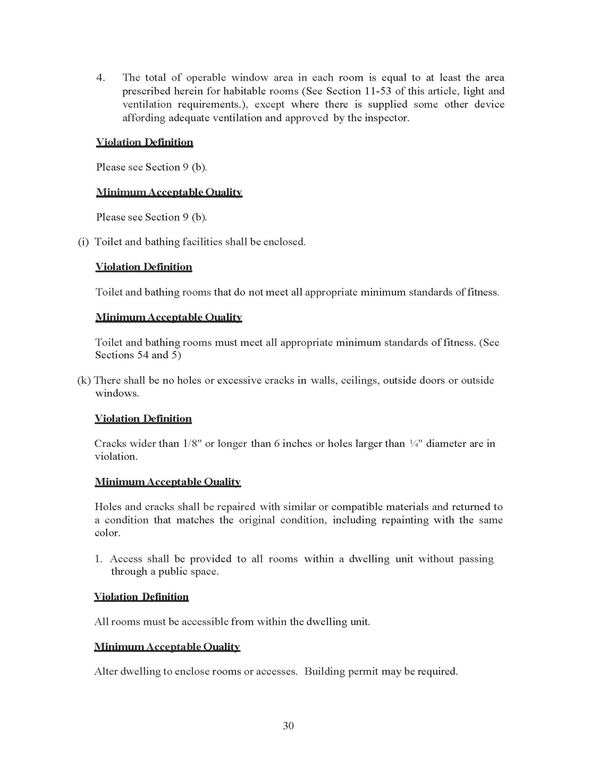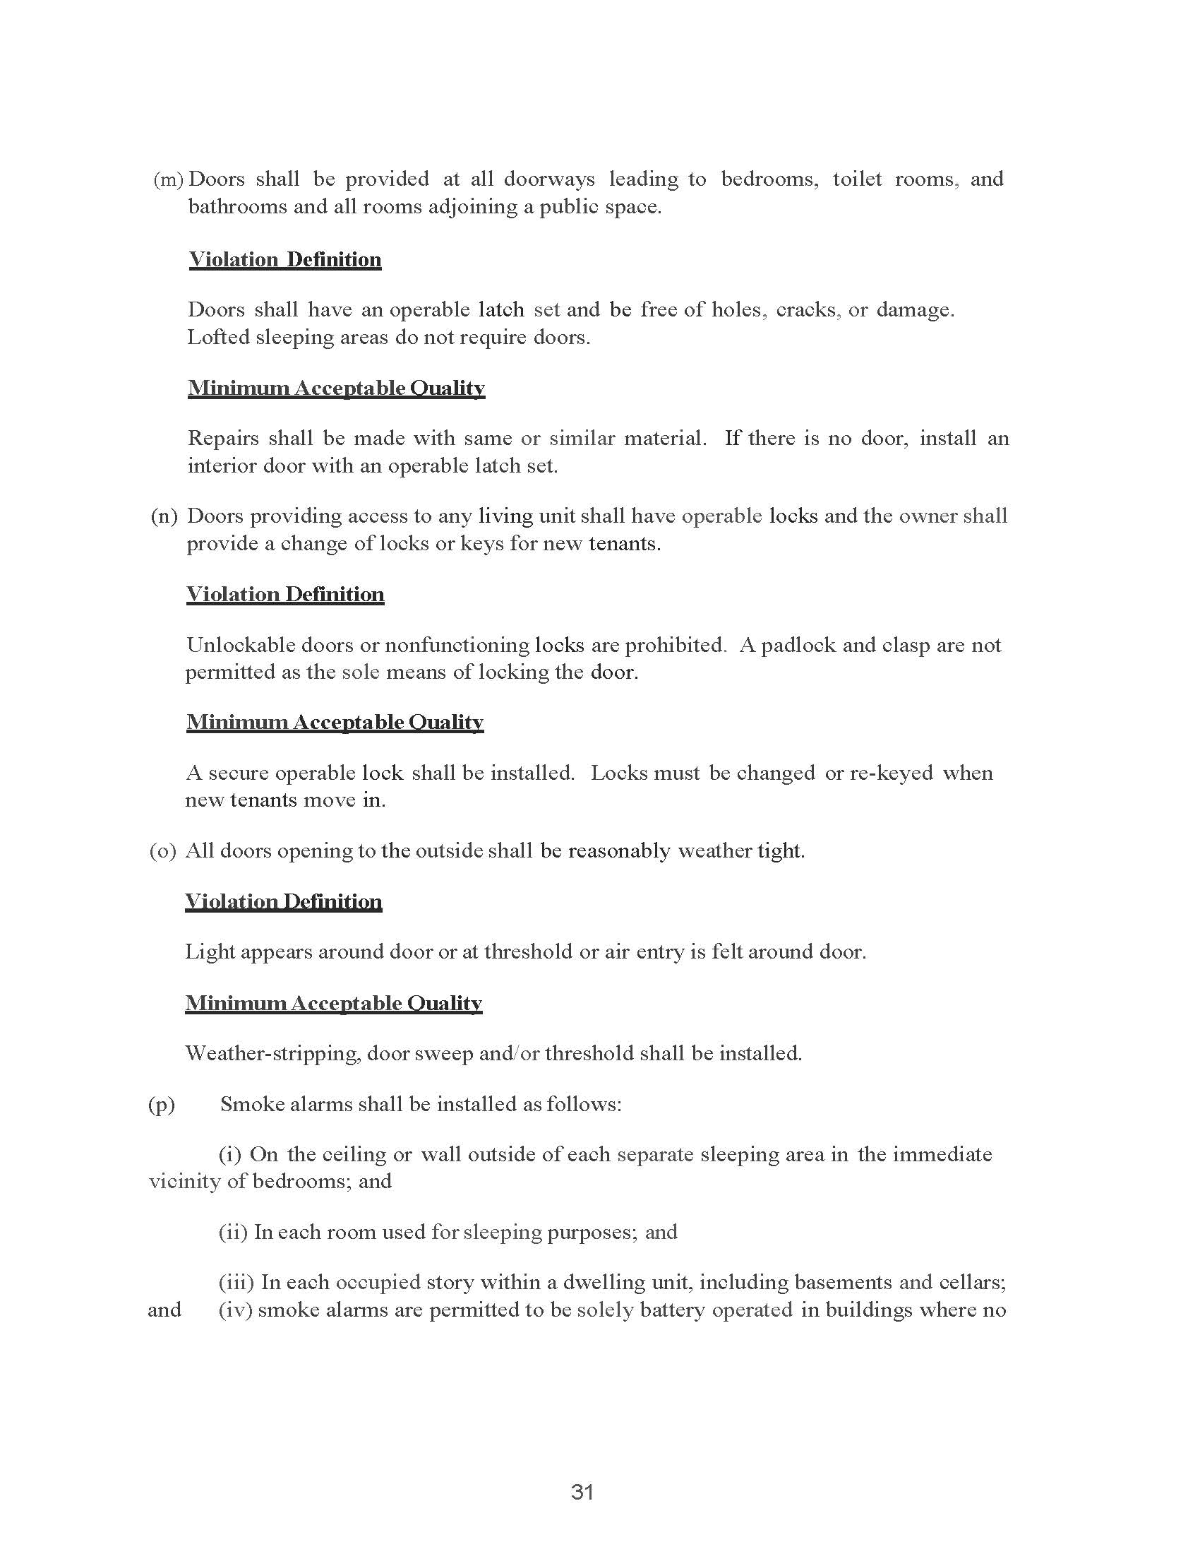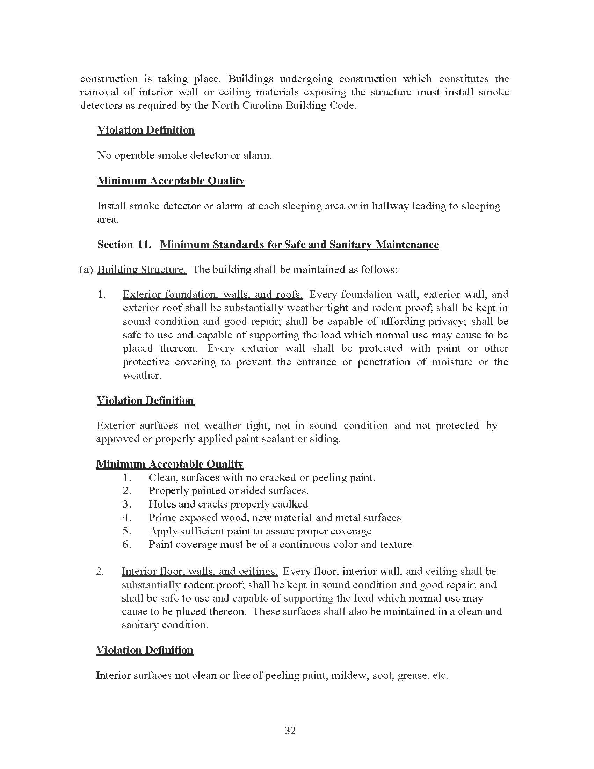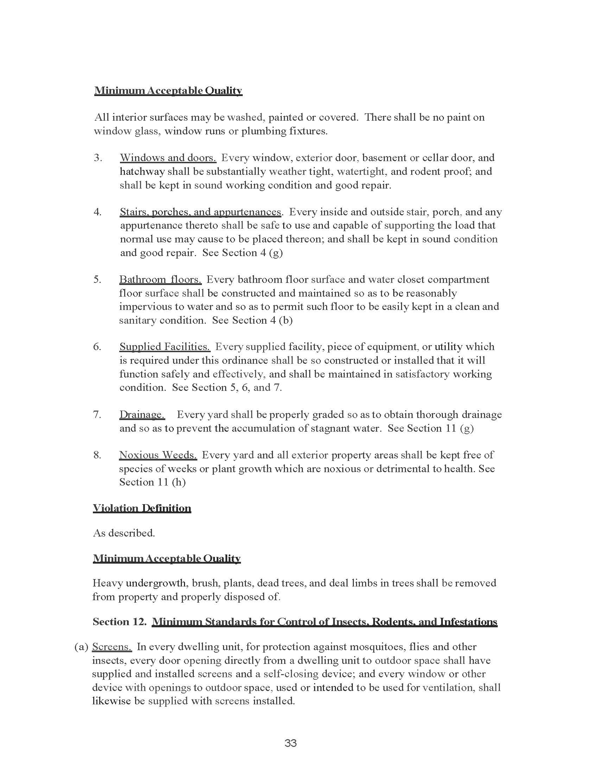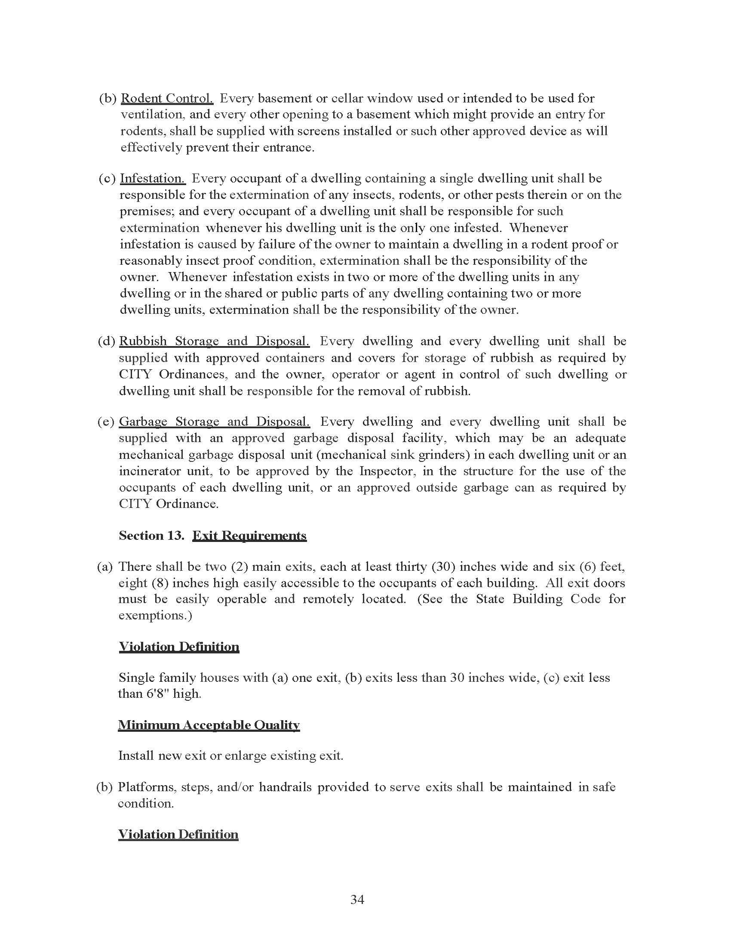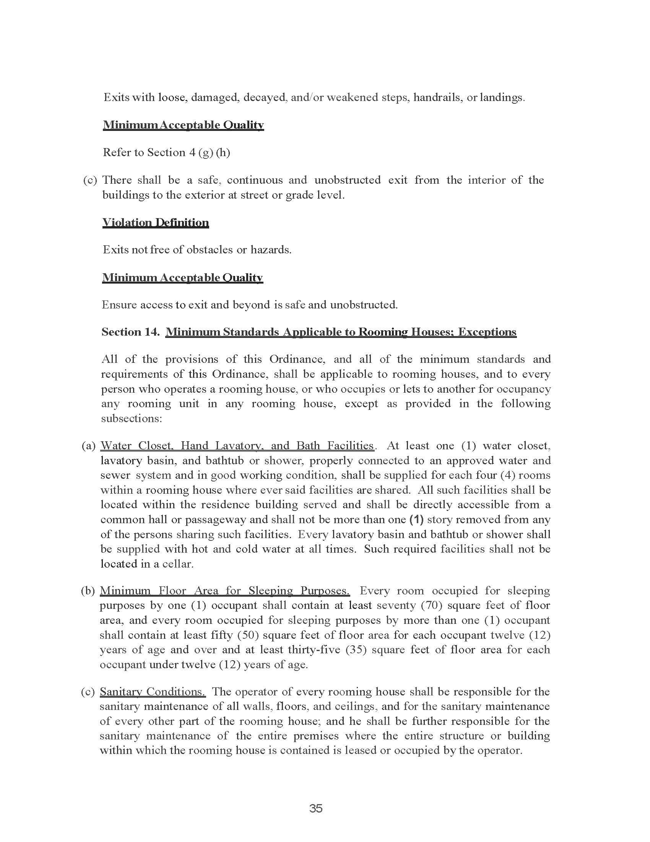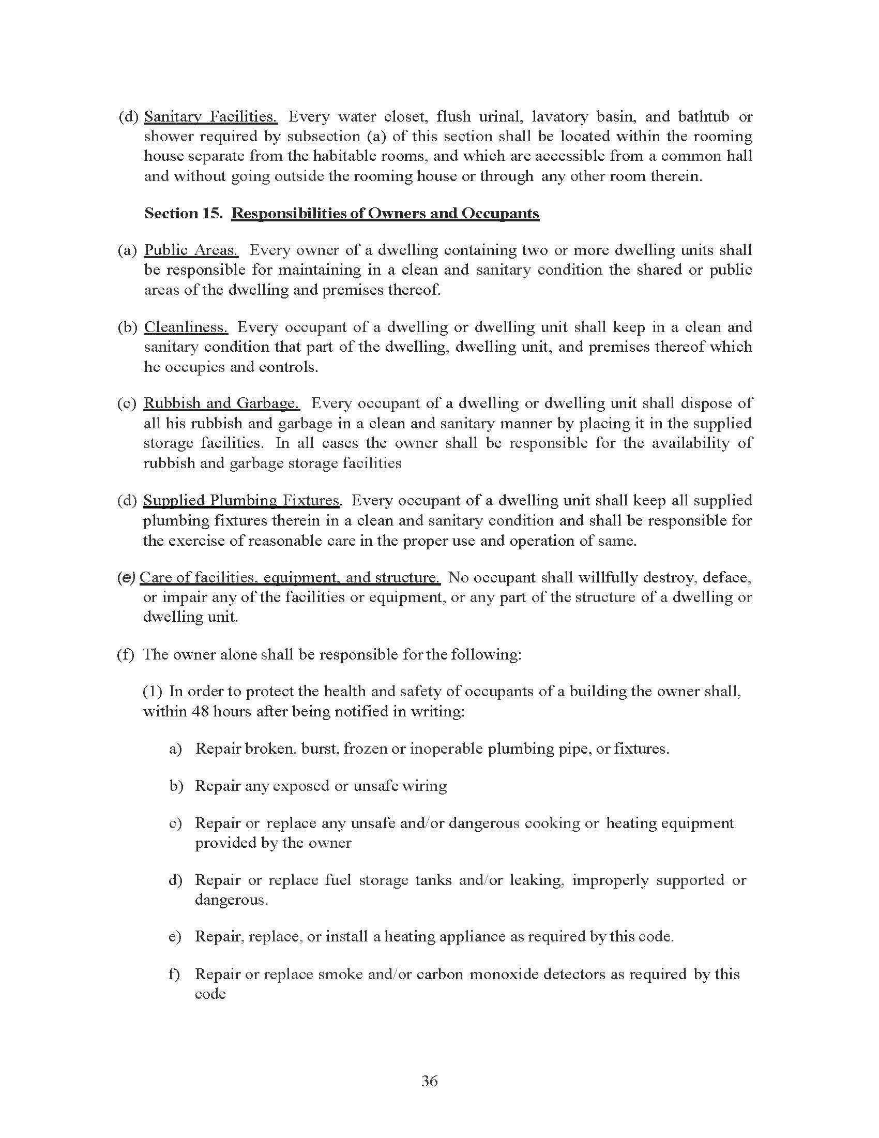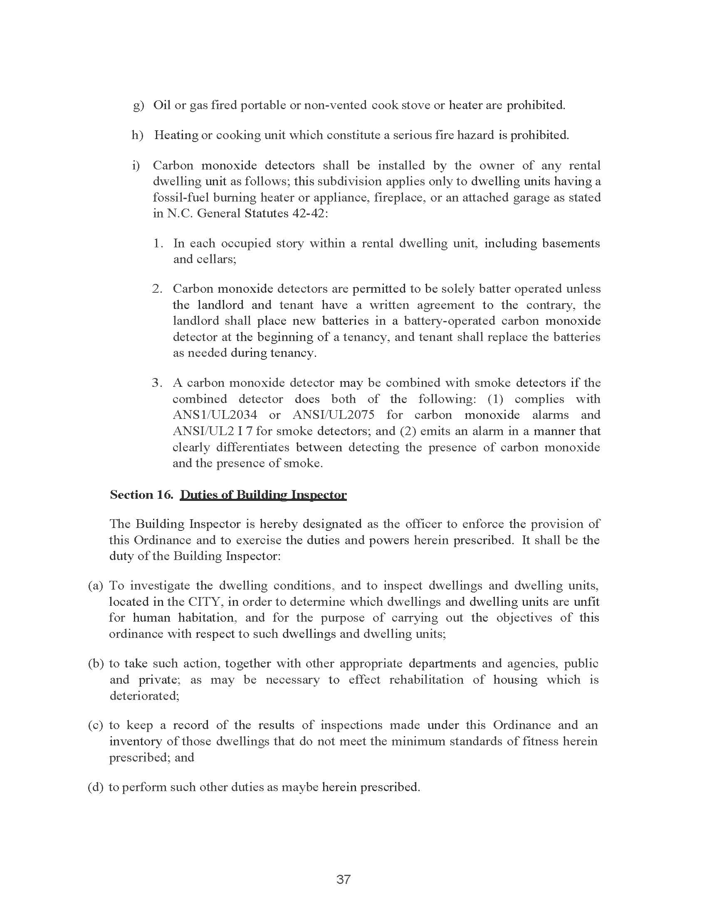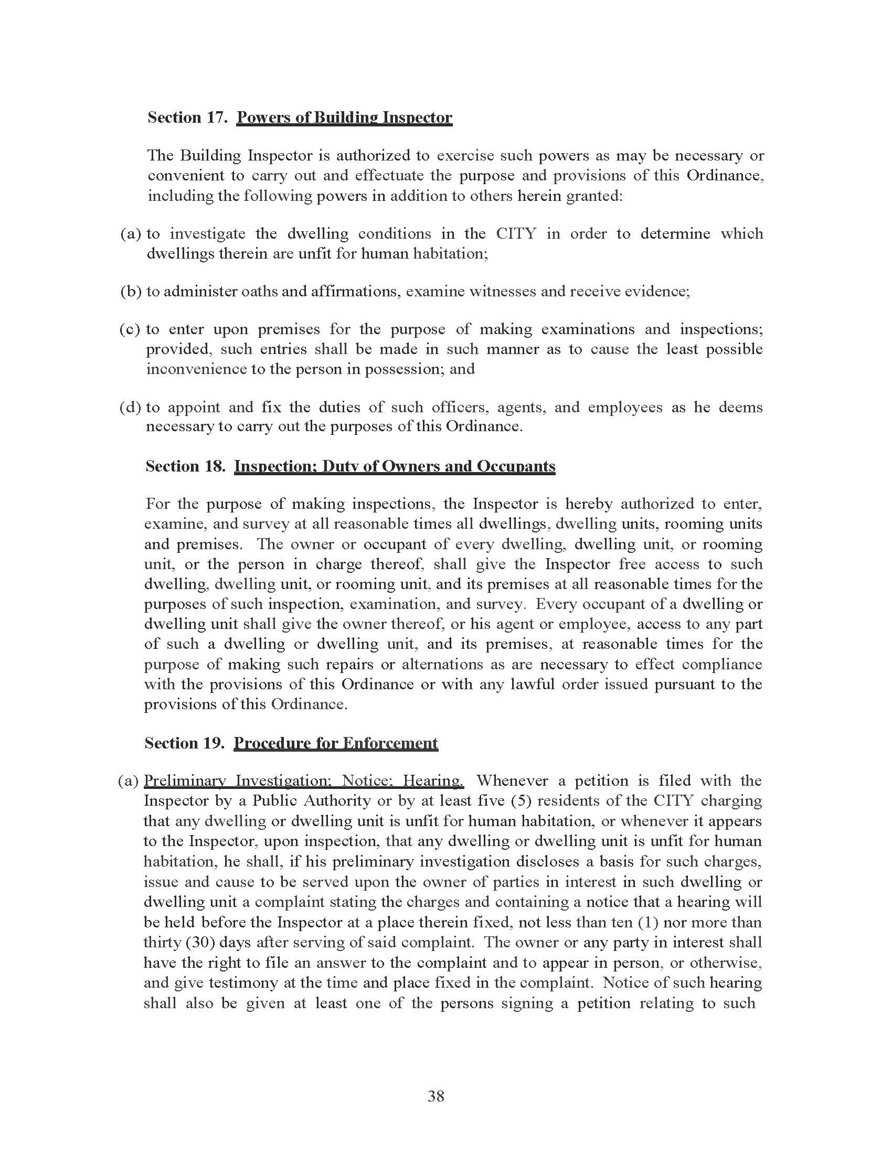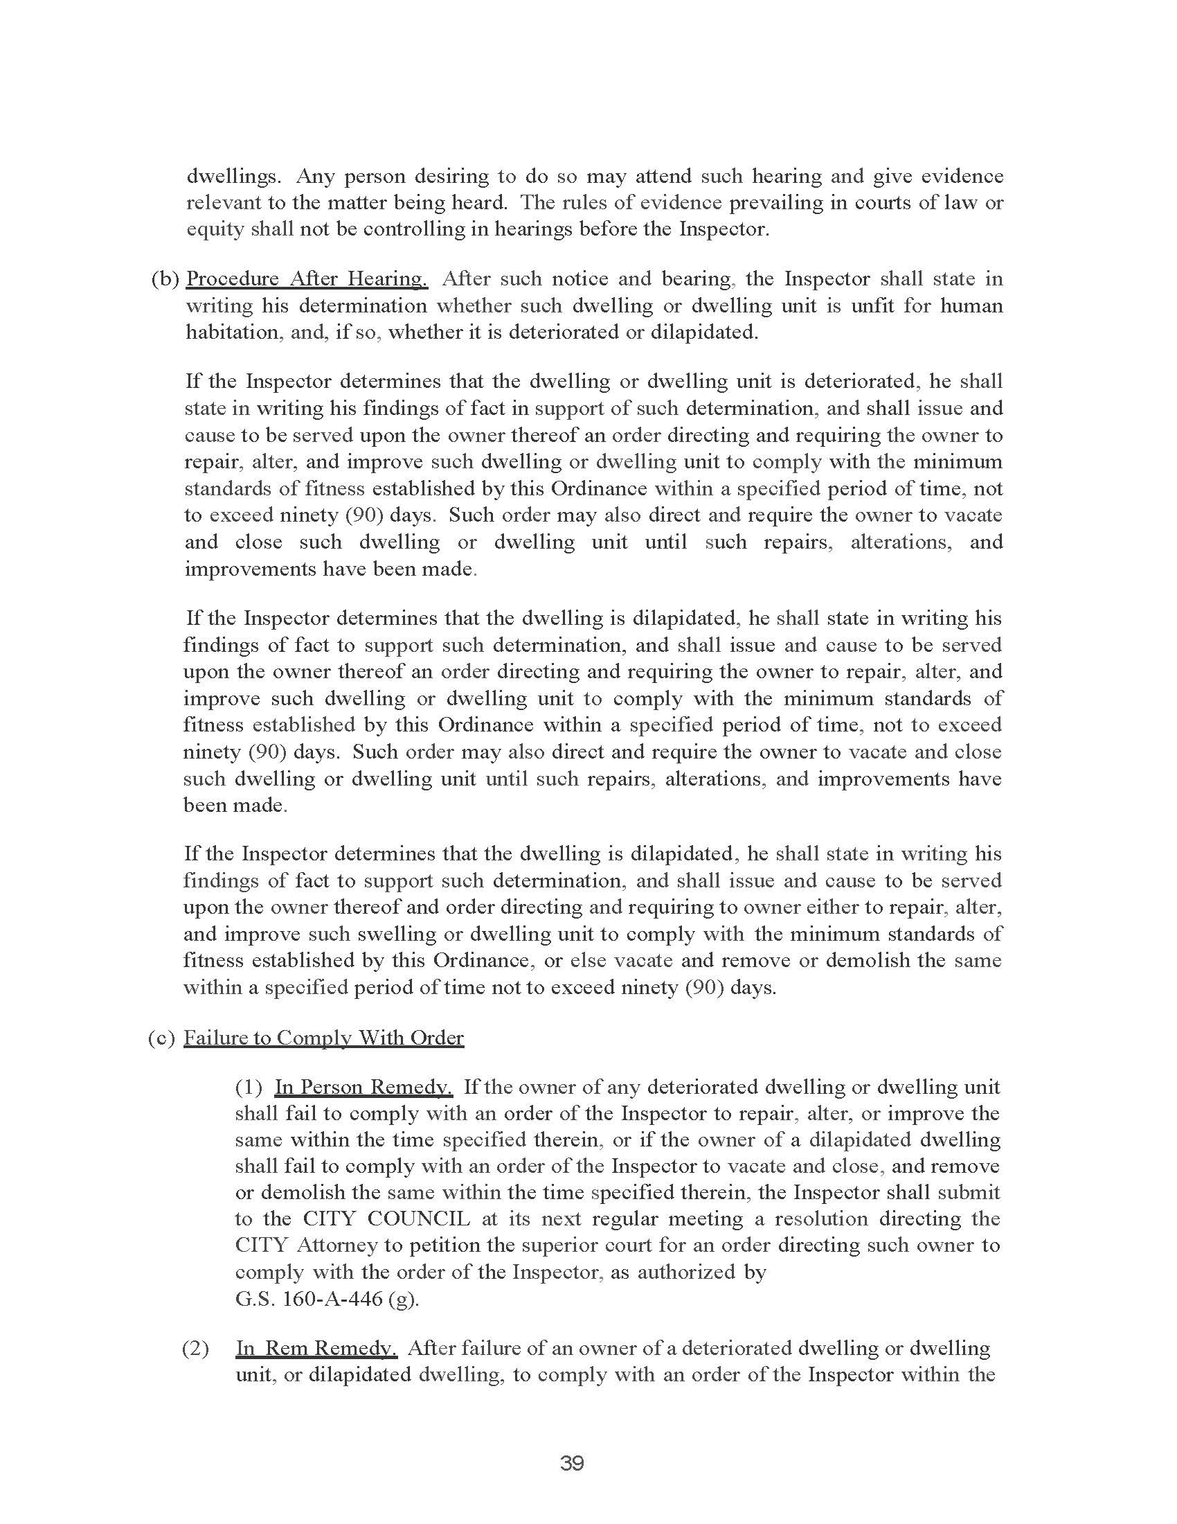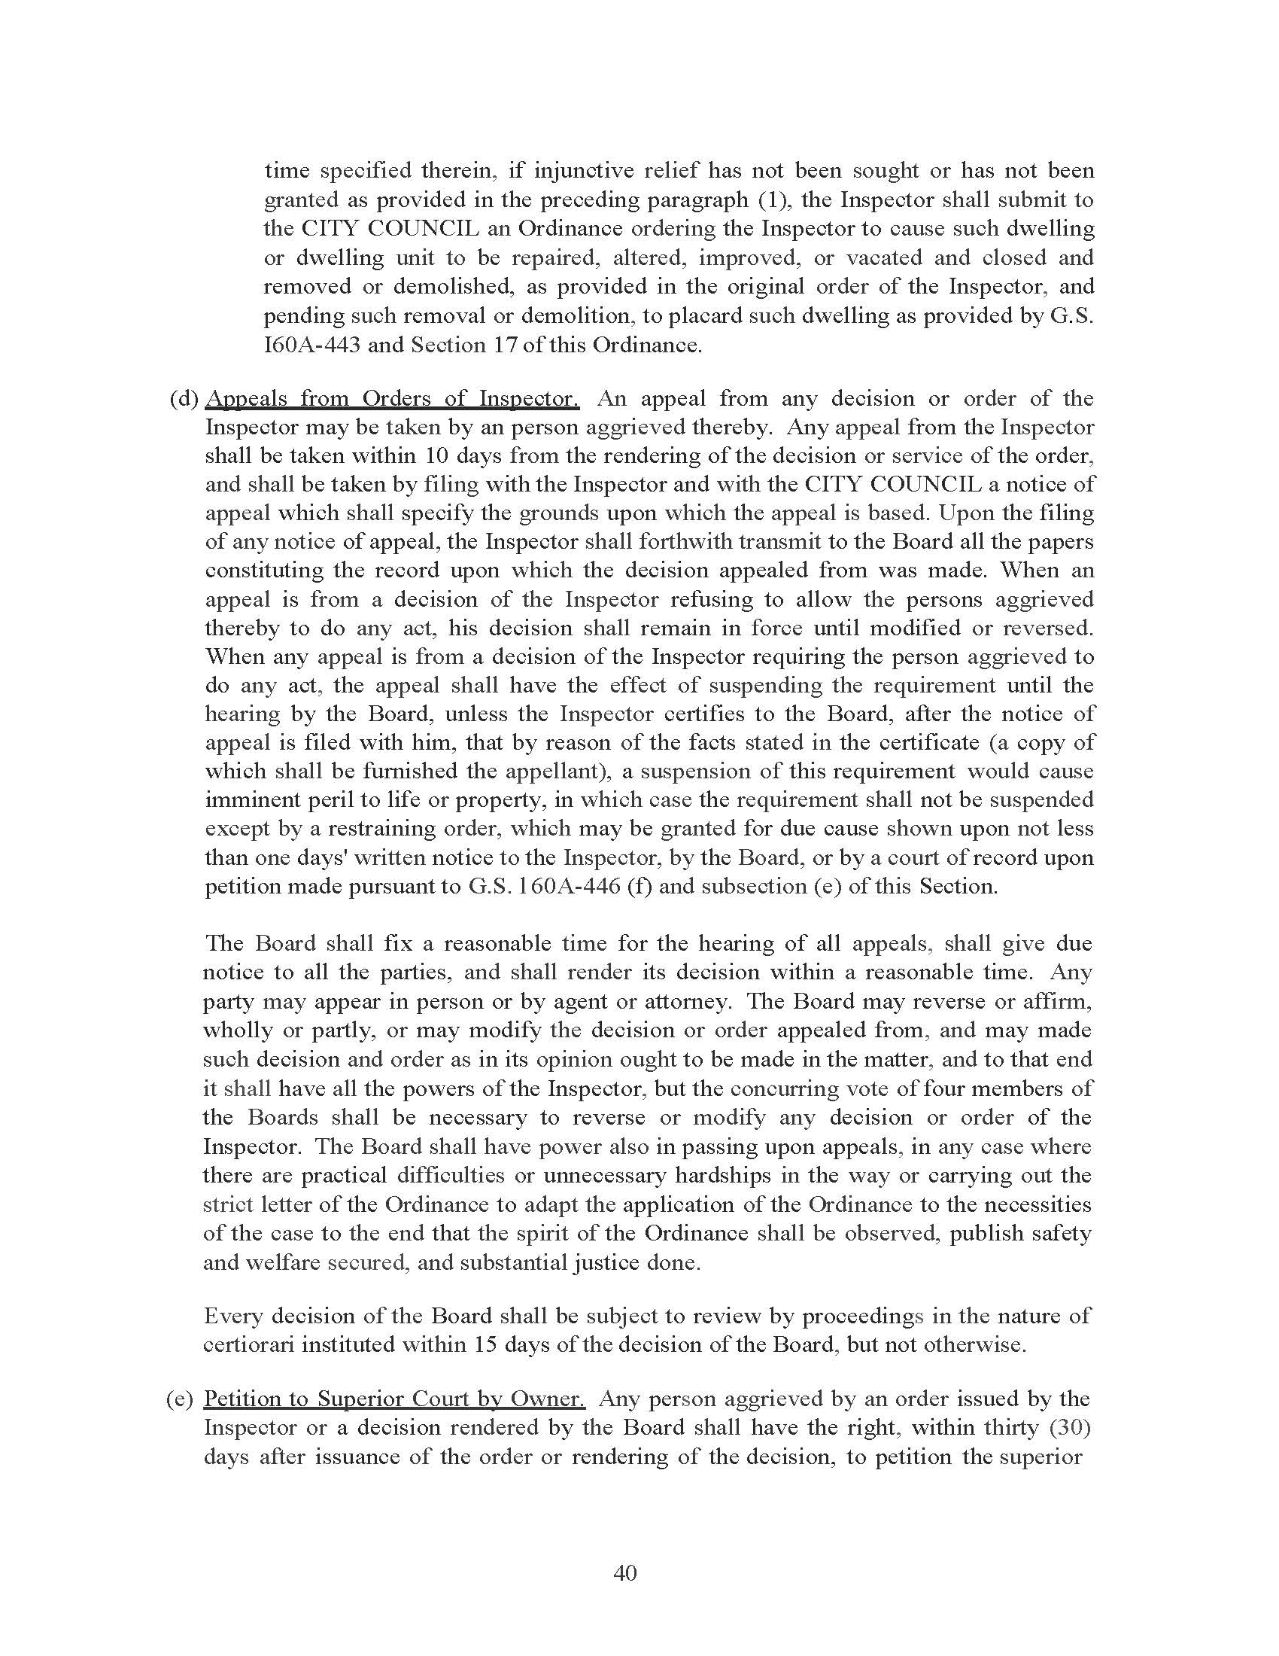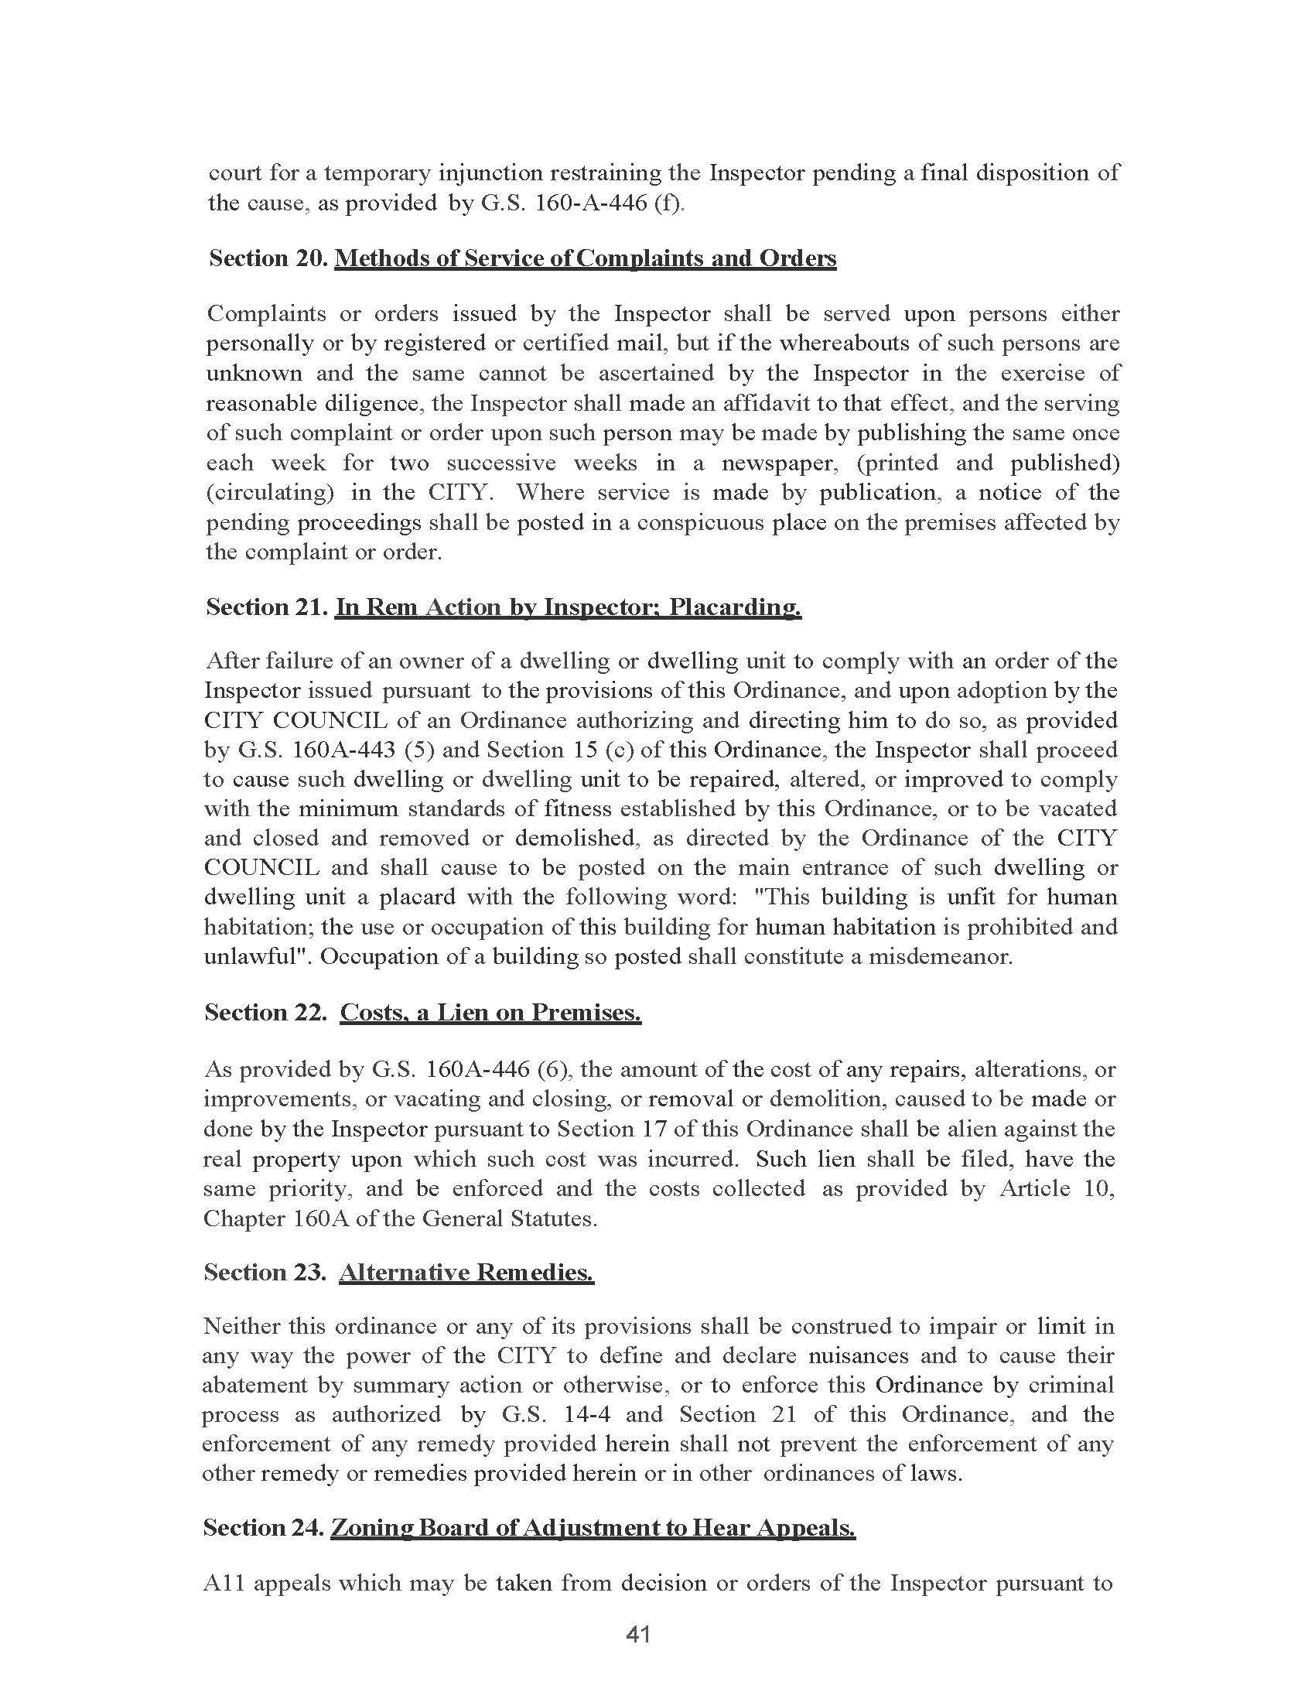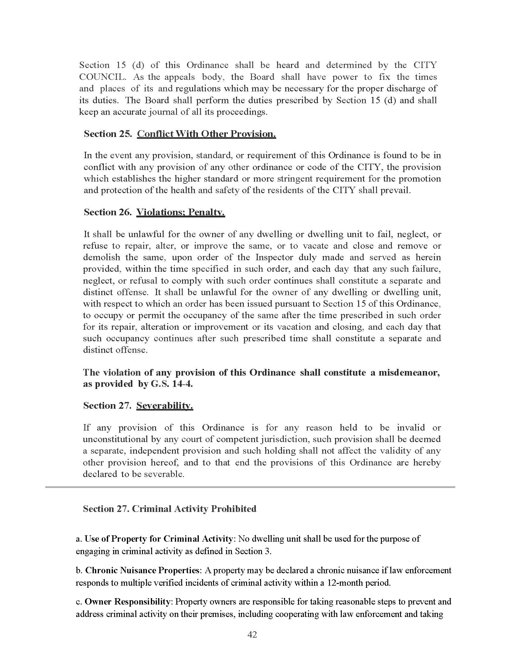

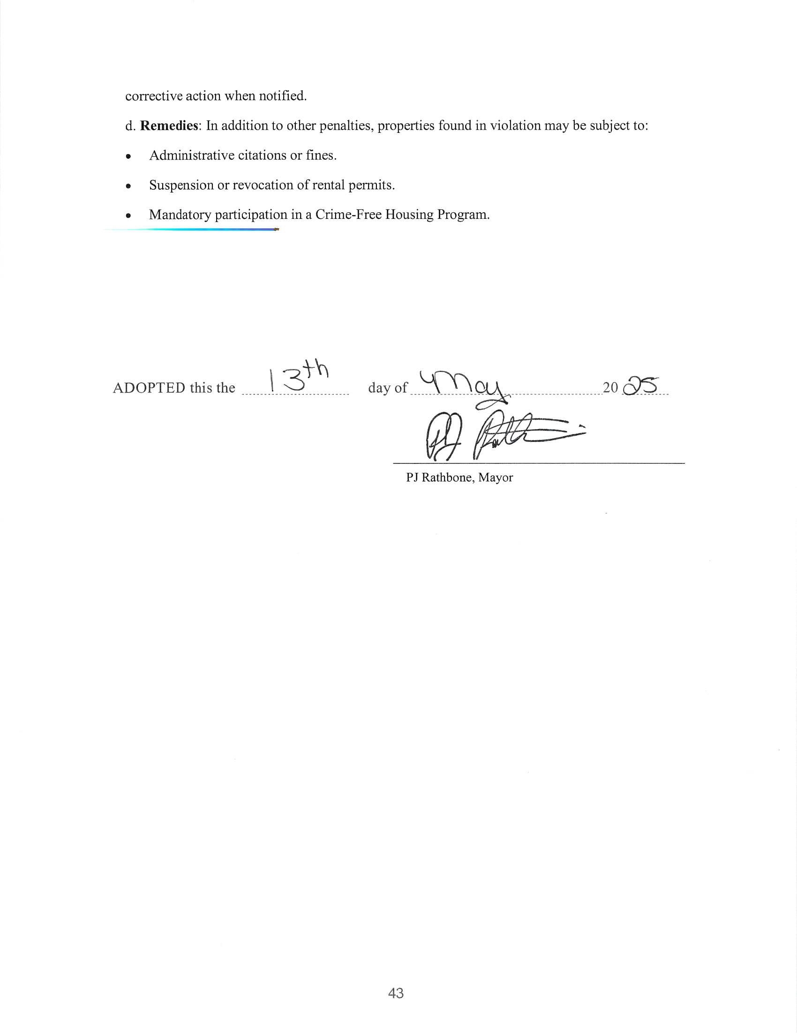

Discussion/Action: Mill Property Update
The council discussed the progress on the mill property project. Key points included:
- A cost estimate of approximately $70,000 for additional sampling and well installation.
- The need to decide whether to proceed with the project, given the potential for increasing costs.
- The possibility of seeking infrastructure funding to support the project.
- The suggestion to split the costs between budget years, potentially allocating $50,000 from the current budget if funds are available.
No immediate action was required, but the council agreed to continue exploring funding options and budget allocations.

Discussion/Action: Utility Billing Policy
The council discussed potential changes to the city's brush and bulk pickup policies. The main points of discussion were:
- Considering free brush pickup throughout the year.
- Implementing two free bulk pickup days annually, one in spring and one in fall.
- The current process of charging for brush pickup and its administrative challenges.
- The perception that other municipalities offer free brush pickup.
- The existing policy of providing curbside pickup twice a month for residents within city limits.
It was noted that these changes were already included in the utility policy. The council decided to approve the policy as presented.
A motion was made to approve the updated utility policy and was seconded by Member Bo Rhyne. The motion was carried with unanimous consent.
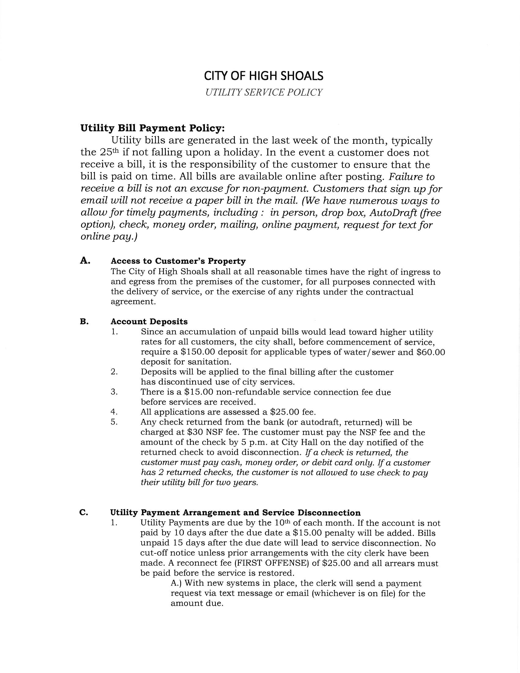
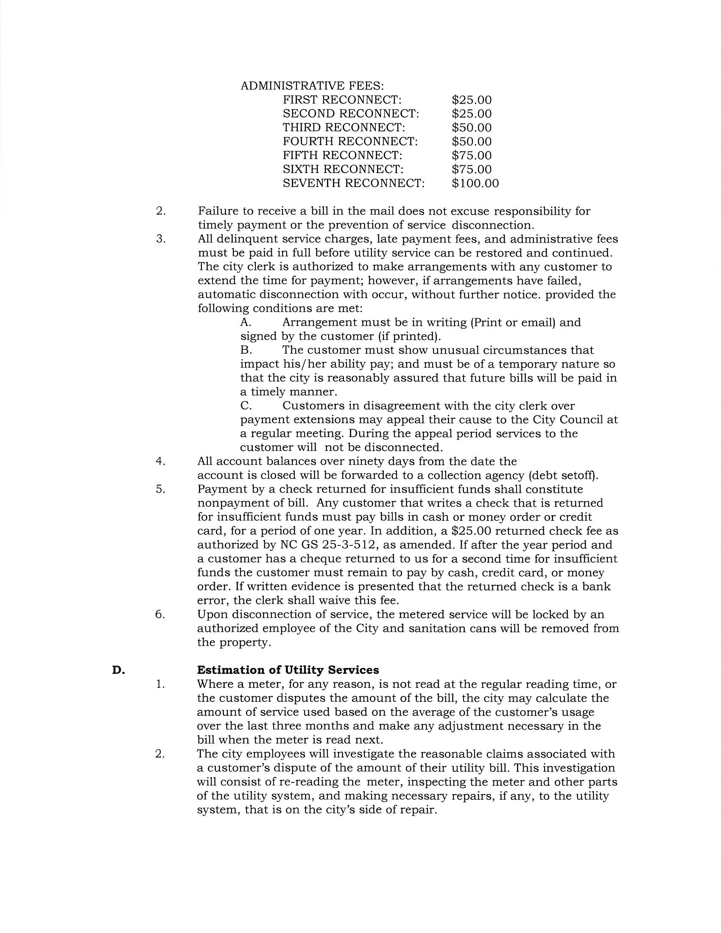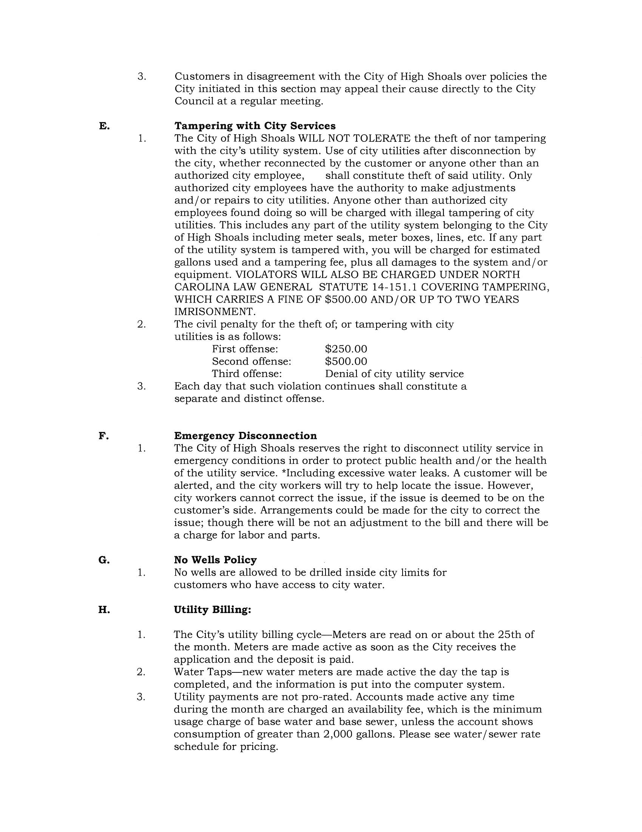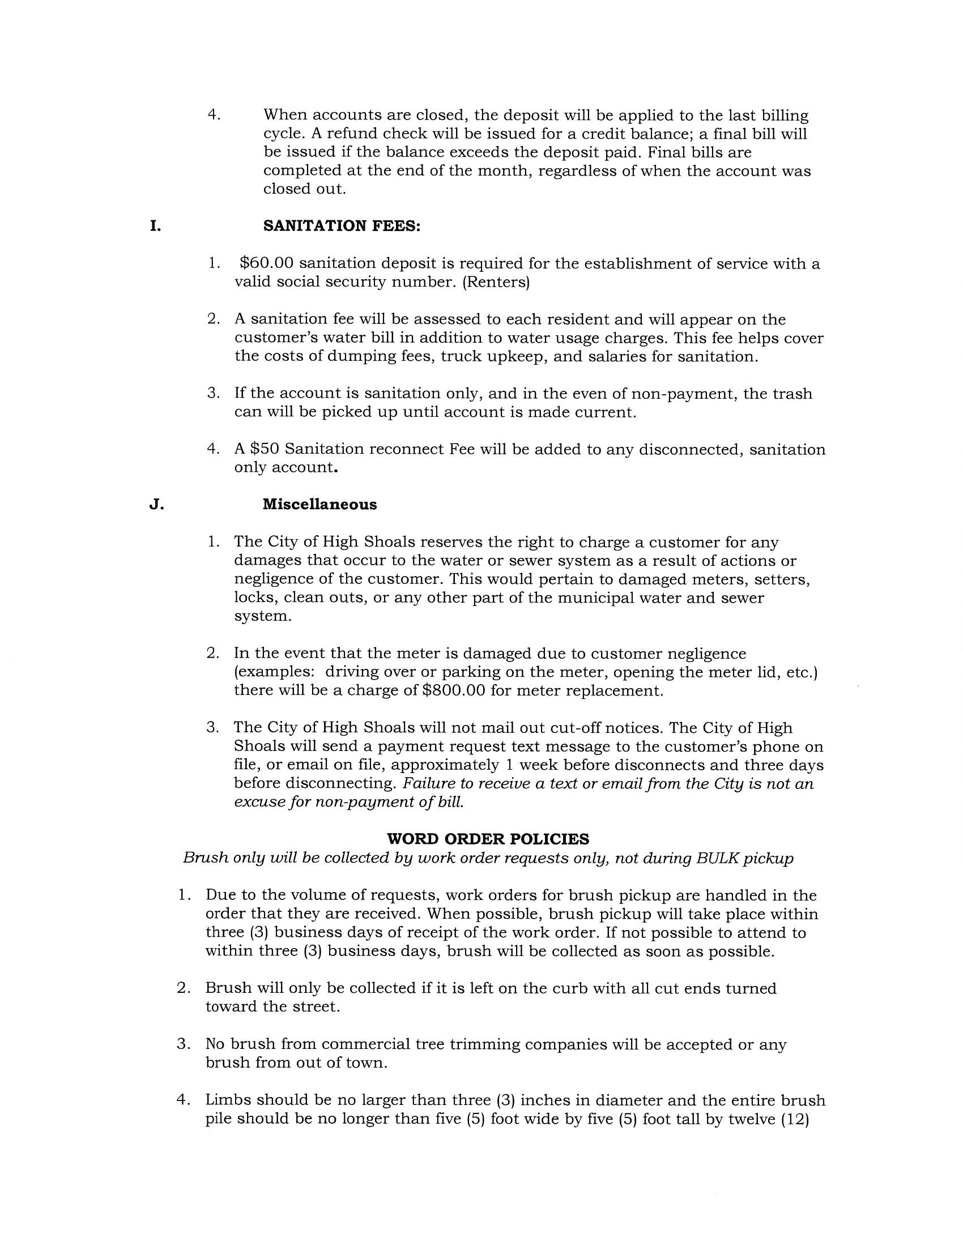

Discussion/Action: Budget Amendment FEMA
The council discussed a budget amendment for FEMA funds that were recouped.
Motion to approve the budget amendment for FEMA funds amounting to $76,685.66 was made by Council Member Dennis Cash and seconded by Council Member Bobby Vassey. The motion received unanimous approval.

Discussion/Action: Closed Session
Motion to enter a closed session under N.C. Gen. Stat. § 143-318.11(a)(6) was introduced by Council Member Dennis Cash and seconded by Council Member Bobby Vassey. The motion carried unanimously.
Motion to exit the closed session was proposed by Council Member Dennis Cash and seconded by Council Member Tim Eidson. The motion passed with unanimous approval.

Action: Motion to Adjourn
A motion to adjourn was put forward by Denese Cook and seconded by Dennis Cash, receiving unanimous consent from those present.

