City of High Shoals
Regular Council Meeting
April 8, 2025
- Call to Order
  - Dennis Cash has called the meeting to order at 6:30 p.m. In attendance there are the following members: Tim Eidson, Bobby Vassey, Dennis Cash, Kathy Rhyne, and Bo Rhyne. PJ Rathbone and Denese Cook were excused, absent.
- Invocation
- Pledge of Allegiance
- Approval of Agenda: Motion to approve the agenda made by Kathy Rhyne, seconded by Bobby Vassey. All in favor.
- Approval of Minutes: Motion to approve the minutes for March 11th made by Kathy Rhyne, seconded by Tim Eidson, all in favor.
Citizens’ comments/concerns: The City of High Shoals Council offers citizens the opportunity for Public Expression issues per NCGS 160A-81.1 (limited to 3-5 minutes per speaker).
Good of the Order: This is a time set aside for members to offer comments or observations (without formal motion) about the organization and its work. The good of the order is also the time to offer resolution to bring disciplinary charges against a member for the offenses committed outside a meeting.

- Departmental Reports:
- Police Report-Gaston County
- Financial-Dennis Cash
    - Checking 1: $312,006.84
    - Checking 2: $11,123.227
    - Savings: $161,200.39
    - Cap Mgmt: $50,526.09
    - Total: $534,856.59
- Cemetery-Denese Cook
    - Nothing
- Water/Sewer-Bo Rhyne
    - North Street has a leak, Tim is going to fix.
- Streets/Maintenance/Sanitation-Kathy Rhyne
  - Kathy said she’s not aware of anything not being fine.
  - Parks/Recreation-Bobby Vassey
    - Yard of the Month:– 231 River St
      - Anakarys Rivera
        - Easter Egg Hunt April 19th 11am-1pm
        - Concert in the Park May 24th (1 band, 1 food vendor)
- Vehicles- Tim Eidson
    - Oil changes & tire rotations on both new vehicles
- Administration/Mayor Report-PJ Rathbone

- New Business:
- Discussion/Action: Gaston County Tax Collection Interlocal Agreement (Updated)
  - Motion to accept the interlocal agreement made by Tim Eidson, seconded by Bo Rhyne. All in favor.
- Discussion/Action: NCDOT Drug/Alcohol Policy & Resolution
  - This is required by Federal Law
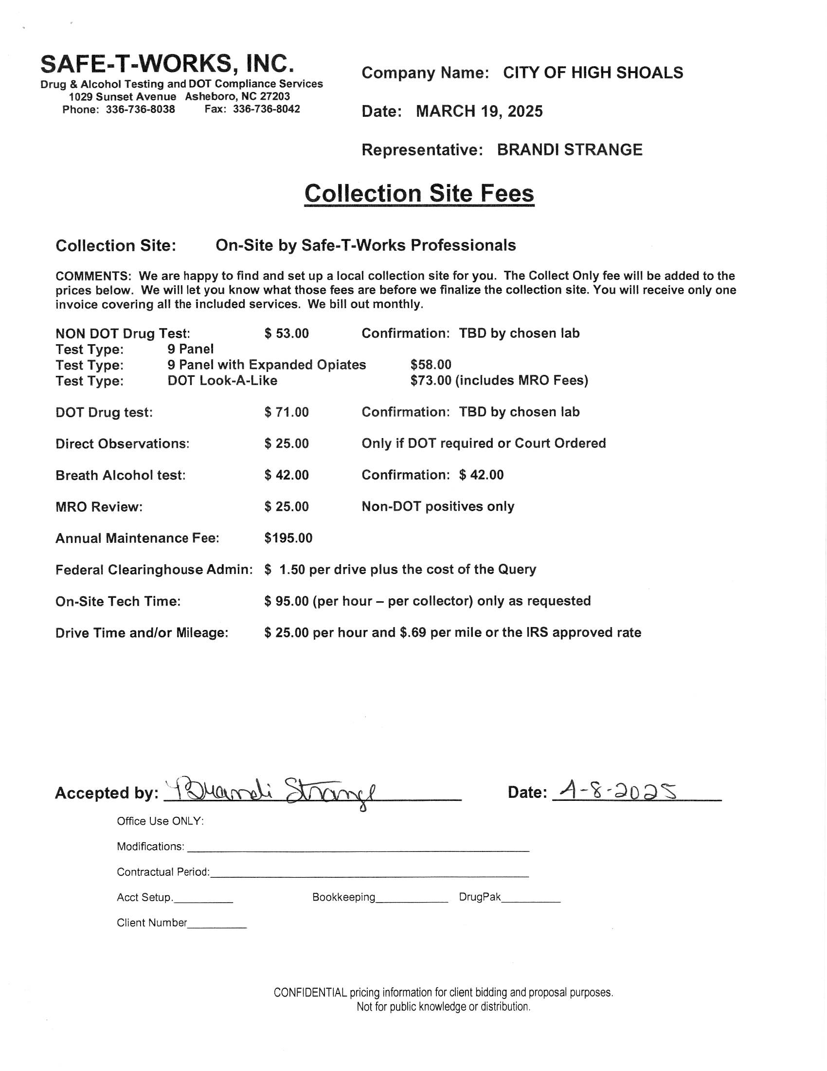
  - Motion to approve made by Bo Rhyne, seconded by Tim Eidson. All in favor.
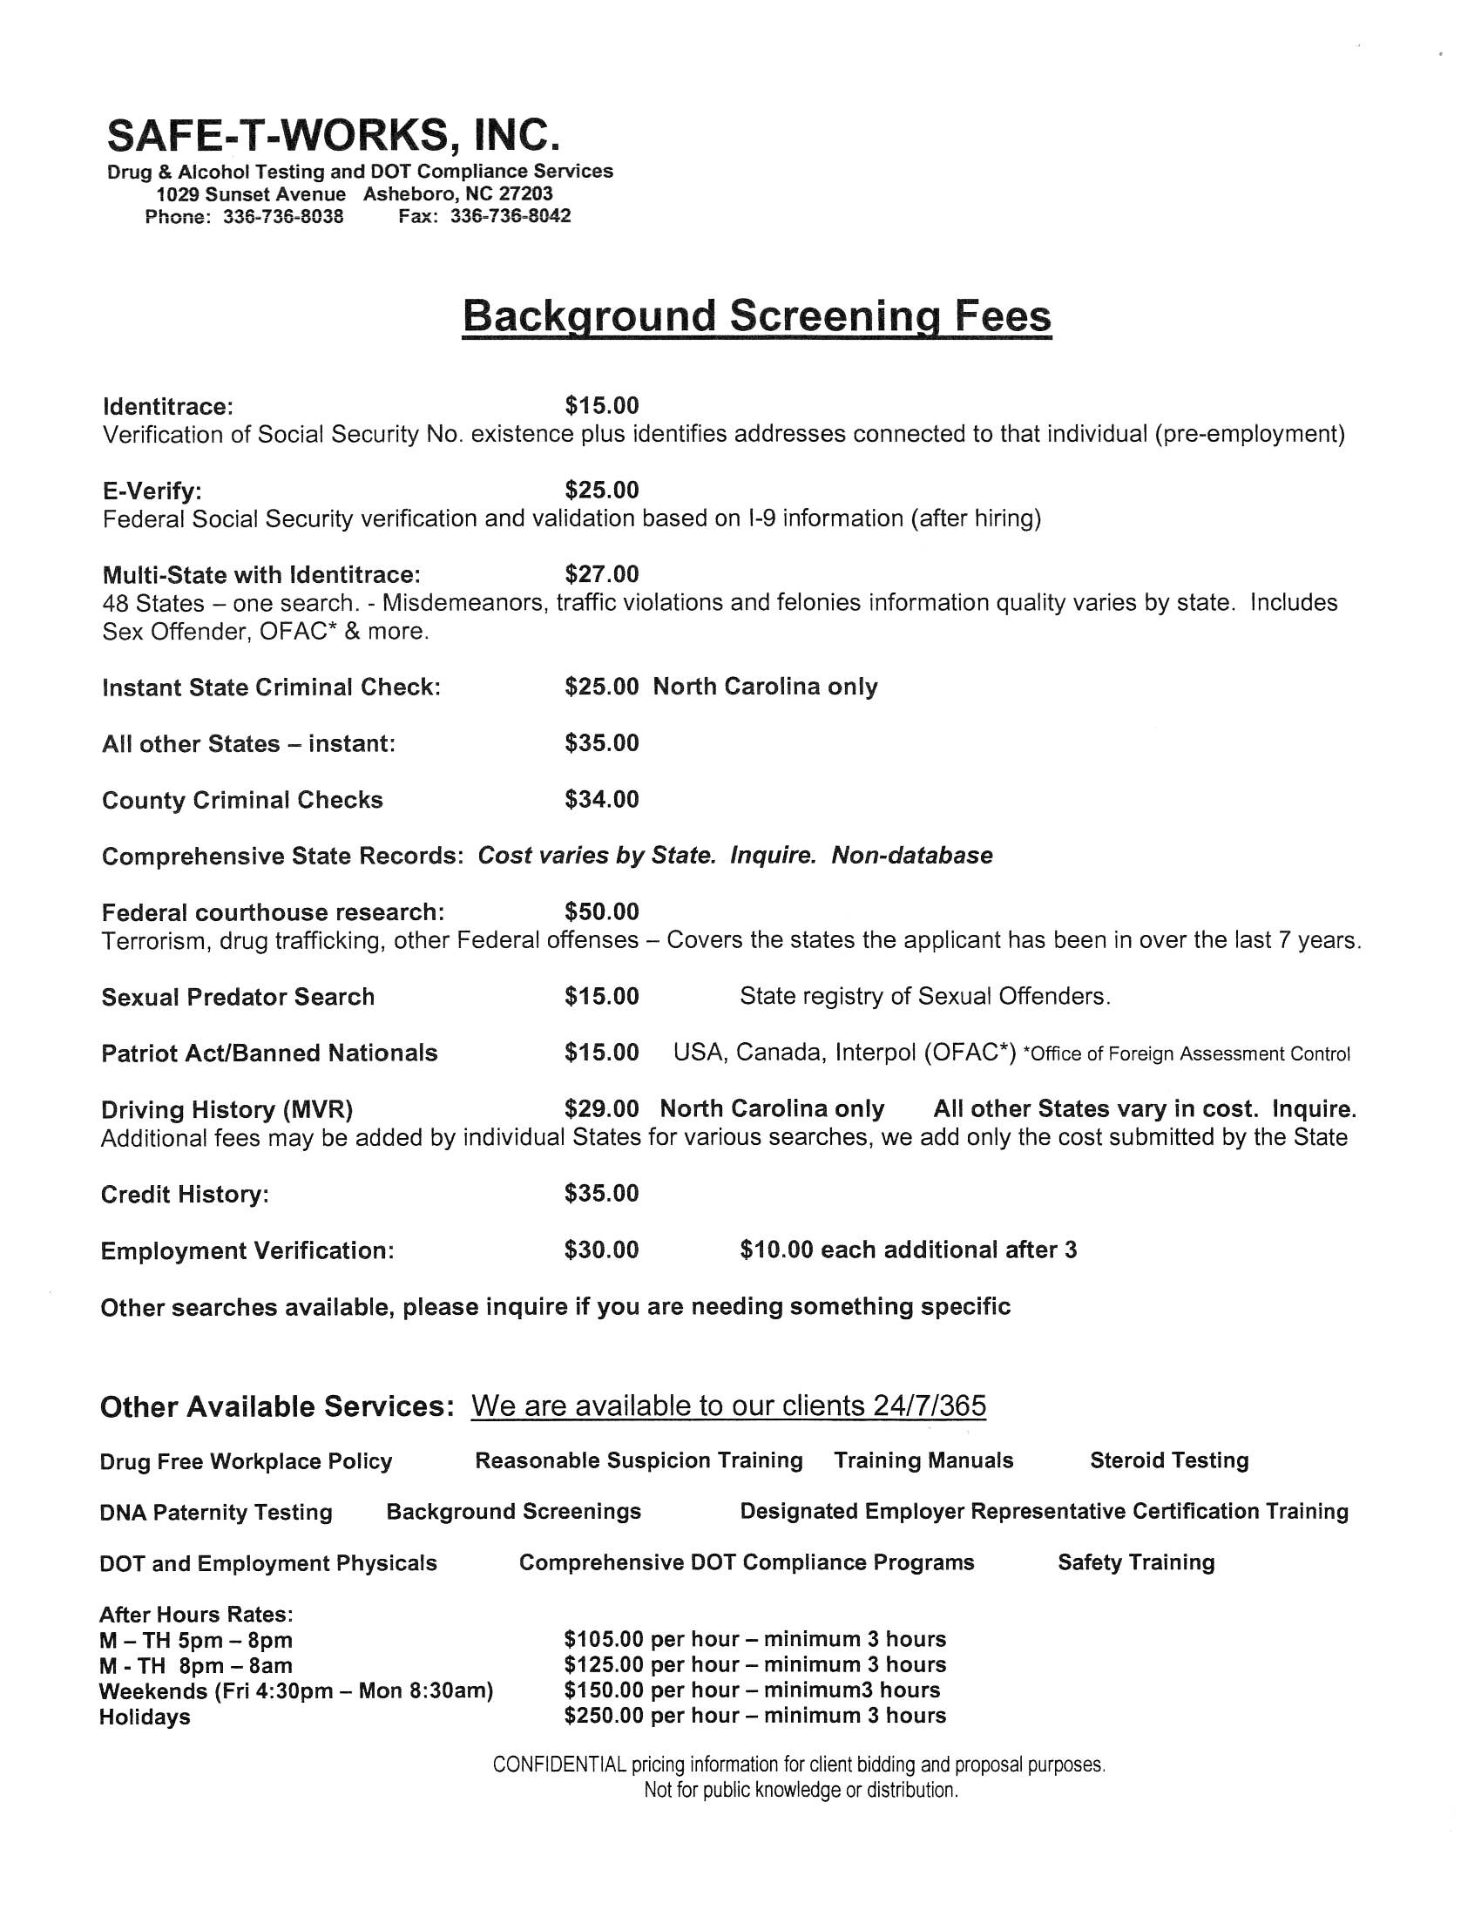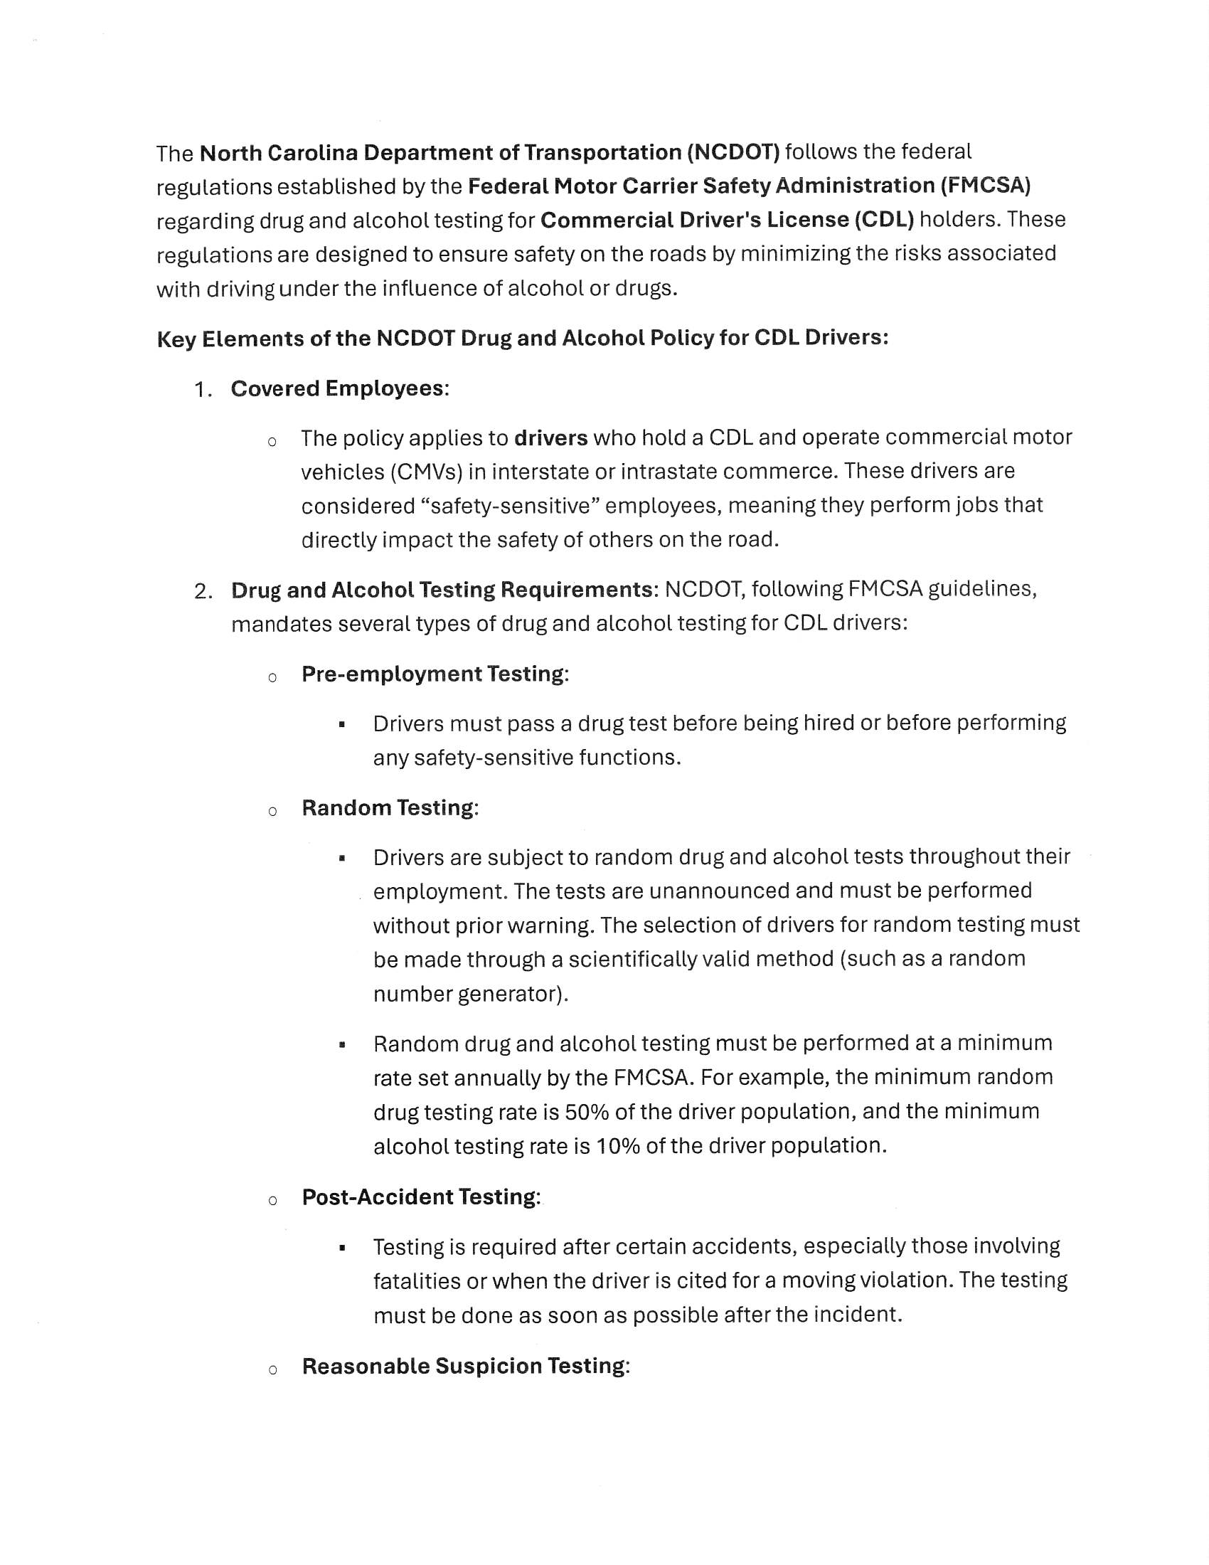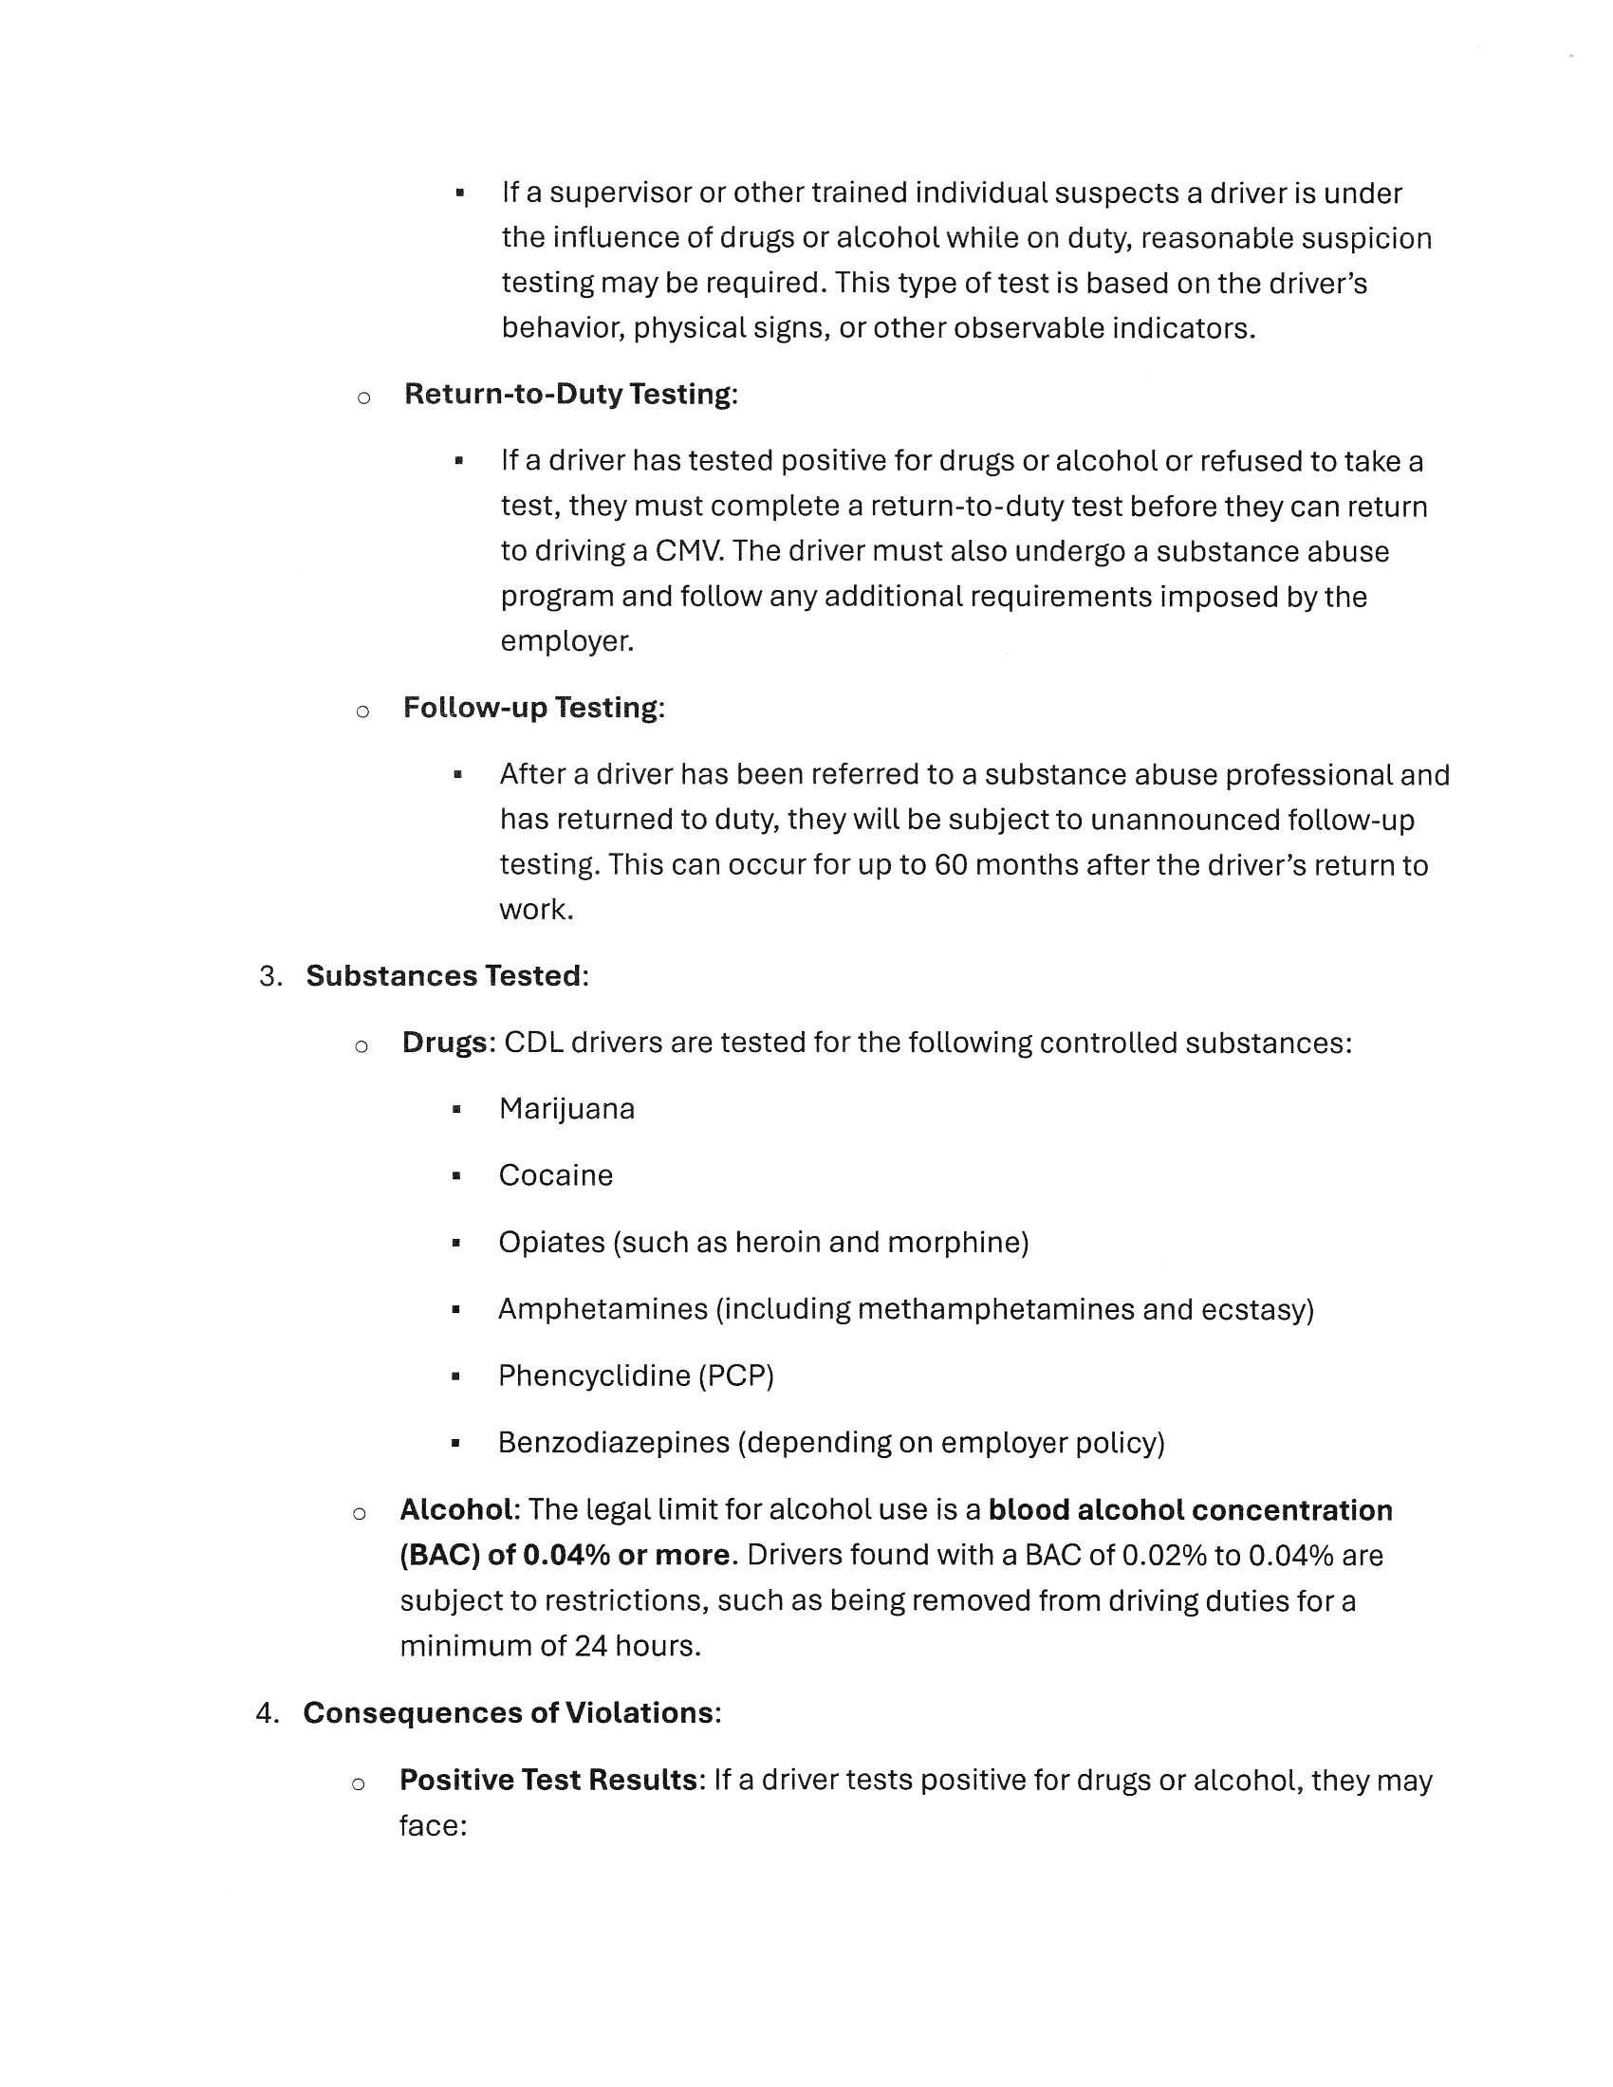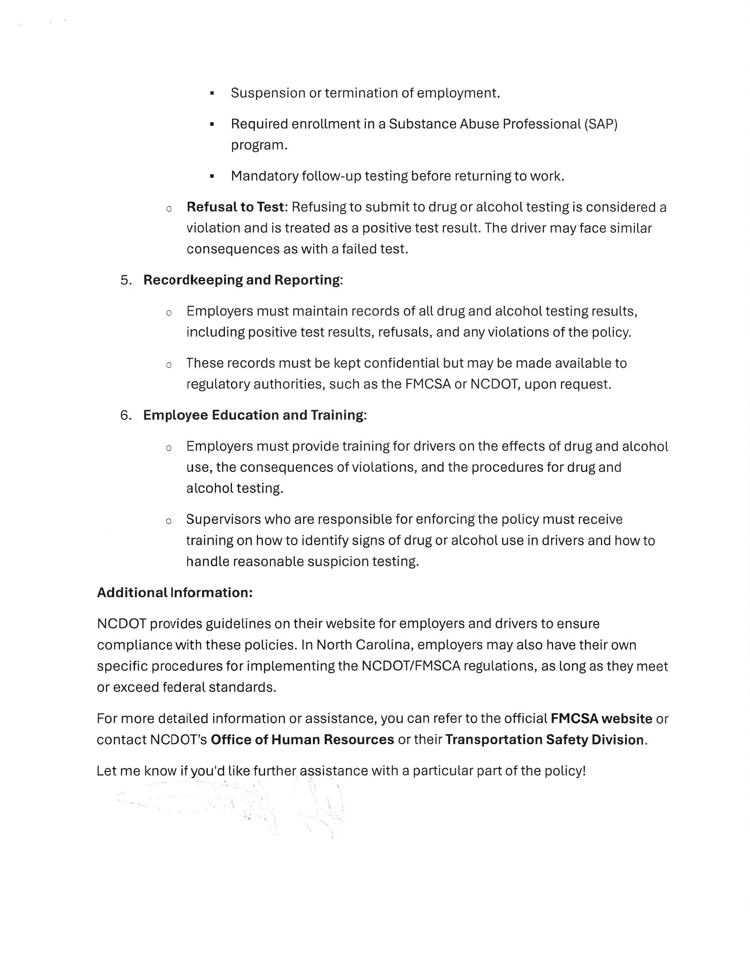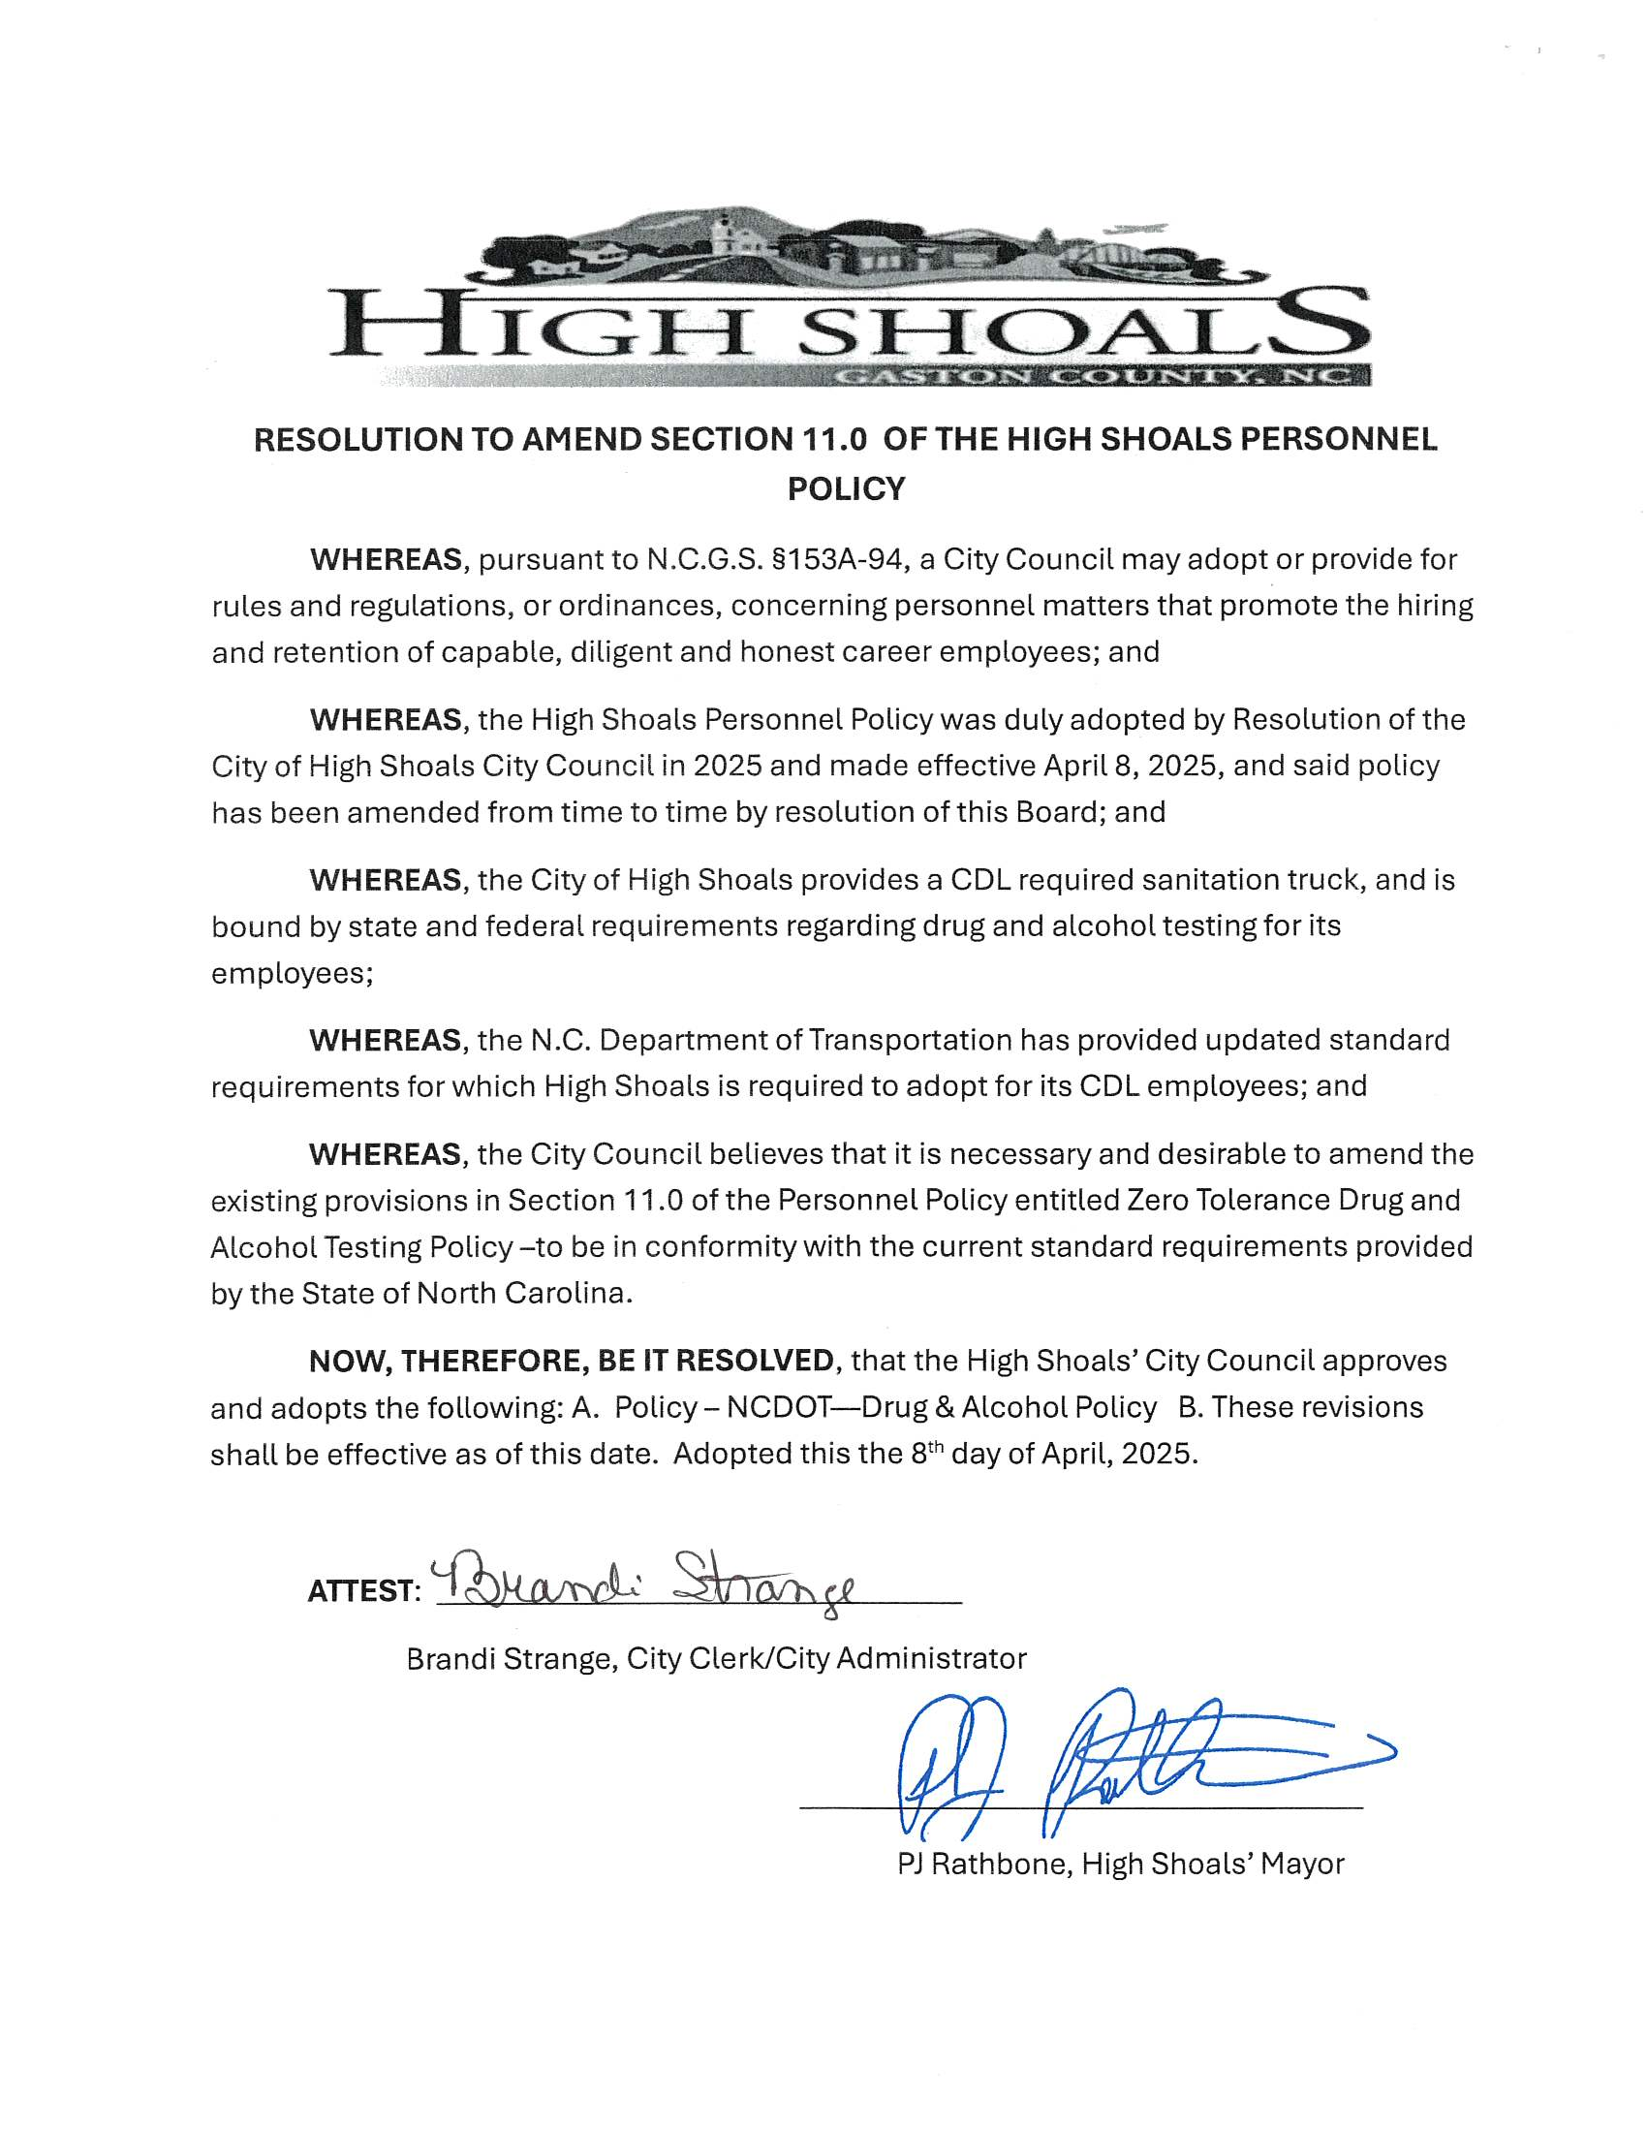
- Discussion/Action: State St drainage from ball field
  - Tim will check on it to see what it looks like and see if it’s something that the city needs to take care of.
- Discussion/Action: National Two Lights Proclamation
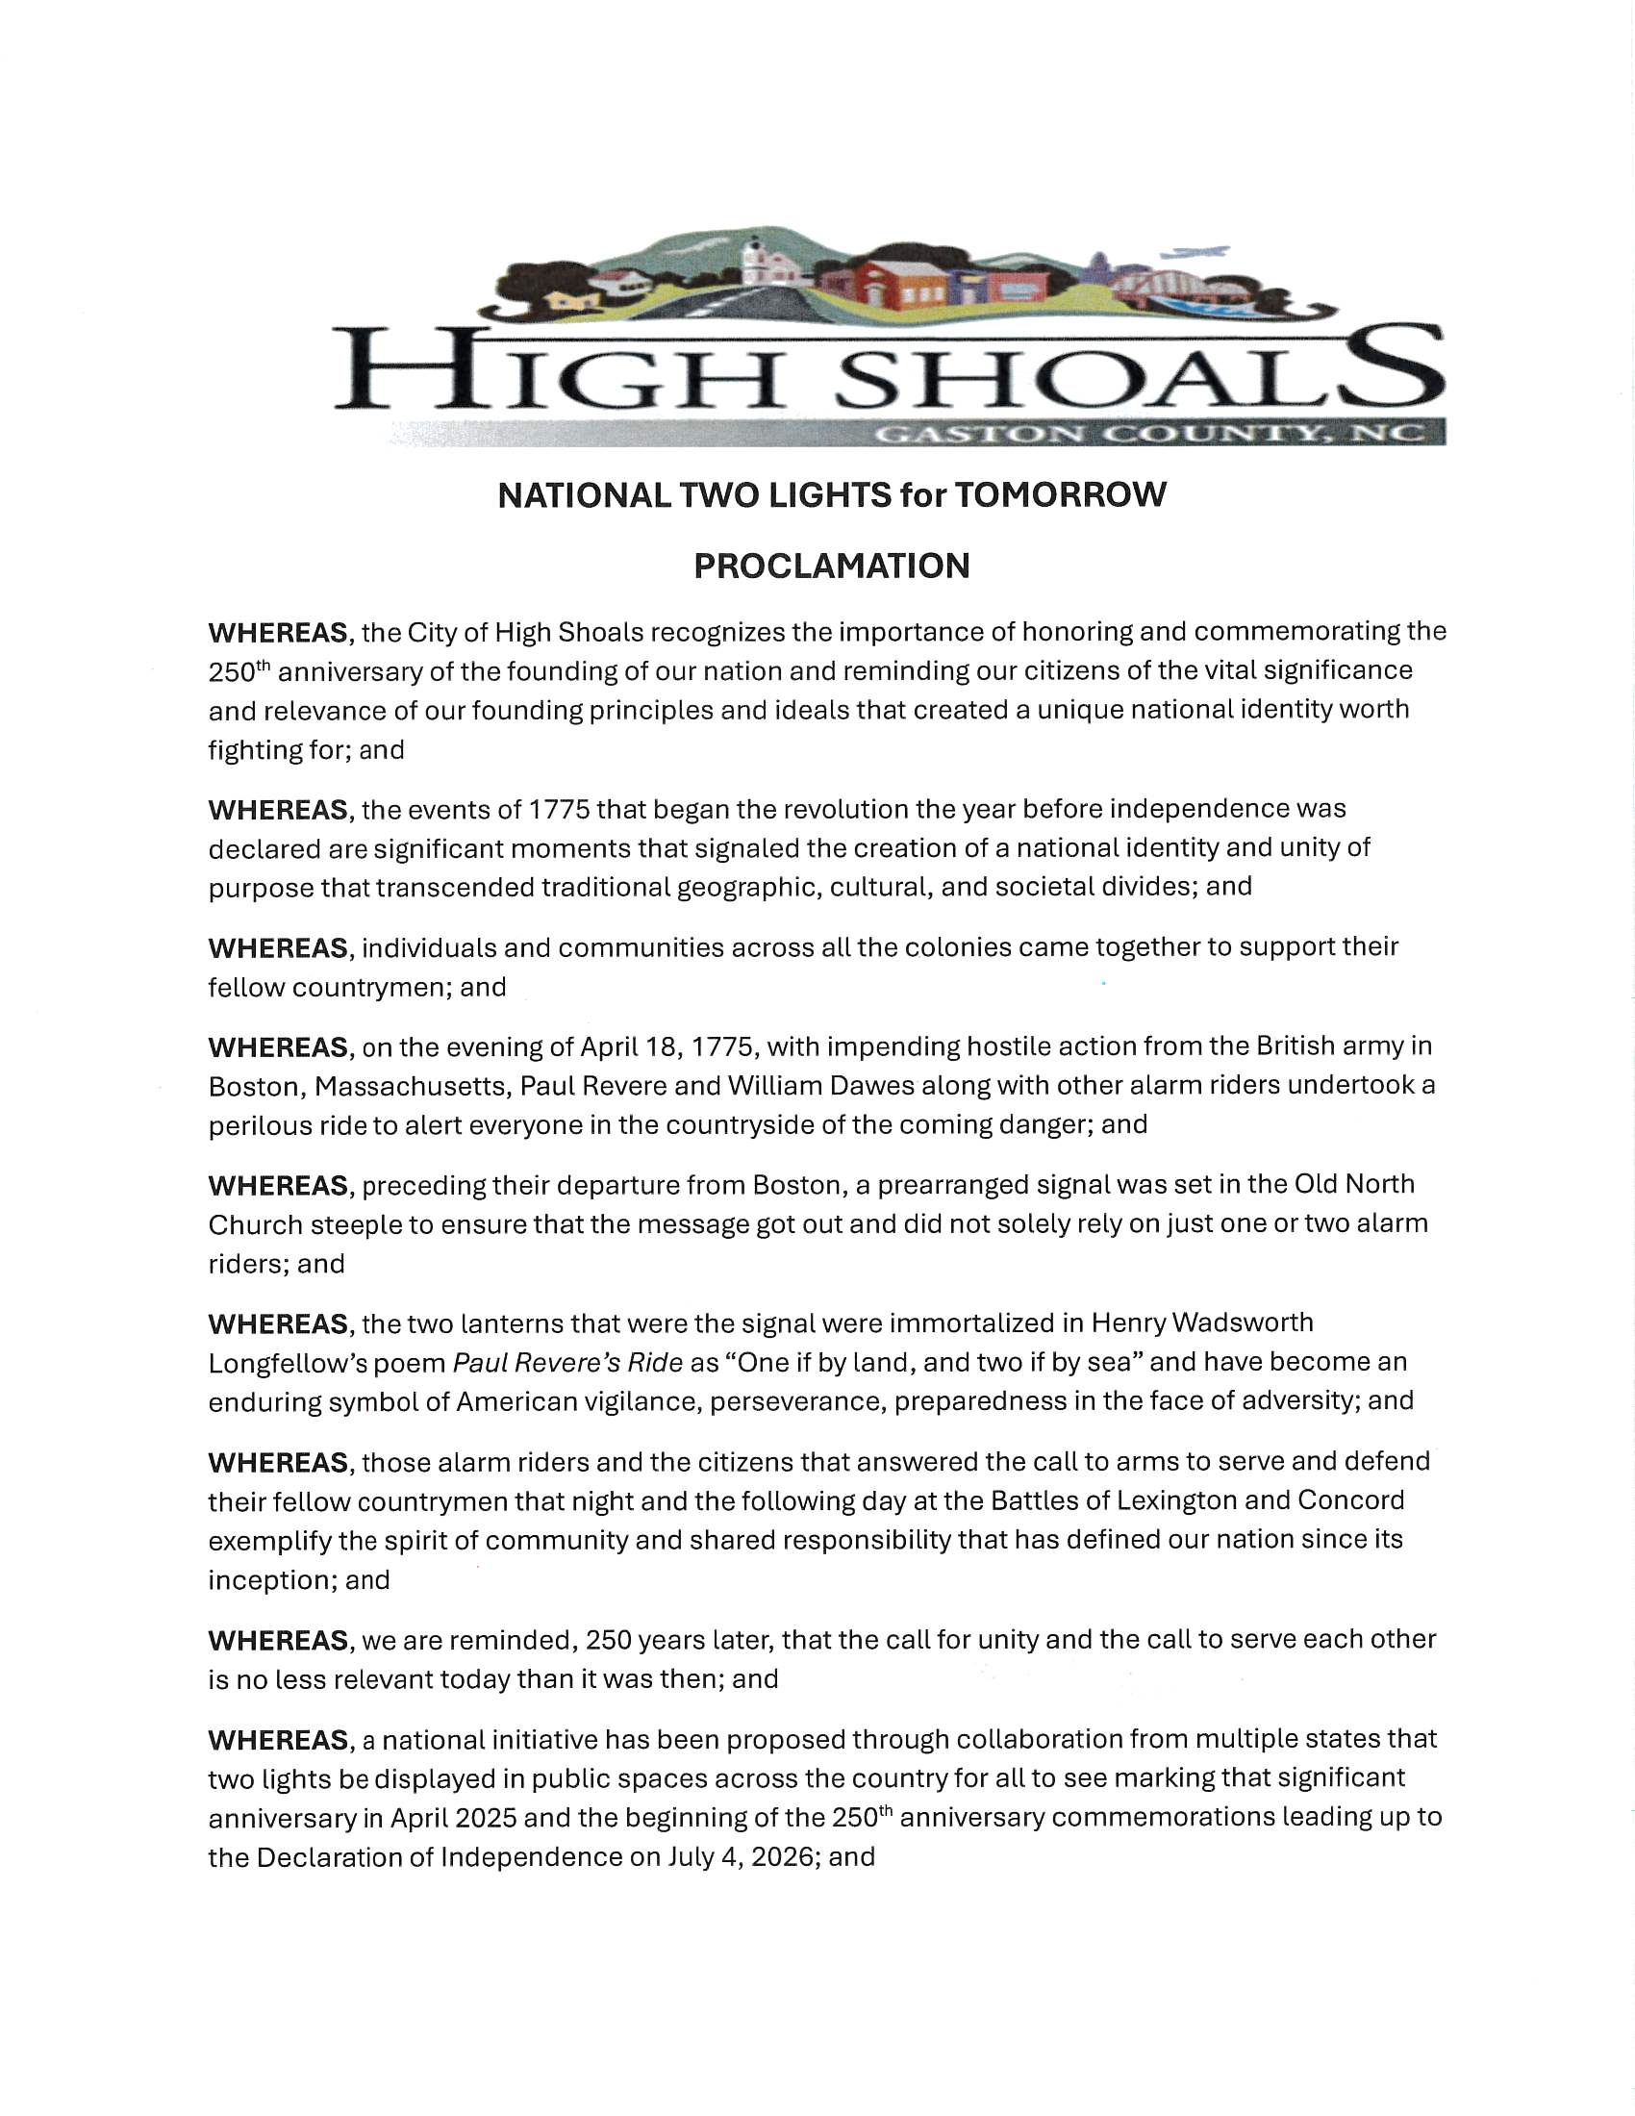
  - Motion to accept the proclamation made by Kathy Rhyne, seconded by Tim Eidson. All in favor.
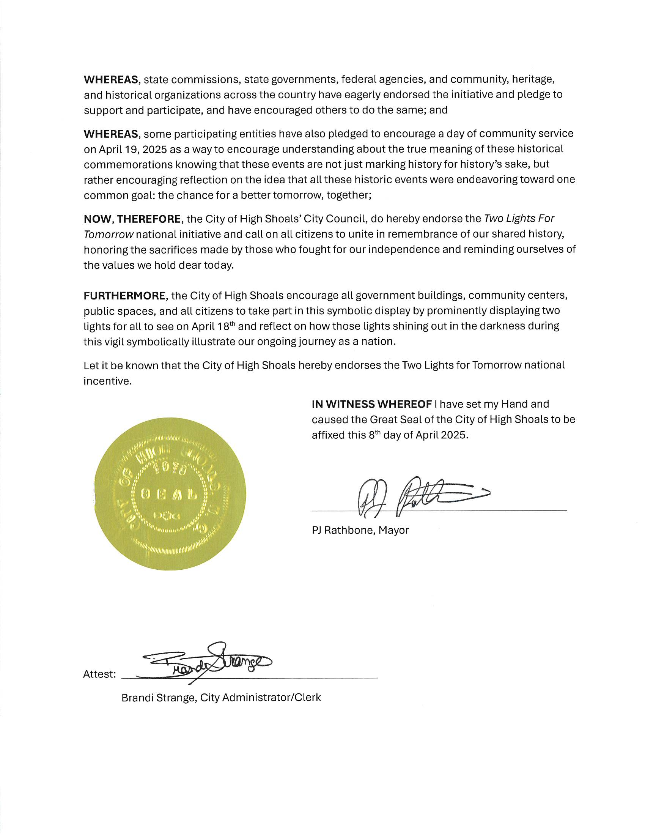
- Discussion/Action: Spring/Summer Hours
  - Kathy Rhyne requested to table until May. Bobby Vassey seconded. All in favor.

- Action: Motion to Adjourn
  - Motion to adjourn made by Kathy Rhyne, seconded by Bobby Vassey. All in favor.

