City of High Shoals
Regular Council Meeting
March 11, 2025
- Call to Order—Mayor PJ Rathbone called to order March 11th Council Meeting at 6:30pm. In attendance are the following council members: Dennis Cash, Denese Cook, Bo Rhyne, Bobby Vassey, Kathy Rhyne. Tim Eidson was absent.
- Invocation
- Pledge of Allegiance
- Approval of Agenda: Motion made by Denese Cook, seconded by Bobby Vassey. All in favor.
- Approval of Minutes Motion made by Kathy Rhyne, seconded by Bobby Vassey. All in favor.
Citizens’ comments/concerns: The City of High Shoals Council offers citizens the opportunity for Public Expression issues per NCGS 160A-81.1 (limited to 3-5 minutes per speaker).
Judy Taylor spoke to thank Jerry and Brandi for fixing her sister-in-law’s gravesite (Dora Mullenax). She said we responded quickly, and it was appreciated. She also asked when the houses were going to be started on the rehabilitation. The City Clerk told the council that we’re awaiting the lead inspection results.
Good of the Order: This is a time set aside for members to offer comments or observations (without formal motion) about the organization and its work. The good of the order is also the time to offer resolution to bring disciplinary charges against a member for the offenses committed outside a meeting.

- Departmental Reports:
- Police Report-Gaston County
    - Only one case in February, 100 block of Church Street. Extortion case.
    - No one was arrested inside the city in February.
    - 911 calls – 25 calls for the month, 1 ACE call, 13 other calls
    - 31 special checks, 14 traffic stops, 2 warrant stops, 1 suspicious vehicle
    - Officer initiated calls 11 special checks, 1 meet in person, 5 special checks at Armstrong Circle
- Financial-Dennis Cash
- CHECKING 1: $322,863.54
- CHECKING 2: $ 11,122.21
- SAVINGS: $161,081.24
- CAP MGMT: $ 49,916.71
- TOTAL: $544,983.70
- Cemetery-Denese Cook
    - Damage in the cemetery, unsure if it is weather related.
    - Brandi got Jerry to fill up Ms. Mullenax’s grave, Jerry seeded
- Water/Sewer-Bo Rhyne
    - Leak on River Street and leak on North Street
      - Will contact Tim and/or Dallas to repair
      - May have our guys dig on it in the morning
- Streets/Maintenance/Sanitation-Kathy Rhyne
  - Nothing new
  - Parks/Recreation-Bobby Vassey
    - Yard of the Month:– 213 Cherry St. Max Parker
    - Easter—April 19th Celebration Egg Hunt from 11a.m.-1p.m.
    - We will need help
- Vehicles- Tim Eidson
    - The mowers and such are at James River being serviced. Update on one, the PTO came out of the new one. The small Husqvarna has broken completely.
    - Tractor will be picked up on the 18th for servicing.
- Administration/Mayor Report-PJ Rathbone

- New Business:
- Presentation: Ashton Lamb—Carolina Thread Trail & the role High Shoals plays in the network.
  - Carolina Thread Trail, Ashton Lamb coordinator. An overview for the possibility of the mill property and the opportunity to work with us. It is a partner with Catawba lands conservancy, started in 1991. Focused on mountain island lake and protecting drinking water. 161 miles of water frontage and protected properties. Most of which is in Gaston County, but we cover 15 counties, founded in 2007. We have a lot of supporters coming out of Charlotte: Wells Fargo, Bank of America, Belk Family, groups and entities such as those. The Thread Trail footprint is large 1640 miles of planned trail, second largest only behind in San Fransico. 435 of existing trail. This consists of greenways, sidewalks, natural surface, bike trails, and paddling trails. The benefits are physical activity, mental well-being, being with nature. It also increases job creation, tax revenue, alternative transportation, increasing tourism and tourist spending. As community coordinator, Mr. Lamb has a good portion of Gaston County. High Shoals is part of the Thread Trail Network, ties into Lincolnton. Gaston County’s masterplan was adopted in 2009, first county to adopt the master plan. 500 acres of protected property and specifically it is beautiful. We’re hoping to help with that down the road. There’s a lot of trail activity just to the south. Going from Lake Wylie to Spencer Mountain. The two points is Daniel Stowe Botanical Garden and Spencer Mountain. There is a general statute 38A1 that protects citizens from landowners from liability that allow access to the trail. The landowner would not be held liable if permitted to have the trail. This will allow e-bike style equipment and power chairs to experience the trail and views that able-bodied people are allowed to do. A pocket park is a small park under an acre, activated with benches, hammock stands, etc. The cost is around 1.5 million dollars and breaking ground in November. When you build a destination, 23 miles of trail, approximately 2 million people will come to enjoy that trail. Will benefit quality of life and economy. We partnered with NC State University to look at 6 trails within the network (regional) 3.5 million dollar input per mile per trail, return. Including employment, tax revenue, health care savings, reduction in automobiles. Brent (state trail)—people are recognizing what a gem the river actually is. The river is literally a story-book of the history of the area. The state trail designation, there is no state trails in the Charlotte region. The Southfork river has so many parks and trails within it, connecting to the Western county trails. We look at 15 counties, with trails dispersed throughout the region. But what draws people to the trails; it’s the distance. It’s about getting more miles connected, which gives more recognition of trails. The State trail designation goes through the General Assembly. Senator Overcash is working on the bill to get this designation. We think we have a real justification in requesting this corridor. This is 60 miles of paddling and 60 miles of land opportunity. This is what we want to bring to the region. We’re in authorization phase now. Once this becomes a Bill and is approved, we do a feasibility study. This hones in on the best opportunities for the routes, the challenges (property/highways/etc). This is defined by the river. The land-trail has a wide area to look at. The land can be studied 5 miles of either side of the river. This is where a lot of public input will involve public meetings, which input shapes the recommended routes. Those 14-15 state trails in North Carolina, we’re way ahead of those. We’re past due to this designation. The partnerships helped cultivate this effort. The over-arching message is the fact that we have something really special about the South Fork corridor. The funding opportunities, there are specific monies to fill in the gaps to build the trails. The connecting the community trail grants as well. We can get funding to get connected to the main trail. Each state designated trail has an administrator. The Carolina Thread Trail can get funded to partner with the state. The designation opens up additional avenues for funding. The non-profit organization works with partners so they can help with grant writing and the administration. The local governments own the trail, but they help get the trail planned and built. Then we have educational opportunities to share ideas and networking to advance the trail system. They can work with landowners for trail easements. The grant program, there is a Great Trail State program, and the legislature is behind such. $25 million is non-recurring but advocating for more. There is a program called Carolina Thread Trail Grant Program—we’ve giving well of 8 million to communities getting their trails built. It would serve as leveraging, which hopes to have others match. Mr. Lamb said in Gaston County it is broken up county-by-county, there’s funding restricted to the South Fork River. They can help write and administer grants. The Thread Trail is a ground-up model. We work as a product of local input and local decision making. However, we do not advocateof imminent domain, and that state will not support imminent domain. There’s a lot of programs with volunteers, hikes and bikes on the trails. There are lots of opportunities to volunteer and help with the trials as well.
- Discussion/Action: Pay Scale—Code Enforcement with Gaston County (*Contracting*)
  - Motion to approve the fees for code enforcement violations made by Kathy Rhyne, seconded by Denese Cook. All in favor.
FEES FOR CODE ENFORCEMENT BY HIGH SHOALS
FOR YARD/SPACE CLEAN UP
1/8 TRUCKLOAD |  | $80
1/4 TRUCKLOAD |  | $150
1/2 TRUCKLOAD |  | $250
3/4 TRUCKLOAD |  | $400
FULL TRUCKLOAD |  | $500
plus dump ticket
MOW-OVERGROWN YARDS
UP TO 1/2 ACRE |  | $150
1/2 ACRE UP |  | $300

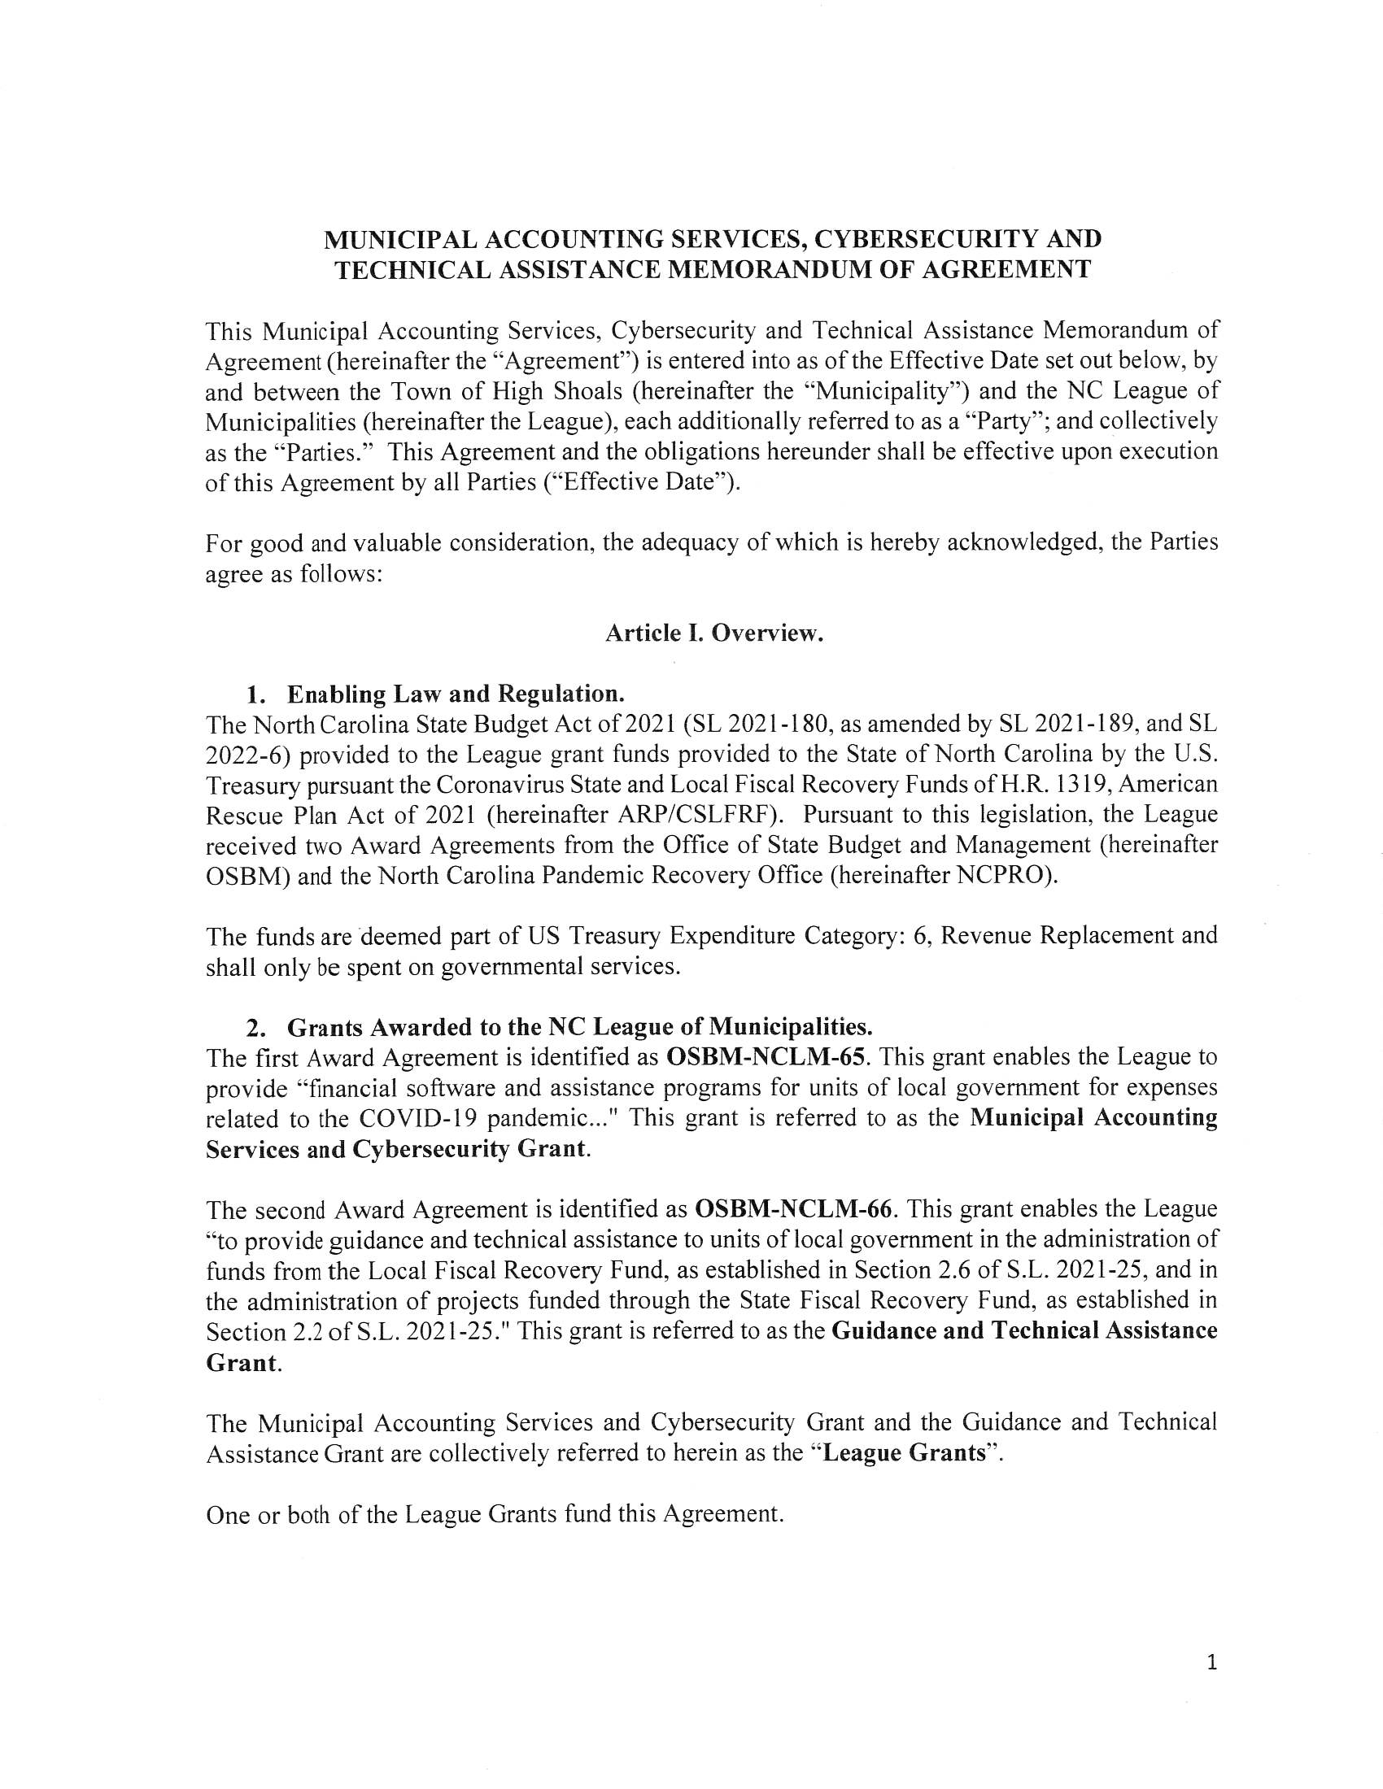
- Discussion/Action: NCLM Cybersecurity MOA & Resolution—Dennis Cash made motion to approve the MOA and Resolution, seconded by Mr. Bo Rhyne, all in favor.
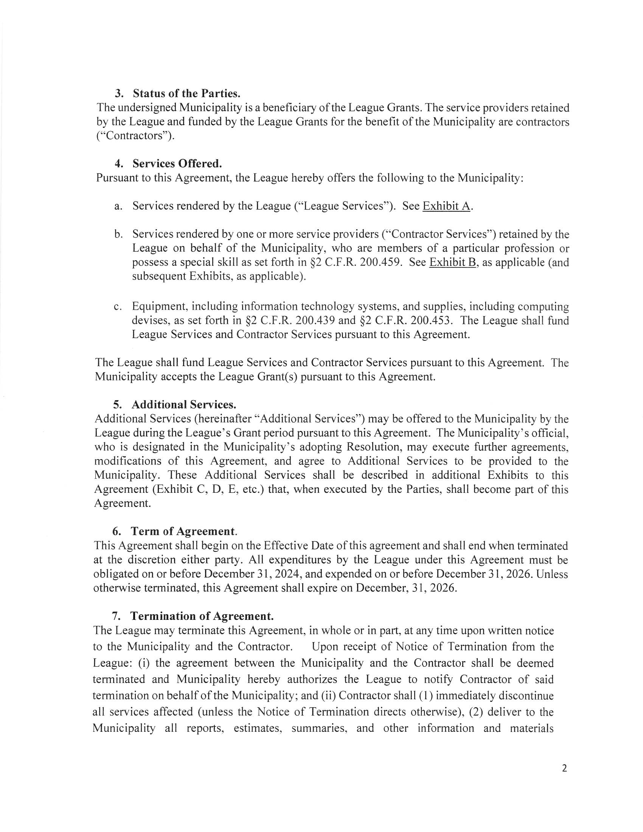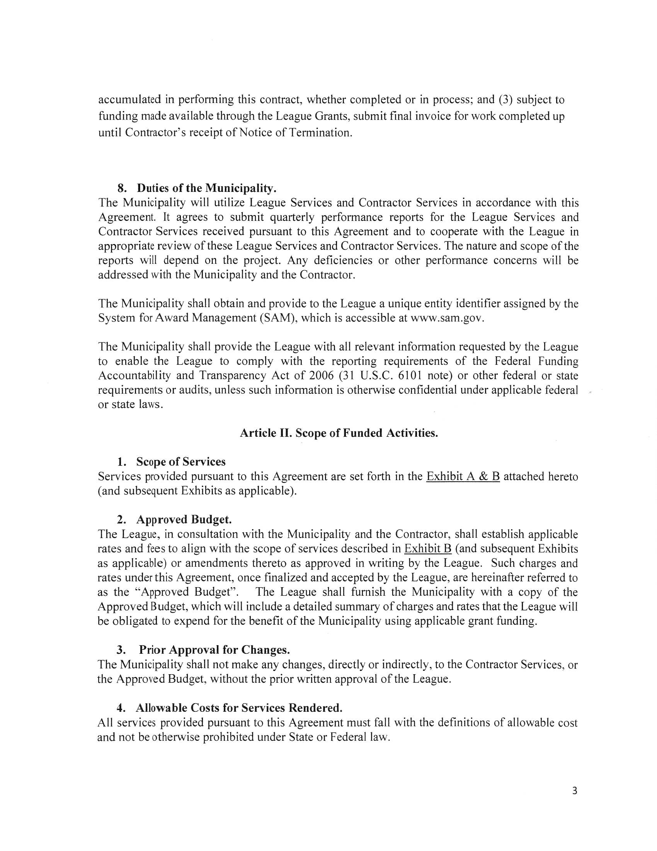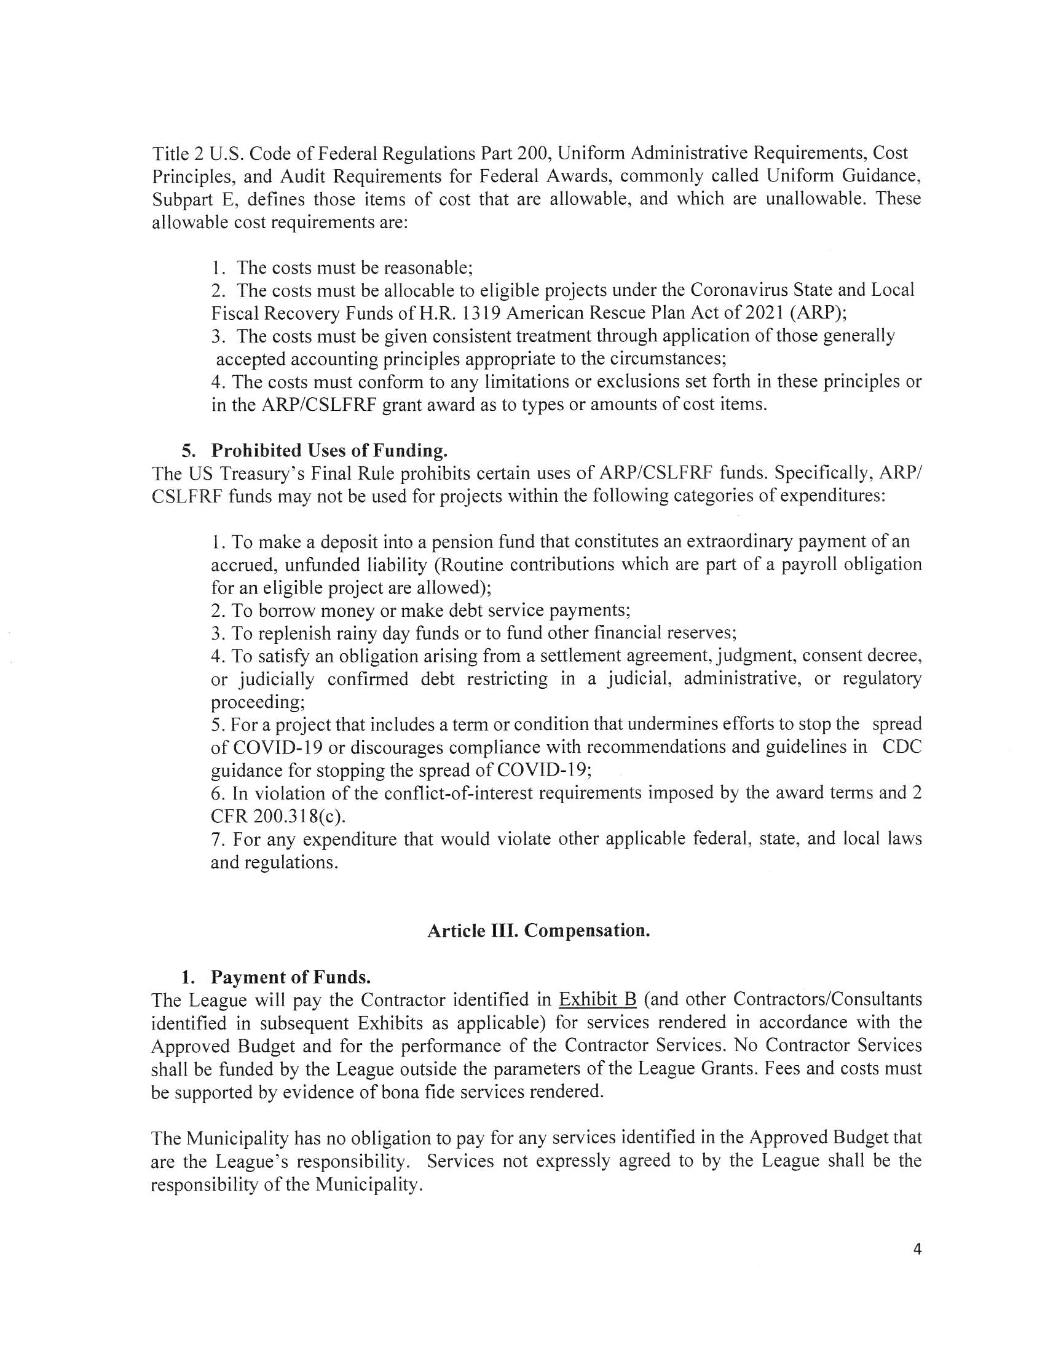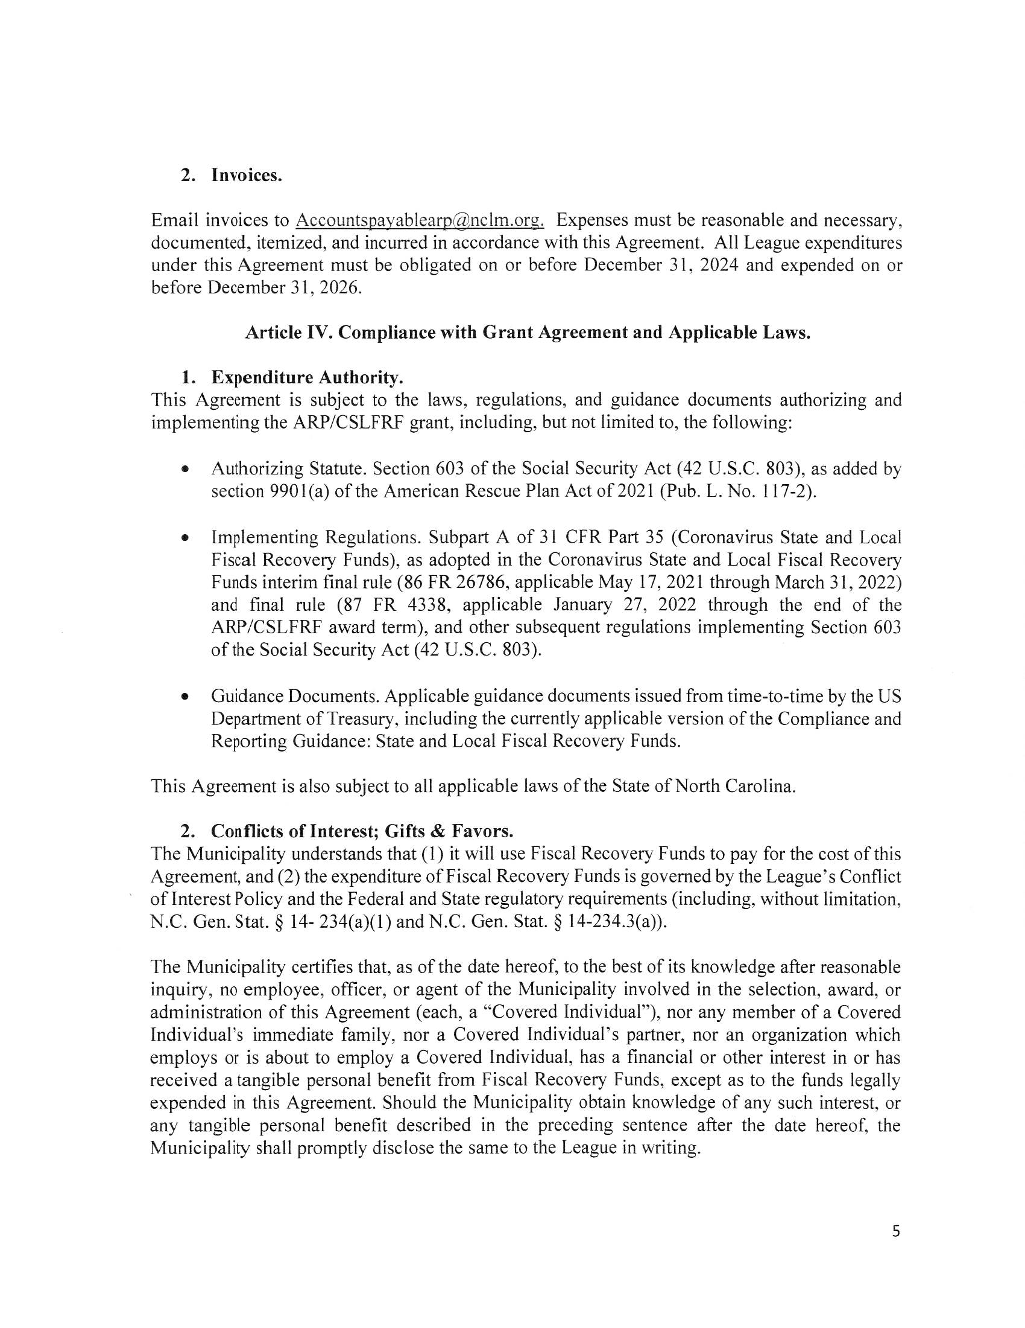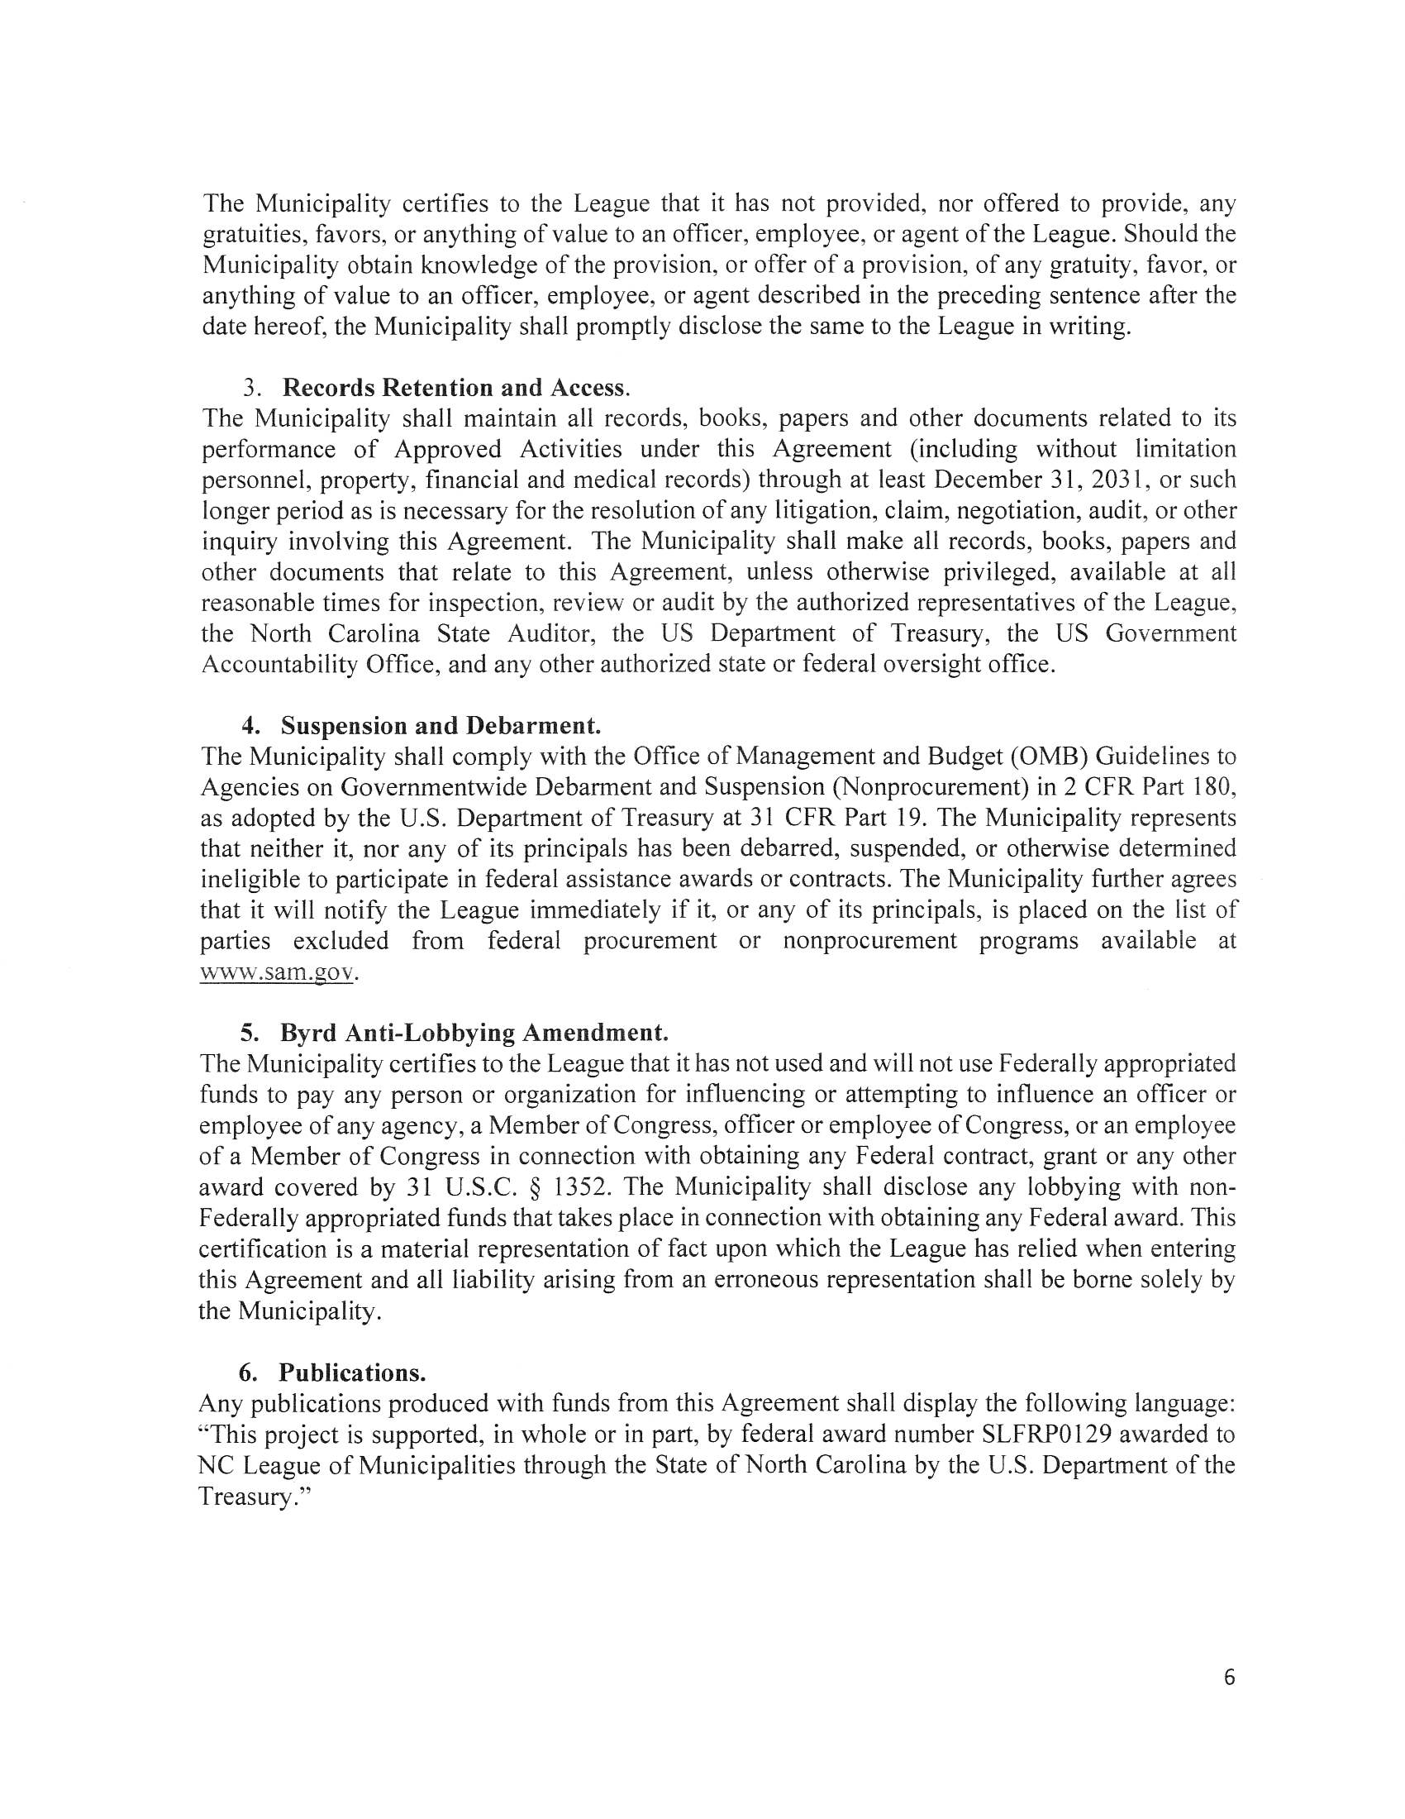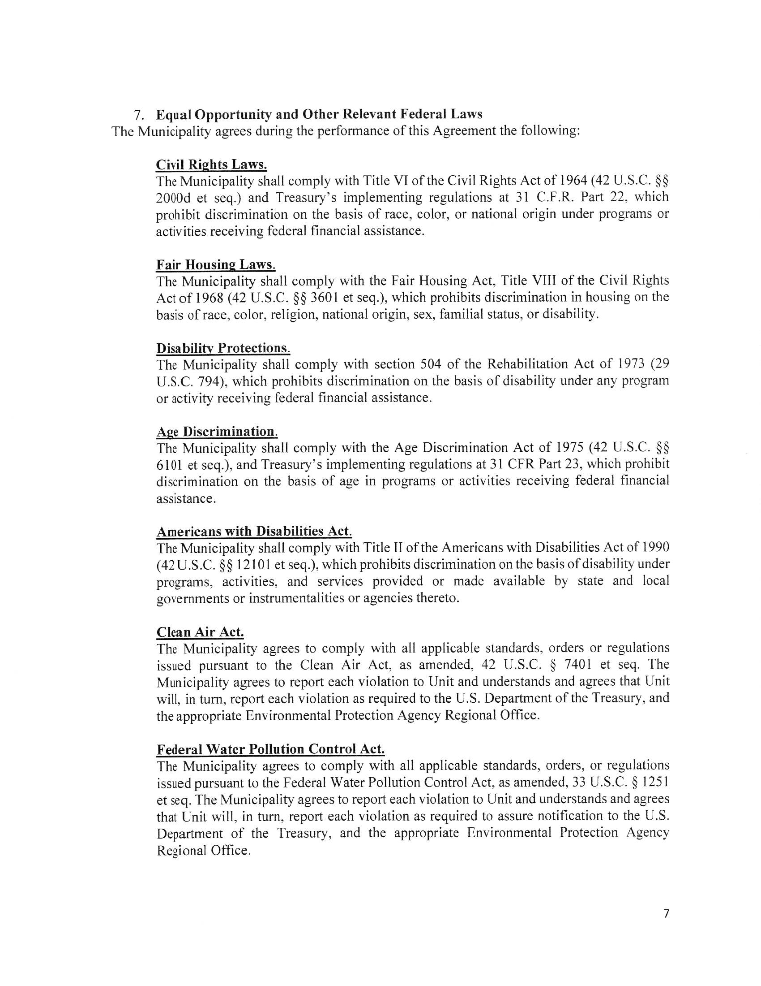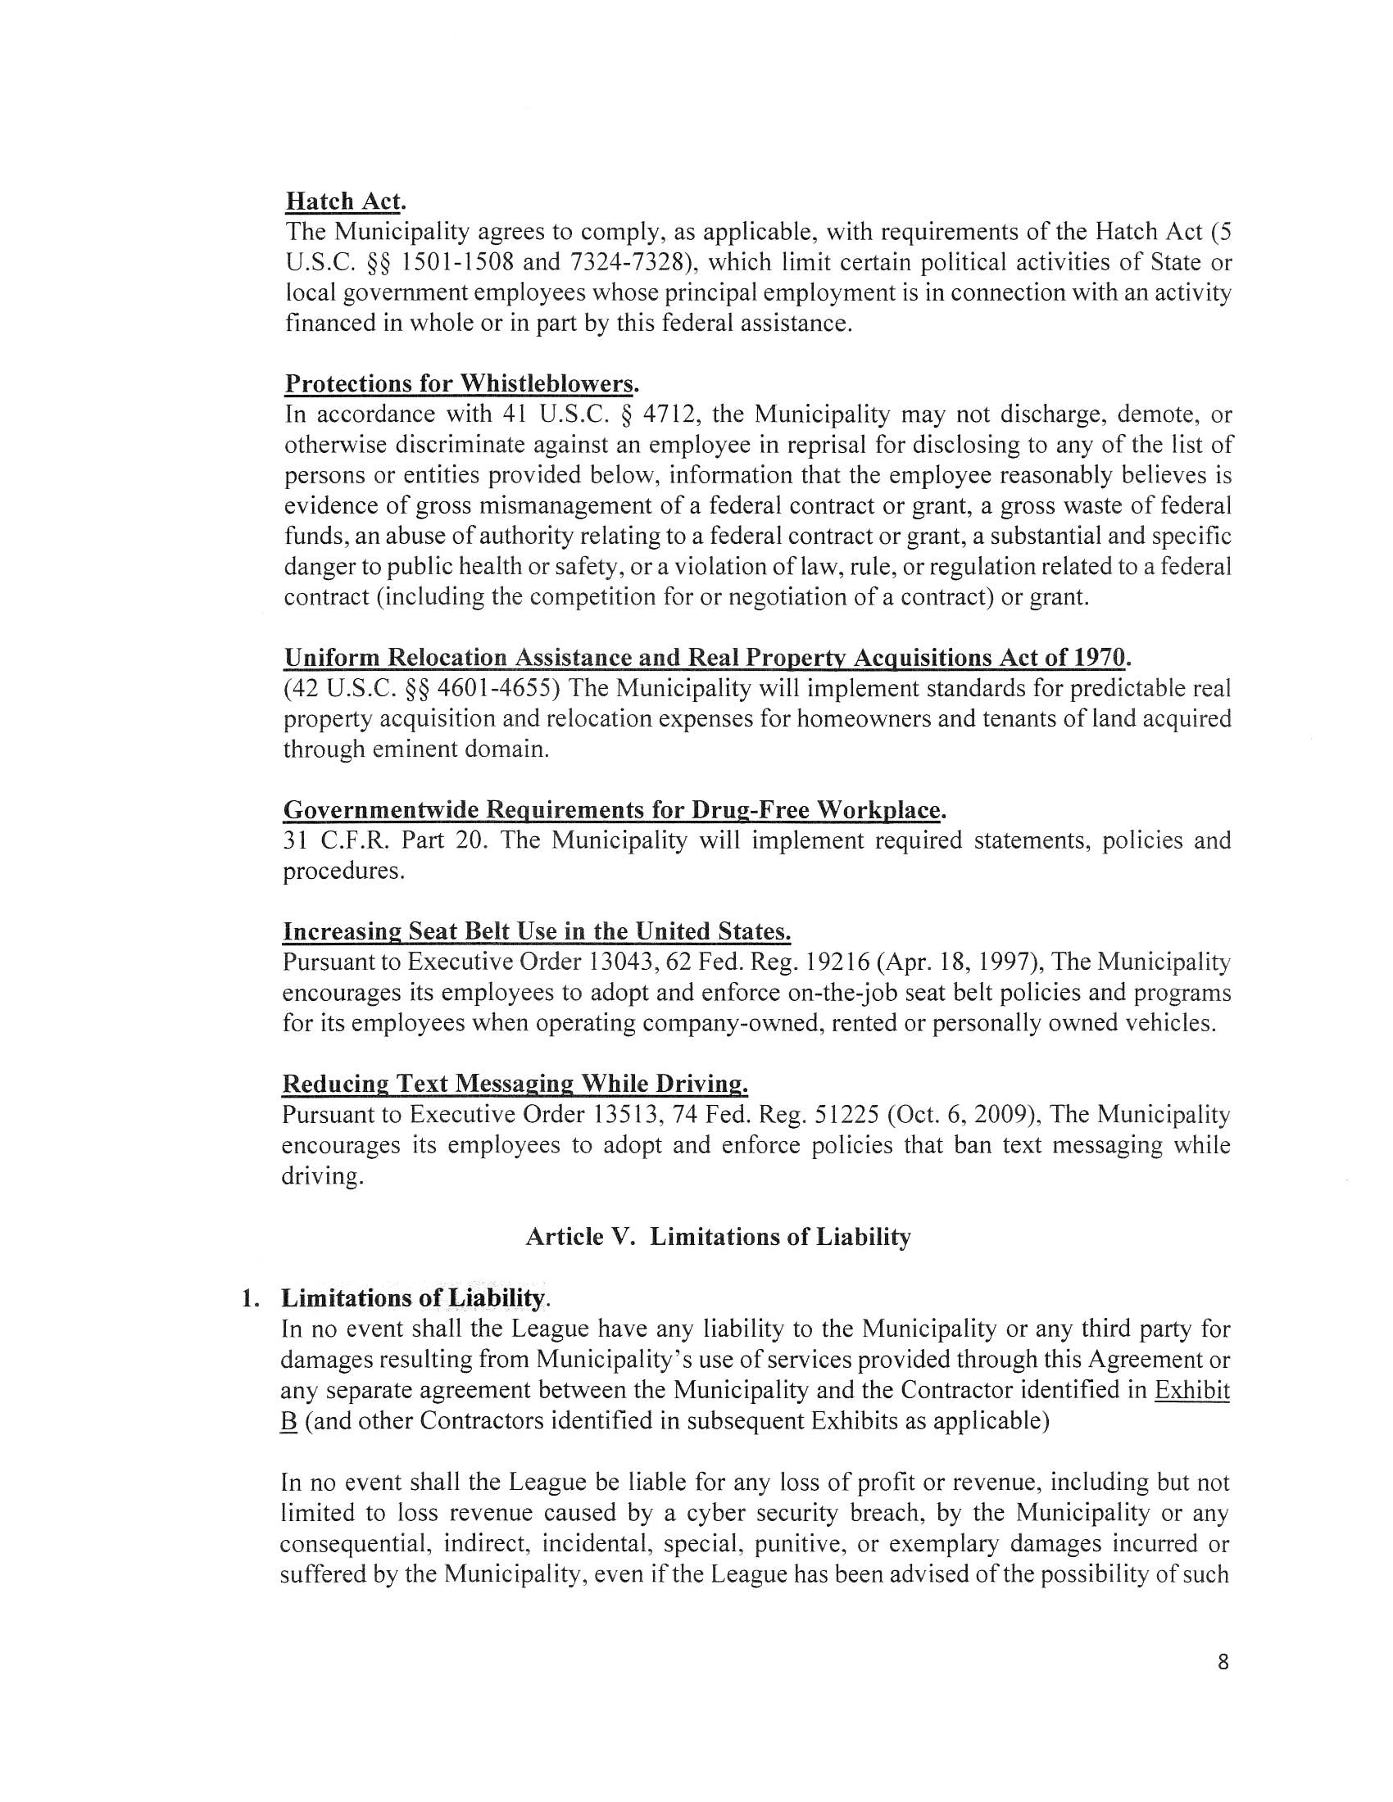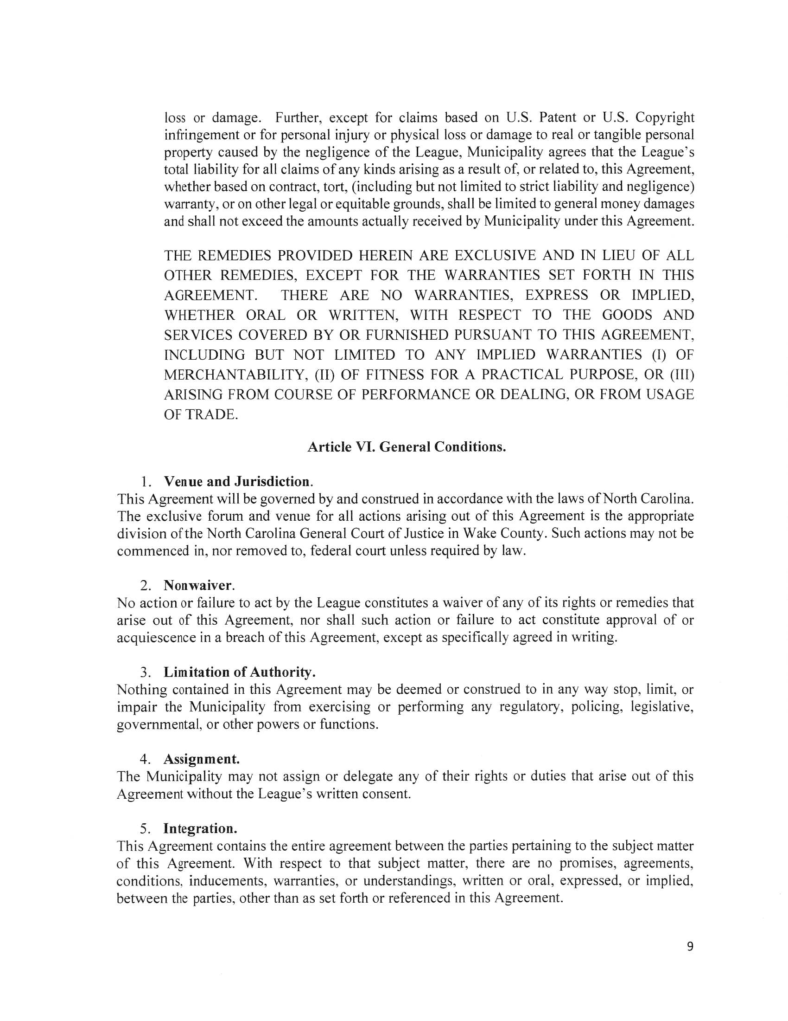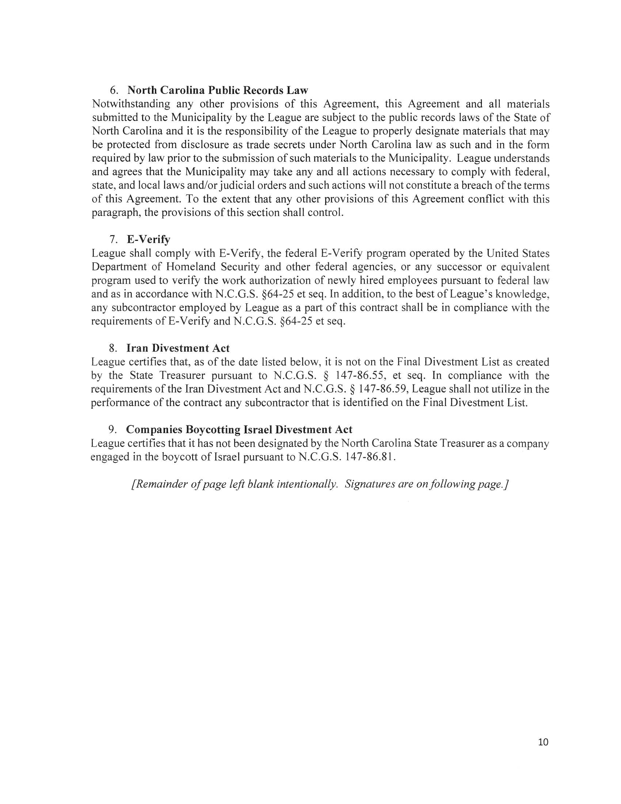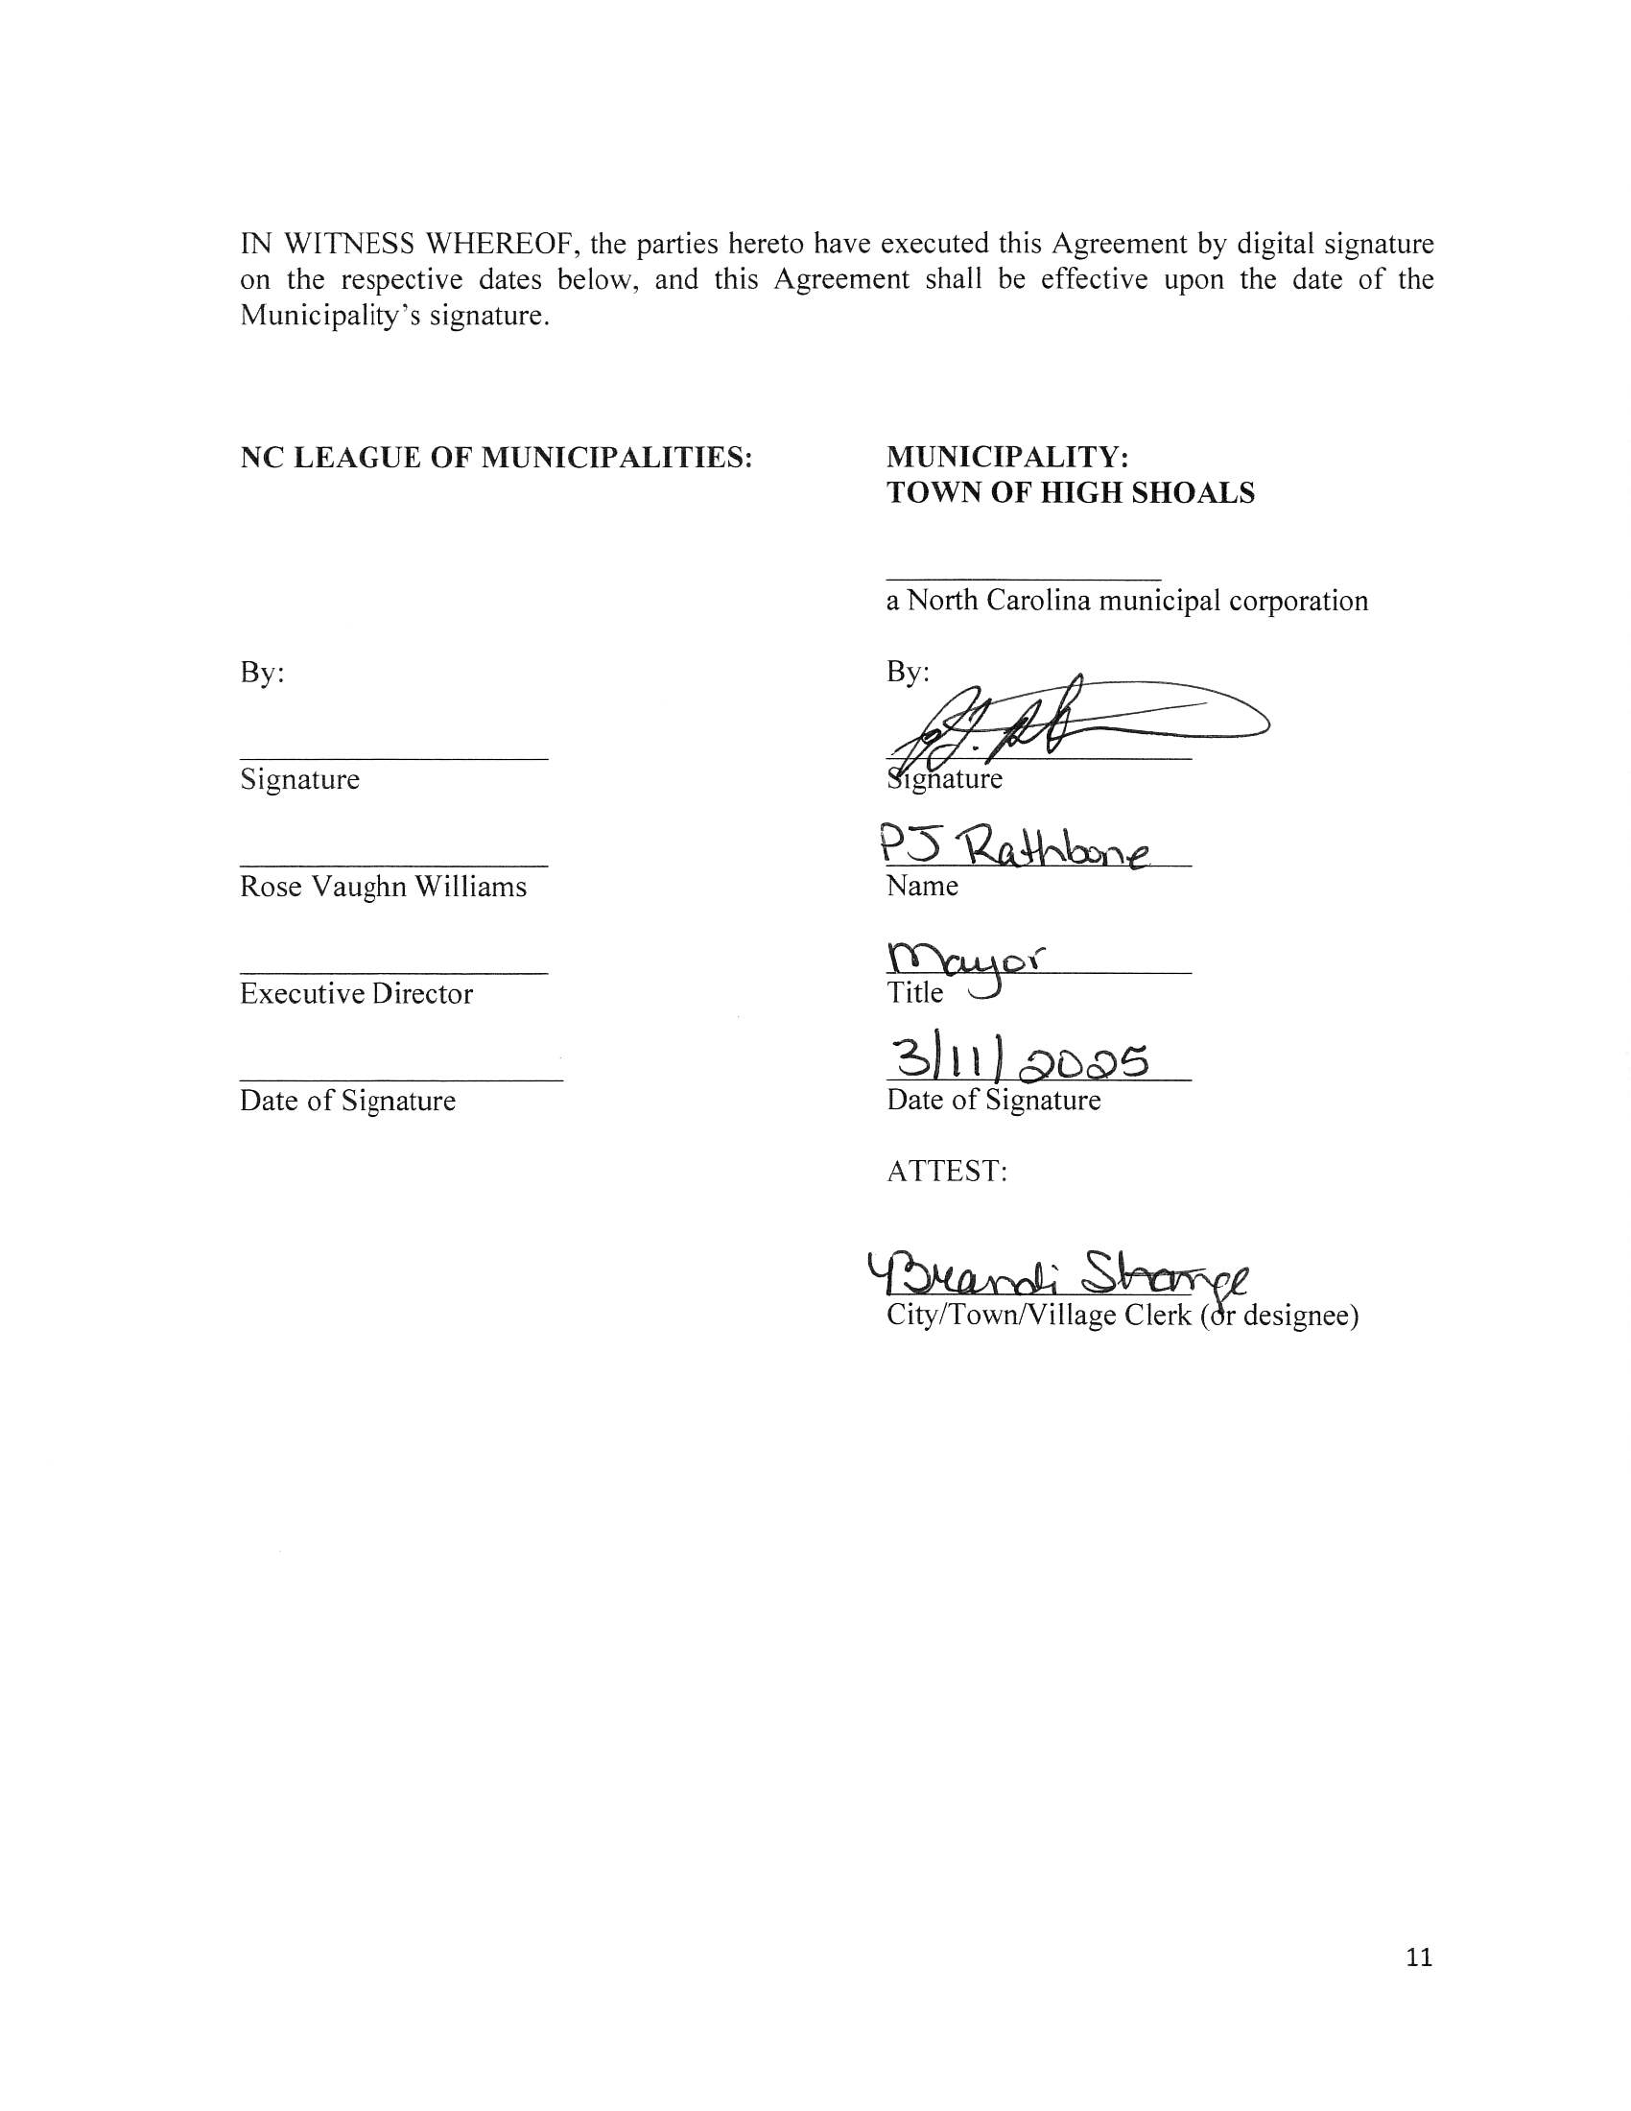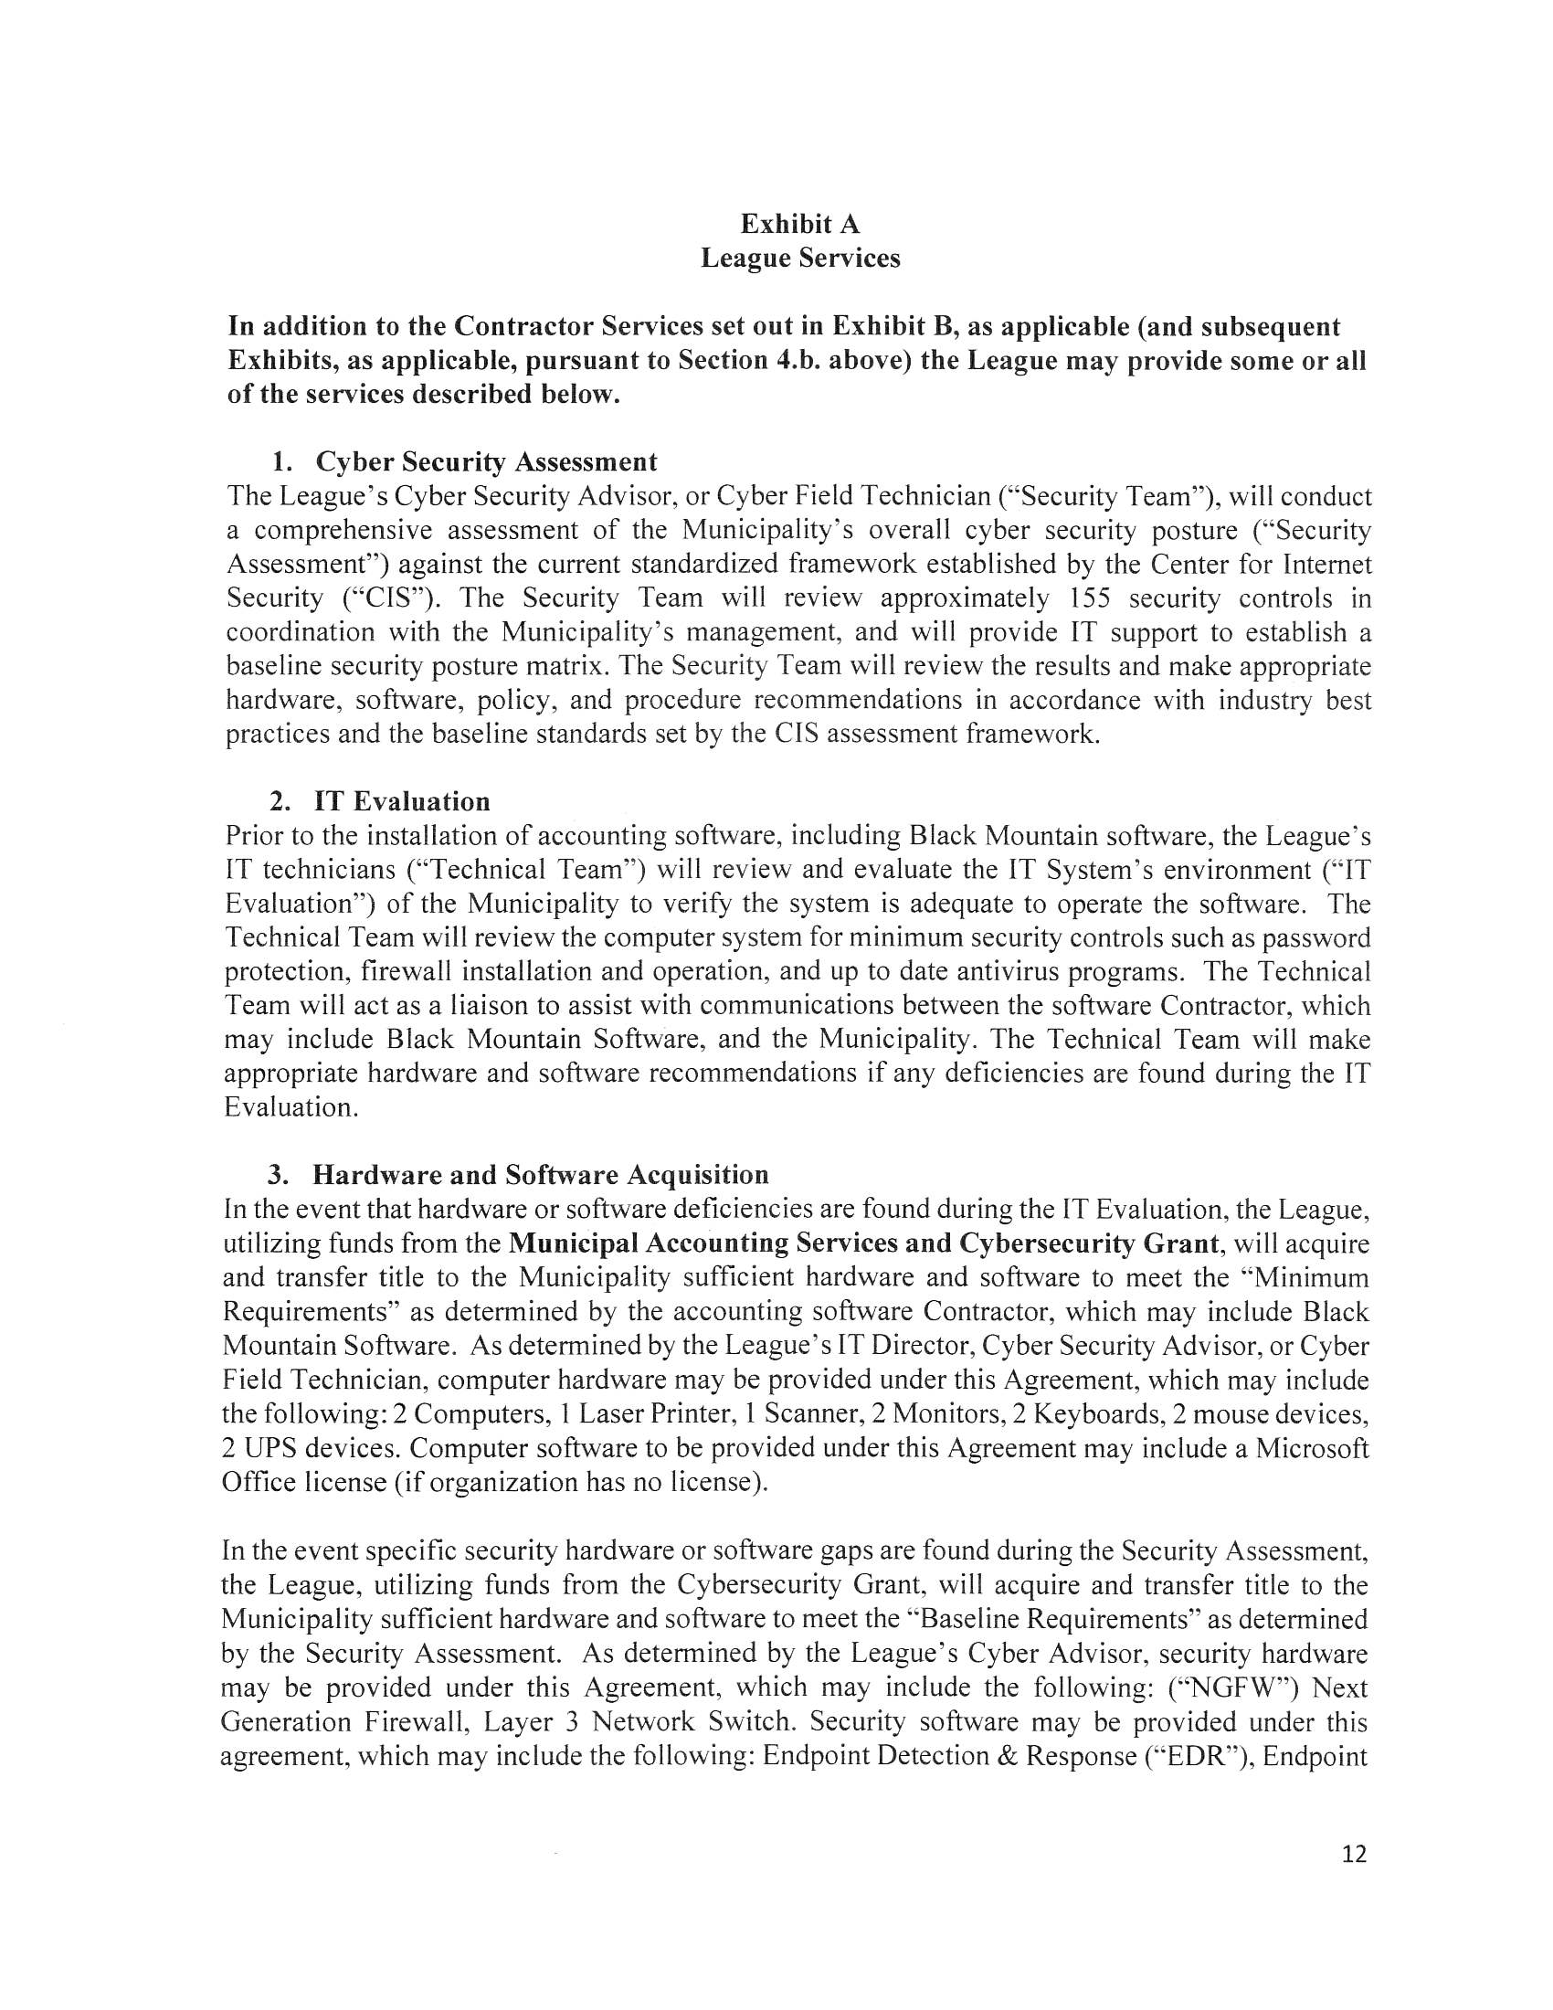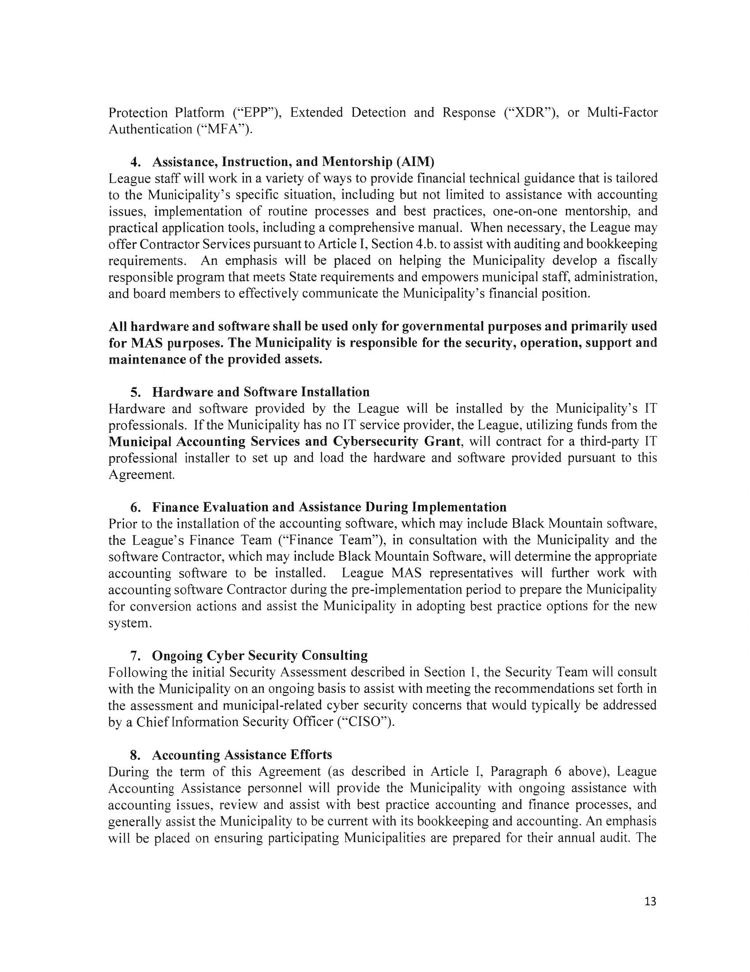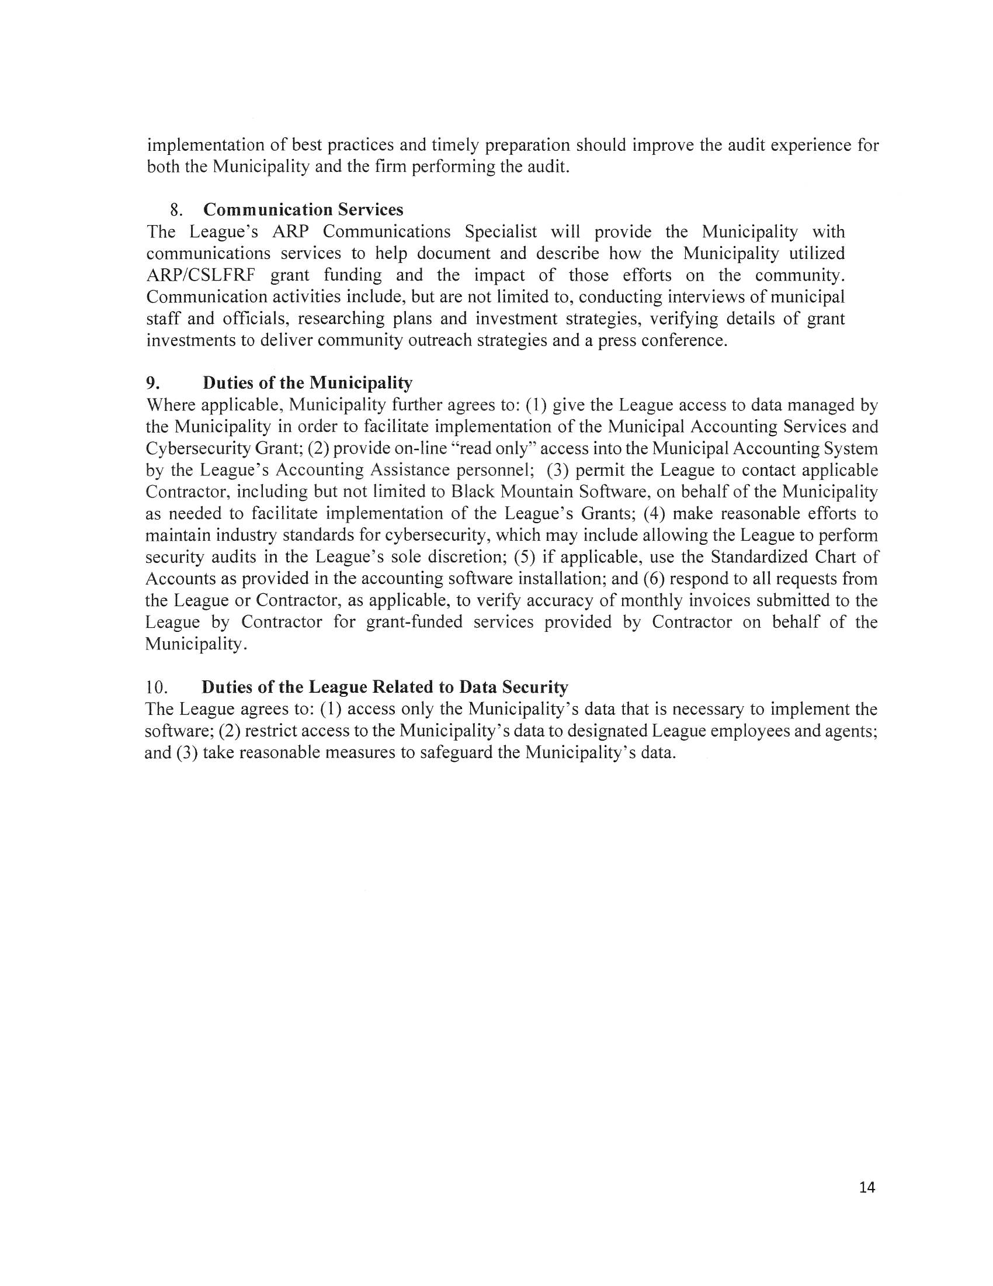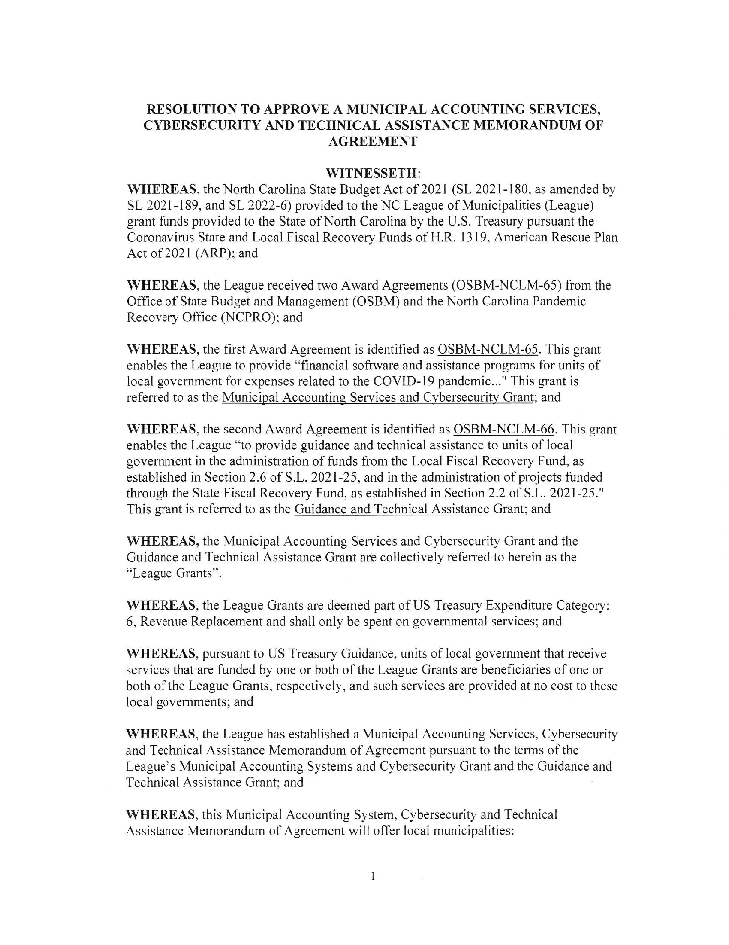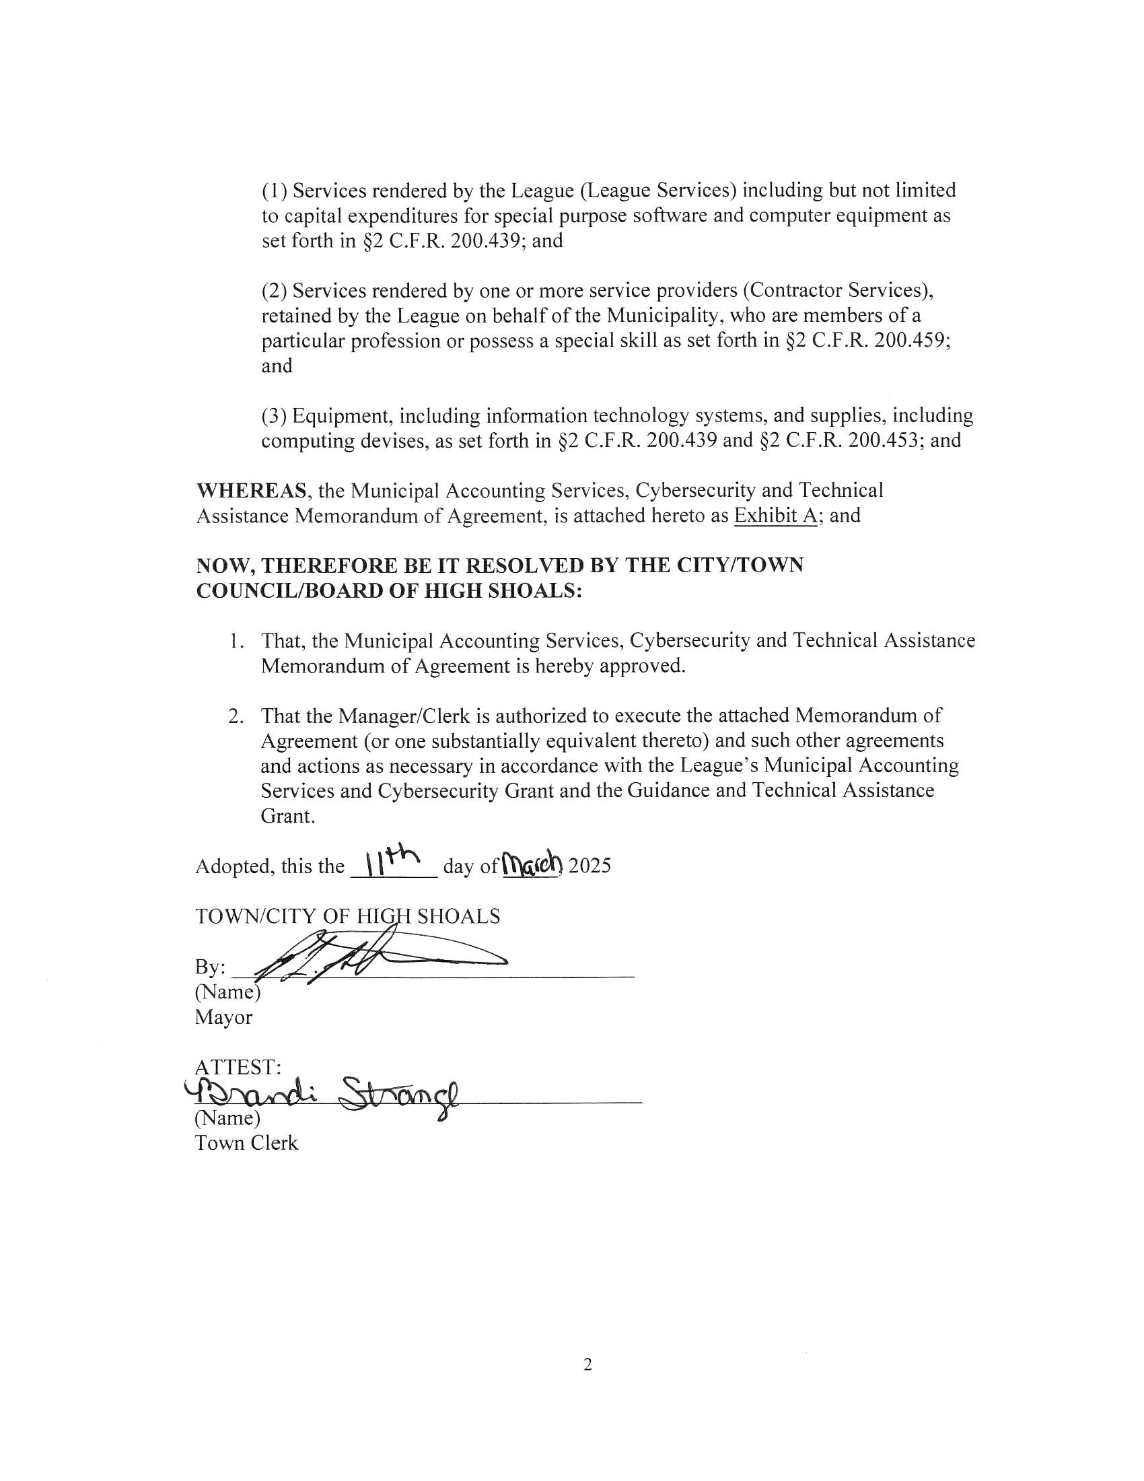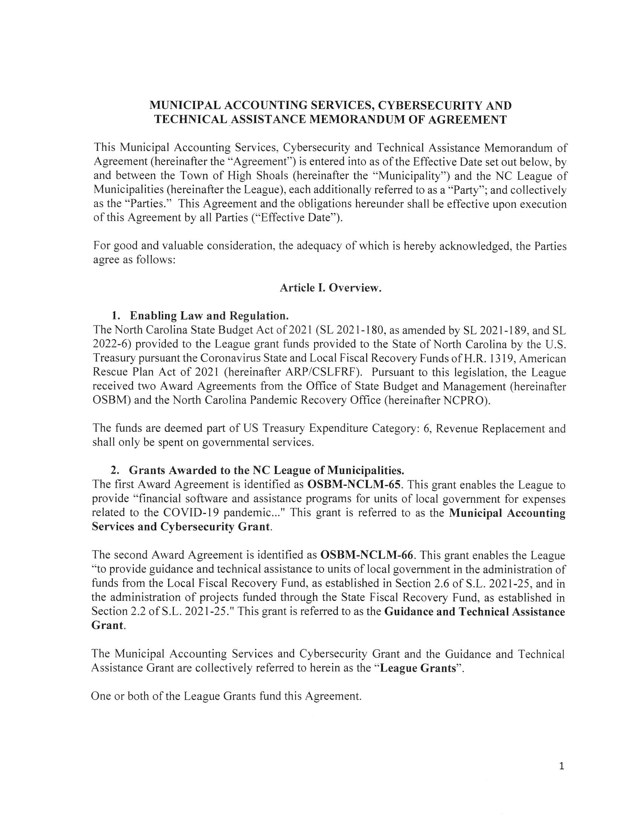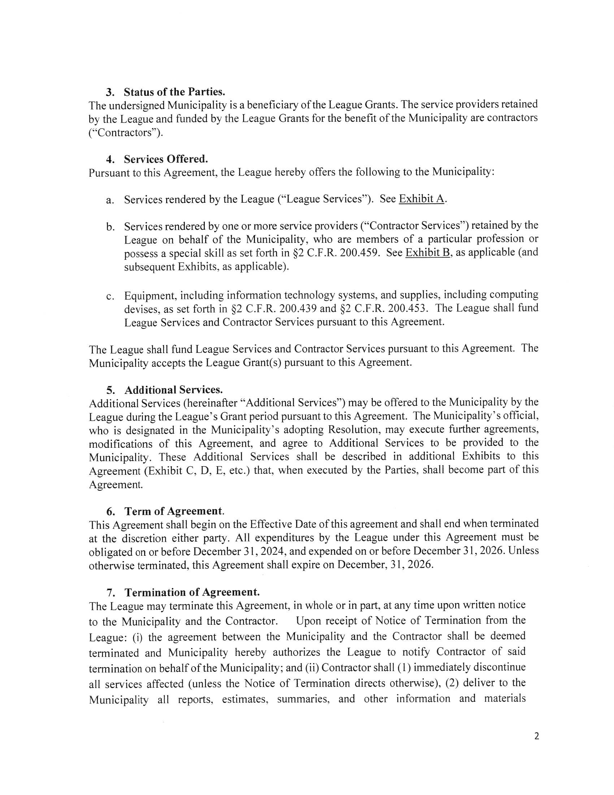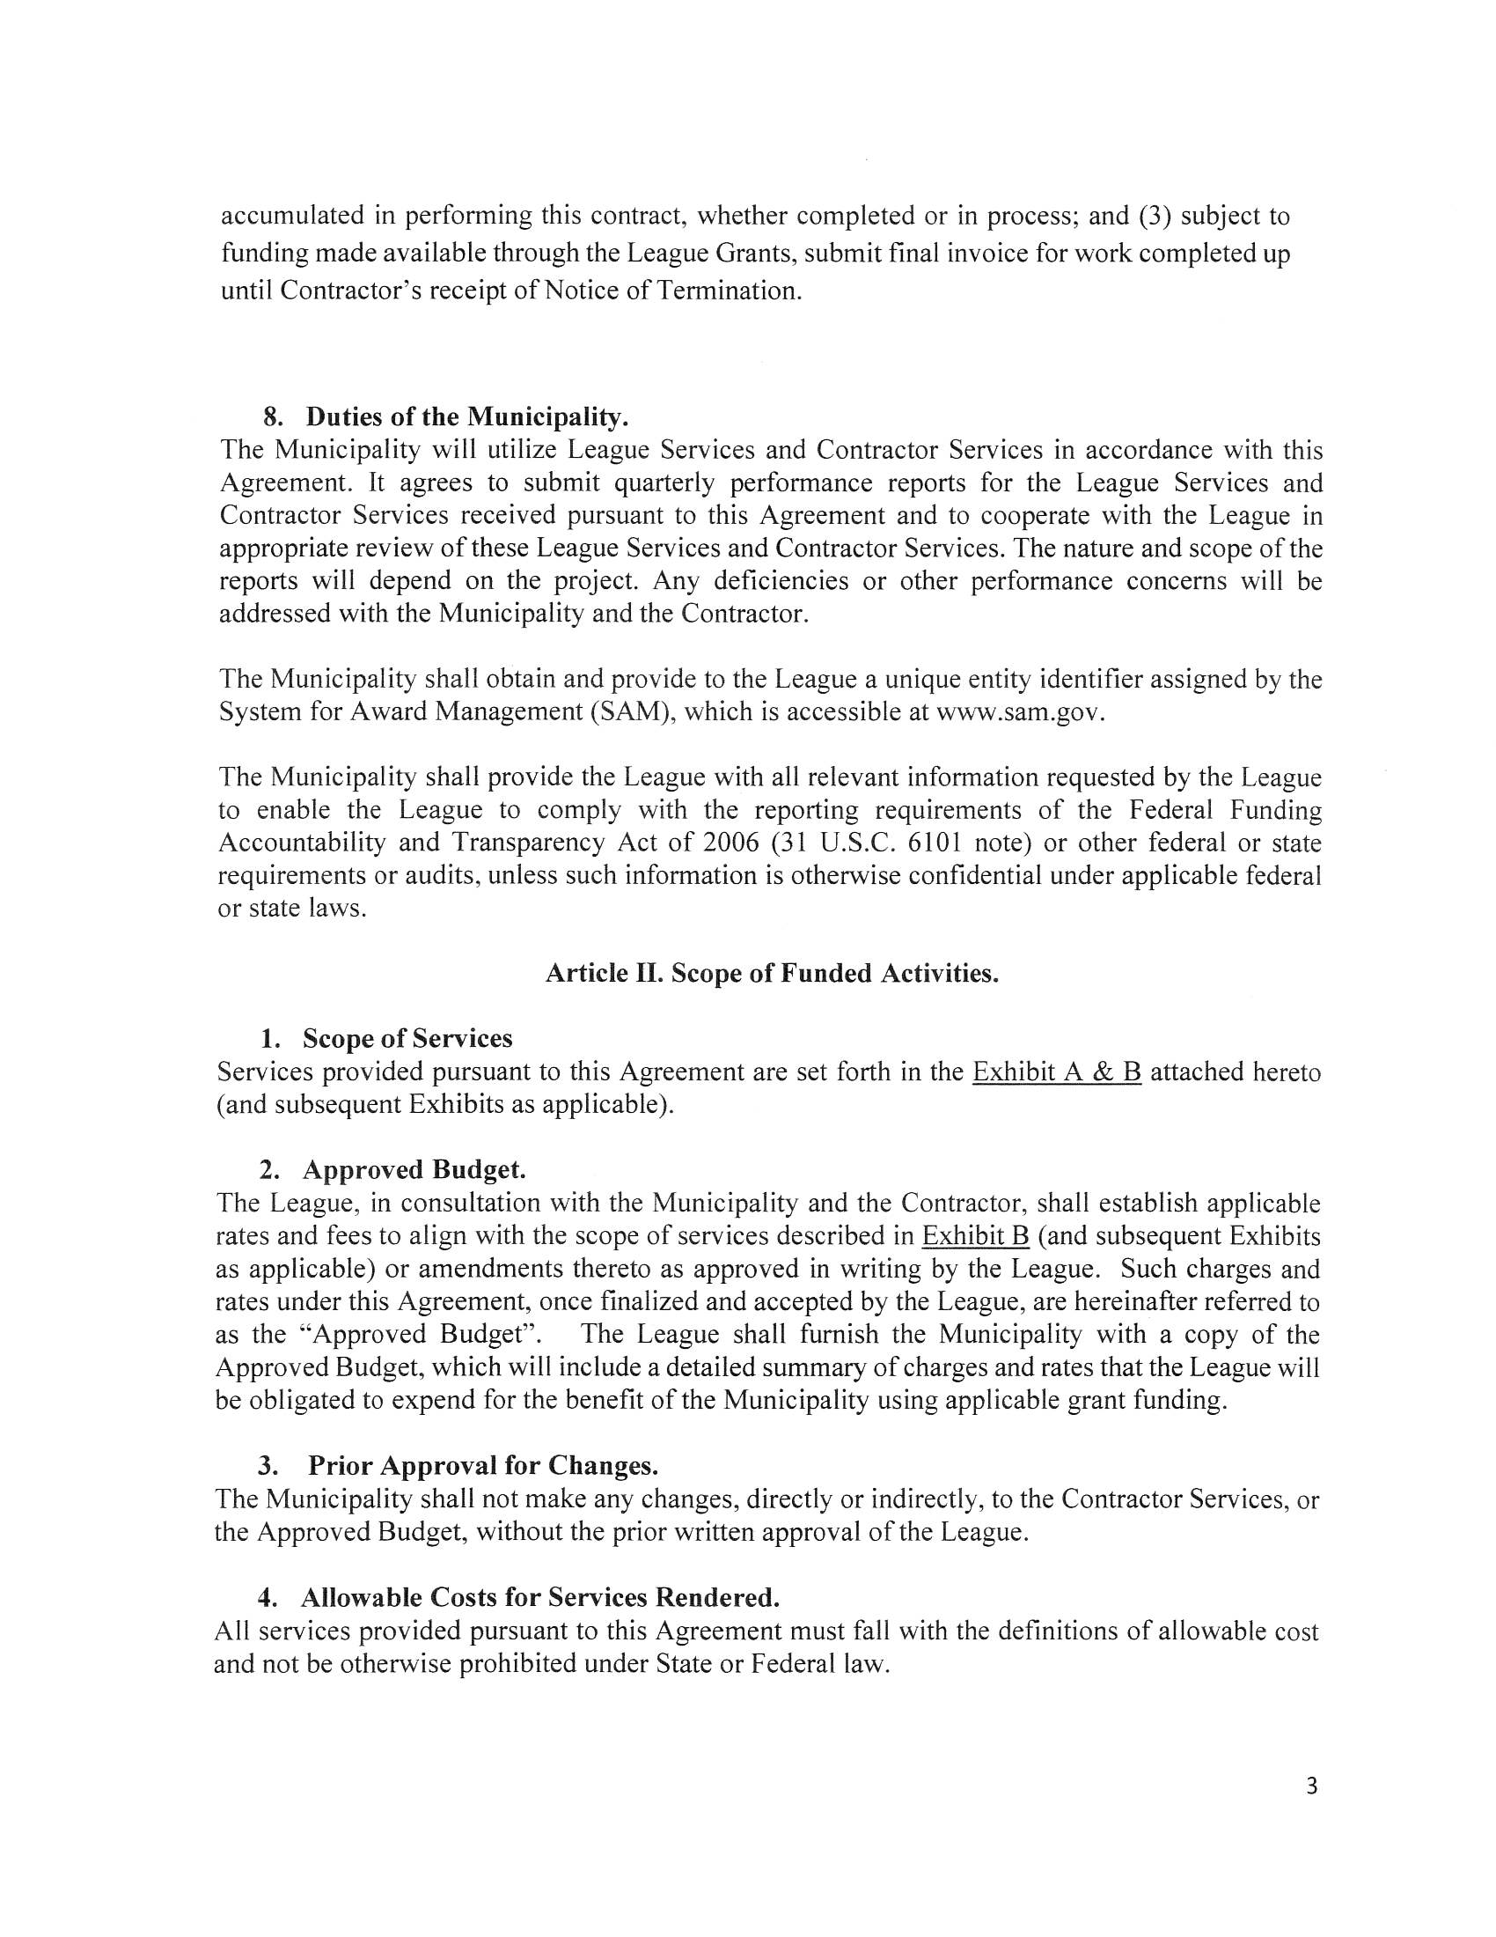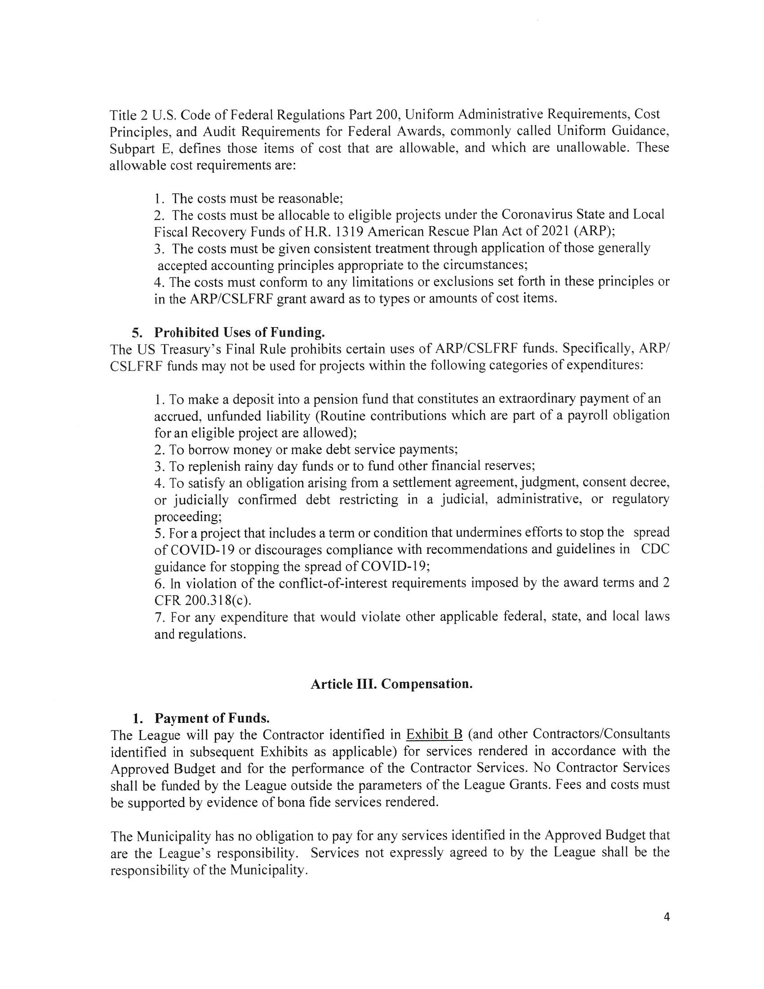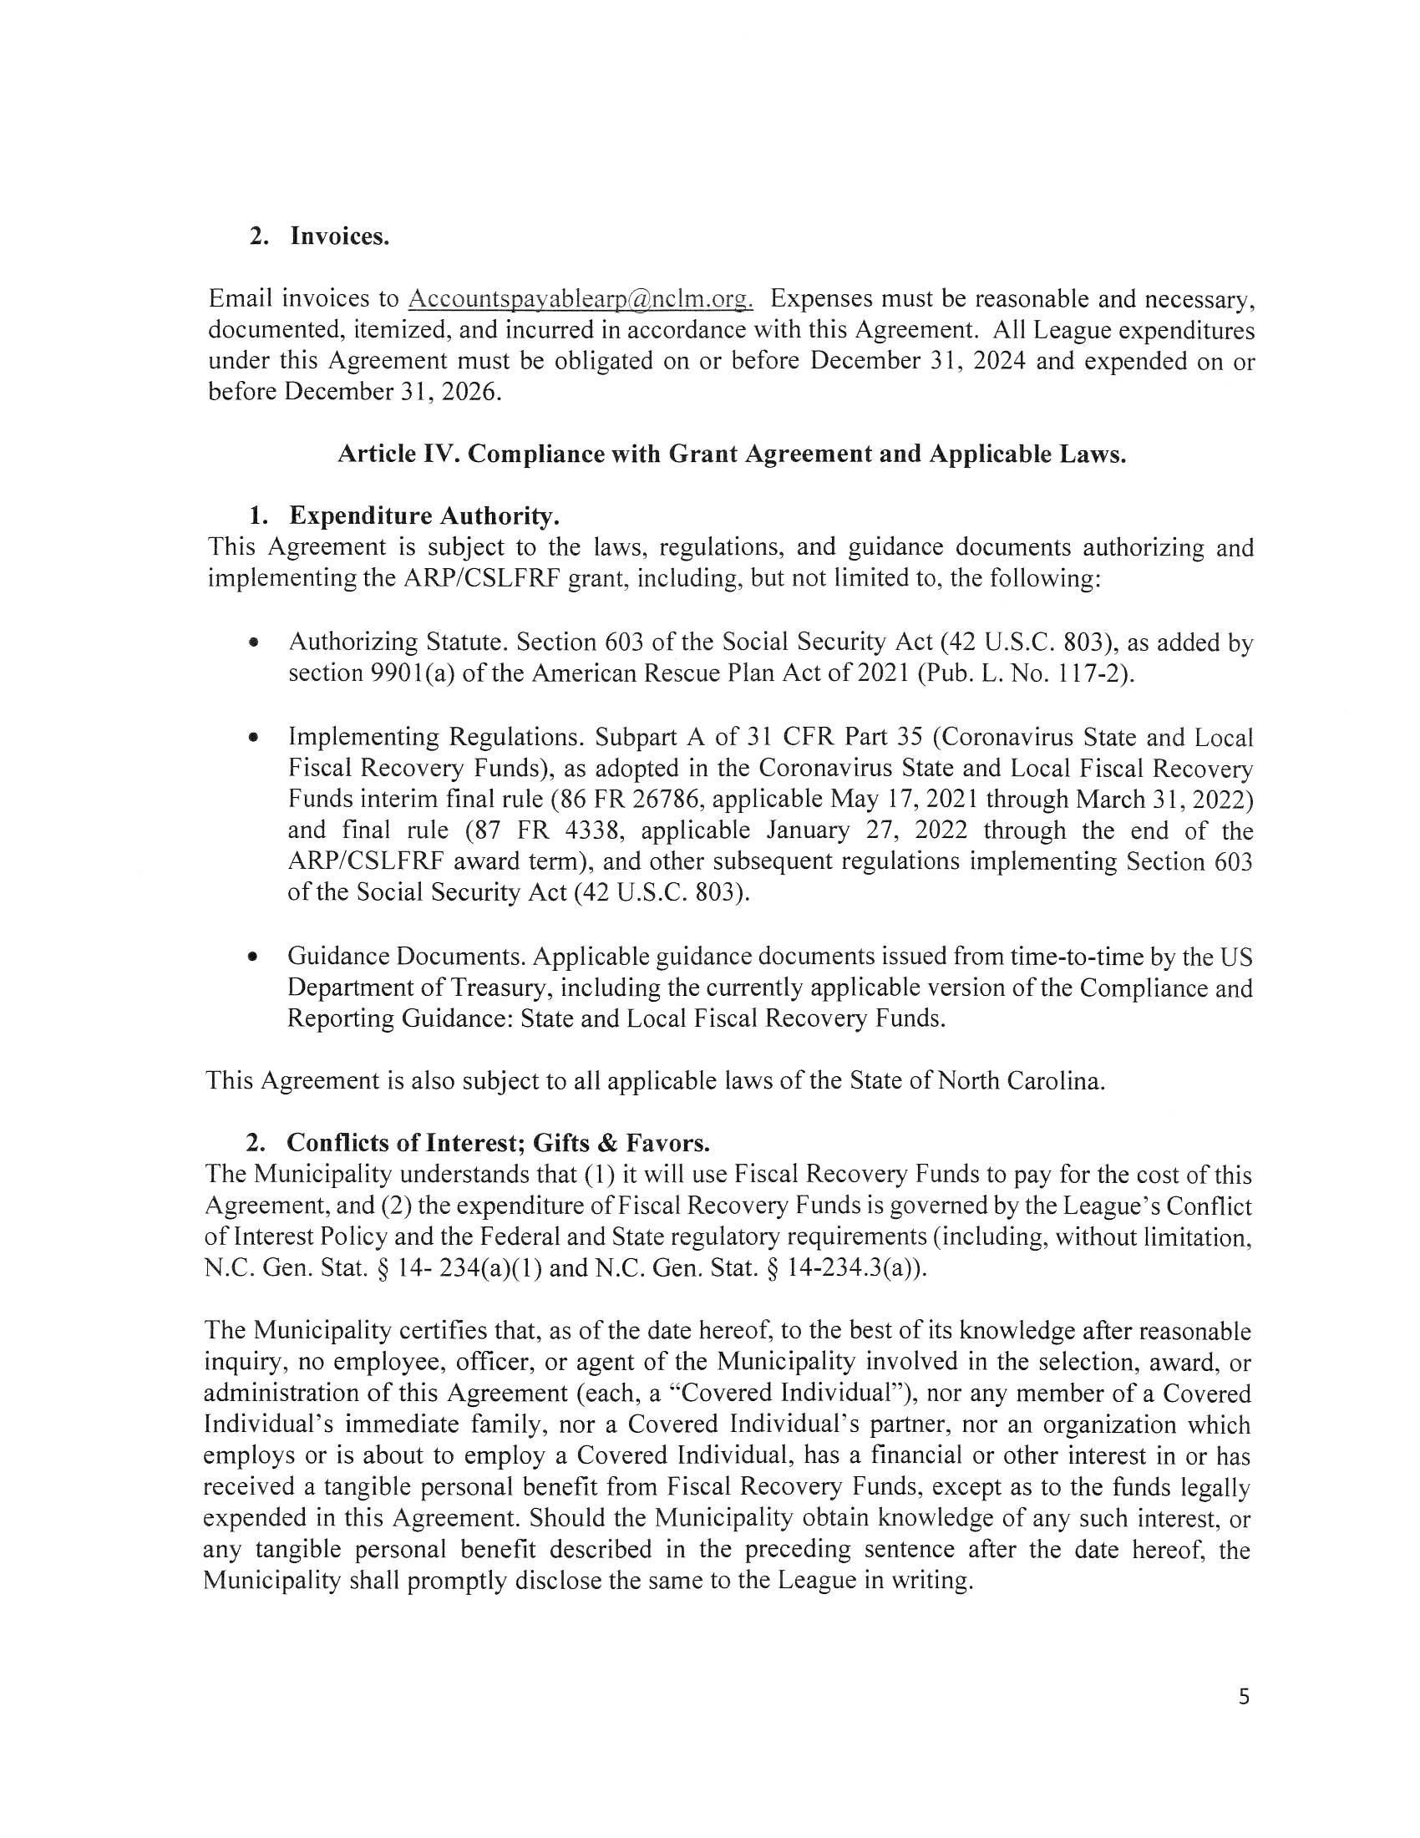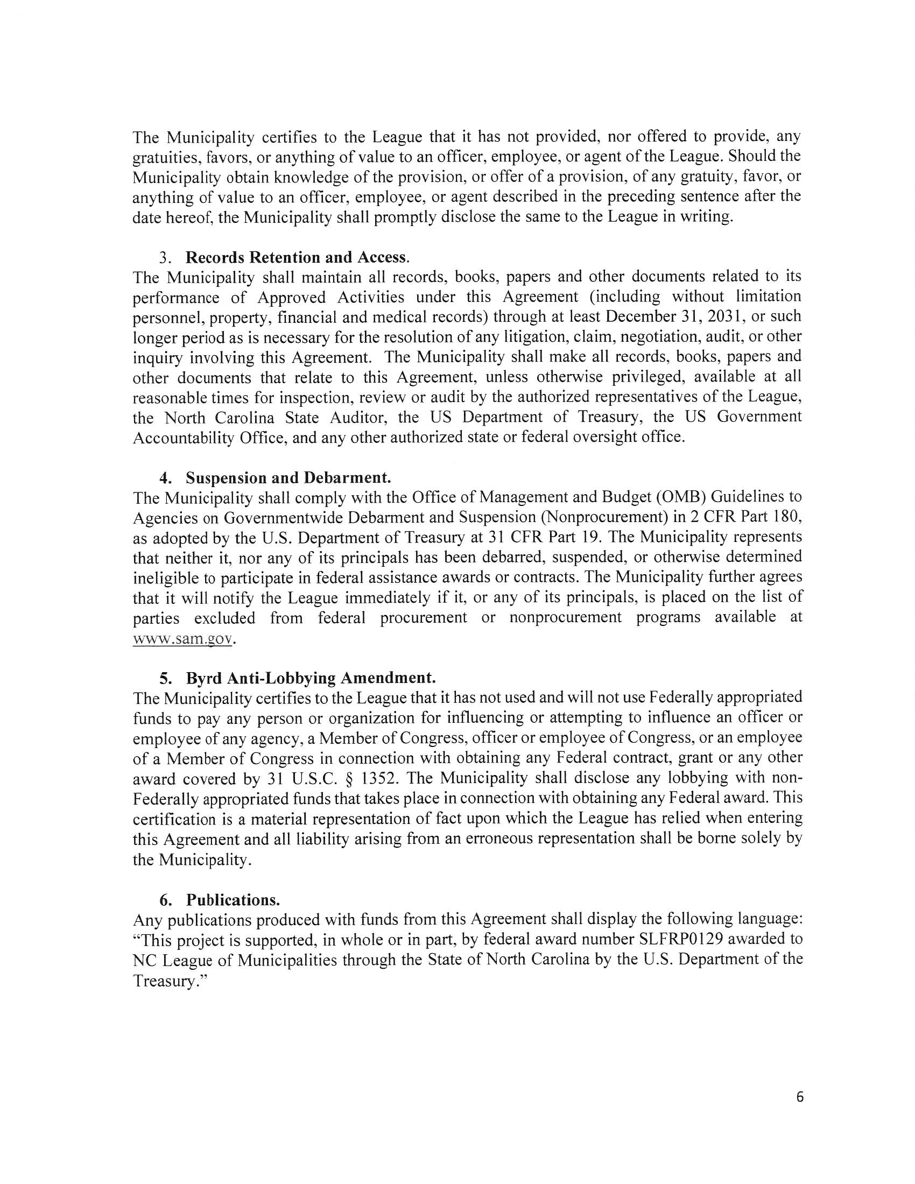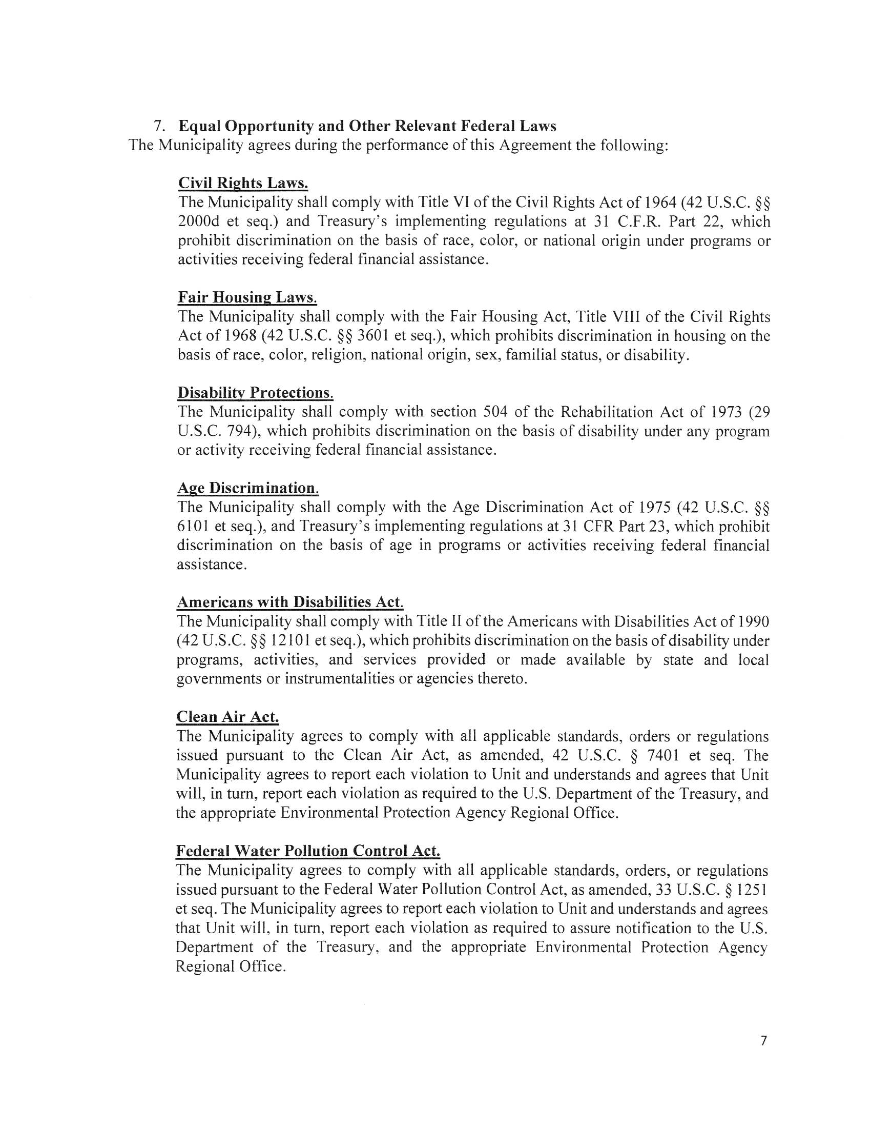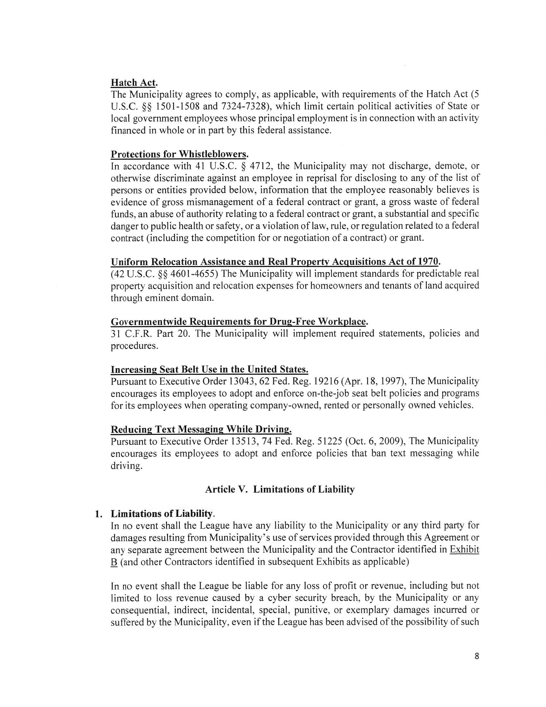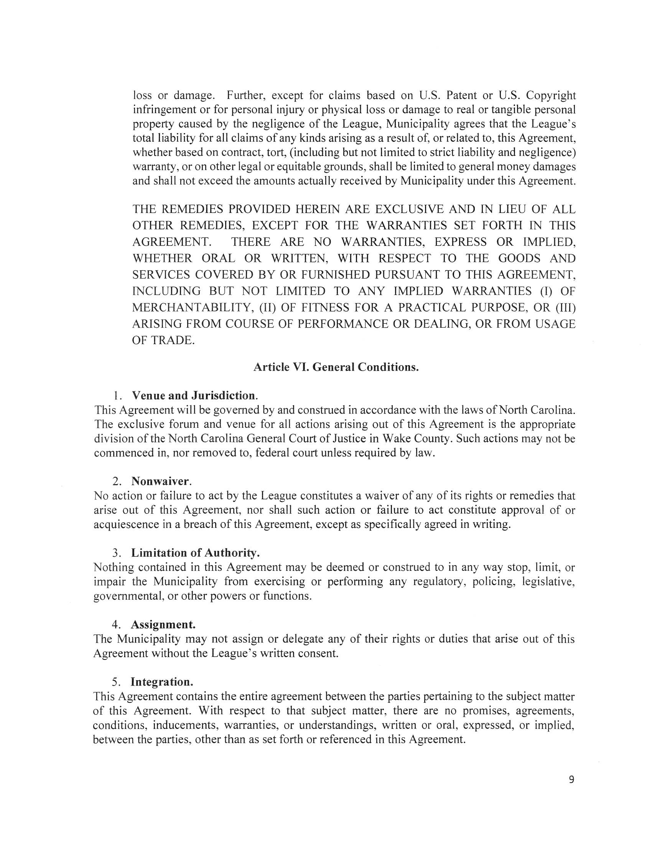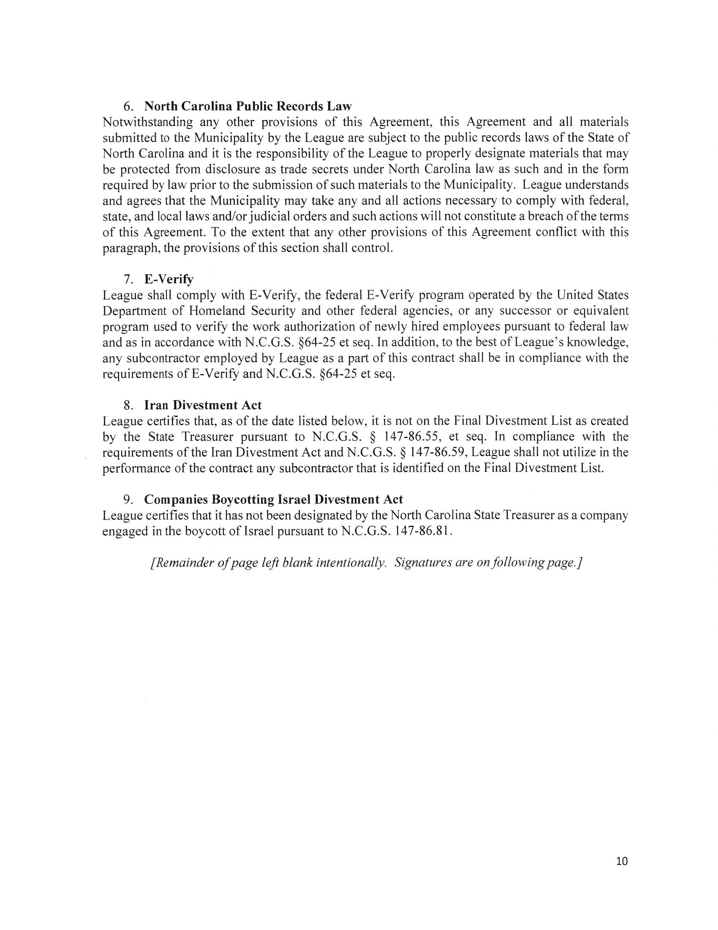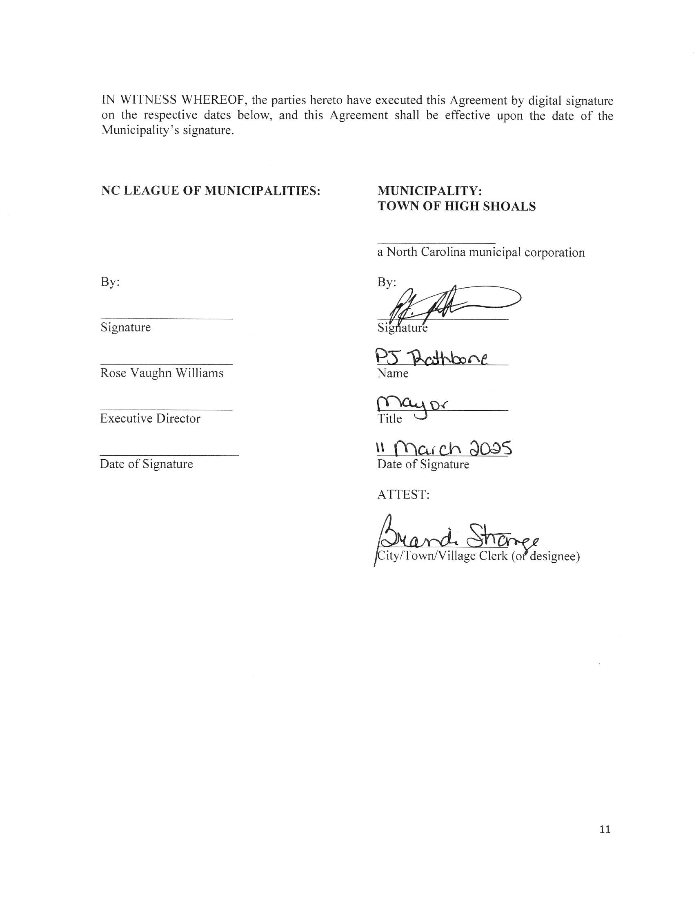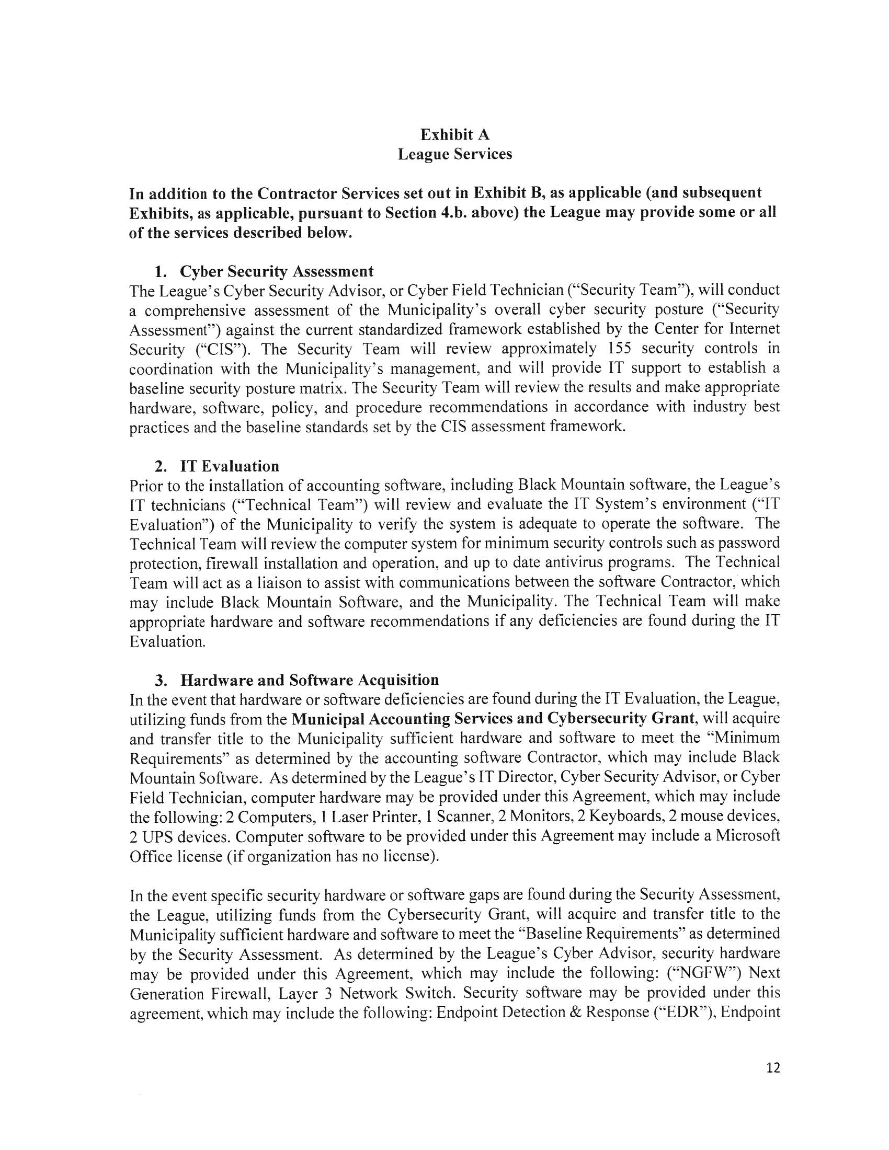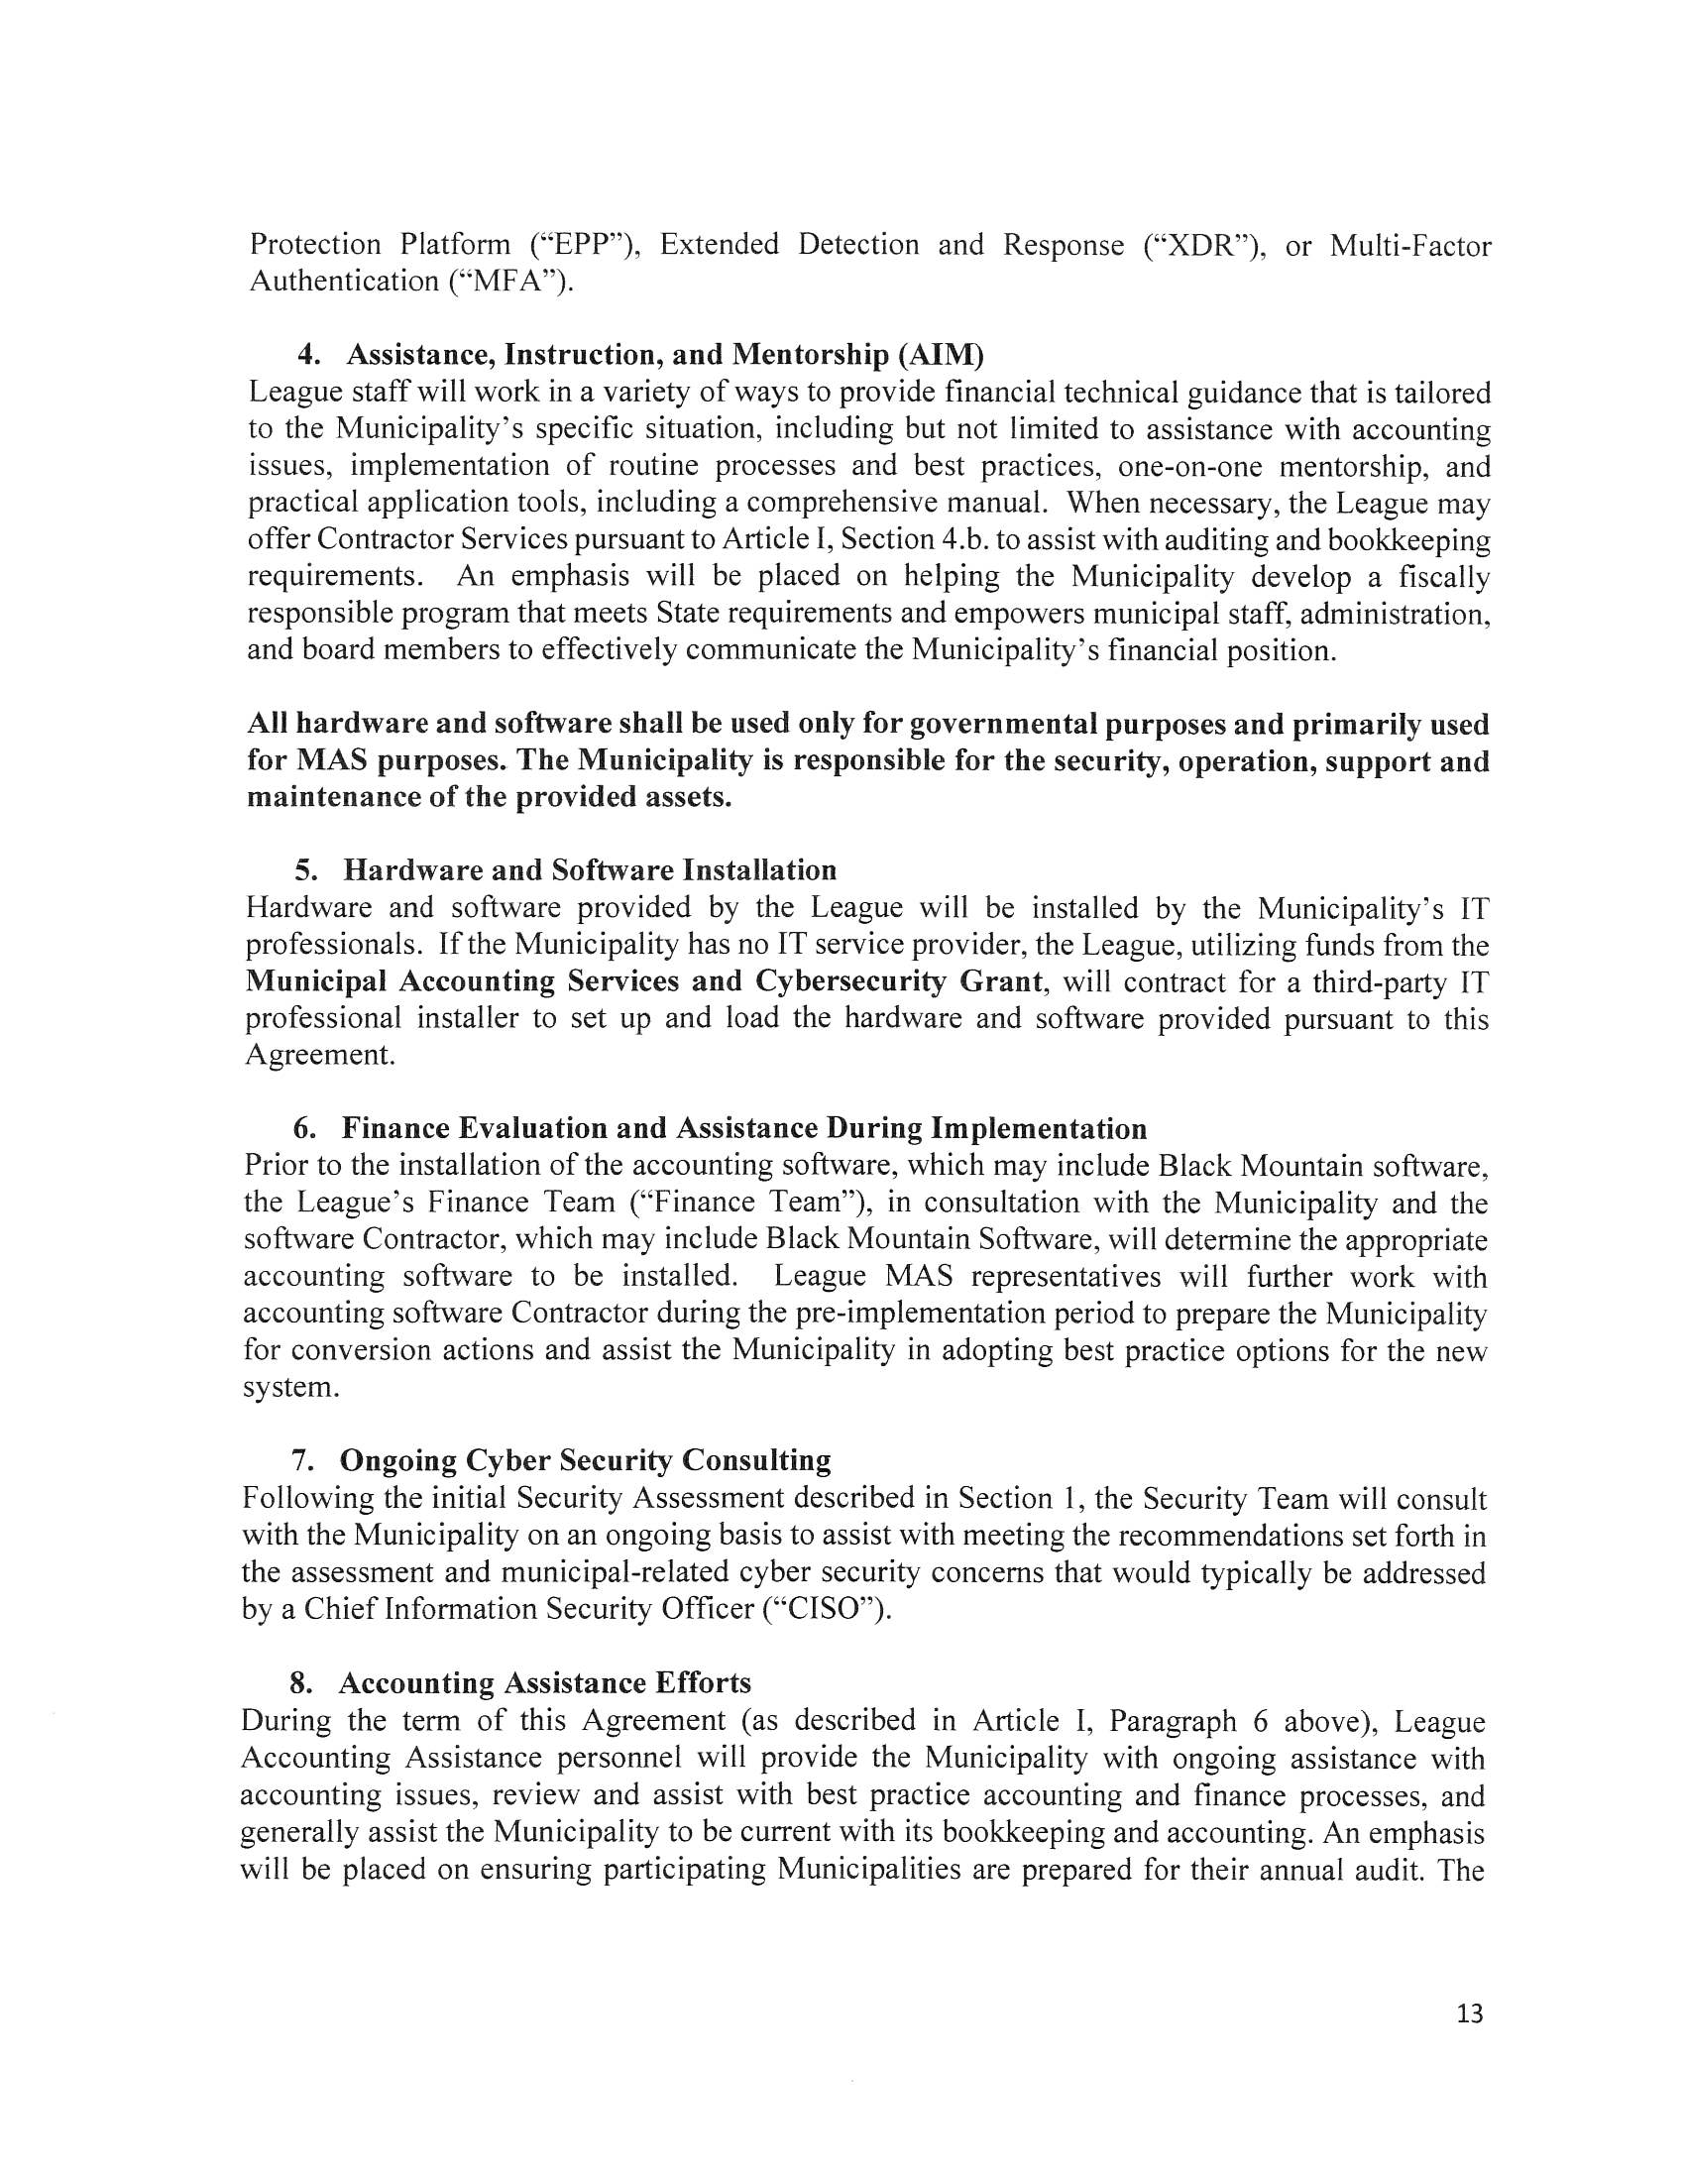
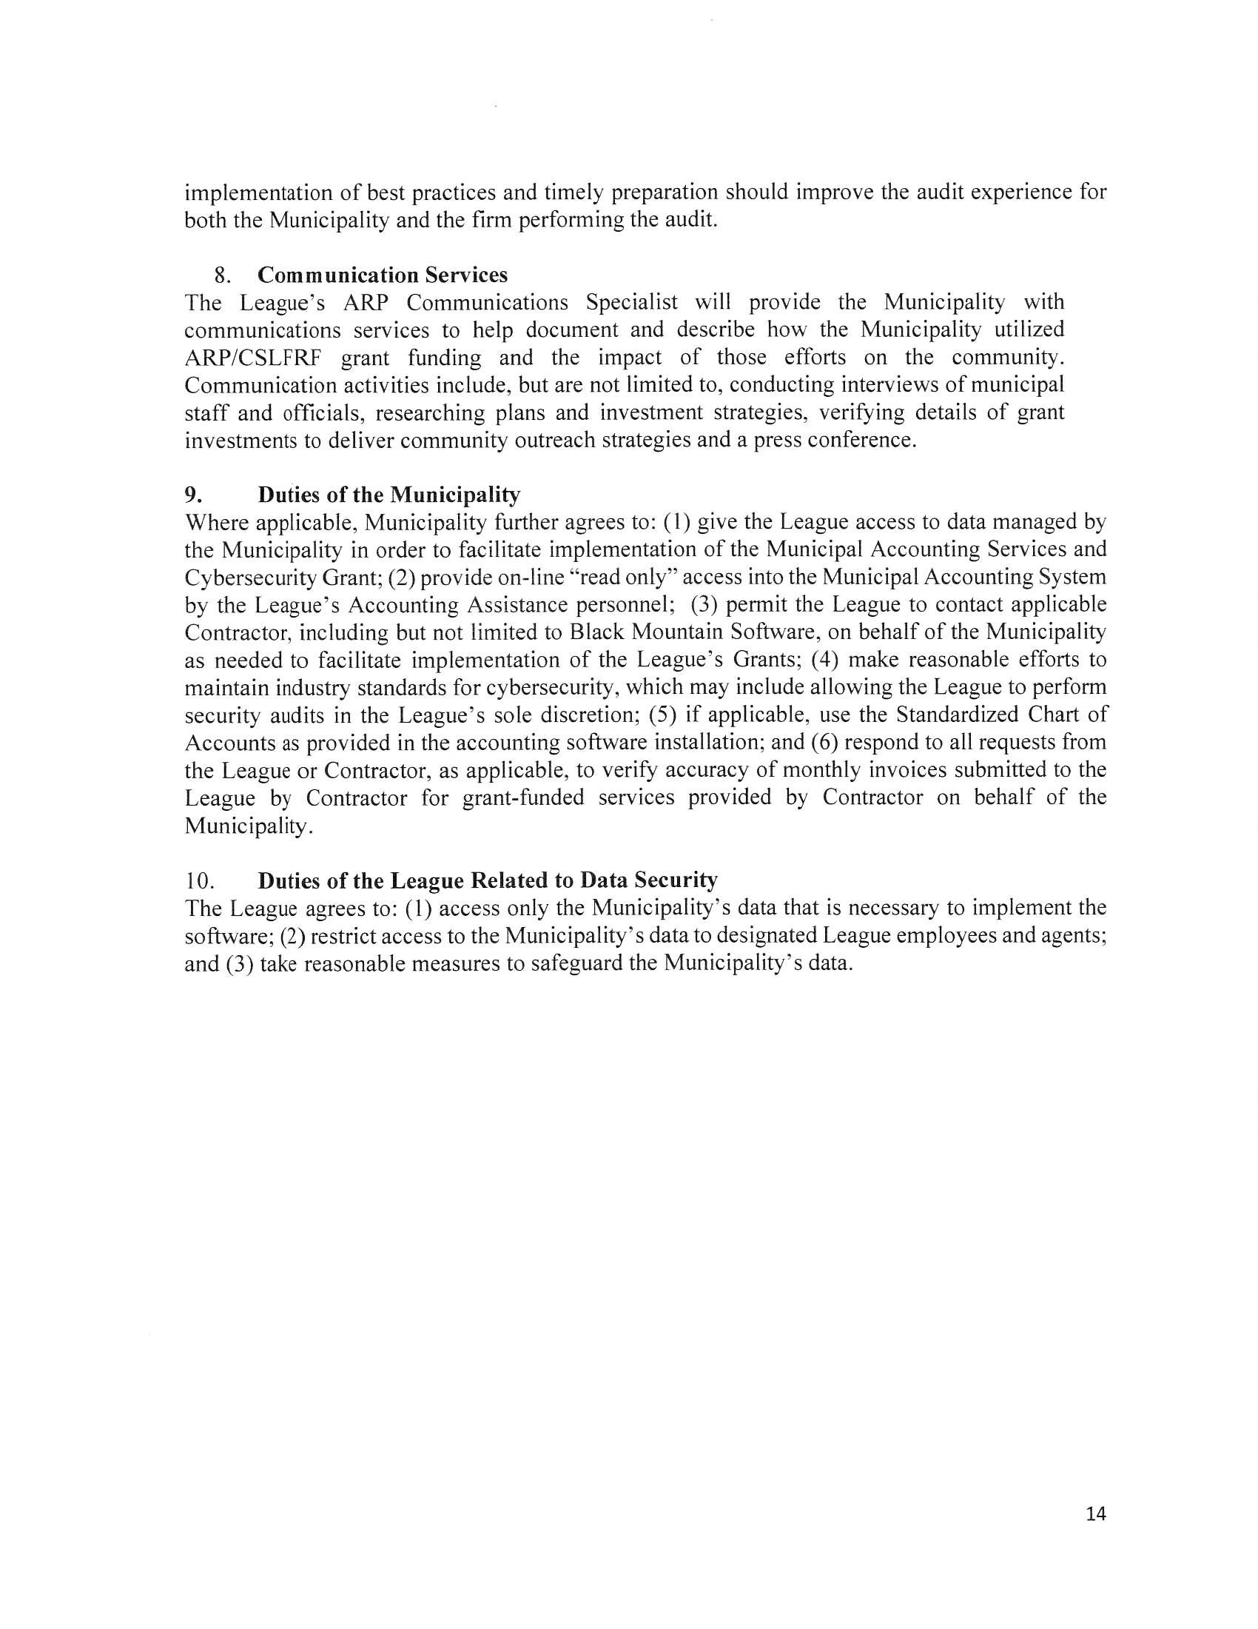
- Discussion: Update on Mill Property
  - We found out some good news. The City has already filed an application through the Brownfield Grant Program, we did receive $260,000 which has been exhausted. So the next step in the process (cutting off a couple years) we are looking at six to seven months. The state has recommended us to perform additional sampling for the risk analysis. Withers & Ravenel are working on getting some Master Funding and a Cost Estimate to see what it is going to take for the sample
- Action: Motion to Adjourn
  - Motion to adjourn made by Dennis Cash, seconded by Kathy Rhyne. All in favor.

