City of High Shoals
Regular Council Meeting
August 13, 2024
- Call to Order
  - Mayor PJ Rathbone called to order the meeting to order at 6:30 p.m. In attendance are following council members: Tim Eidson, Bobby Vassey, Bo Rhyne, Denese Cook, Dennis Cash, and Mayor PJ Rathbone. Kathy Rhyne said that she would be late.
- Invocation
- Pledge of Allegiance
- Approval of Agenda
  - Motion to add engineering and speed bumps to North Street on the agenda made by Dense Cook, seconded by Dennis Cash. All approved.
- Approval of Minutes
  - Motion to approve minutes made by Denese Cook, seconded by Bobby Vassey. All approved.
Citizens’ comments/concerns: The City of High Shoals Council offers citizens the opportunity for Public Expression issues per NCGS 160A-81.1 (limited to 3-5 minutes per speaker).
- First comment from Mrs. Stone. She is here for the situation of the drug situation spreading through the city like wildfire. They are coming in as foot traffic, from 10 pm until 6 am. Aaron is standing across the street sending people from Frye Street to School Street. Last night someone went up Ms. Ellis’ driveway. Drug addicts are pacing in front of her house and watching where her cameras are going to turn on at. This is a continuous thing. The house in question is owned by Michael Poole. Homeless people are staying in the empty houses, throwing trash in the yard and building. They called the cops and the cops said there isn’t anything they’re going to do anything about it because they are after the big fish. The “See something, say something” is a complete joke. The Mayor responded, that she is exactly right, the cops aren’t going to do anything about it. Gaston County is going to come in and condemn the houses but will be costly. This seems to be the only alternative that we have. 205 for a fact, had no toilet in the house, the copper and plumbing had been ripped out of the house until 6-8 months ago, the man that was there for 2 years, would run his truck for power. Everyone of these houses is owned by the same two people and they are refusing to help. The mayor has personally tried to purchase the houses, developer has tried to purchase the houses, and they won’t let them go. Unfortunately, the only way to take control of the situation, the mayor said he wants “shit to change” because it’s not right and we value our neighbors. But these people are not our neighbors. The only route we have is a long process and something will be done. We will not stop until the situation is rectified. Mrs. Stone asked about the noise ordinance, with the dump truck beside it, while she was walking her dog, and the guy started screaming and cussing them while walking on the sidewalk. I had to pepper spray the dogs that tried to attack me while I was walking, and a tow truck driver had to come between us. Police try to come into our house saying they are told to come in there because they’ve got the house. The druggies are the ones that are the root cause of most things. Mr. Stone said he’s been here over 20 years. The main trouble use to be the utility vehicles. Police won’t do anything about them!
  - Mr. Cash said there’s a new brunette, topless, doing cartwheels in the street.
- Michael Poole has been hanging out at Frye Street with the Ose.
- The homeless boy and girl were giving themselves baths at the church. Chris on River Street, has drop cords across the road getting power from Bundy’s house.
- Ms. Neal is here mostly to complain about the mess beside of me. There are trees growing up through my fence. “I’m an 80-year-old woman and my yard is maintained wonderfully”. I can’t keep my house clean because of the traffic coming through constantly all day long. But the trees are killing my fence. Mr. Stone said he’d go look at the fences and see what he can do about the trees in her fence.
- Ms. Ellis said she has done her part, she has the cameras seeing what they are doing. She sends the videos to the policeman and still nothing is getting done. She has videos where they are communicating with lights. She called Duke power, they were stealing the power, now they’re communicating with flashlights. They were pointing a gun in her window. One of the men at that house was taking her pictures. A few days later, they came from Frye Street, to mess around with the meter and they turned the light on. She called Duke Power again, they power company came and cut the power from the pole. I have all the video and try to live her safely, but this city is becoming a “drug-town”. Only the government can start taking some action. To get rid of the 7 houses that are selling drugs. They don’t go to the door when the police knocks, the police just leave. We need police to be here day and night!
- Ms. Ellis requested that at least start legal letters. PJ said we are working toward condemning the property but it takes a lot of time.
- Ms. Judy said she wanted to thank Brian because she has been having limbs fall and Brian told her not to be on the bank weed eating because she almost fell. She asked when the second phase for the homes will begin. Steve said we are waiting for the state to release the funds.
Good of the Order: This is a time set aside for members to offer comments or observations (without formal motion) about the organization and its work. The good of the order is also the time to offer resolution to bring disciplinary charges against a member for the offenses committed outside a meeting.
Ms. Denese said the organ was donated to us by the Cloninger family. There was an Episcopal Church on the hill.
- Departmental Reports:
- Police Report-Gaston County Did not show up to the meeting.
- Financial-Dennis Cash
    - Checking 1: $352,175.58 Checking 2: $ 11,115.65
    - Savings: $160,838.57 Cap Mgmt: $48,099.50
      - Total: $572,229.30
- Cemetery-Denese Cook
    - Brandi has been working hard with the graveyard. We now have two forms for columbarium and a form with headstones. We’re having problems with people taking too long for headstones to be put in. We need to know when they’re coming in to put headstones up.
- Water/Sewer-Bo Rhyne
    - Nothing to report on leaks
- Streets/Maintenance/Sanitation-Kathy Rhyne
  - Everything is working well with sanitation
  - We have filled holes on River Street and at the apartments
  - Parks/Recreation-Bobby Vassey
    - Yard of the Month: – 220 Cherry Street
          - Brennan & Lora Cesena
- Vehicles- Tim Eidson
    - We got HS1 fixed. It is our oldest truck; I don’t believe we need to spend any more money on it.
- Administration/Mayor Report-PJ Rathbone
    - A small update for the old mill property—we finally got a meeting with them. We have a to-do list for us. We have some items that we need to do first before we can move forward. The first thing is we need to do additional sampling. We’re looking into the most economical way to do the sampling.
    - With all the water, power outage, with the exception of one street and one house. There was a tree that fell on the main line at the substation that feeds the entire town and past Long-Shoals Rd. The tree wasn’t in a right of way of the lines, it was large and just fell. We have a lot of lines that are covered by trees.

- Old Business:
- Discussion/Action: HR manual approval
  - Ms. Becky is here regarding the HR manual. The council has a chance to make any updates or changes to the manual.
  - Dennis Cash made the motion to approve the HR manual, seconded by Bo Rhyne. All approved.
    - The mayor asked how we implement this the correct way.
    - It is important that everyone knows it has to be followed. There can be legal consequences for violating your own policy. Ms. Becky said she is happy to answer any questions if there are any questions that may arise.
    - The issue implementing the pay plan is to get the pay plan to get the tier implemented to phase in the pay. The council has started initiating the pay scale.
From this point on is sharing the expectations and getting the information to our employees and our council.
    - There are some pieces in here that can’t be implemented such as the retirement system. The biggest issue that she sees in towns is that the employees have too many bosses. They get pulled into too many directions. Having CLEAR regards to who tells the employees what to do. That is one that council has to work together on. One thing that she has done is 2-3 hours retreat with towns/cities to be effective. The biggest thing is following the policy. They councils don’t want to change.
- Discussion/Action: Military Banners
  - We have five applications ready to go and these will be the last five that will be ordered.
- Discussion/Action: Updated Dallas Water Contract
  - We have previously voted on this, and we had to change the wording and there was no start date. It has the exact same cost. Denese Cook made the most to approve the contract seconded by Bo Rhyne. All approved.
Public Hearing—CDBG #21-C-4014 (additional $320,565 for Rehabilitation of Private Dwellings & Administration

Public Hearing – CDBG #21-C-4014 -Additional Funding Request.

Mayor Rathbone asked for a motion to open the public hearing. The motion was made by Dennis Cash and seconded by Bobby Vassey. The Mayor then asked Steve Austin to provide background information. Mr. Austin stated that in December 2022, the City of High Shoals was awarded $950,000 in Community Development Block Grant (CDBG) funds to rehabilitate up to six single family homes located throughout the City under the program called Neighborhood Revitalization. That grant is named CDBG #21-C-4014 by the state. Five units have been completed. In April 2024, the City was awarded another Neighborhood Revitalization grant also in the amount of $950,000 which targeted five homes. That program is CDBG #22-C-4125. With the first grant, the city was only able to provide assistance to five of the six targeted units. Inflation was the factor involved.

In June 2024, the state sent out a notice that additional funds were available to local governments with open grants that needed extra money. The city applied and was awarded an additional $45,065. This grant is called CDBG #17-D-4014 That allowed the city to complete the five units under construction without having to cut out any repairs needed in the homes.

Mr. Austin stated that the Department of Commerce had sent out a notice in July that if more funds were needed, they were available. However, the money had to be spent by the middle of September 2024. With this opportunity, the City can apply for an additional $287,000 that would allow the City to provide assistance to one unit targeted in the new grant. The $287,000 would be combined with the $45,065 received last month for a total of $332,065.

The unit was targeted to be demolished and replaced with a modular home. The extra funds could provide for that purchase in the time frame, unlike with the remodeling which can take months to complete. The funds for the new grant (CDBG +#22-C-4125) are expected to be released any day now so the work can begin on the other five homes targeted in the new grant.

The unit in question for replacement with a modular home will have the same restrictions as with the rehabilitated houses in that a lien is placed on the property and the owner must sign a promissory note not to sell the property for 10 years.

The extra money from the state comes from left over Community Development Block Grant money from 2017 that must be spent as soon as possible, or it must be returned to the federal government.

Based on this, it is recommended that the City amend its Neighborhood Revitalization grant (CDBG #17-D-4014) by submitting a formal amendment application to the state requesting an additional $287,000 for a total of $332,065.

The city has already been approved for an additional $250,000, but the city is now asking for an additional $37,000 to make sure all aspects of the project will have adequate funding. The reason for the public hearing is because the city is asking for more than 10% of the original grant amount.

Once the amendment request forms have been submitted to the NC Department of Commerce, the City will be notified in writing of their approval. Until the City receives that letter of approval no funds can be committed to any work to be done on those additional units.

As always with this program, no city local funds are required to be spent. No other changes in the overall project activities are proposed, and no change in the grant project budget is needed for this amendment request.

Mr. Austin stated that after the public hearing, the Council must approve the attached resolution authorizing the Mayor to submit the amendment application to the NC Department of Commerce as well adopt the attached project budget ordinance for the City’s accounting.

The Mayor asked if there were any questions from the Council. There were none. He then asked if there were any questions from the audience. There were none.

The Mayor asked for a motion to close the public hearing. That motion was made by Kathy Rhyne and seconded by Bobby Vassey. All approved.

A motion was made by Denese Cook to adopt the resolution authorizing the Mayor to submit the amendment application on behalf of the City. It was seconded by Bobby Vassey. All approved.

A motion was made by Denese Cook to adopt the resolution authorizing the Mayor to submit the amendment application on behalf of the City. It was seconded by Bobby Vassey. All approved.
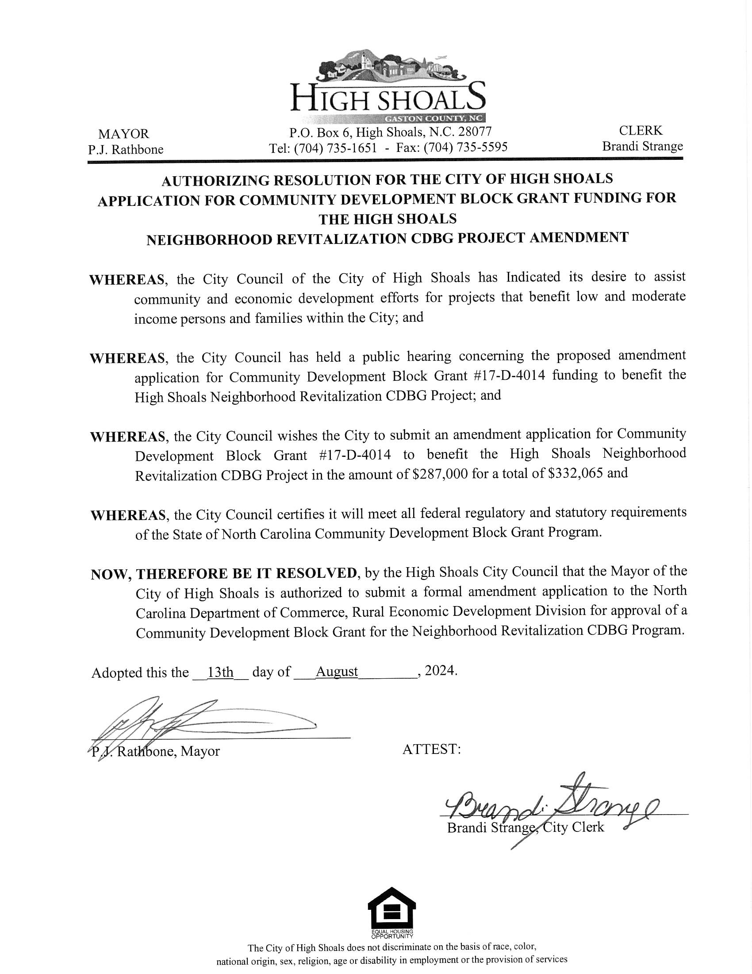
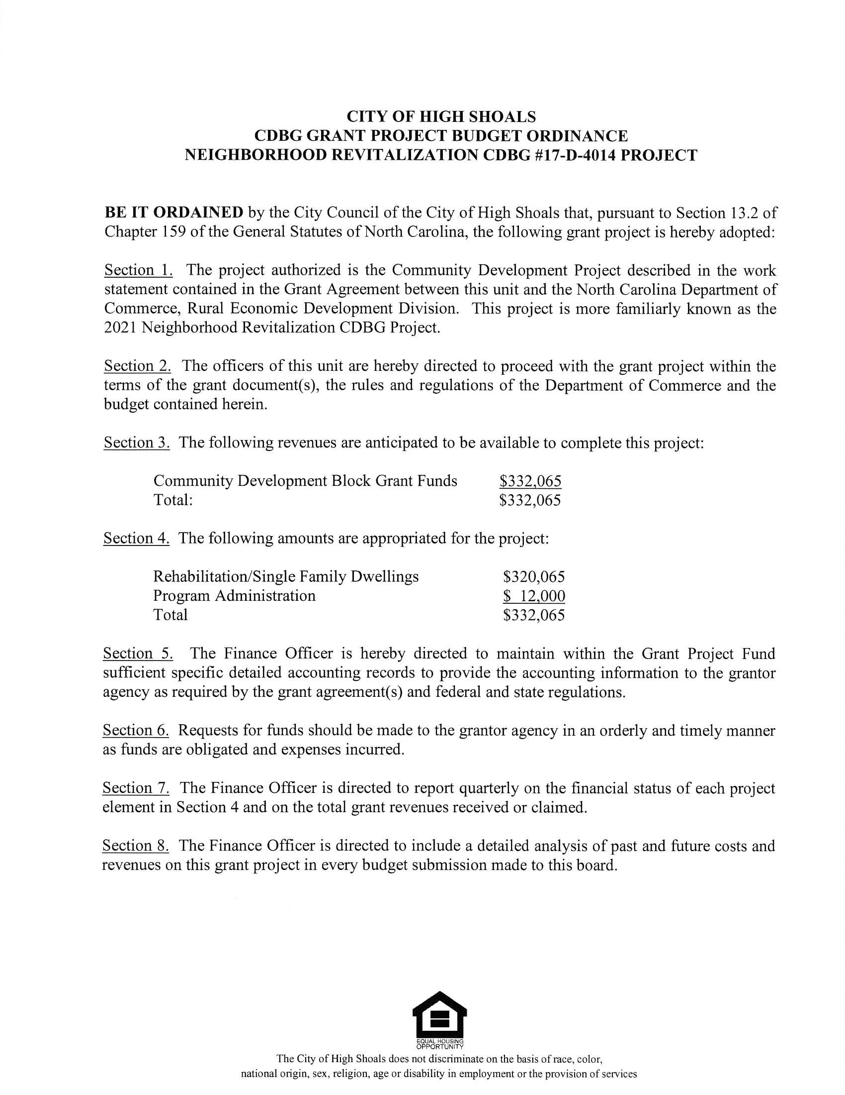

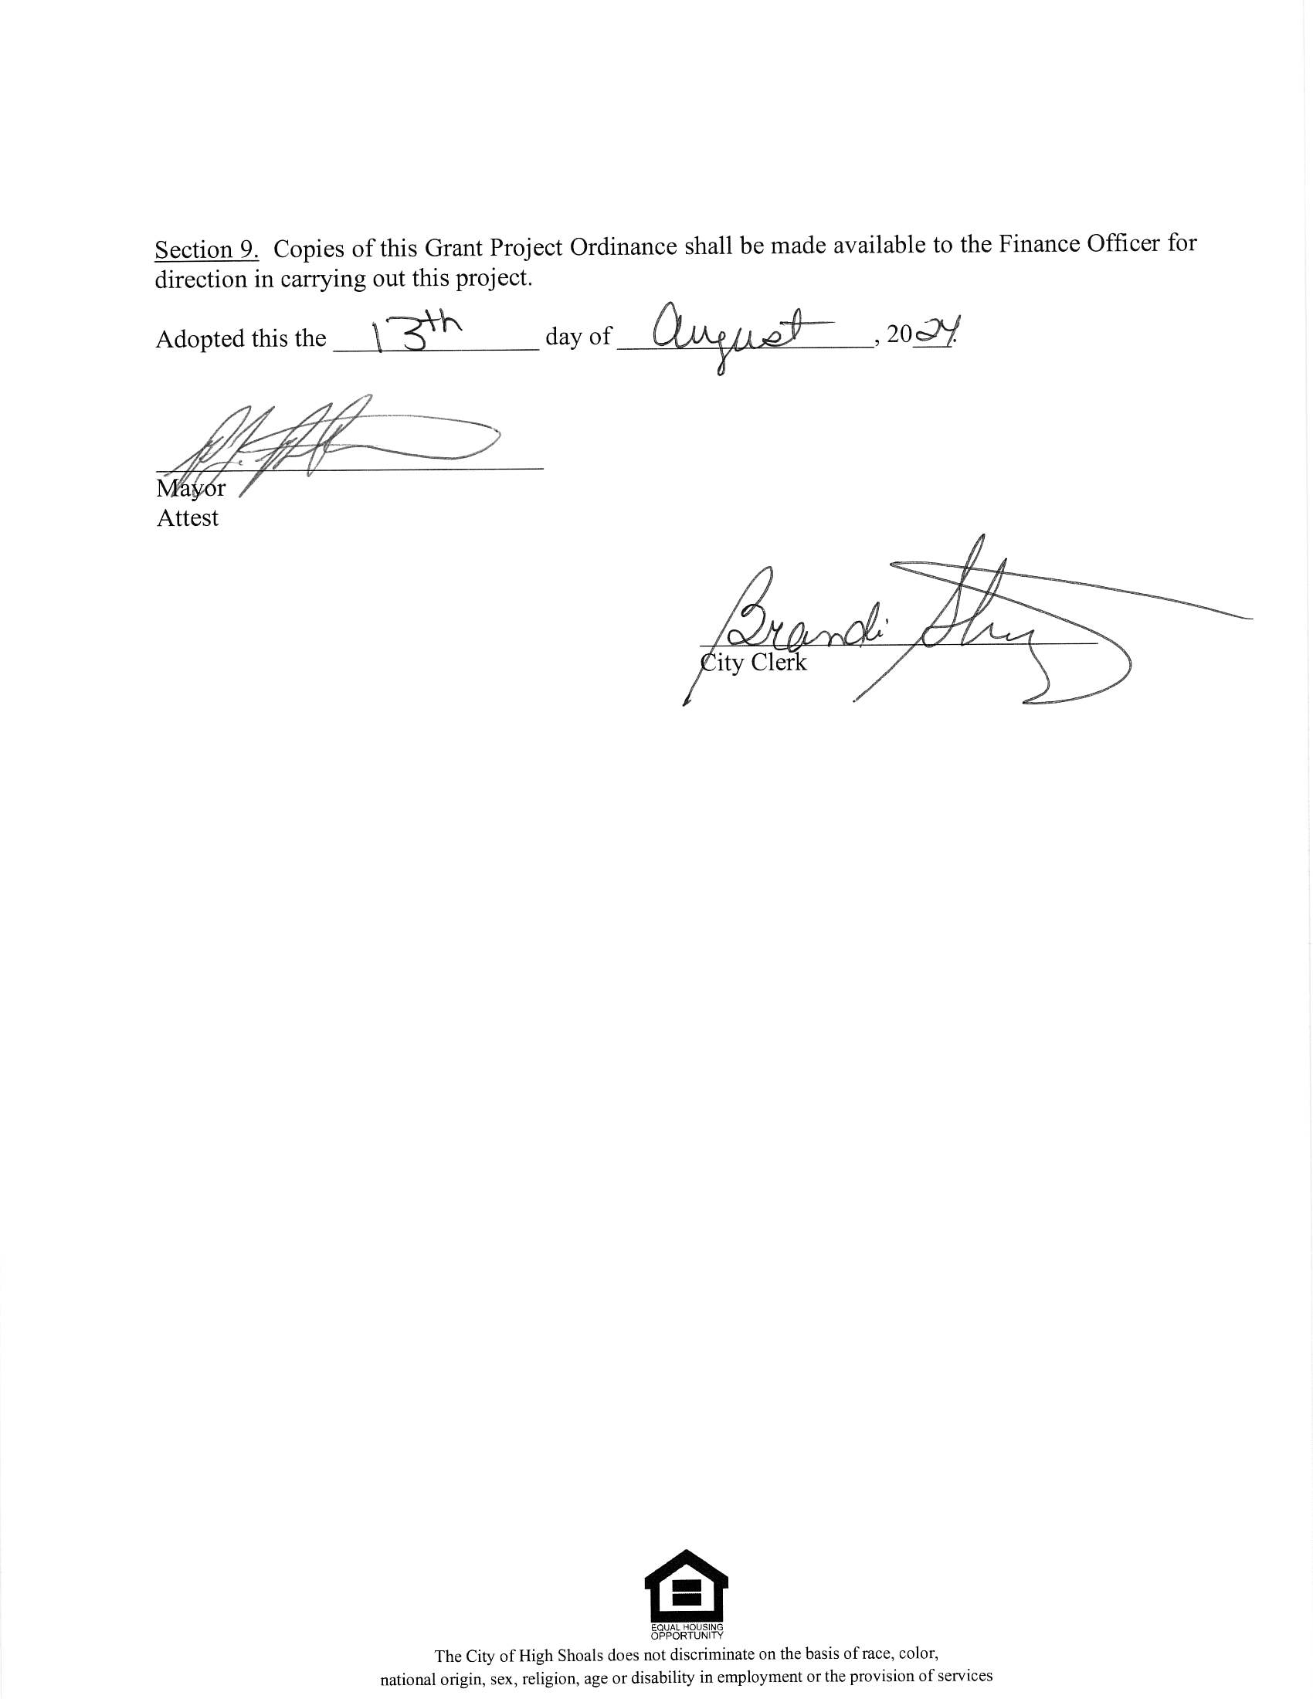

- New Business:
  - Engineering contract for water grant coming up. There are two books in front of you. There is Thrasher and Diamond Engineering, we read through the rating sheet. Don Smith had double bypass a few years ago. The stress was killing him. In 2021, he was going to close his business down. He received a call by Thrasher two months later and had seven or eight offices. Thrasher is reputable and Courtney (his daughter) will be working on the project for us. Don is leaving in December of this year. Don said that he can state that we will be in good hands. Kathy Rhyne made motion to accept the Thrasher Group, seconded by Denese Cook. All in favor.
- Discussion/Action: Required Policies, Procedures, Plans, Resolutions, and Ordinances for the 2023 Phase 2 Water CDBG-I Project
  - Motion to approve and accept the following policies, plans, procedures, and resolutions for CDBG revitalization grants: Equal Employment Opportunity, Procurement Policy & plan, citizen participation plan for CDBG grantees, action plan and resolutions, fair housing compliant procedure, code of conduct policy, and section 504 Compliance Officer/grievance procedures and Thrasher Contract for CDBG made by Denese Cook, seconded by Kathy Rhyne. All in favor.

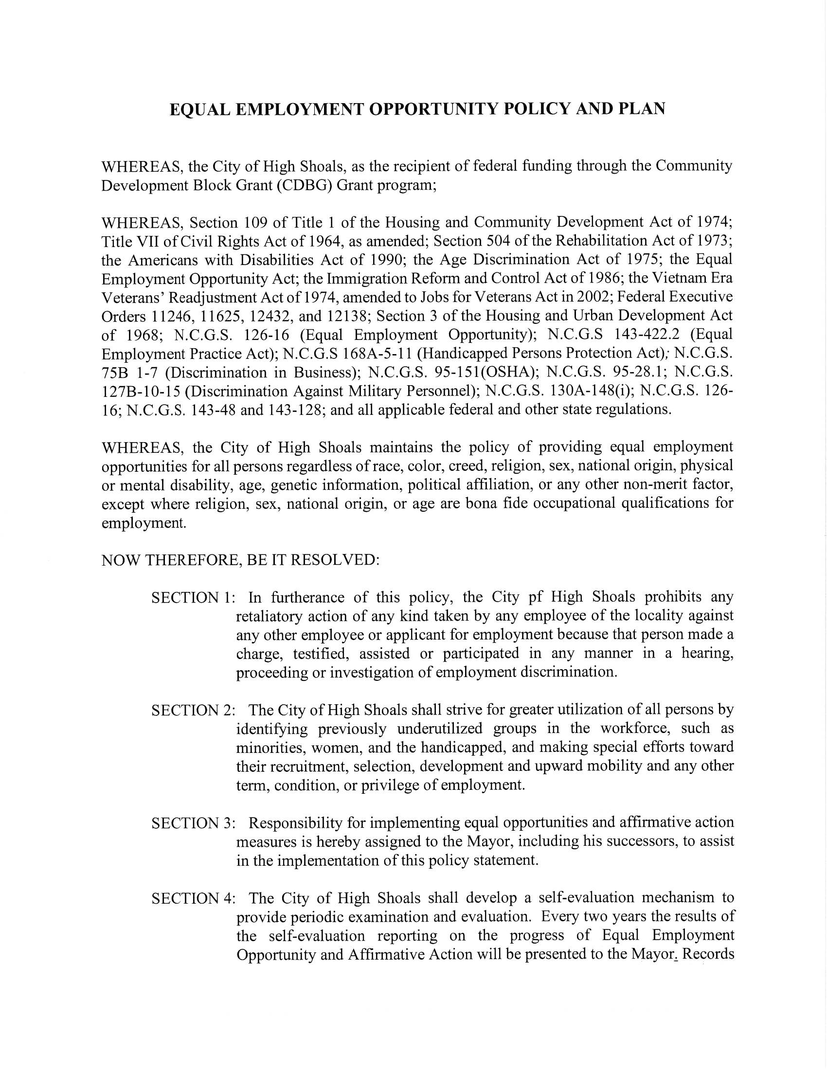
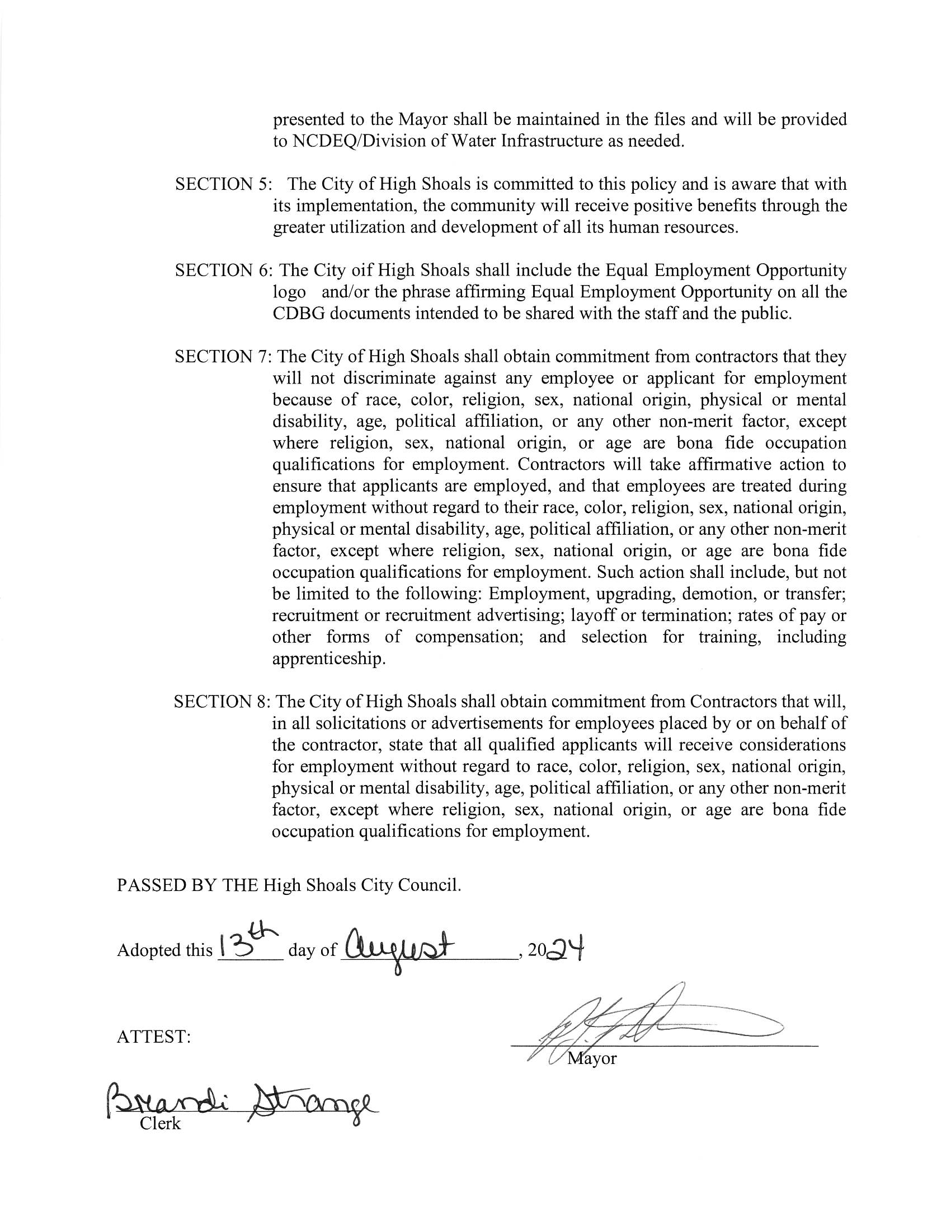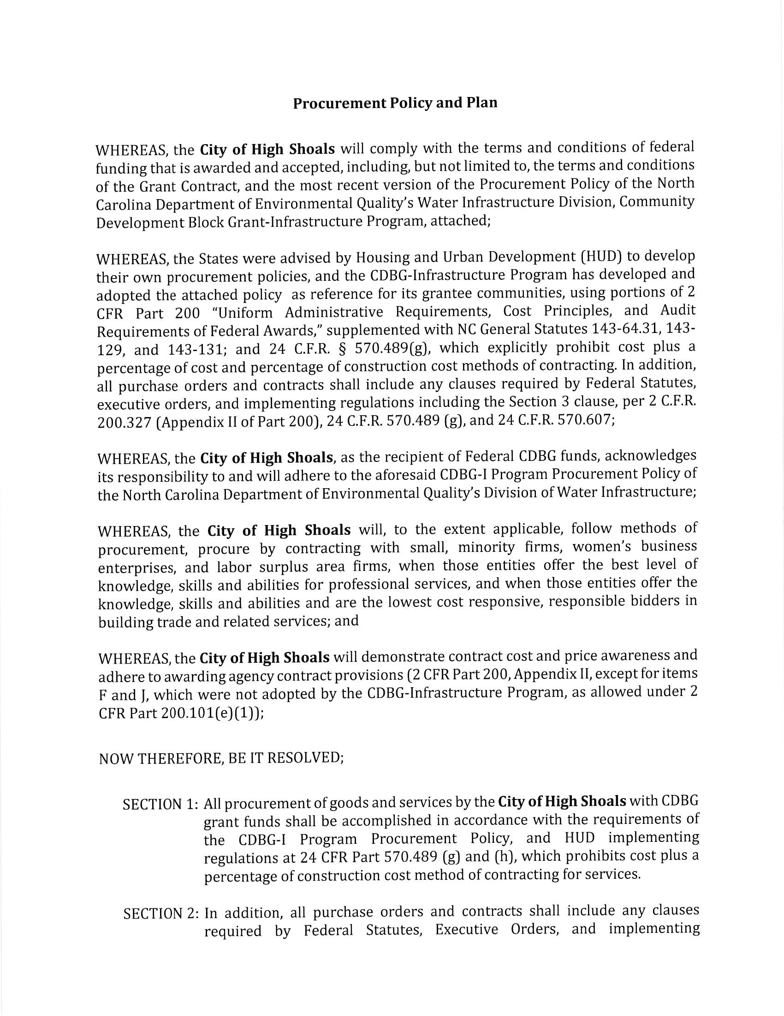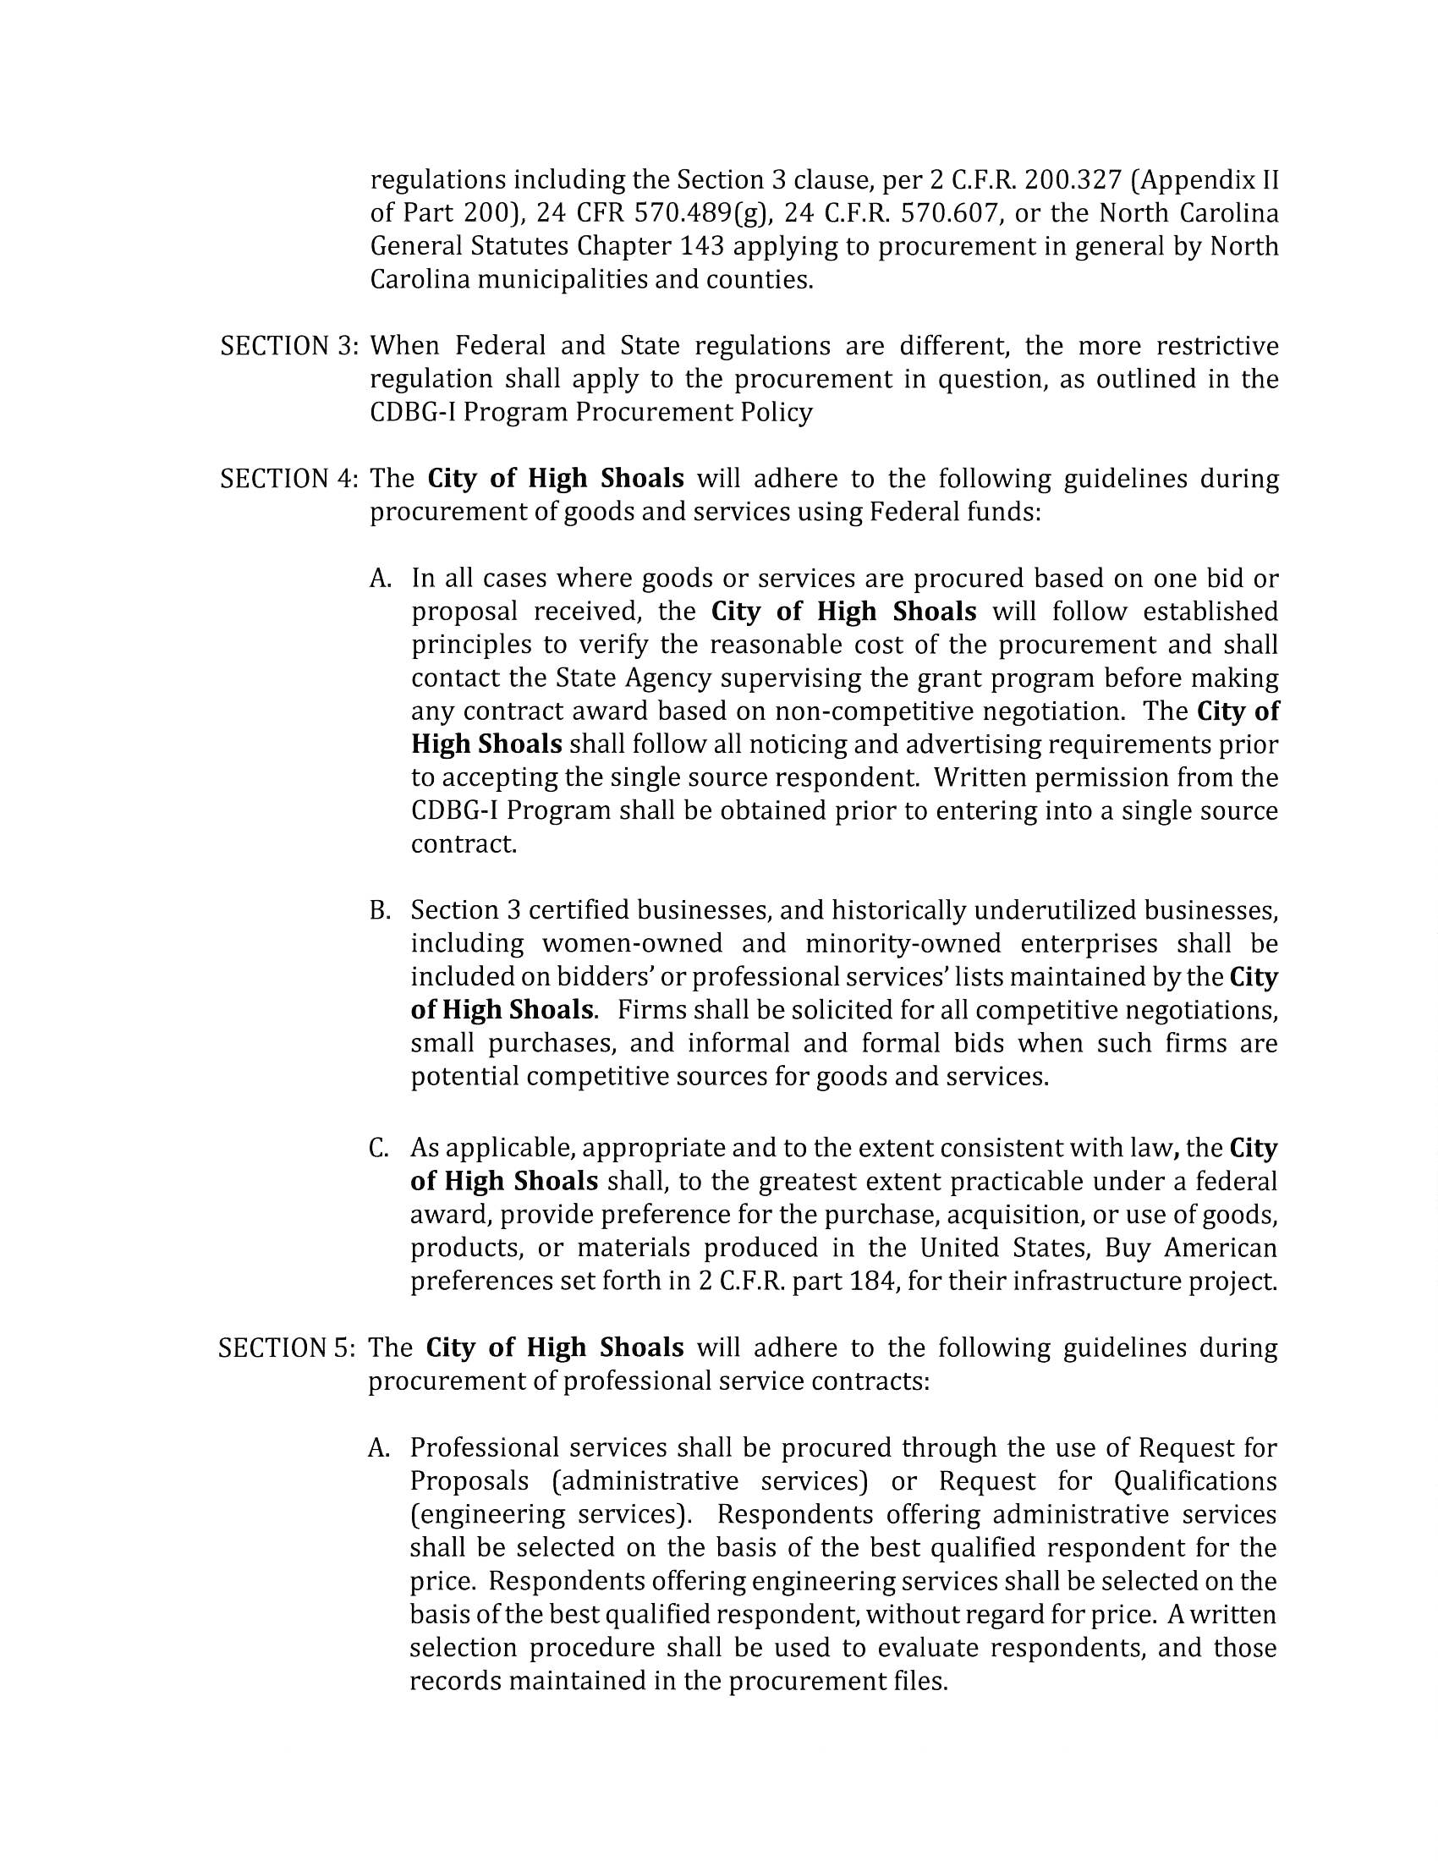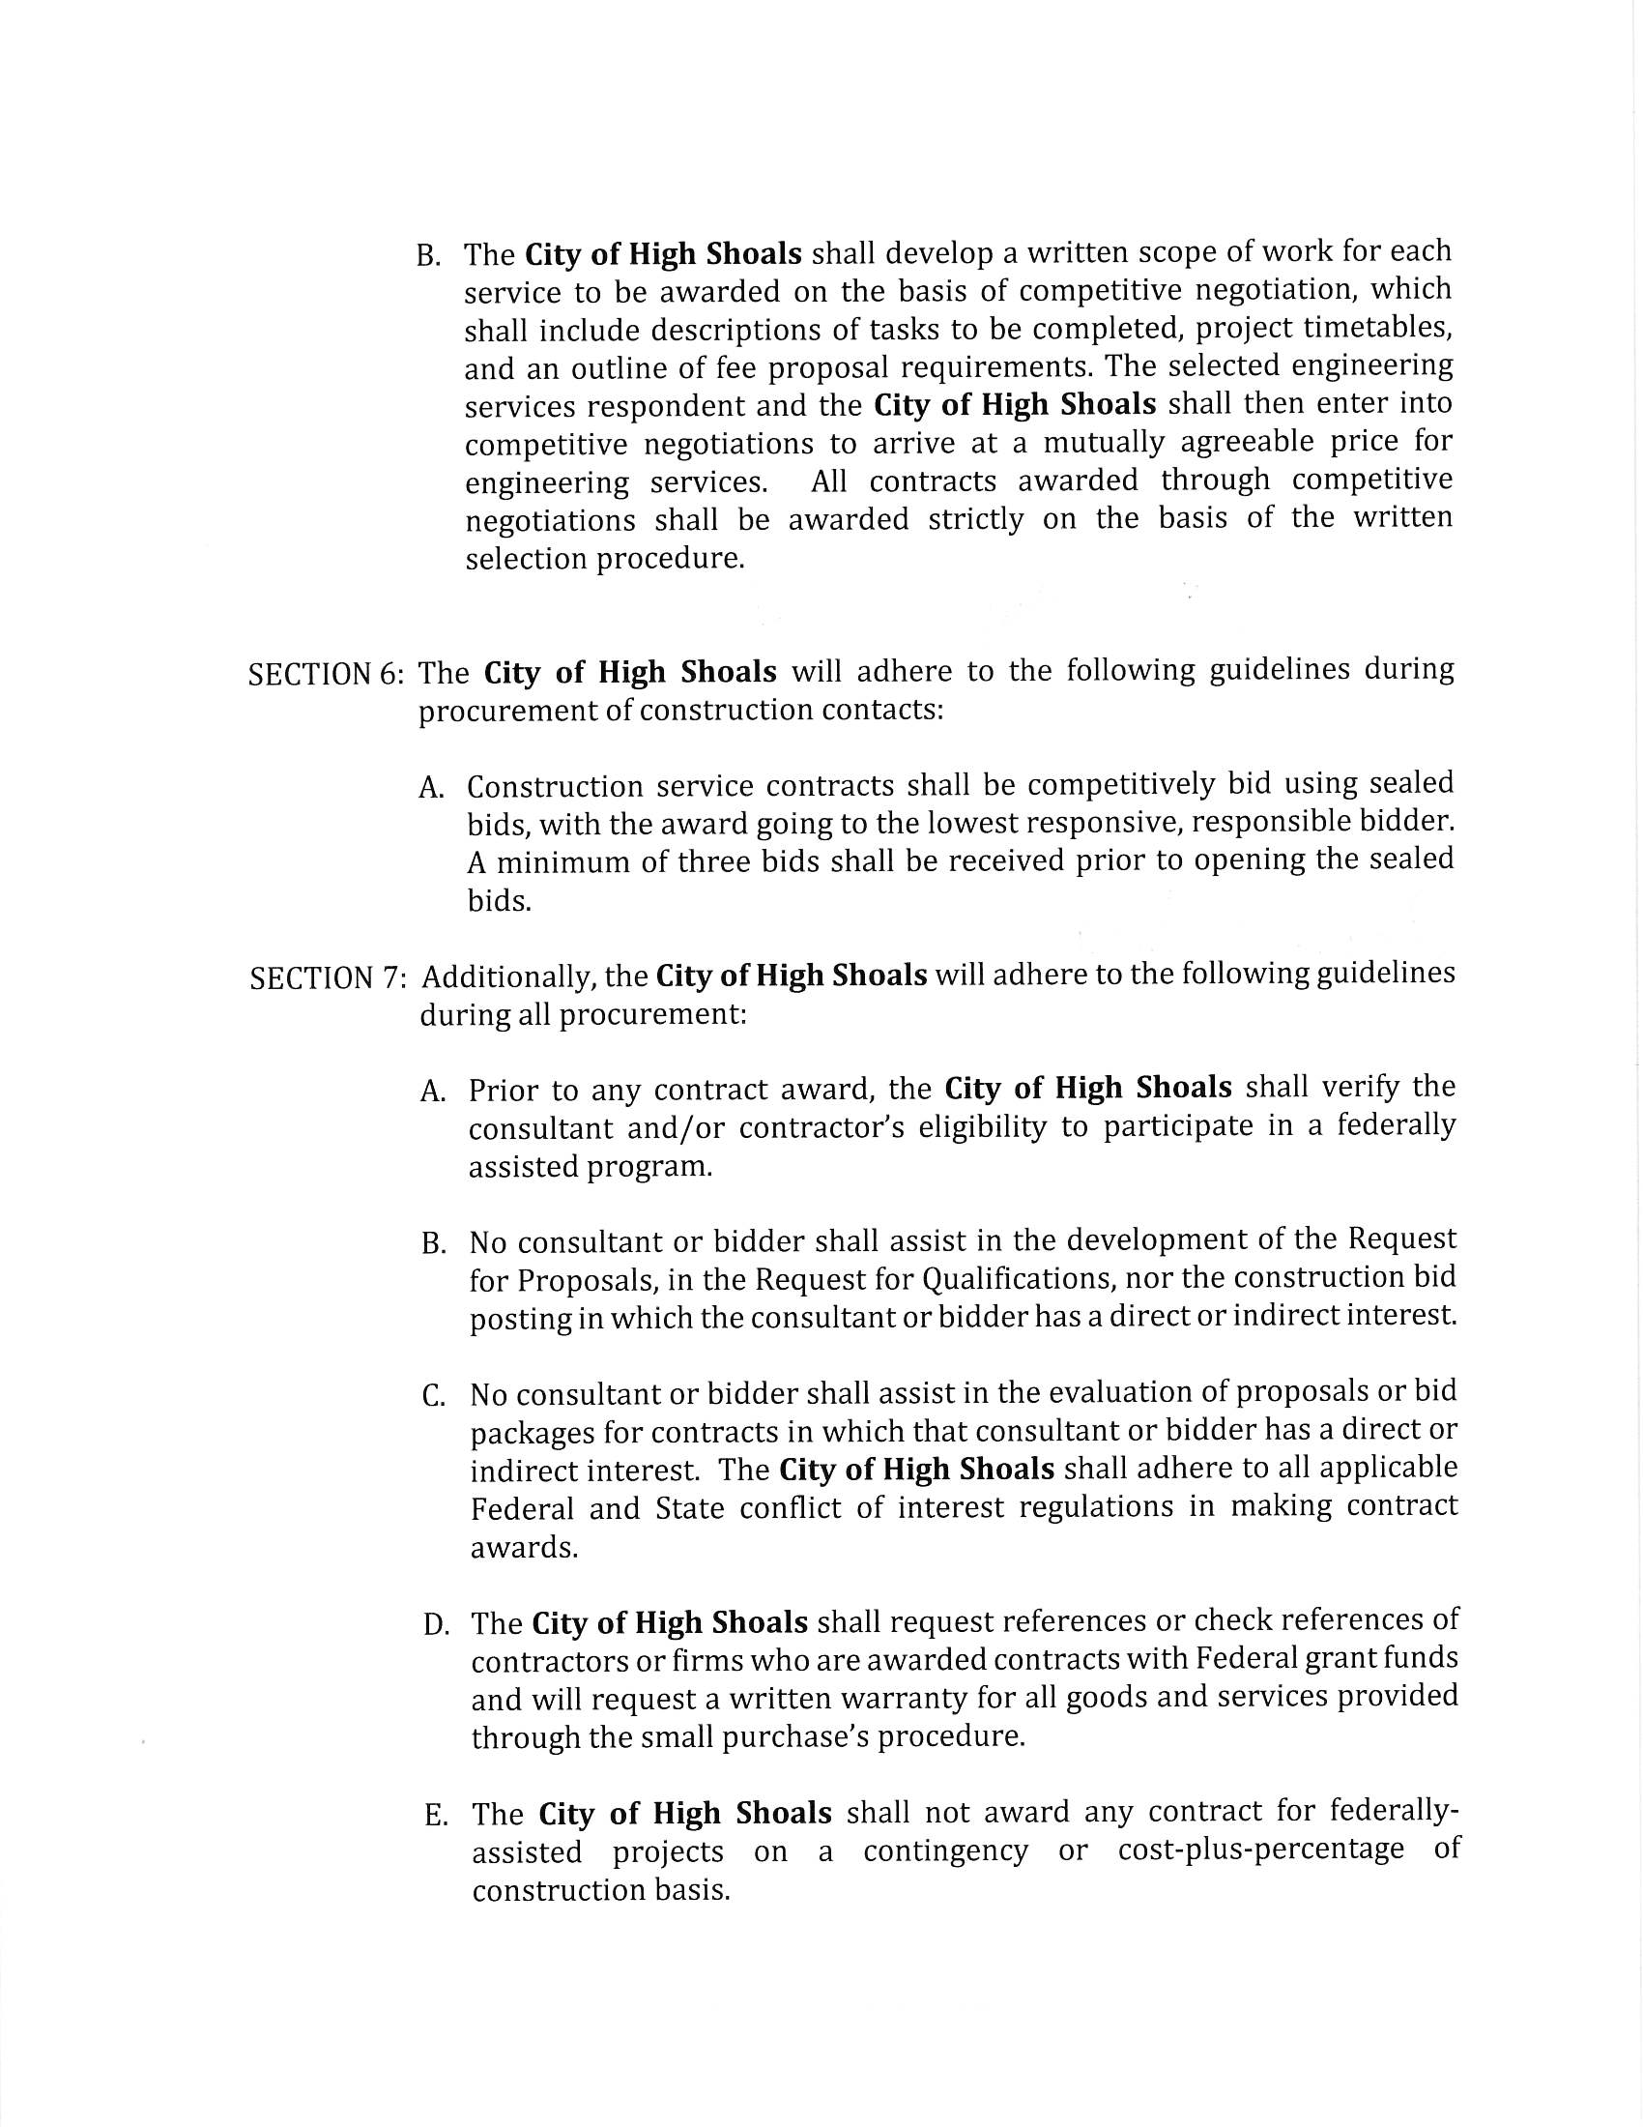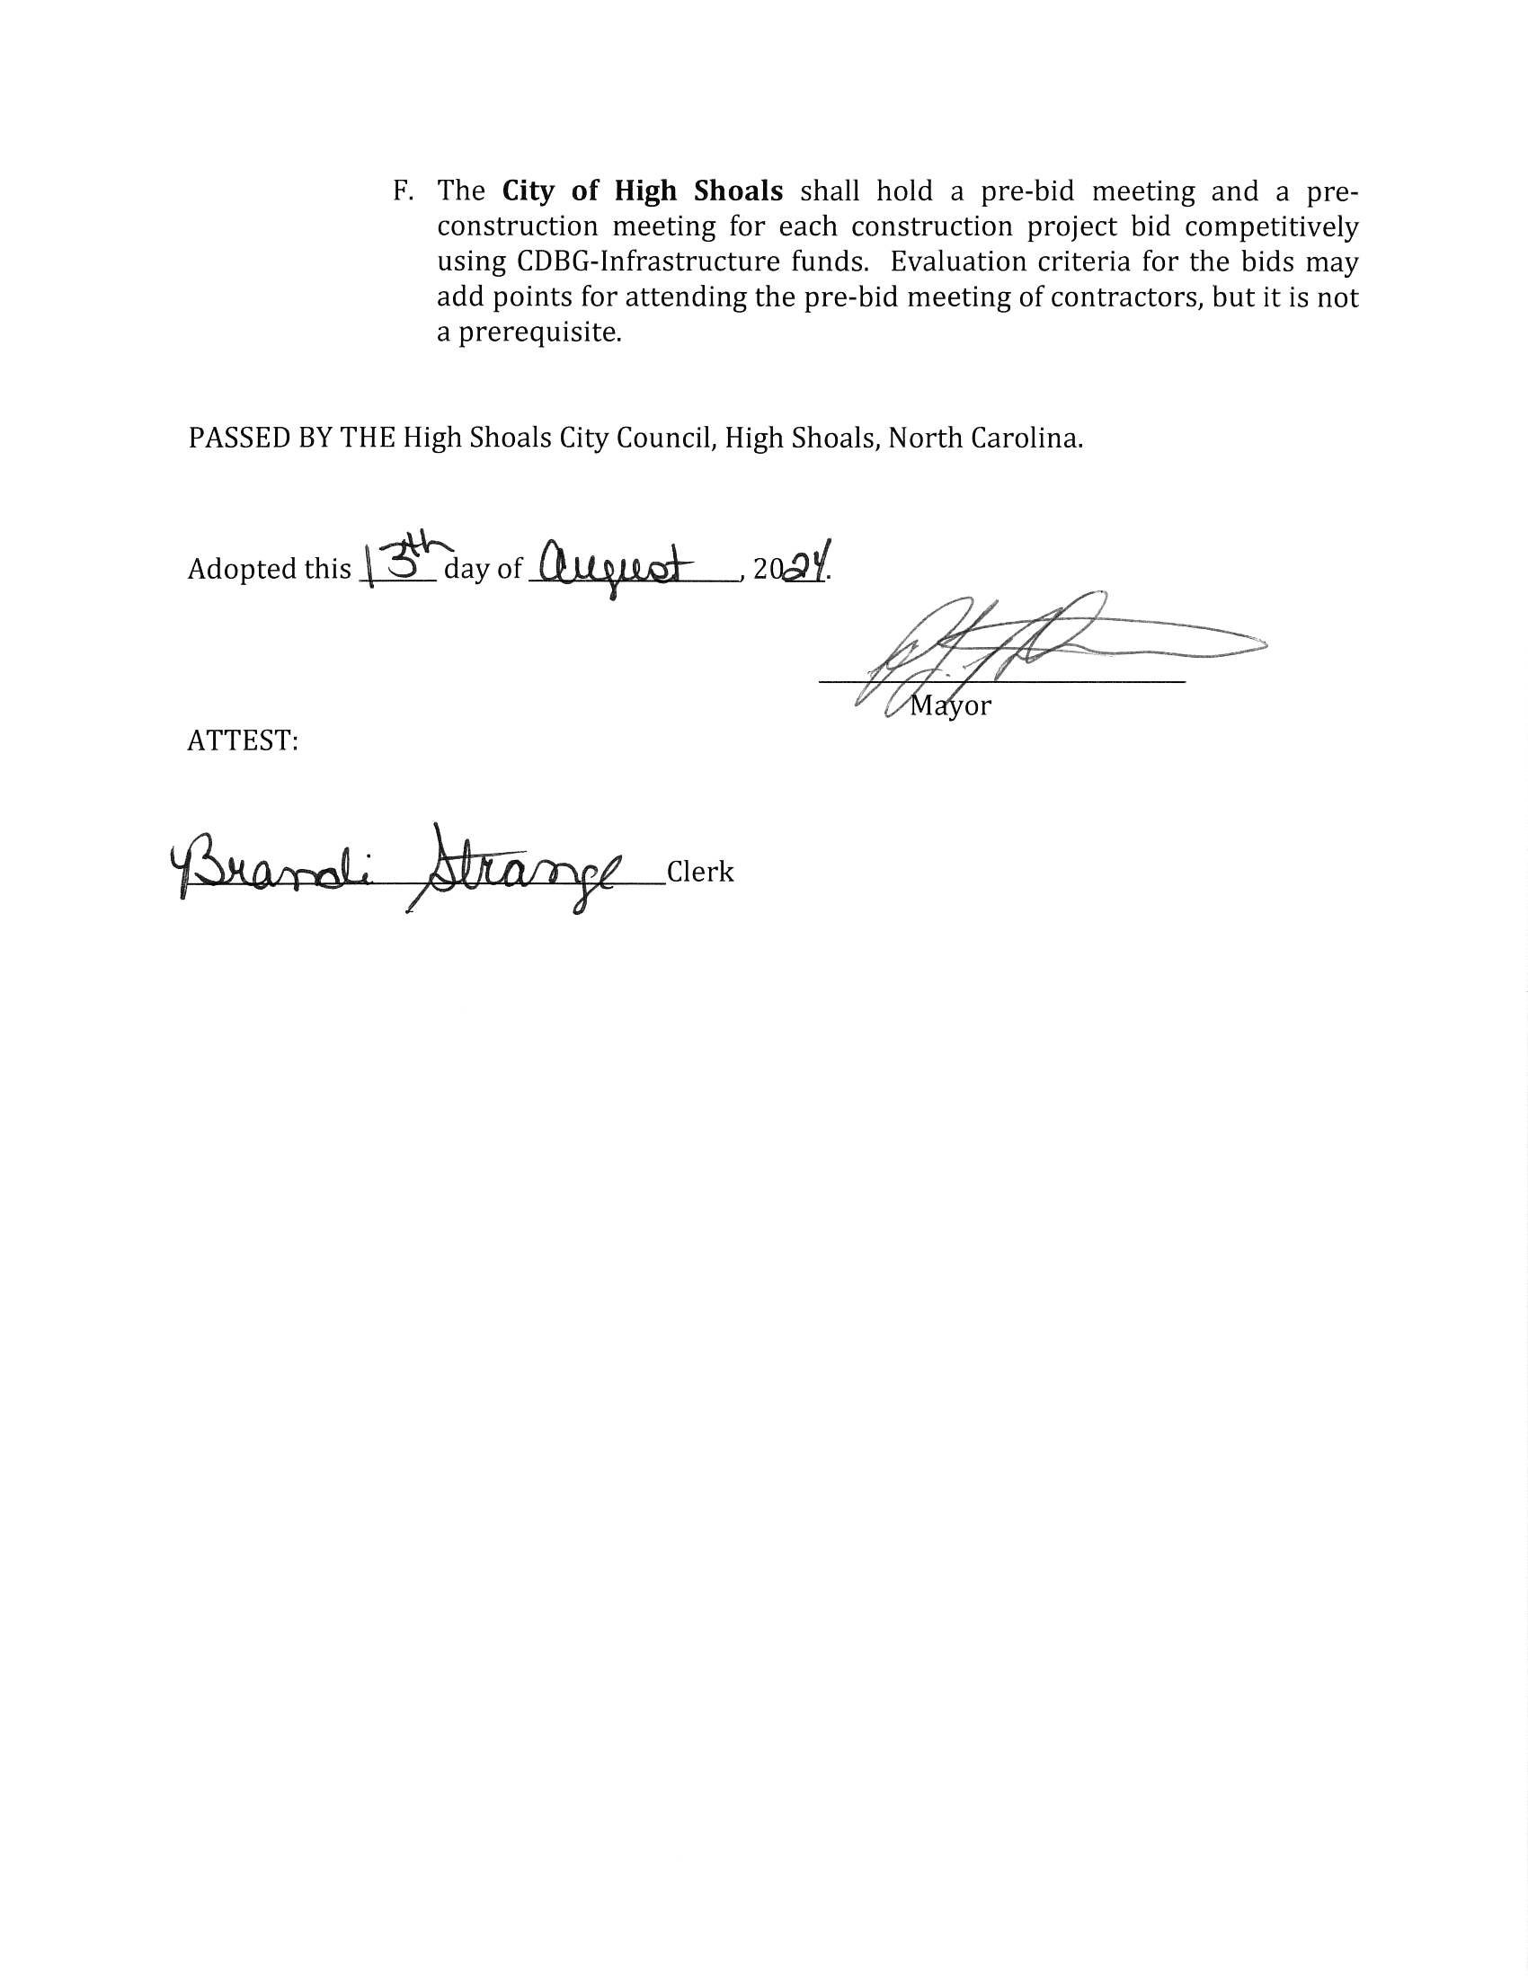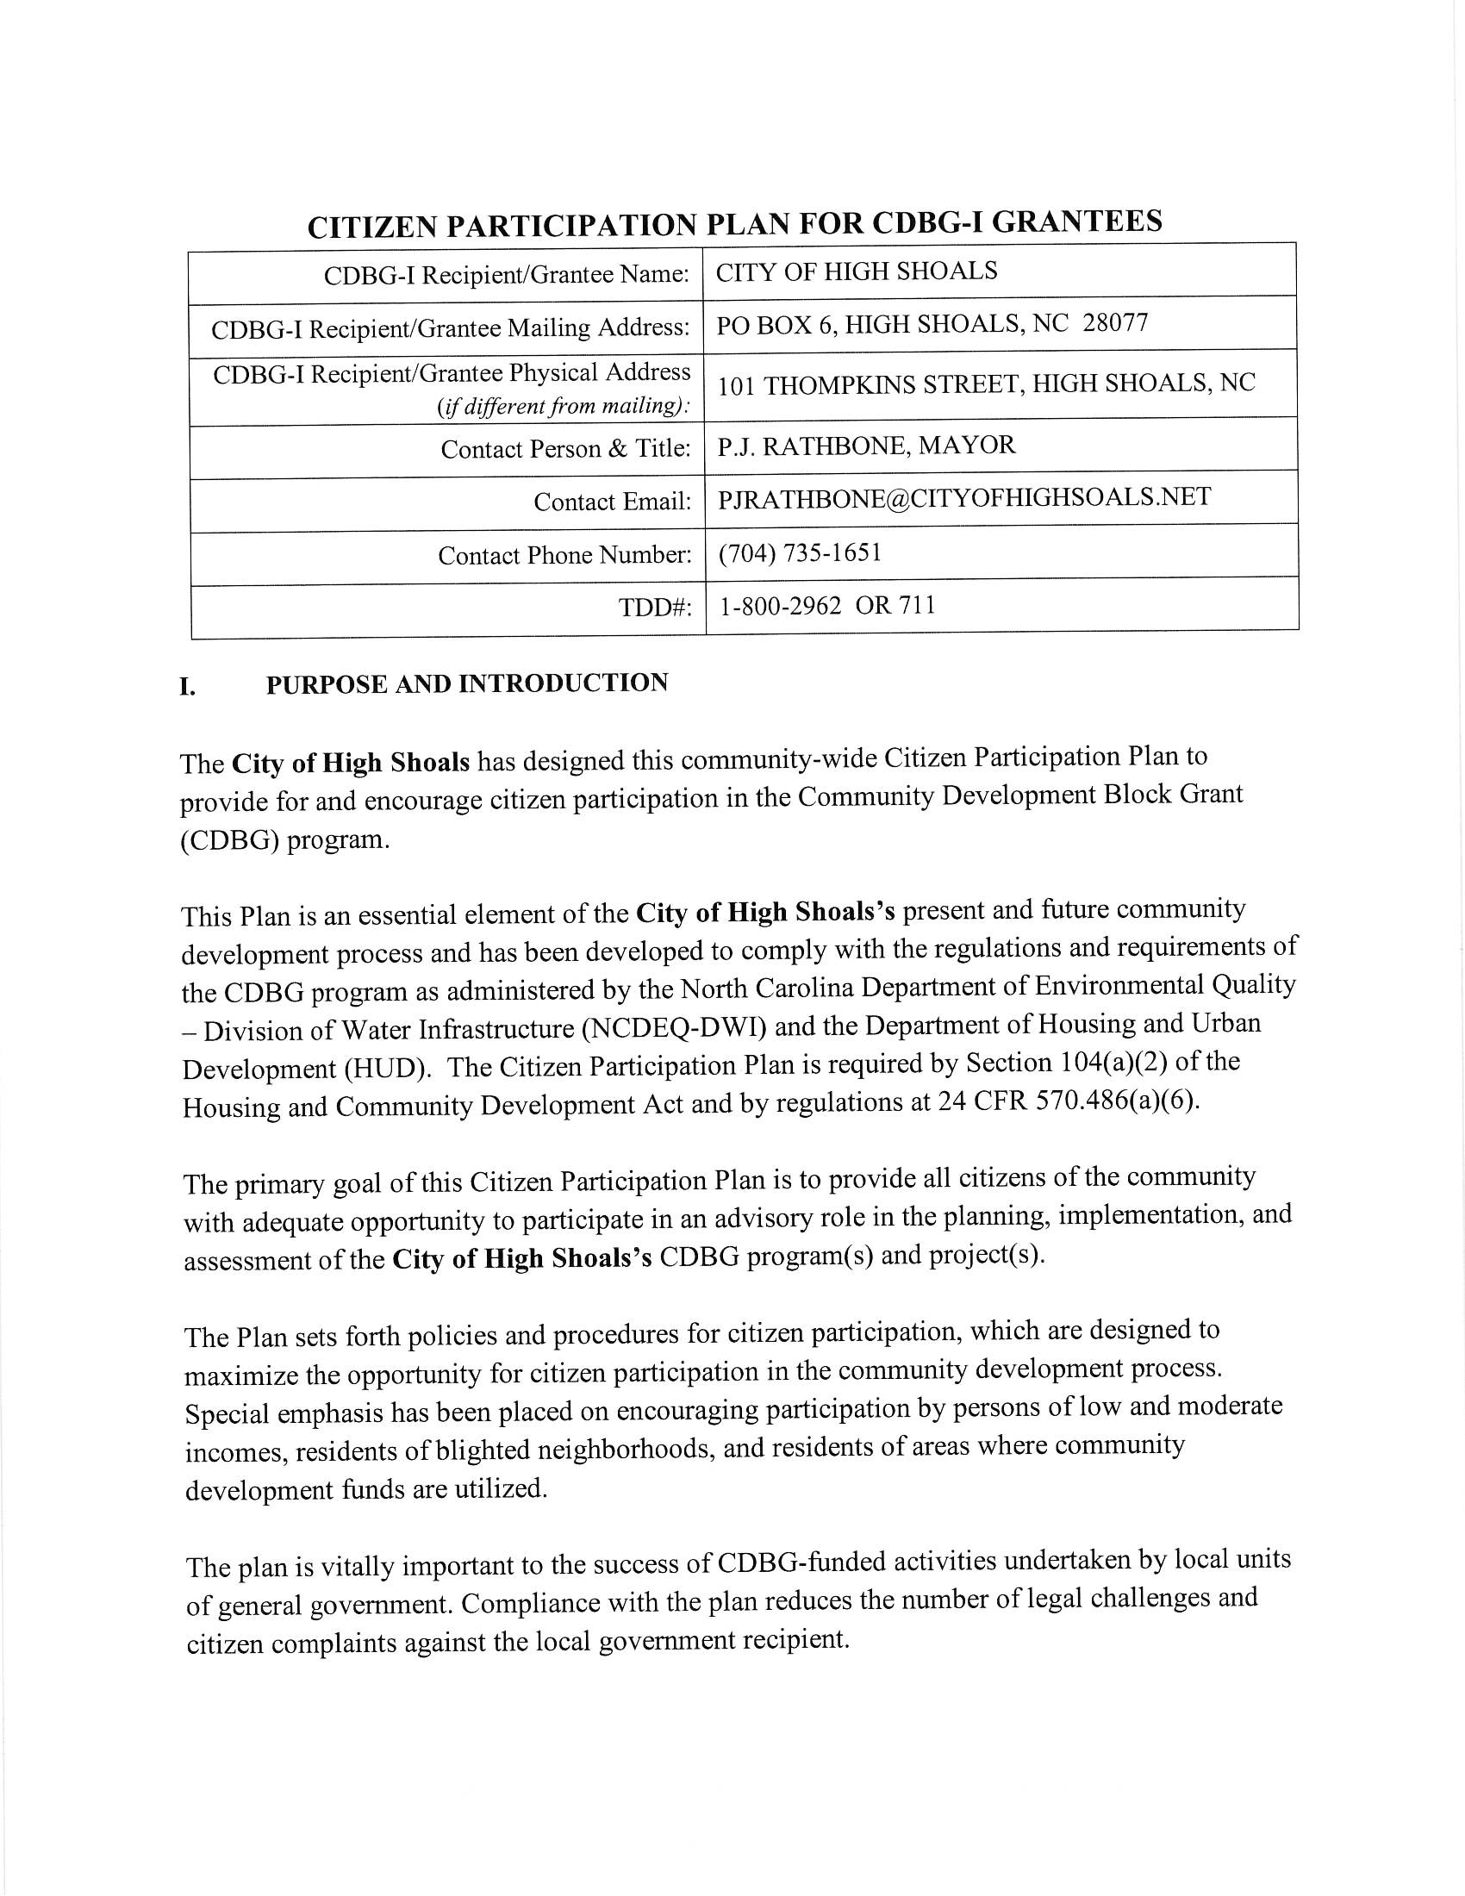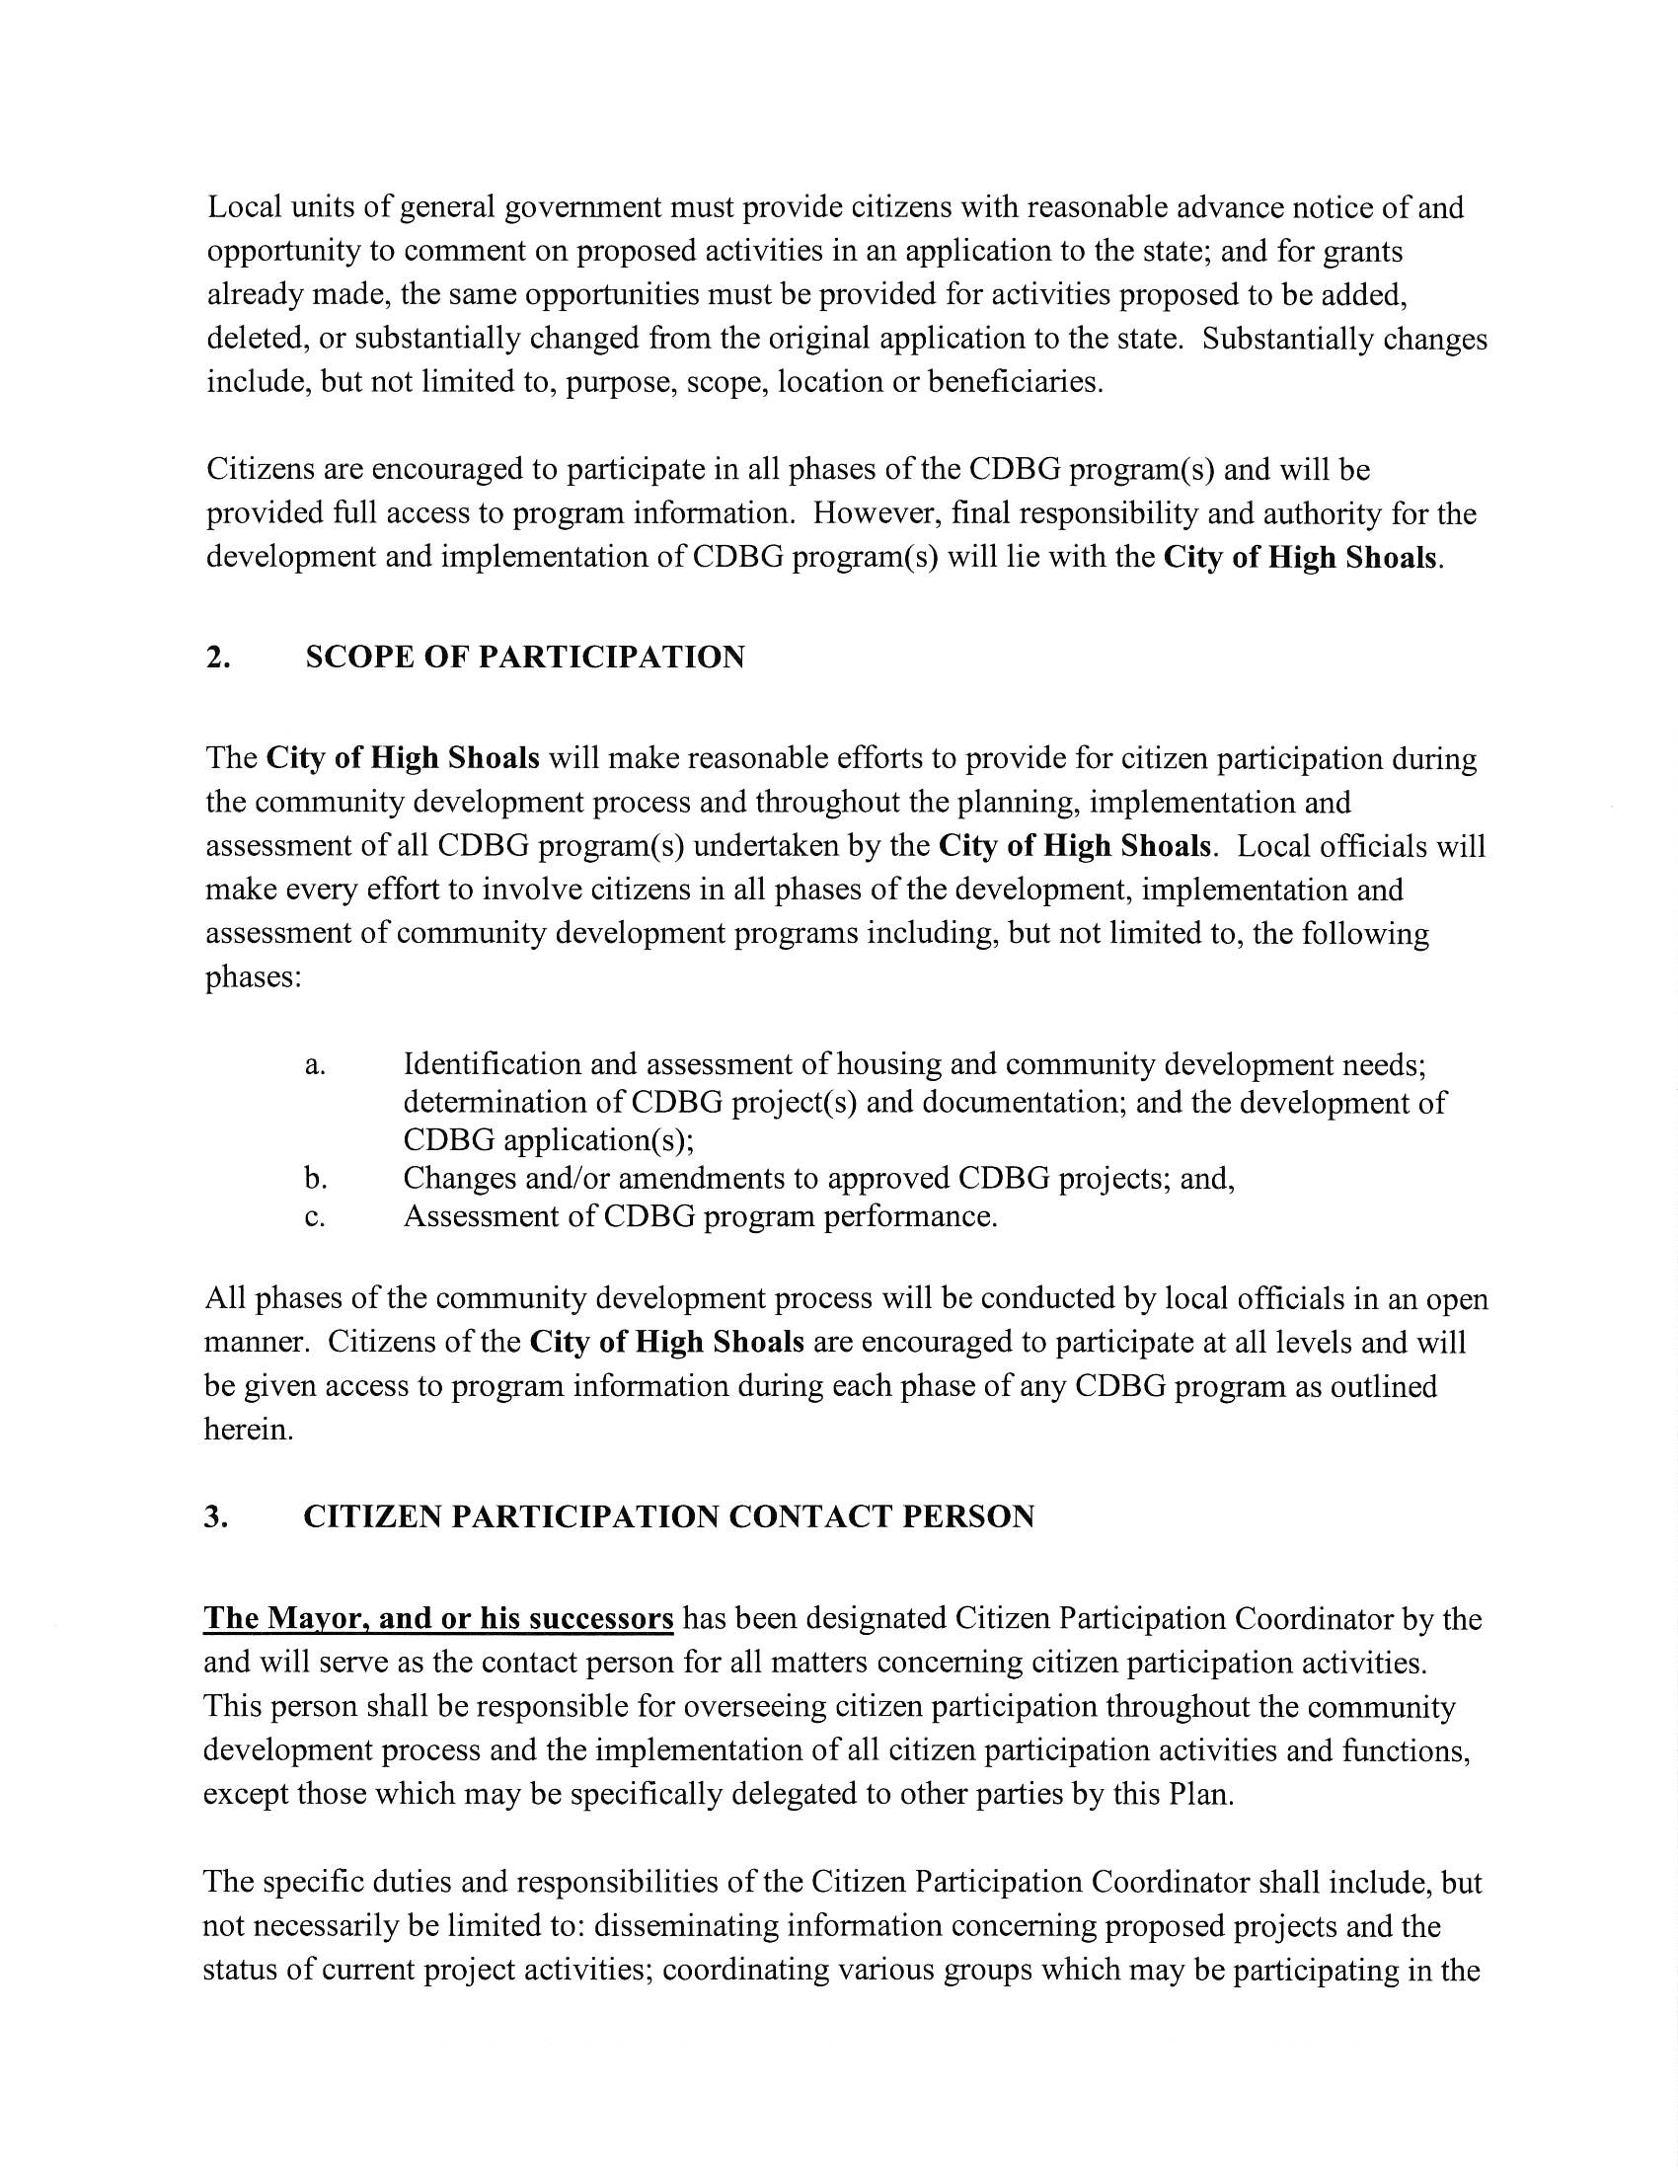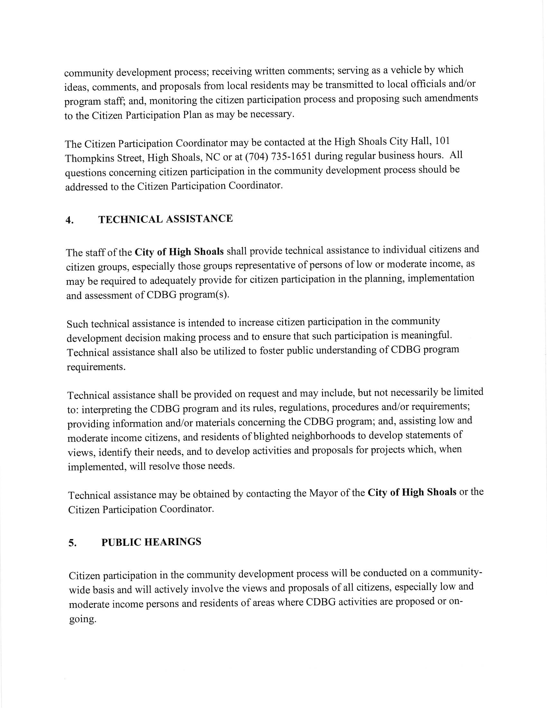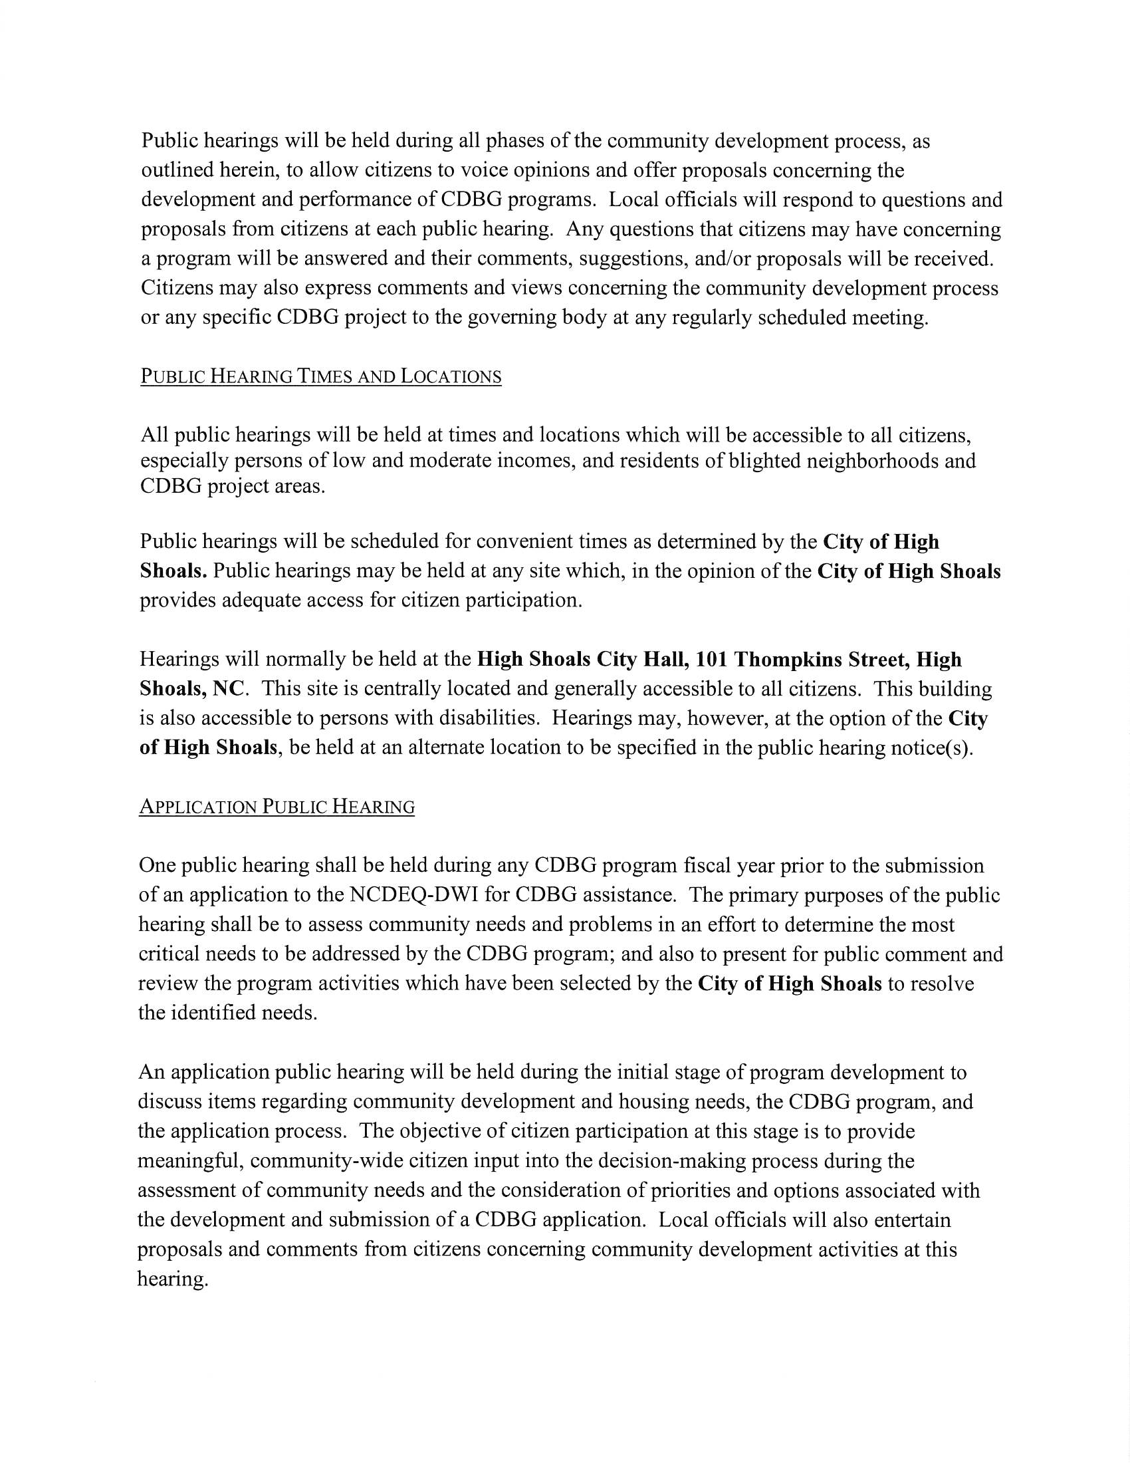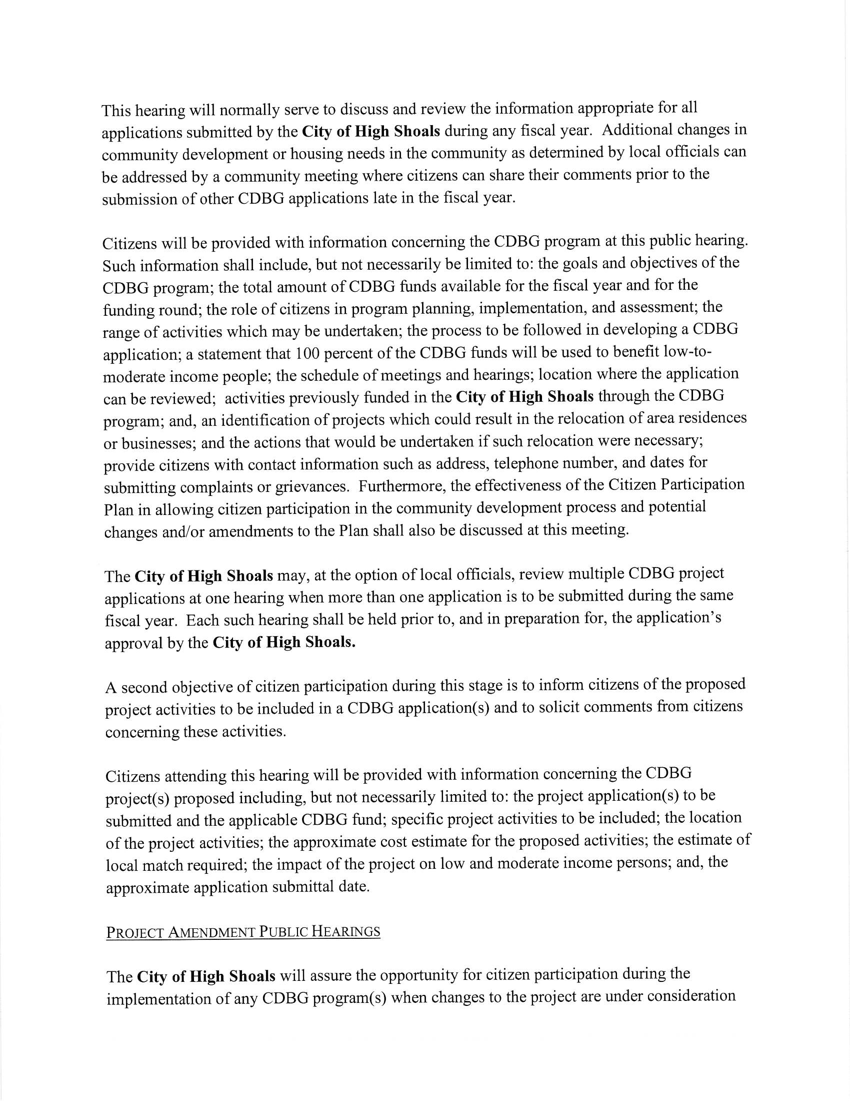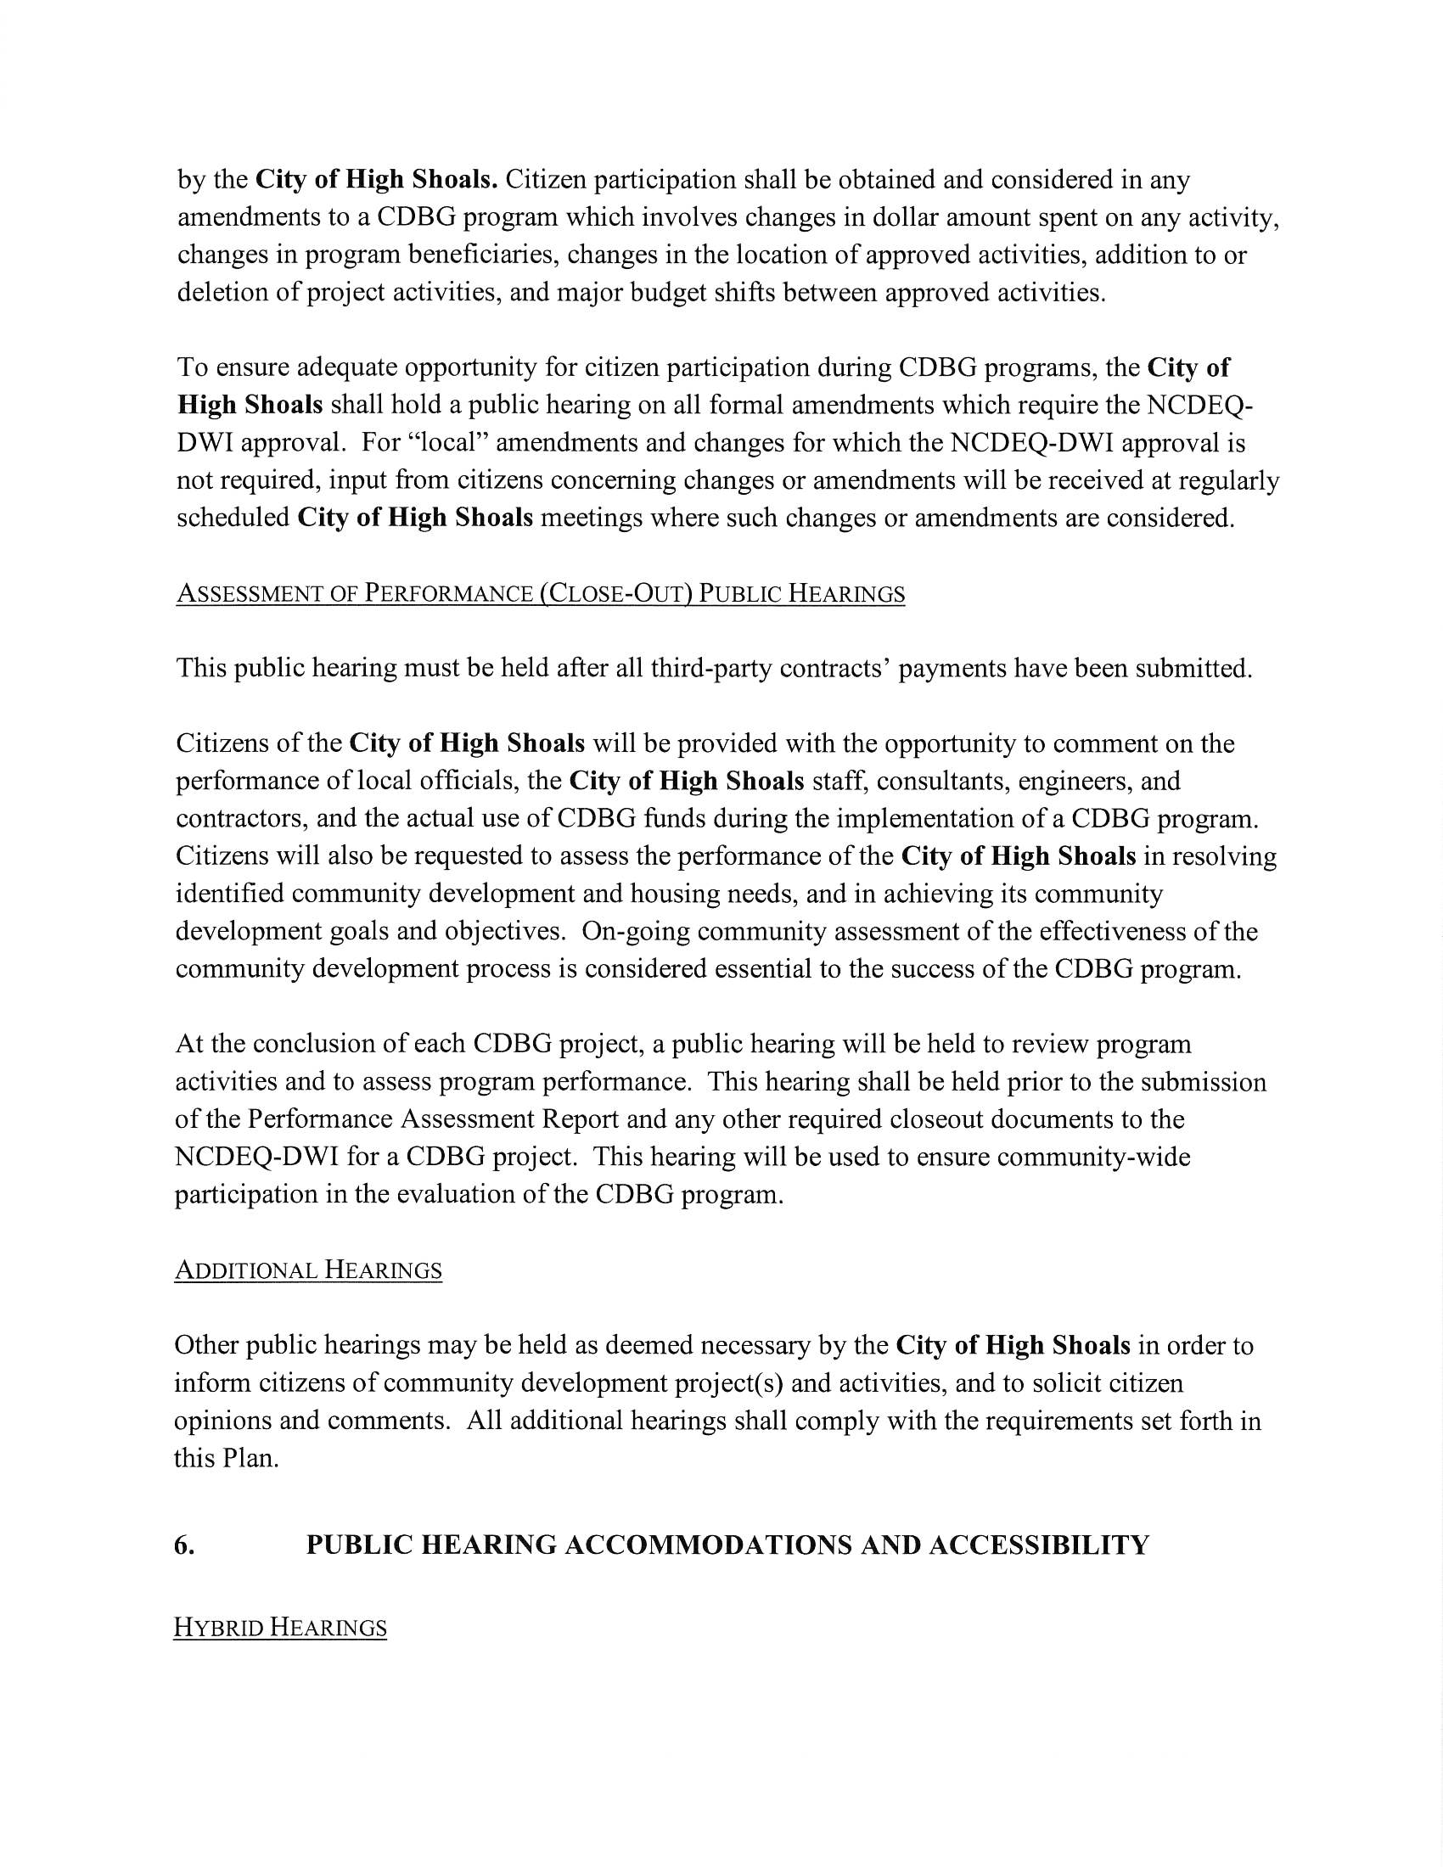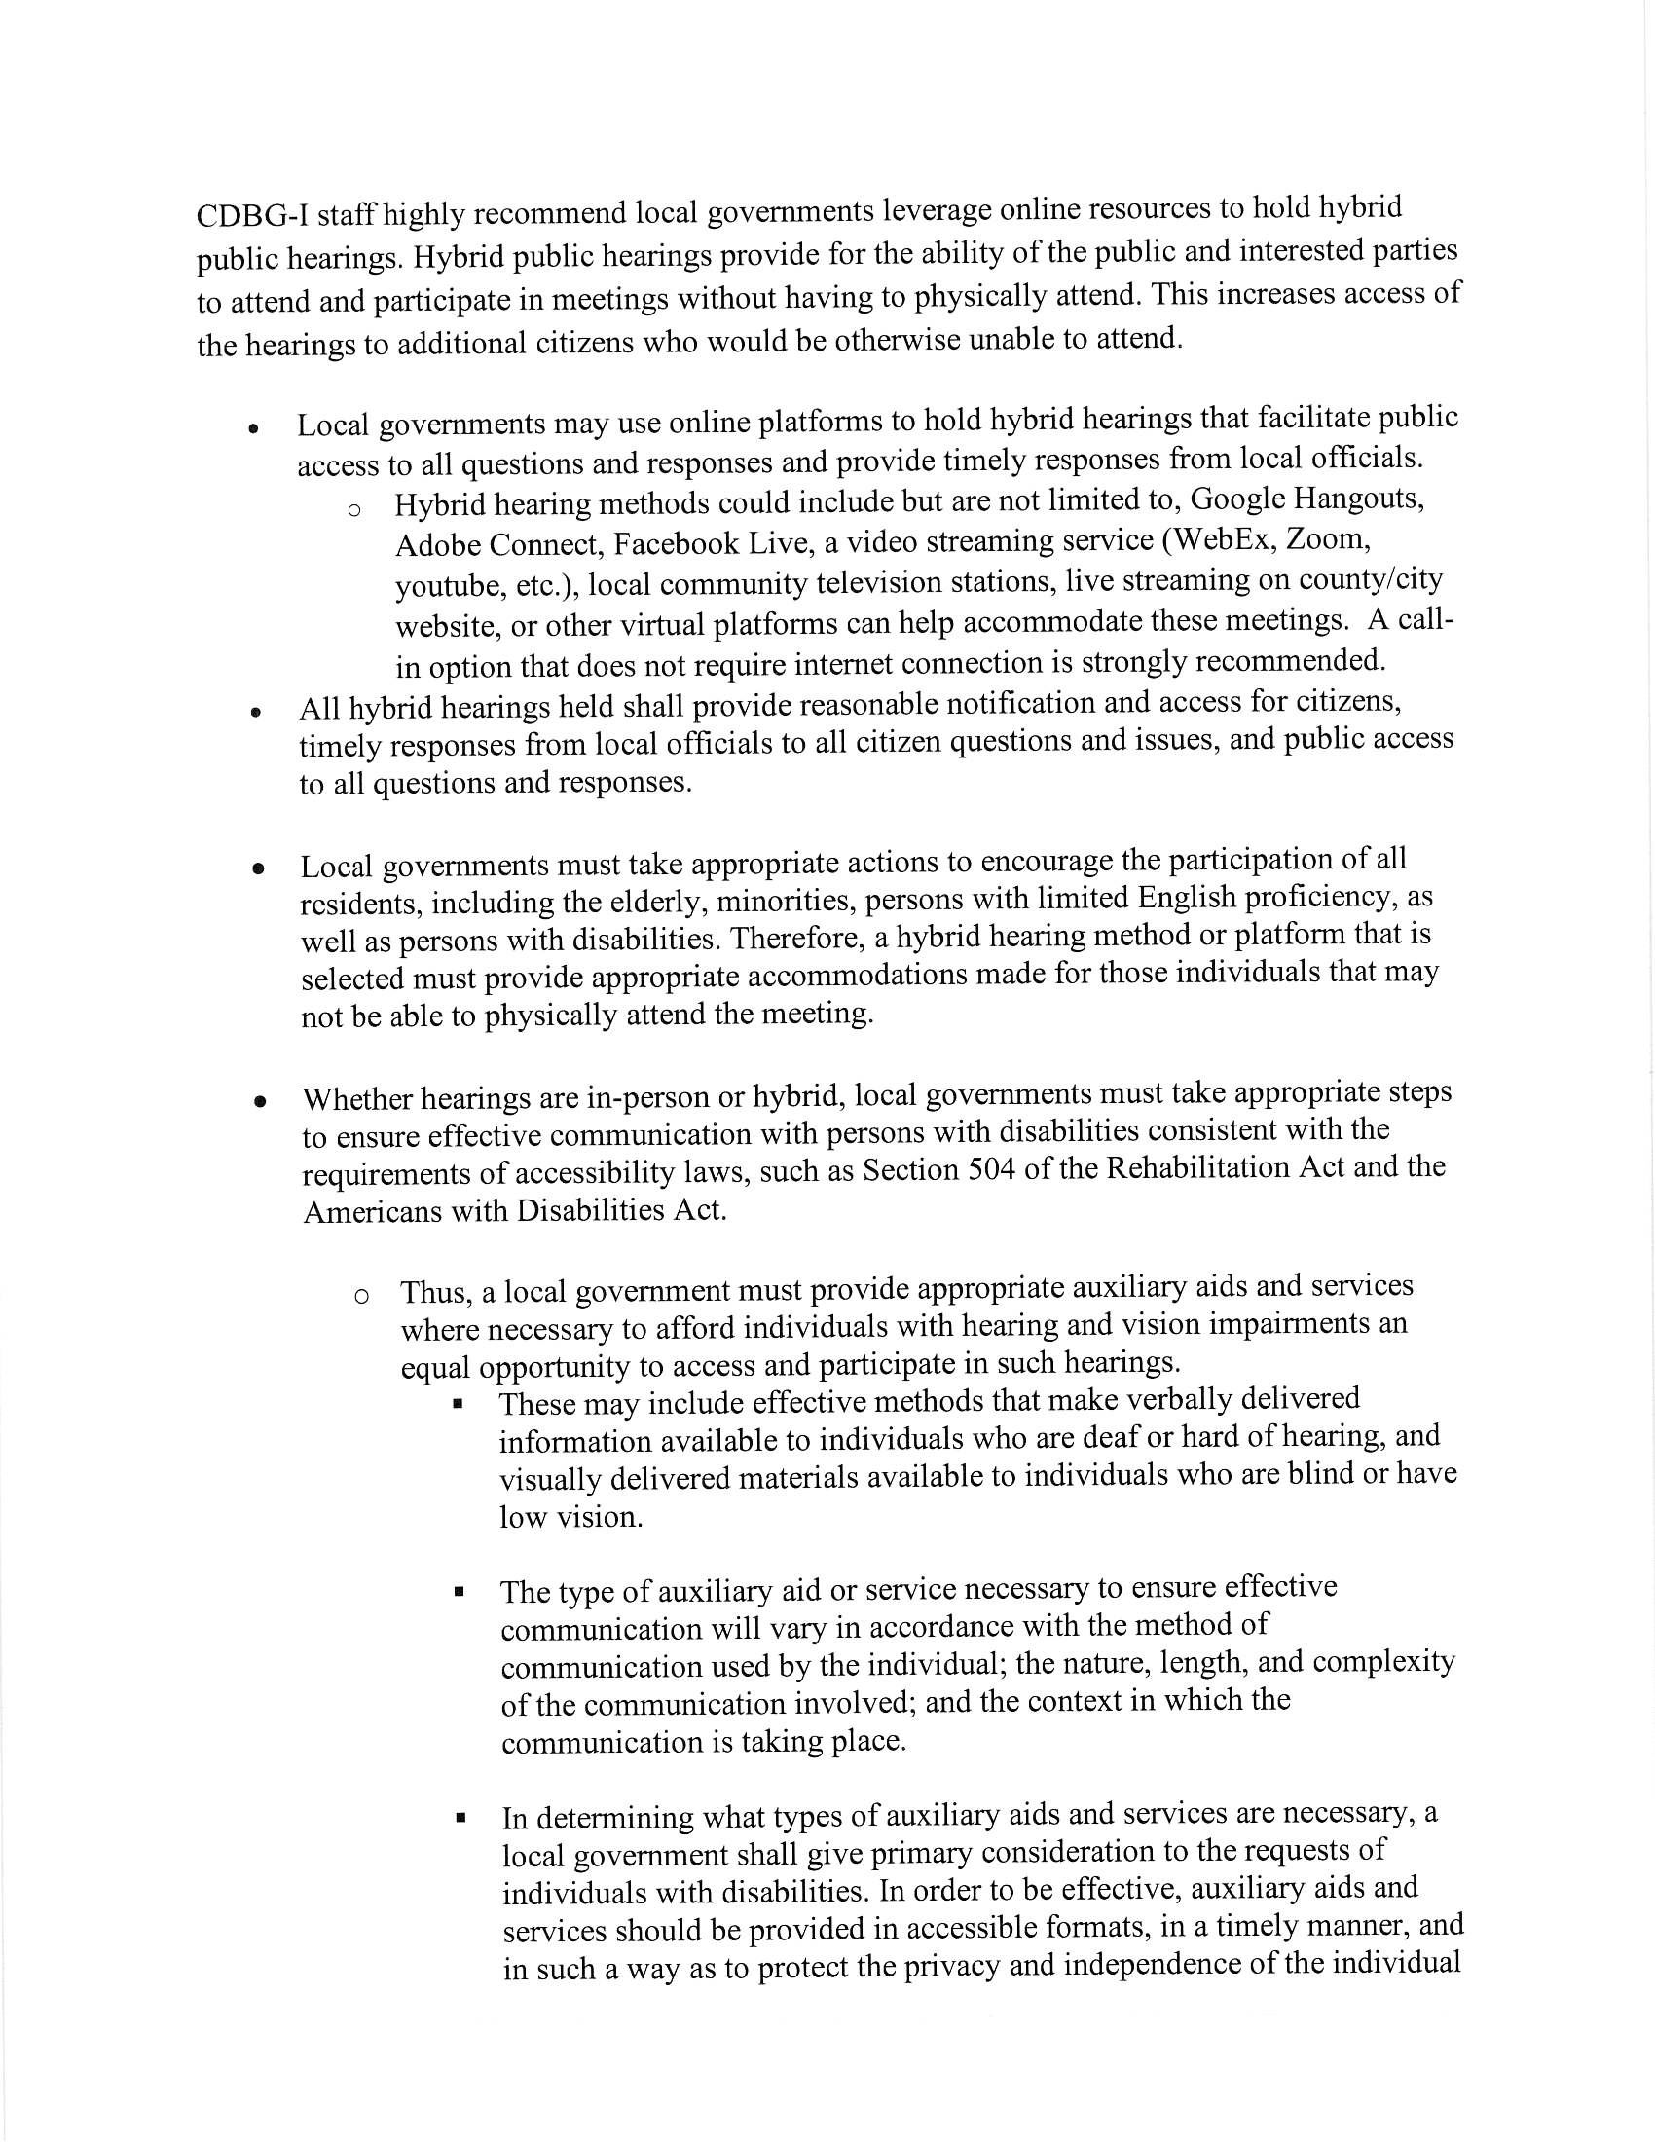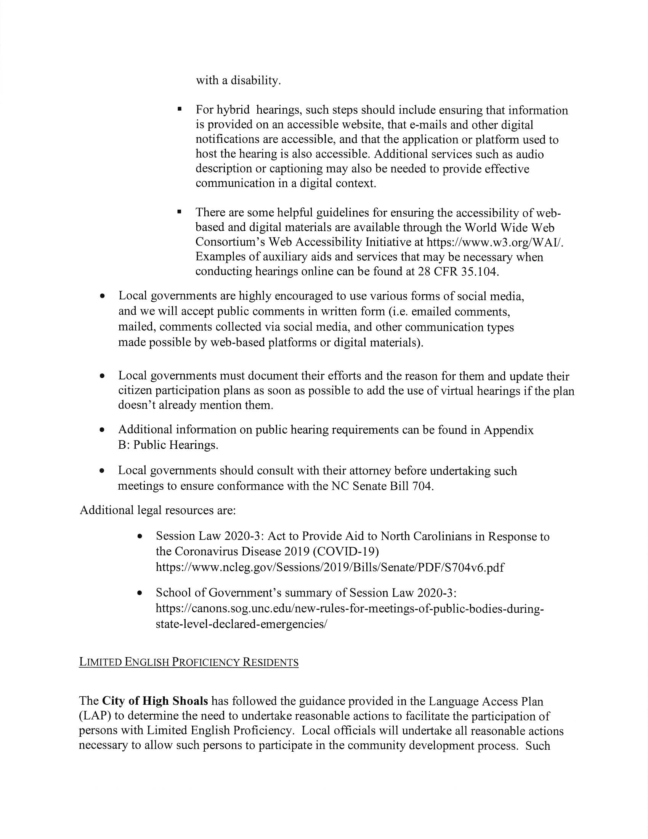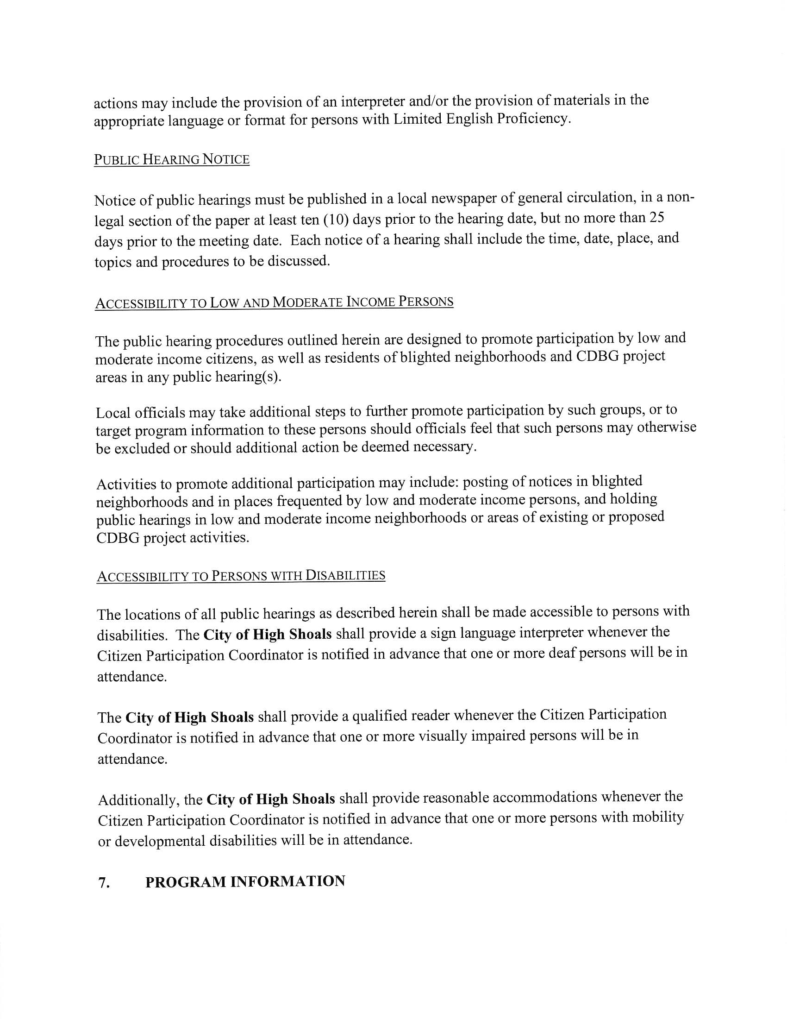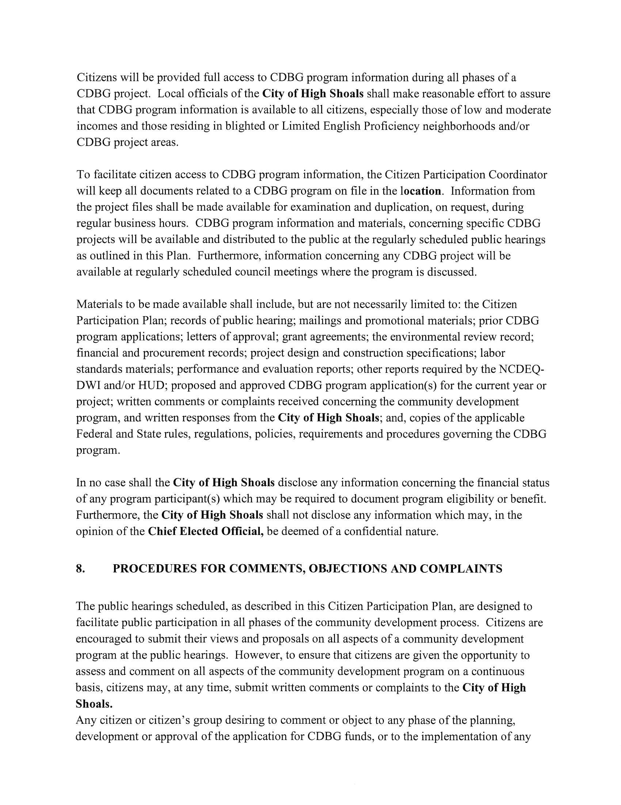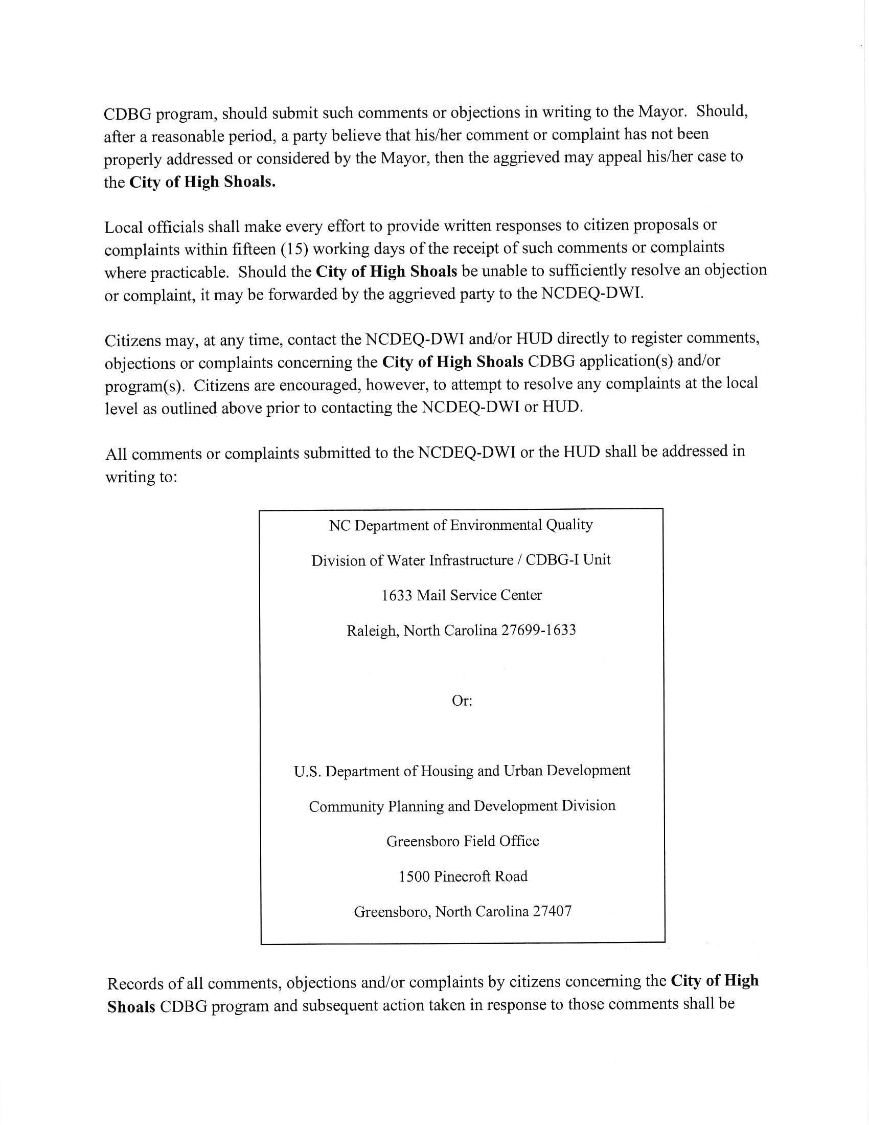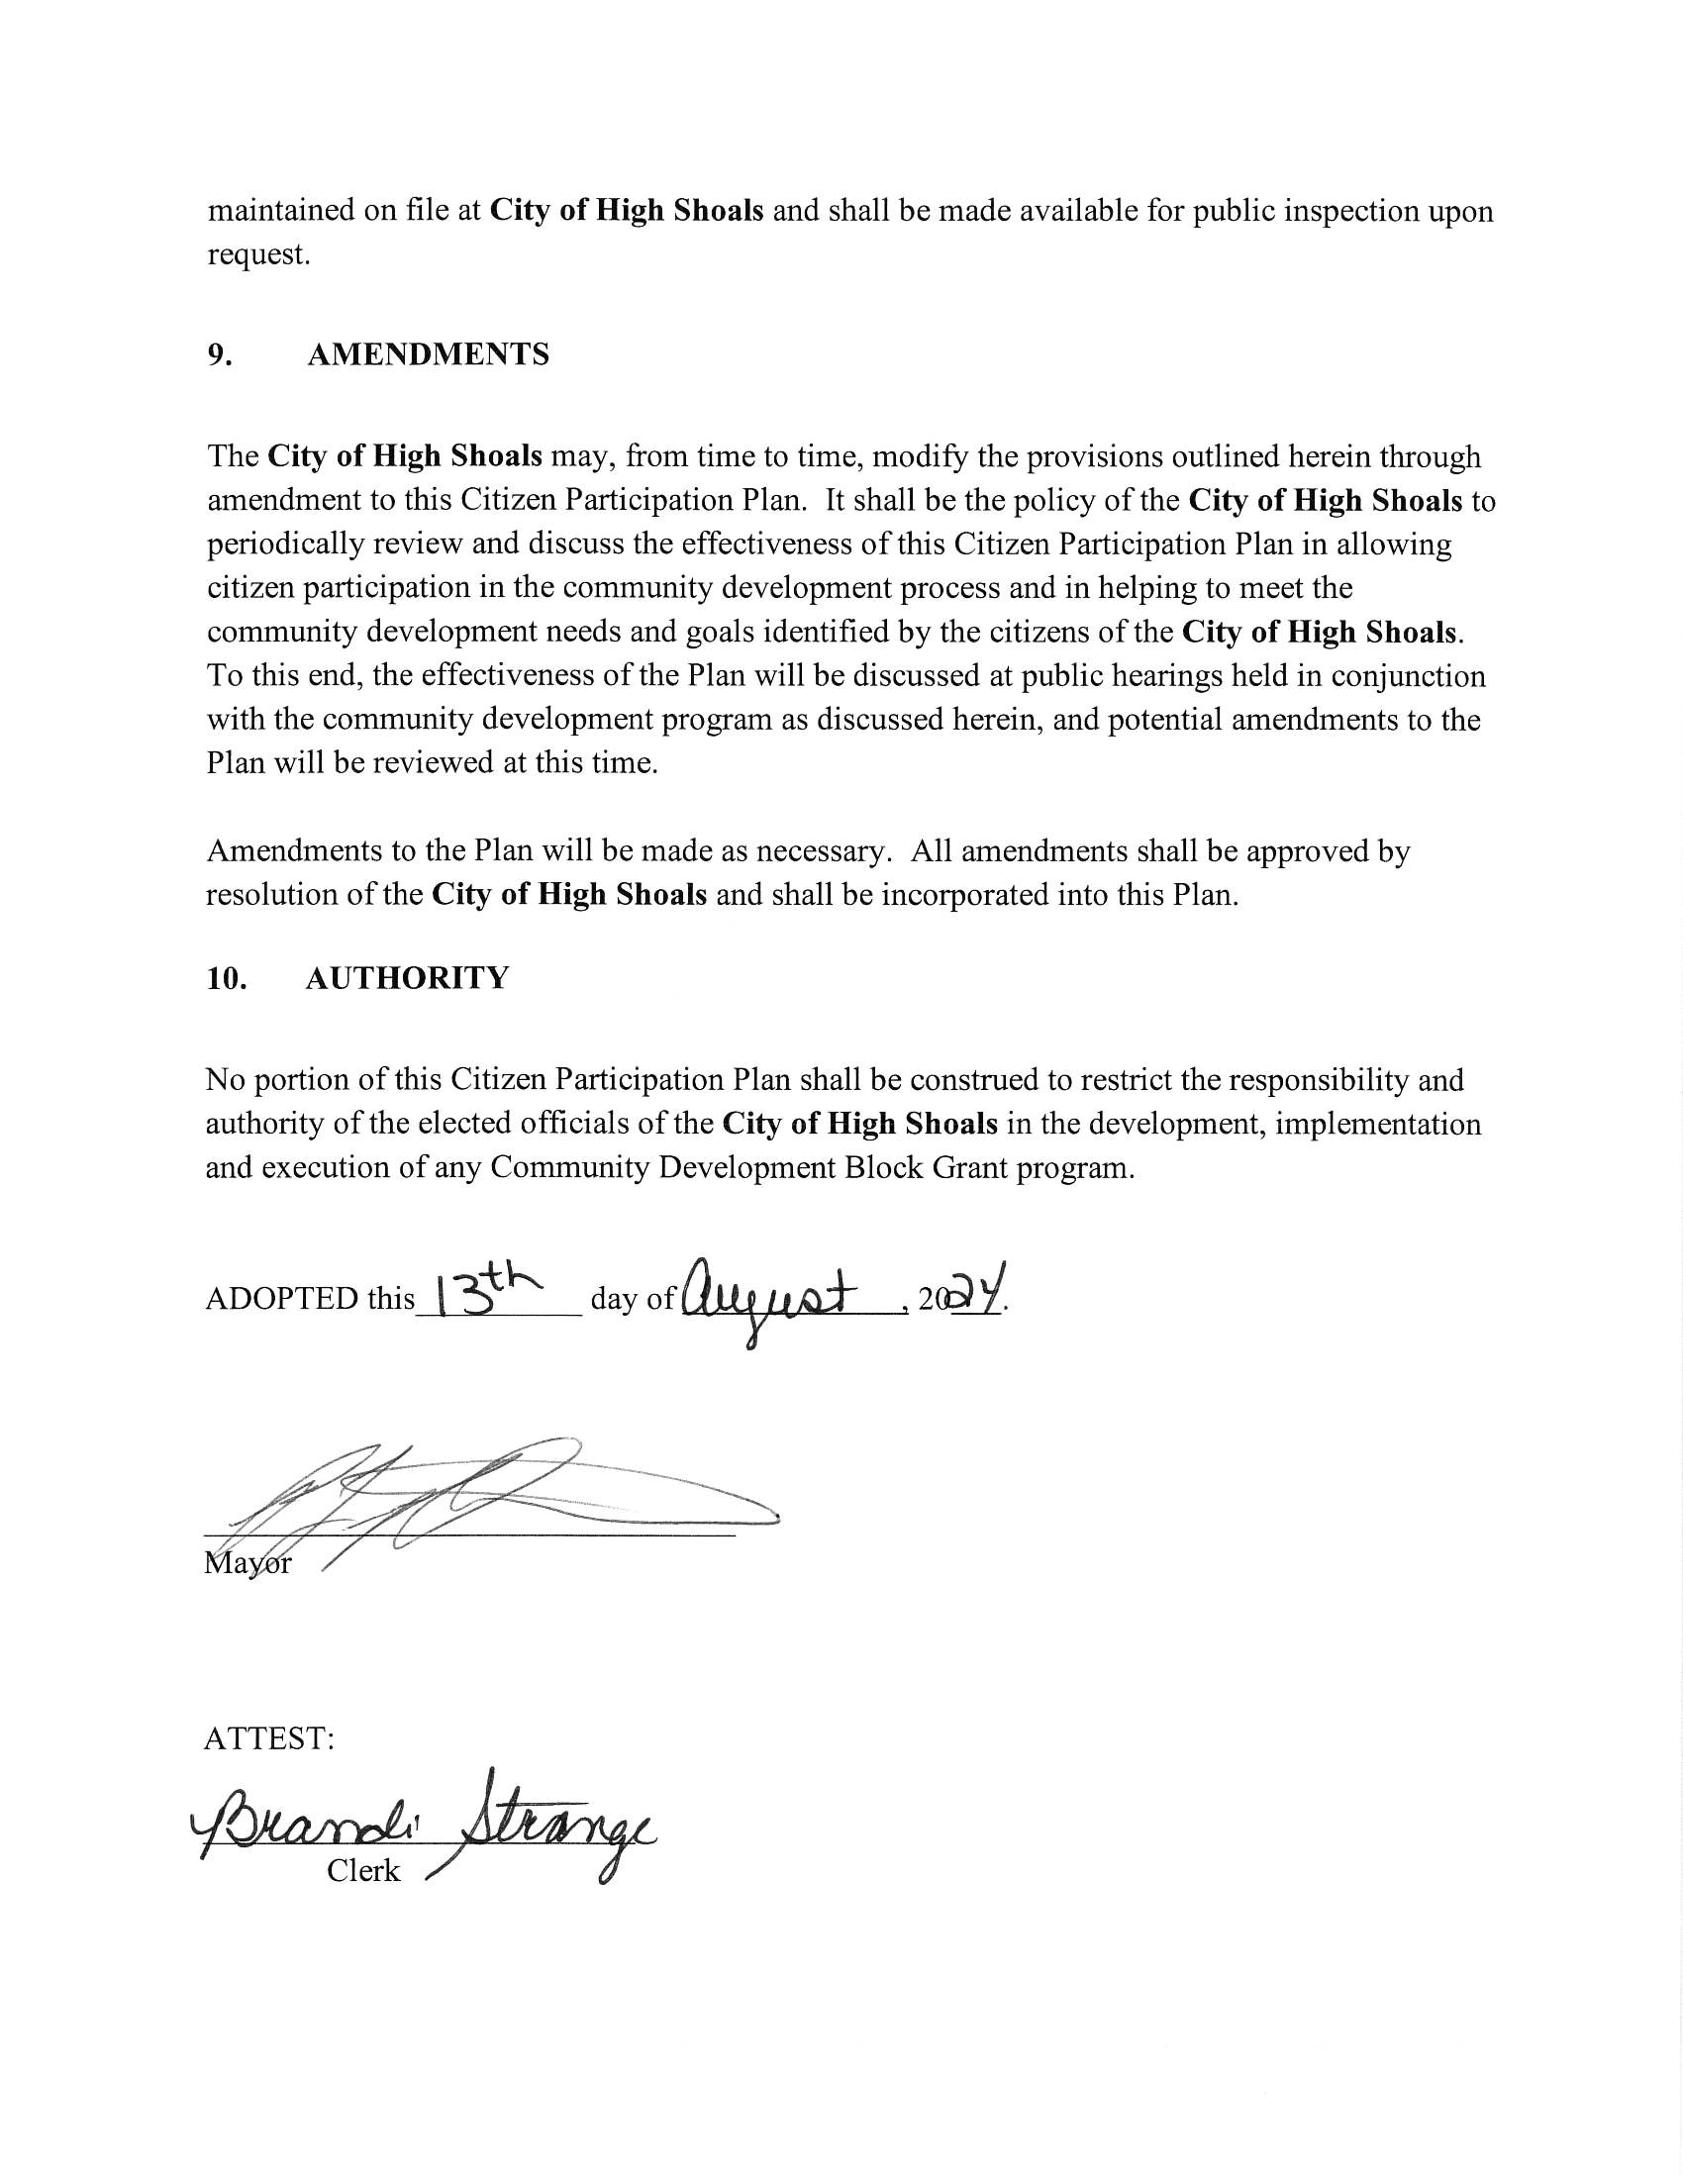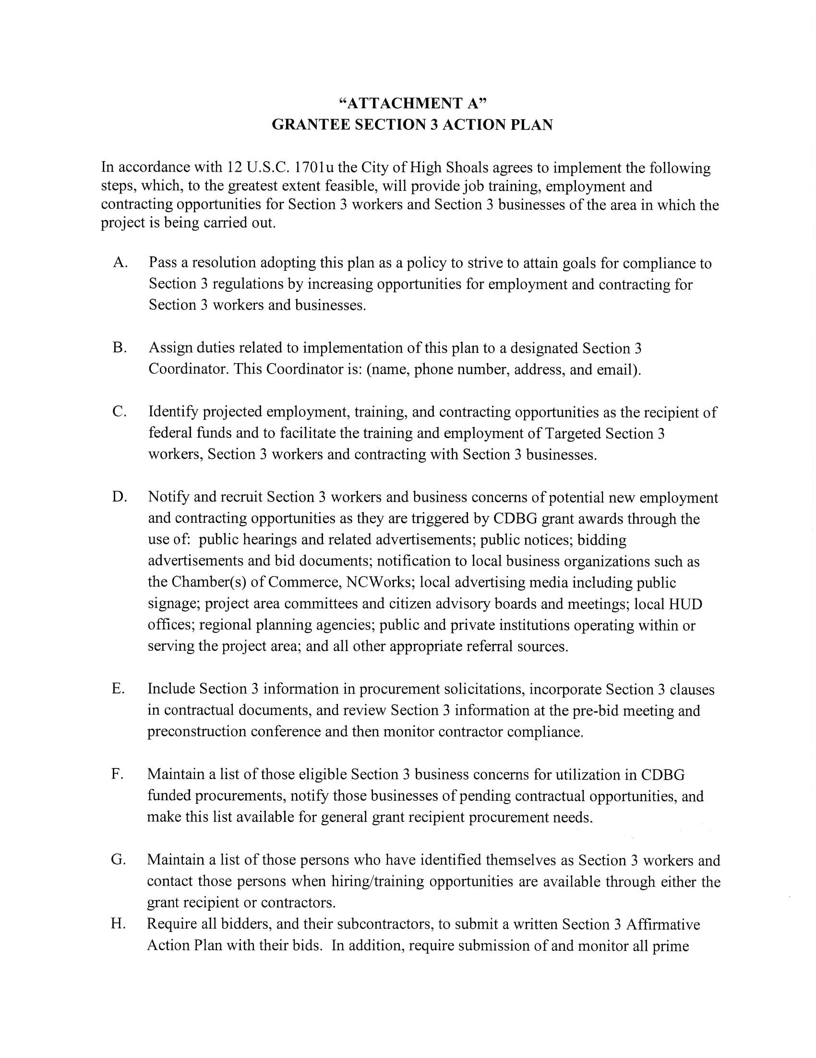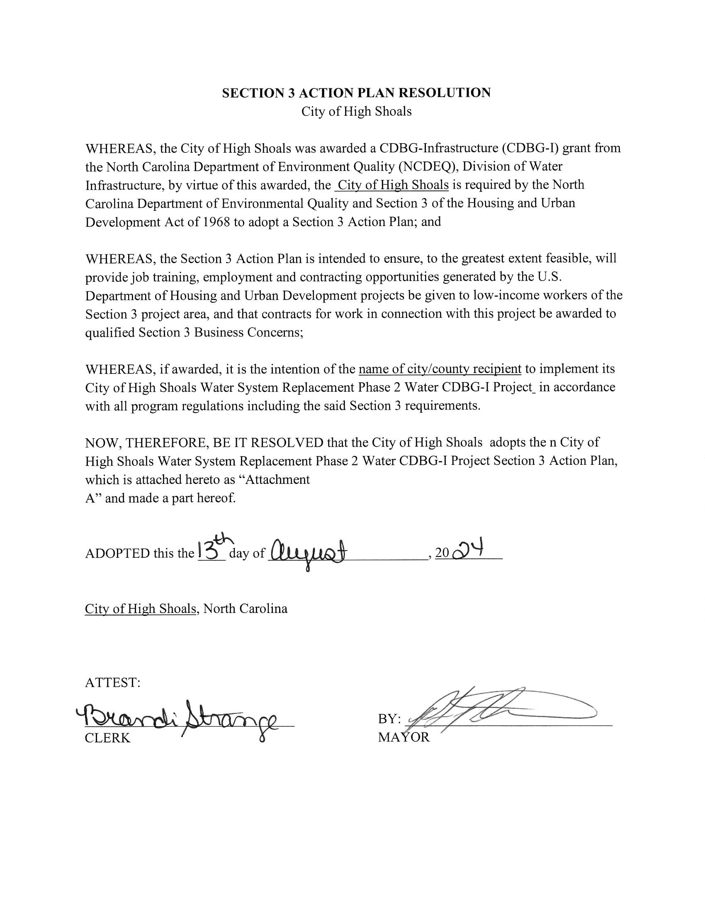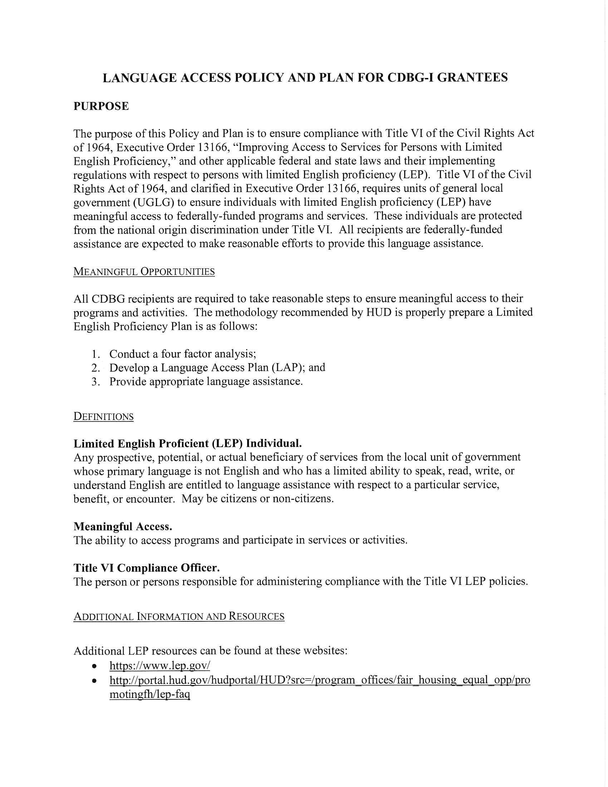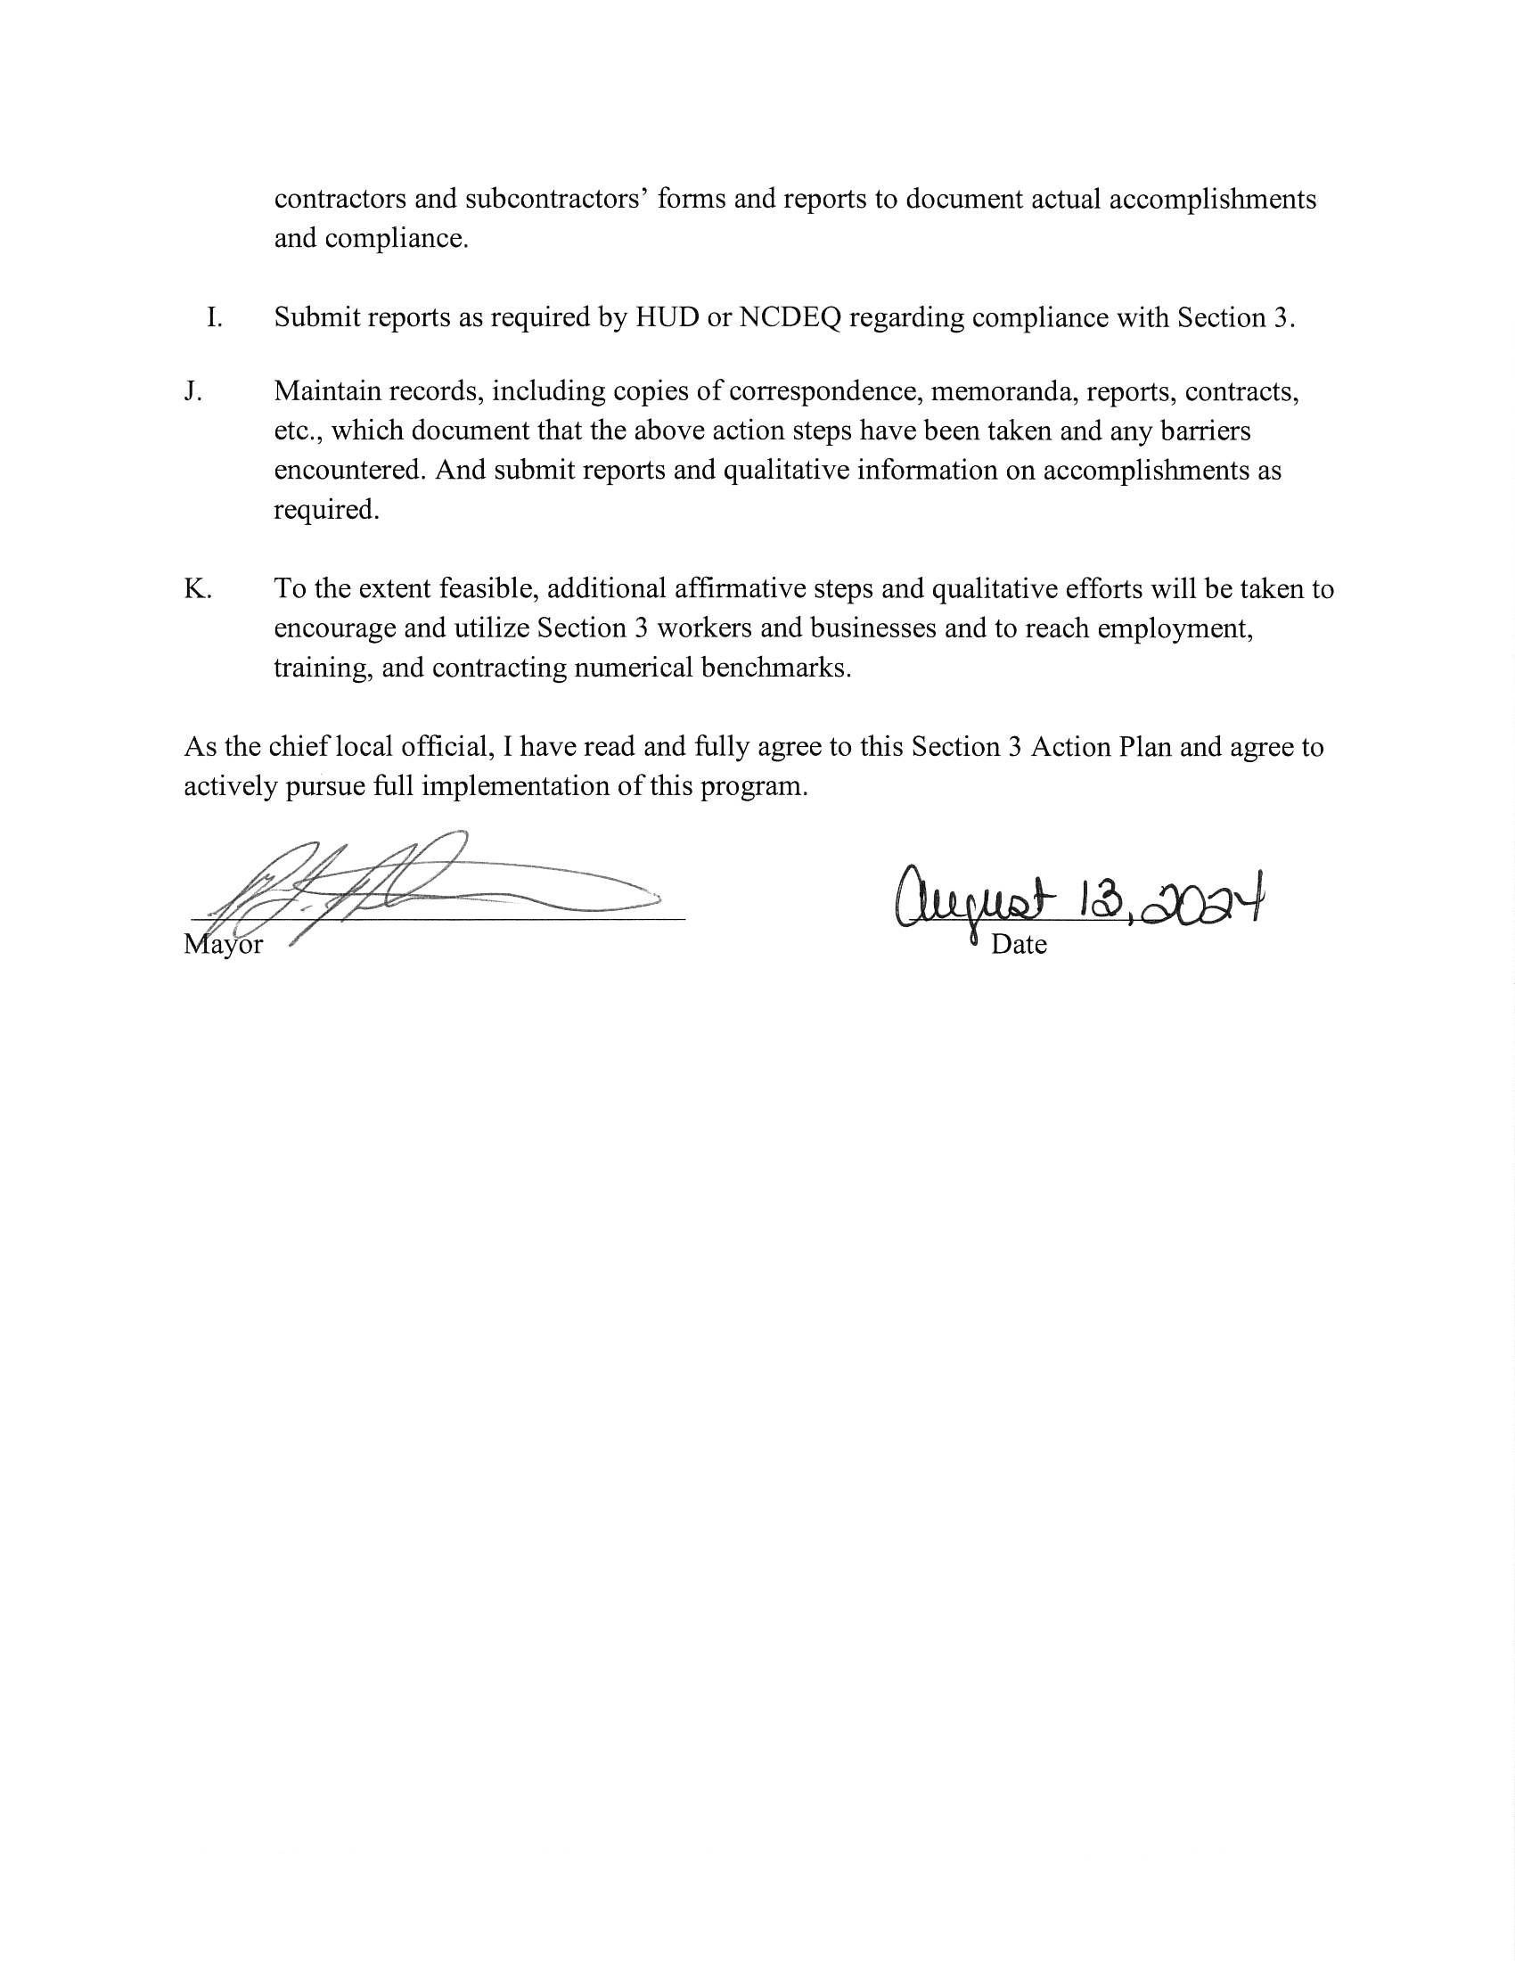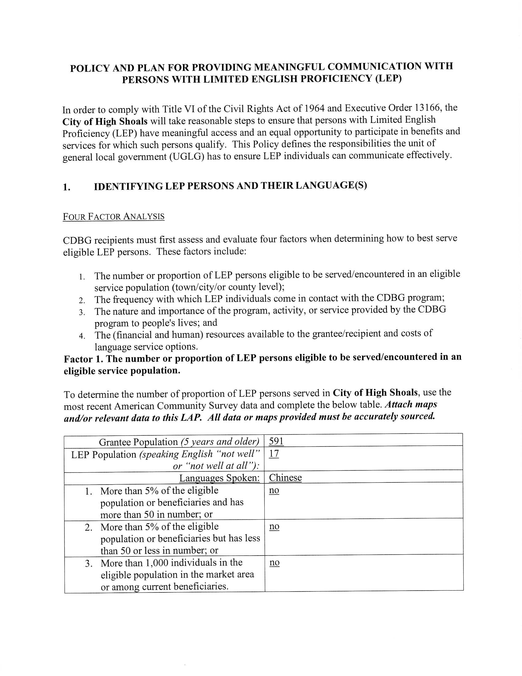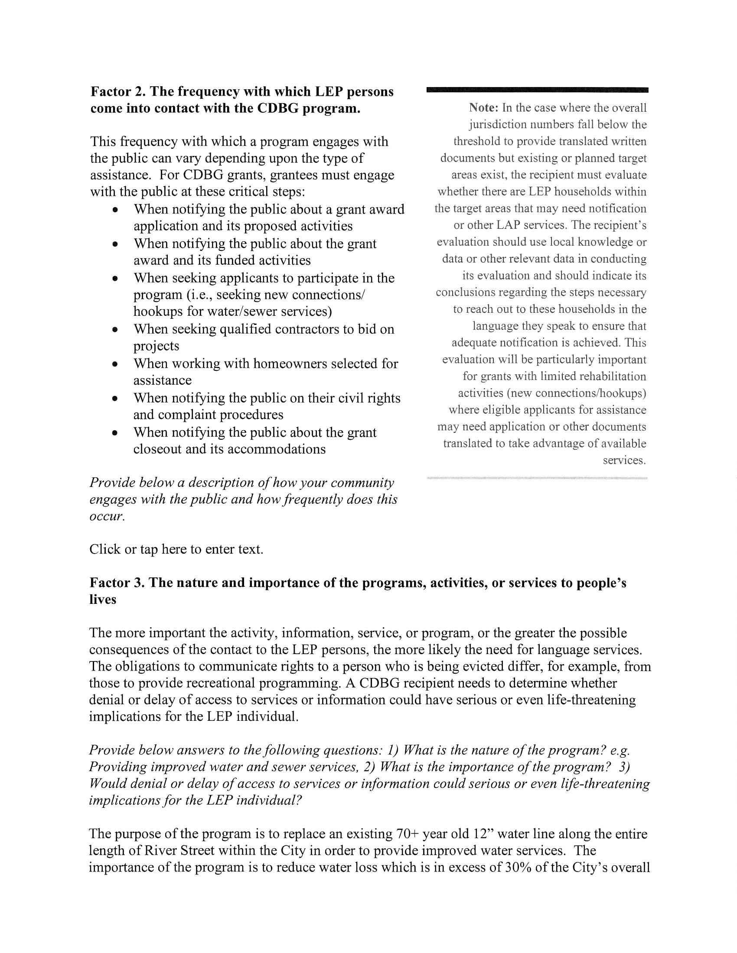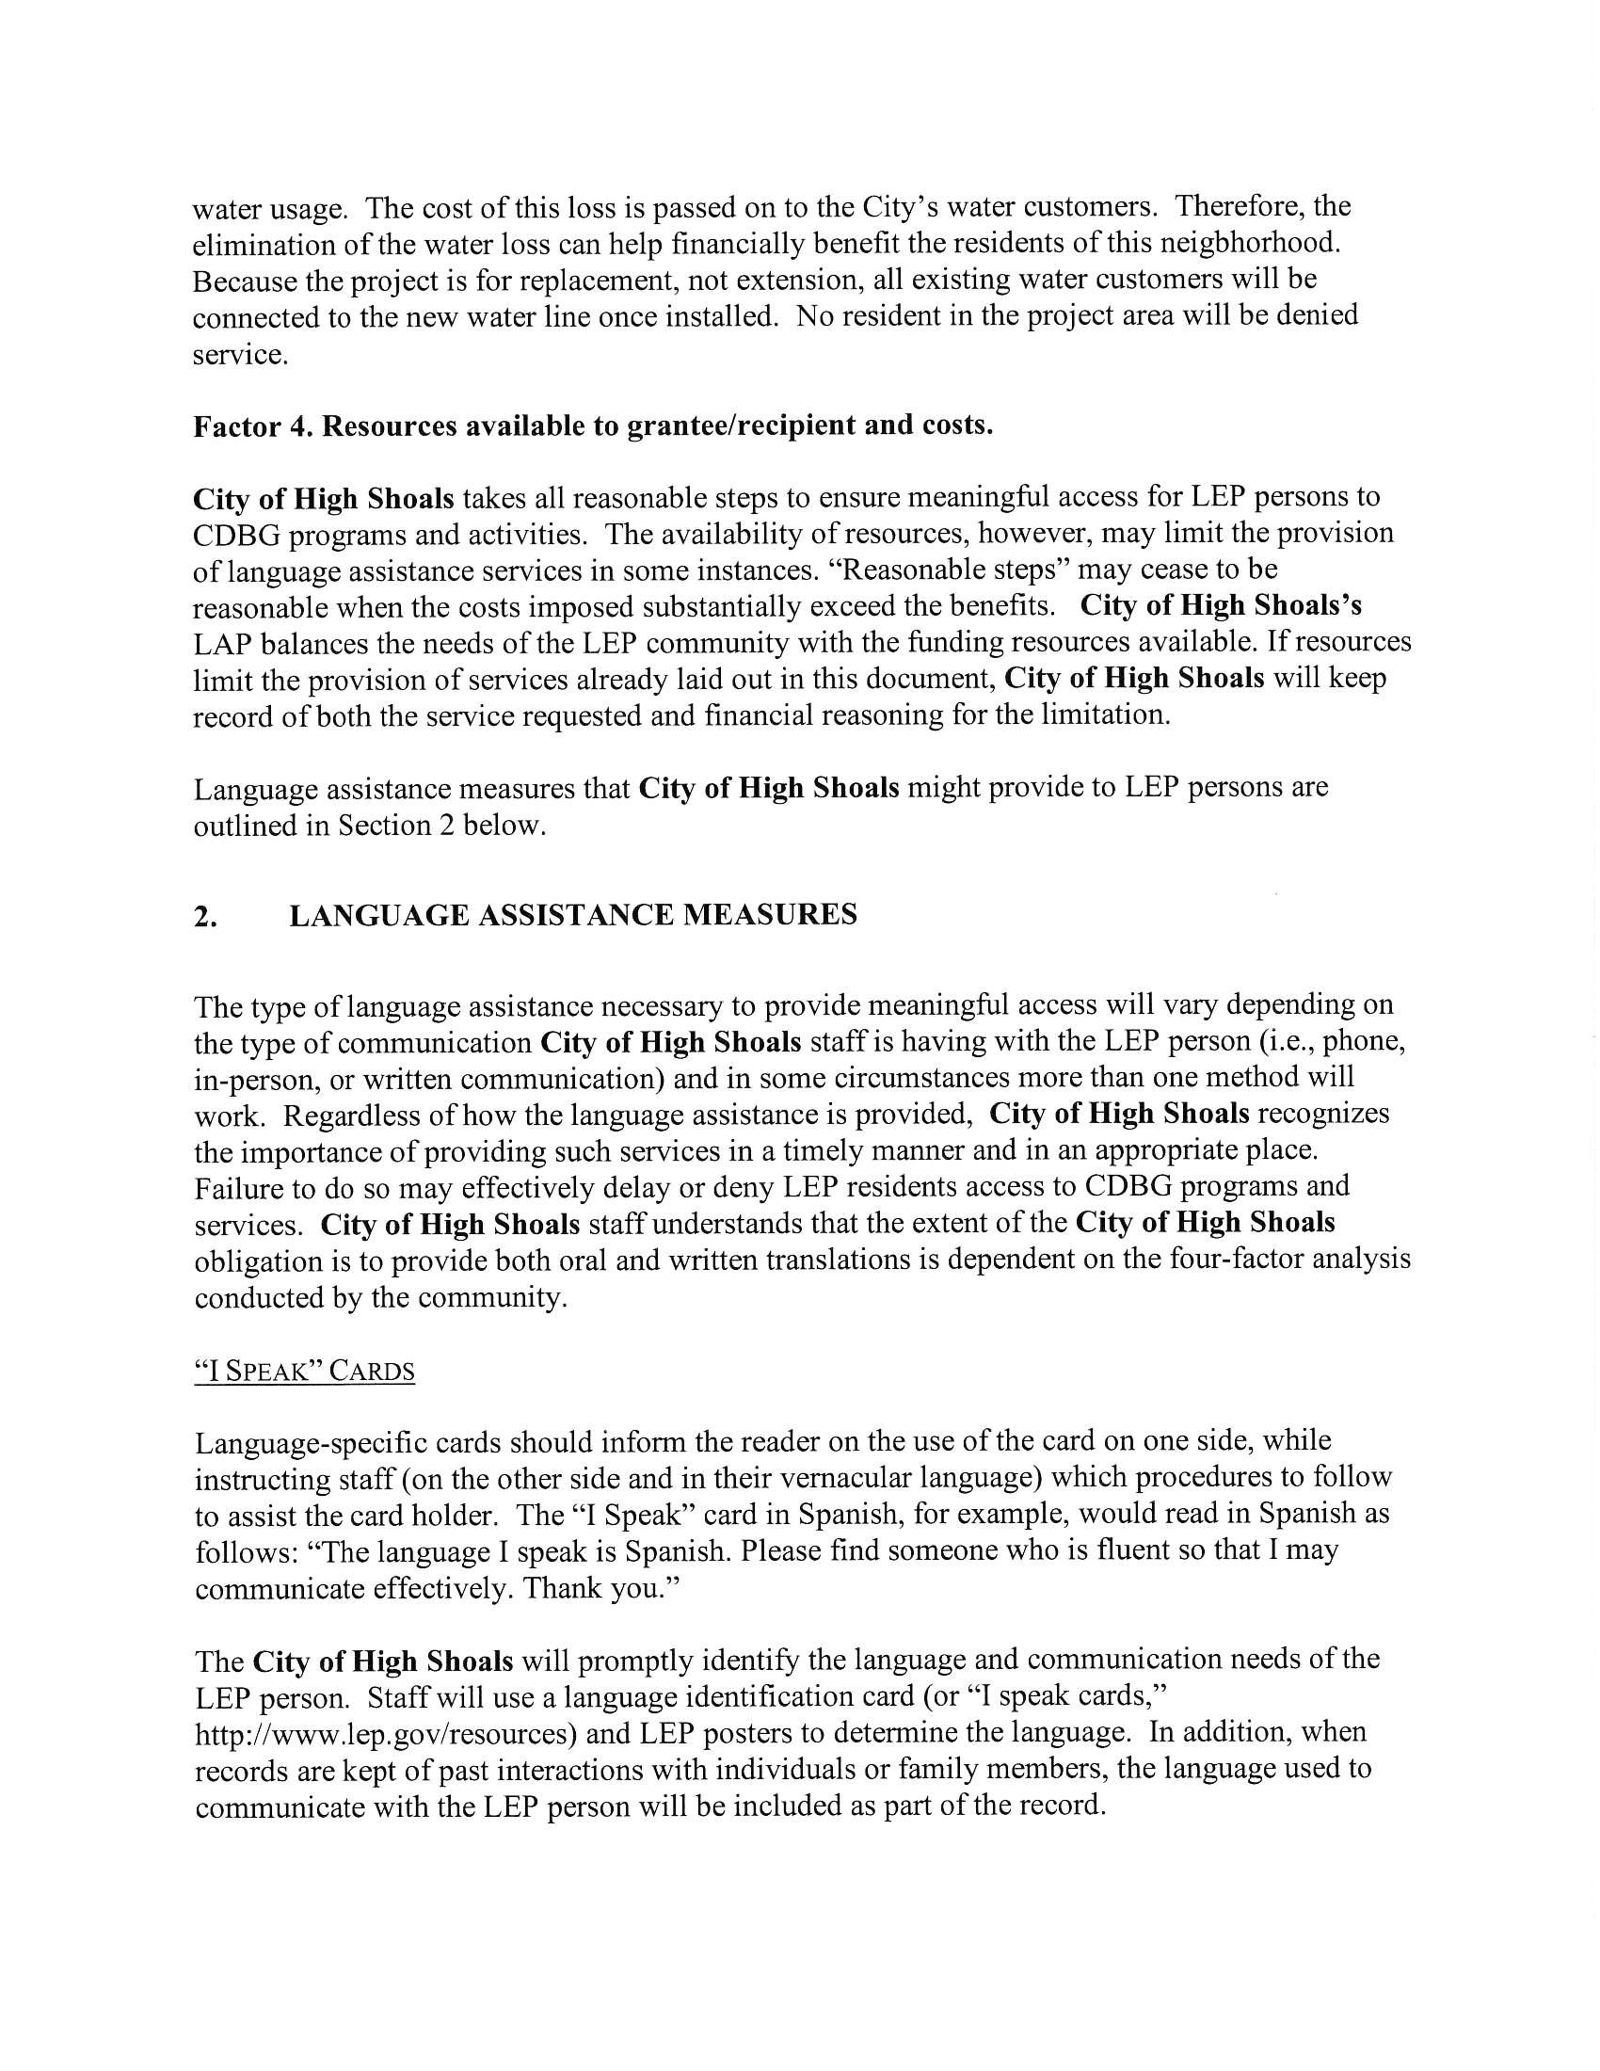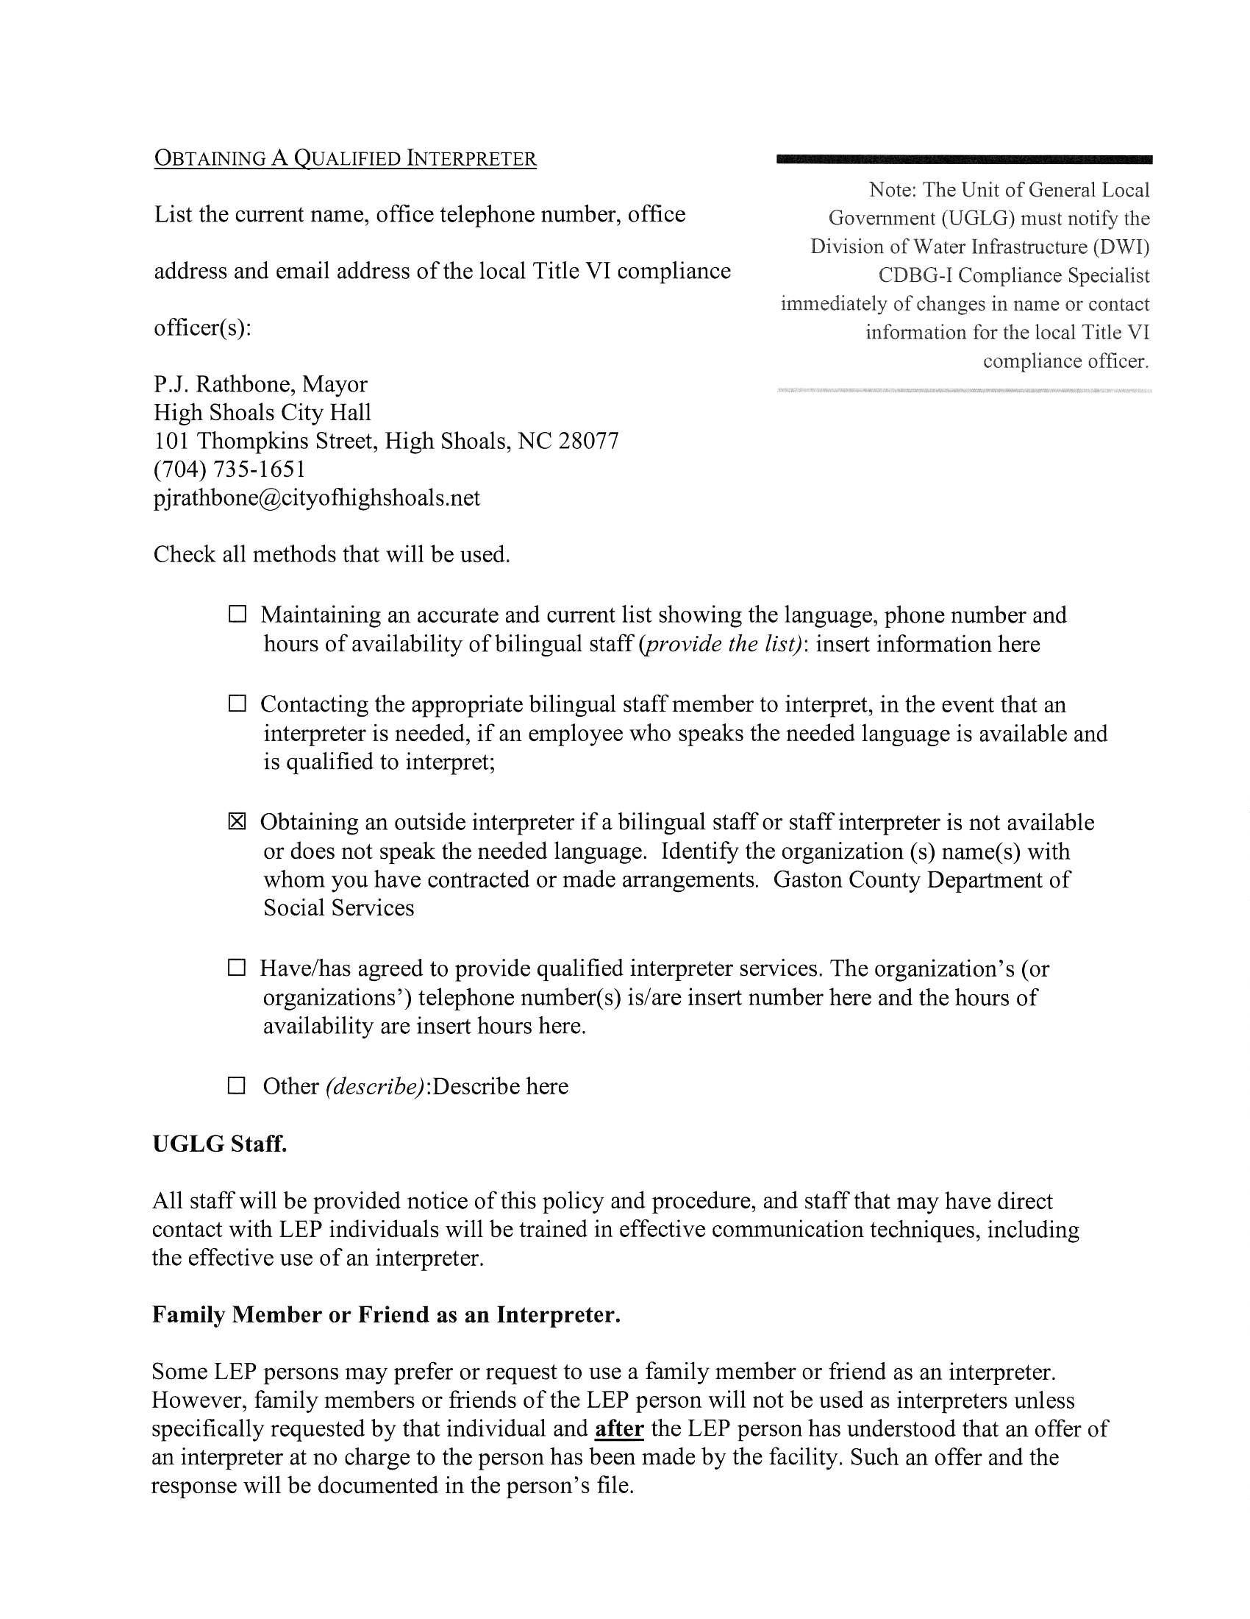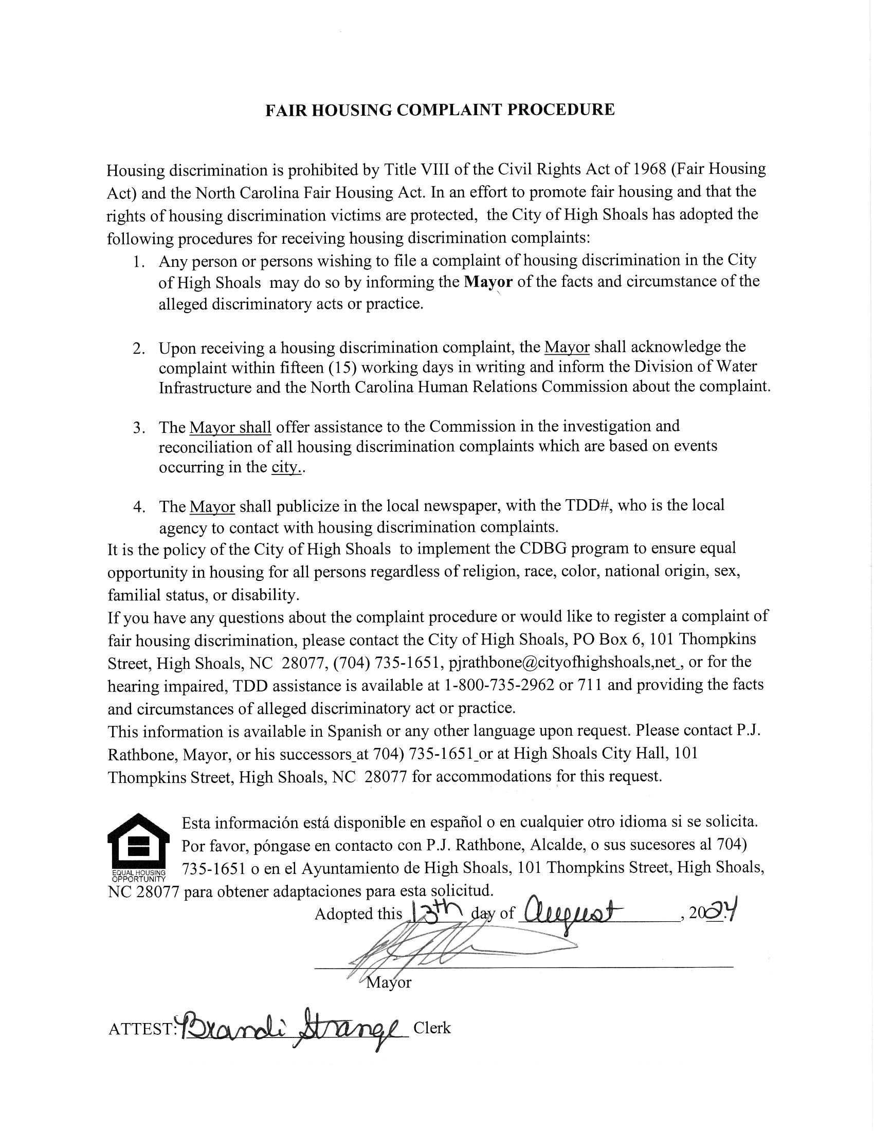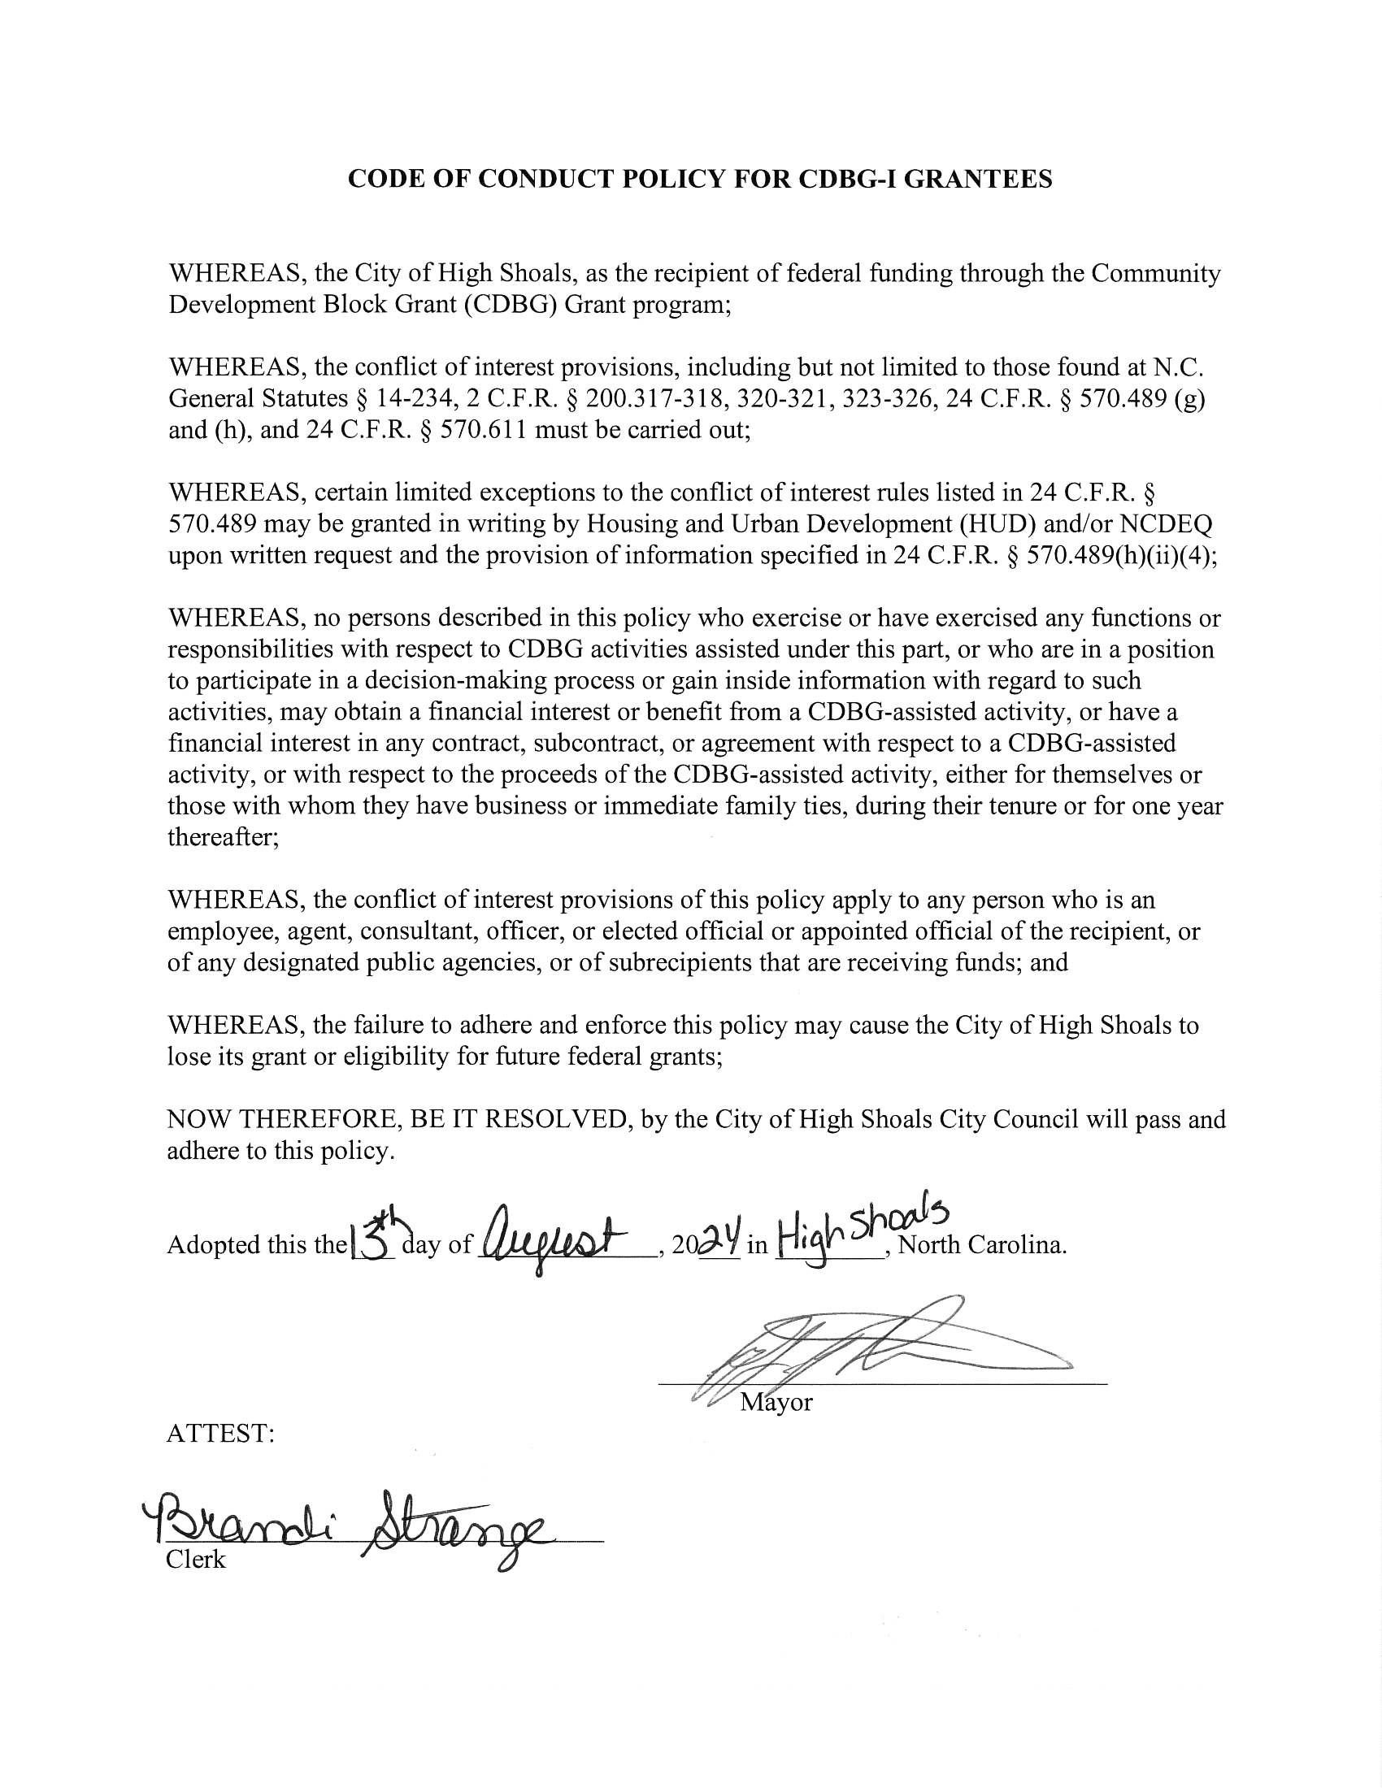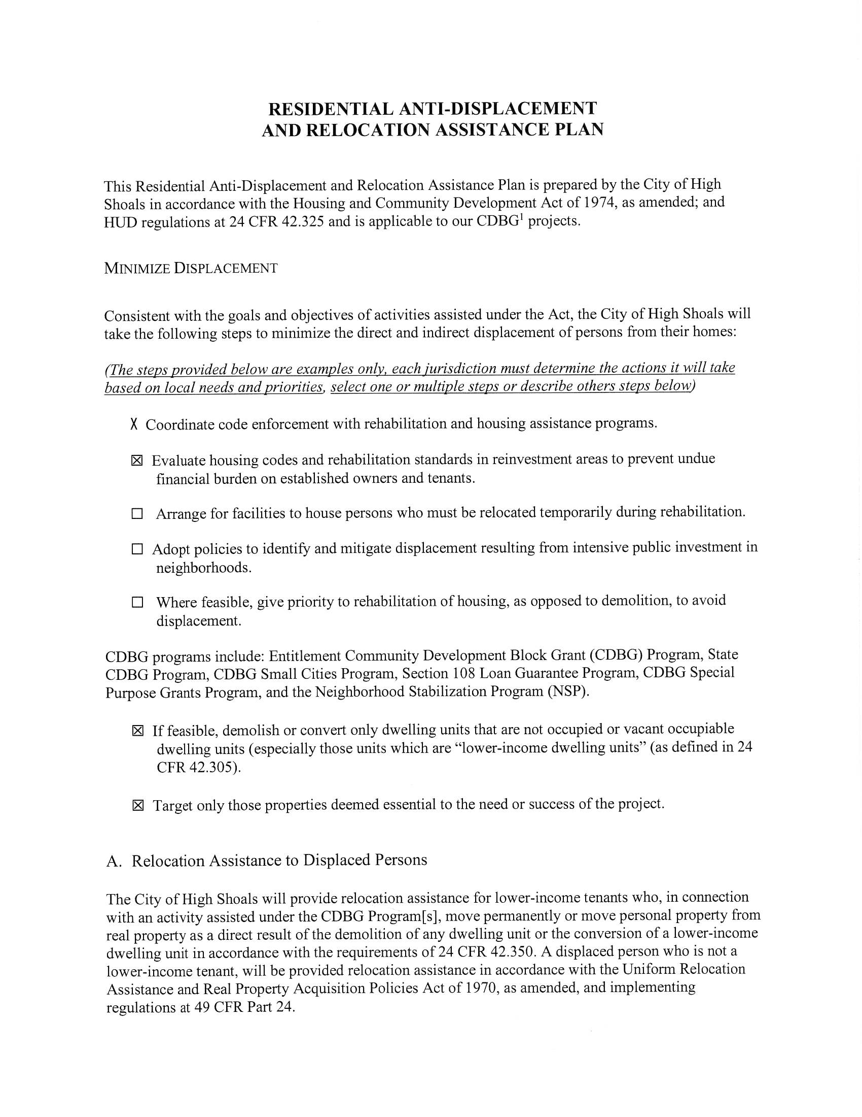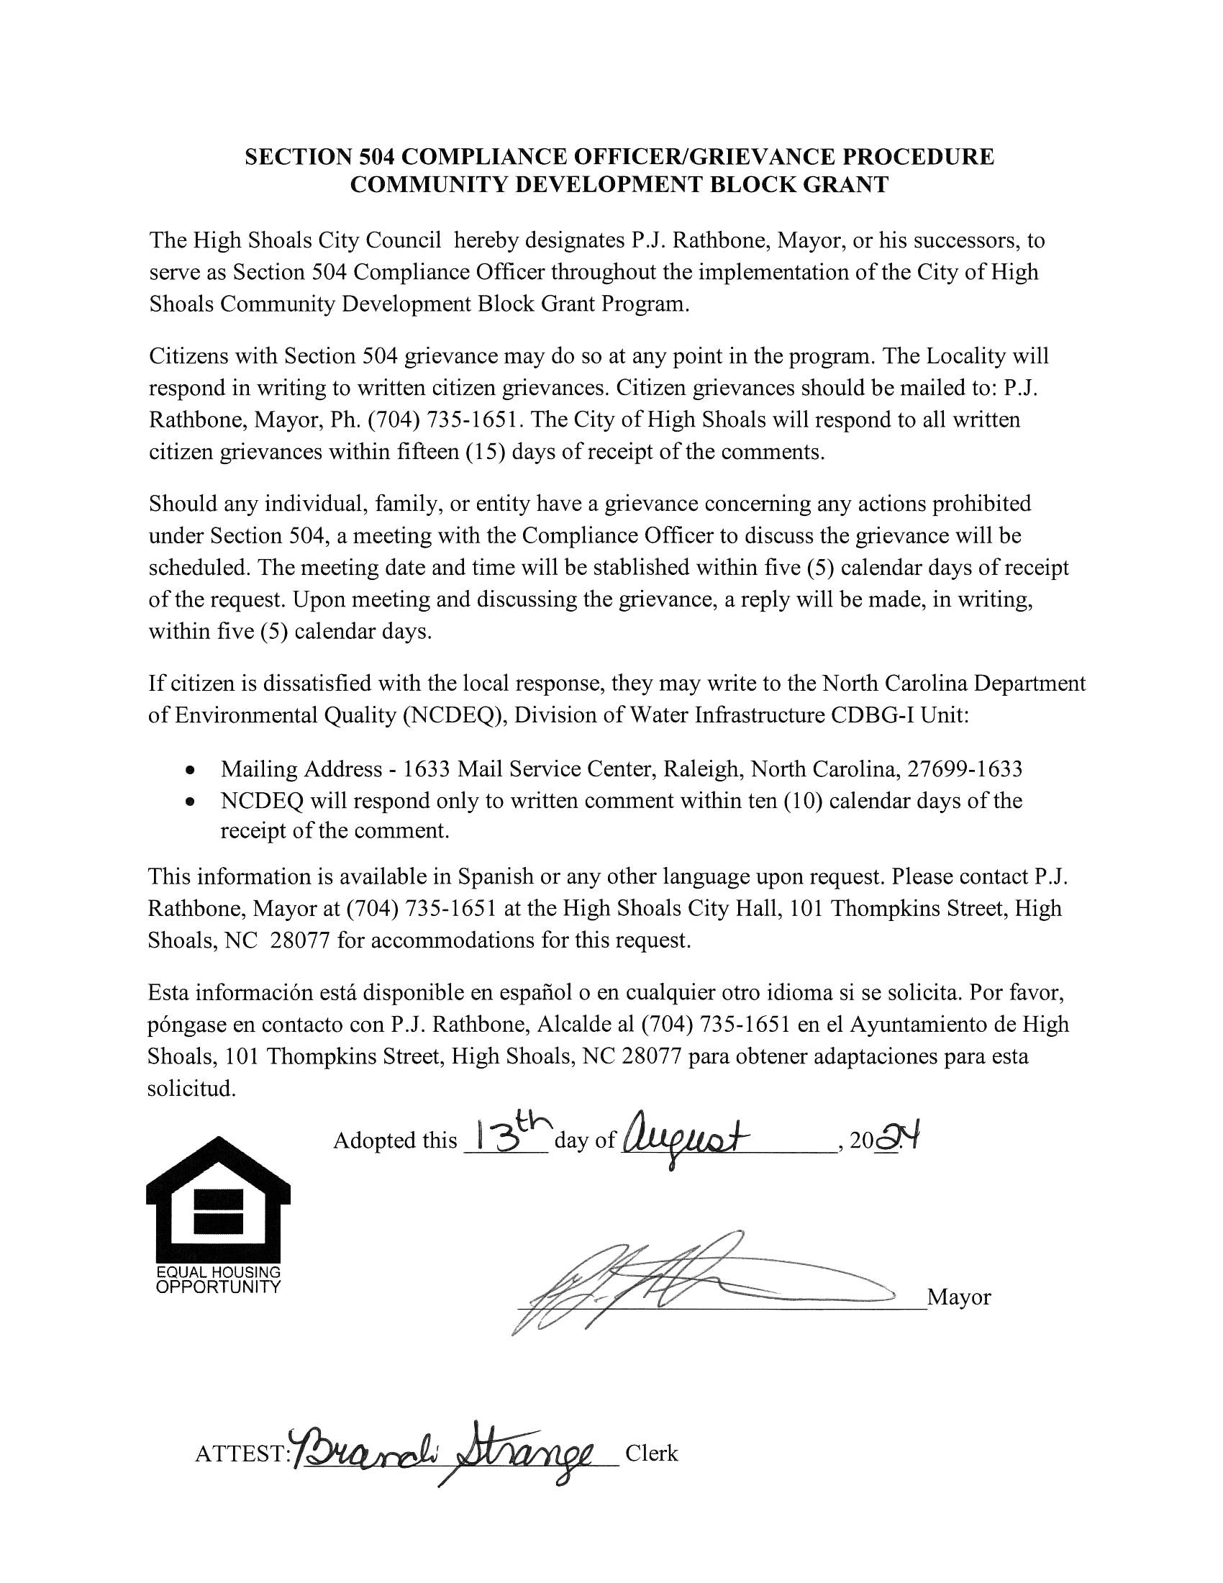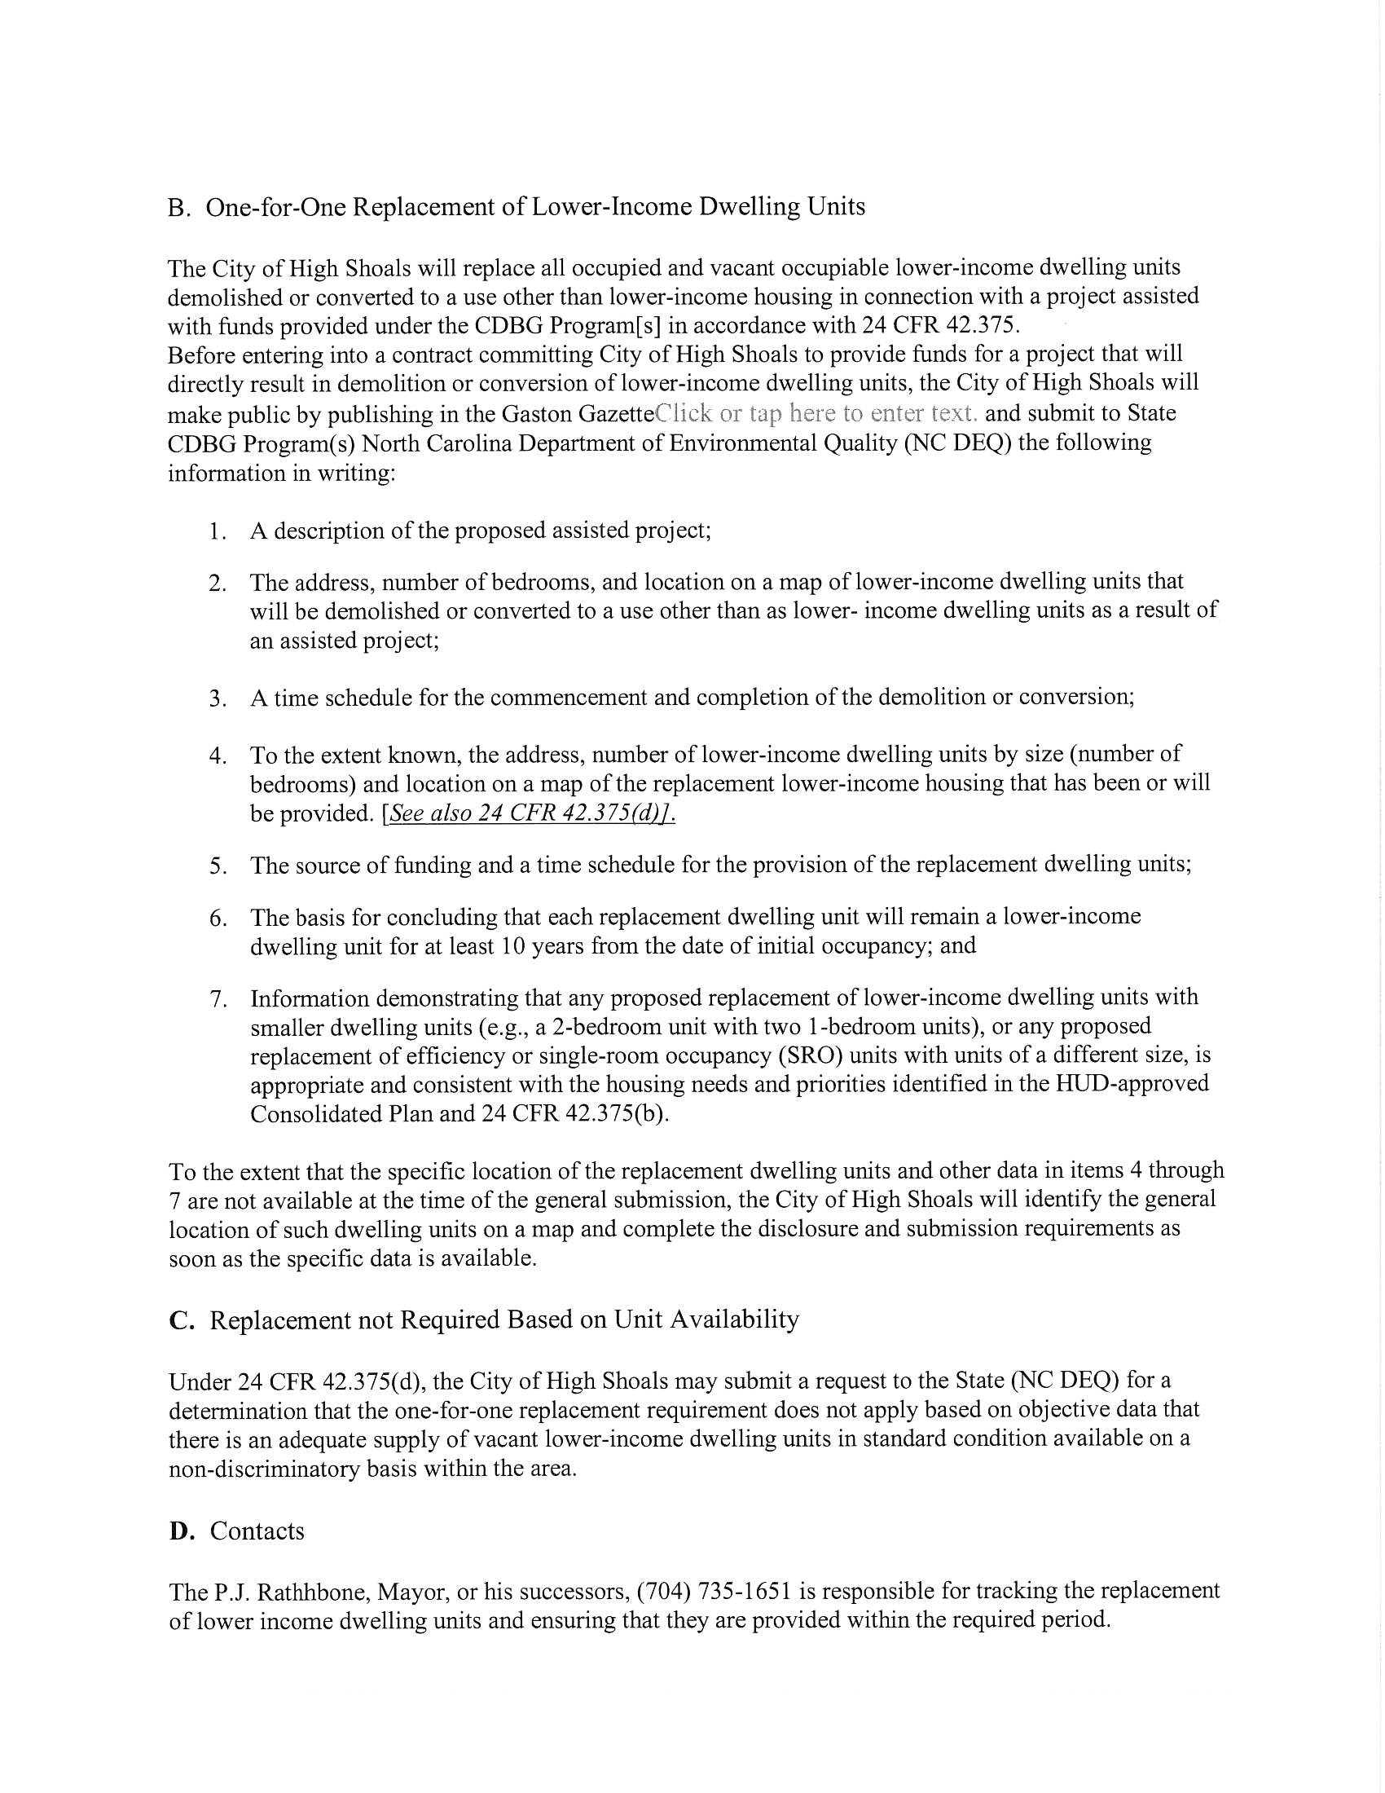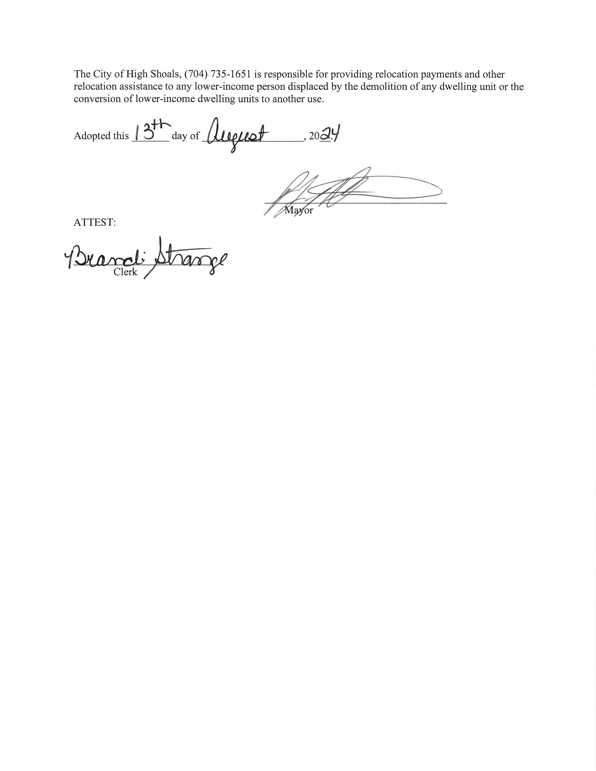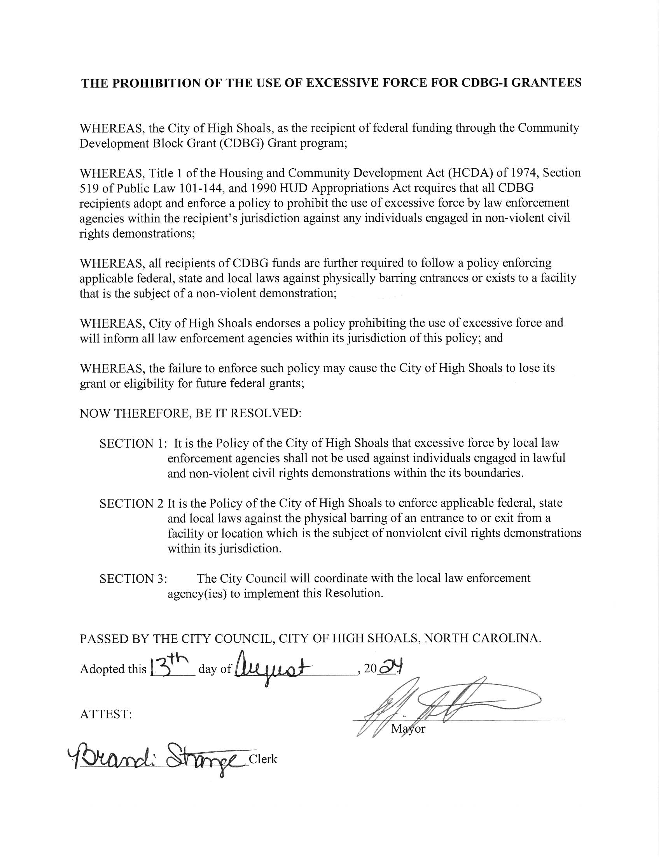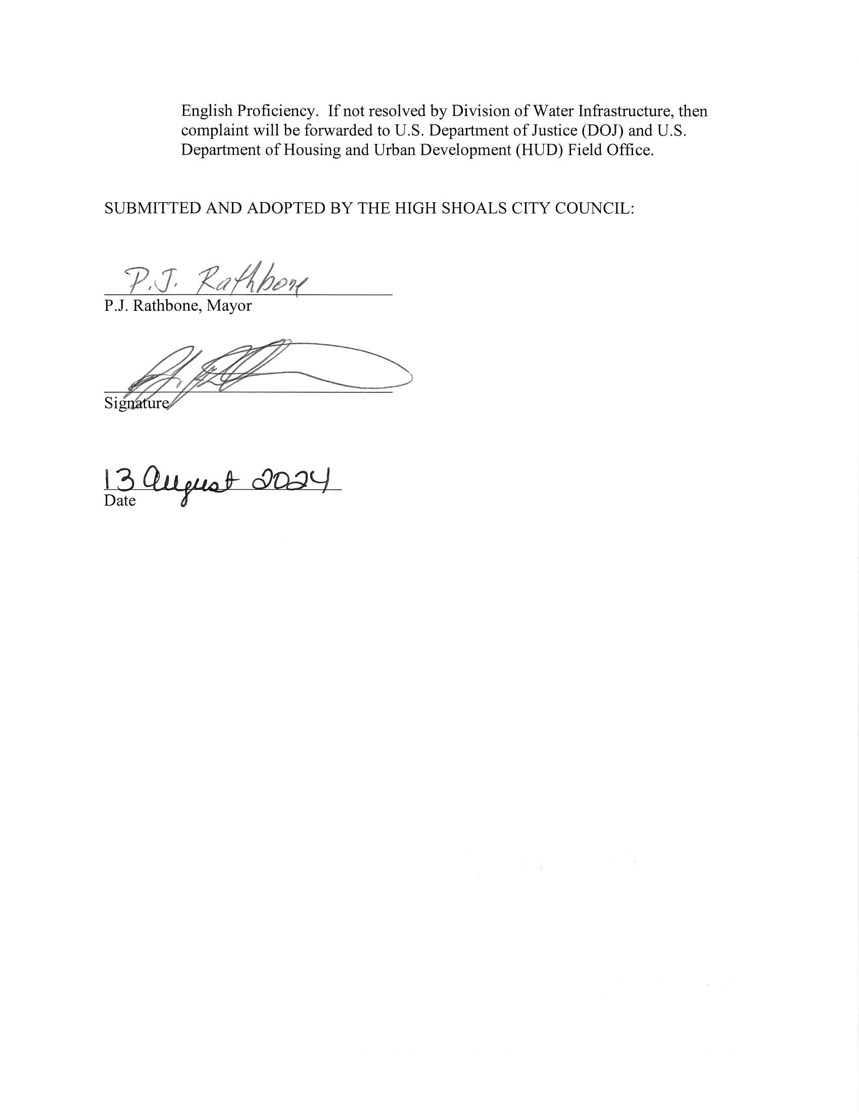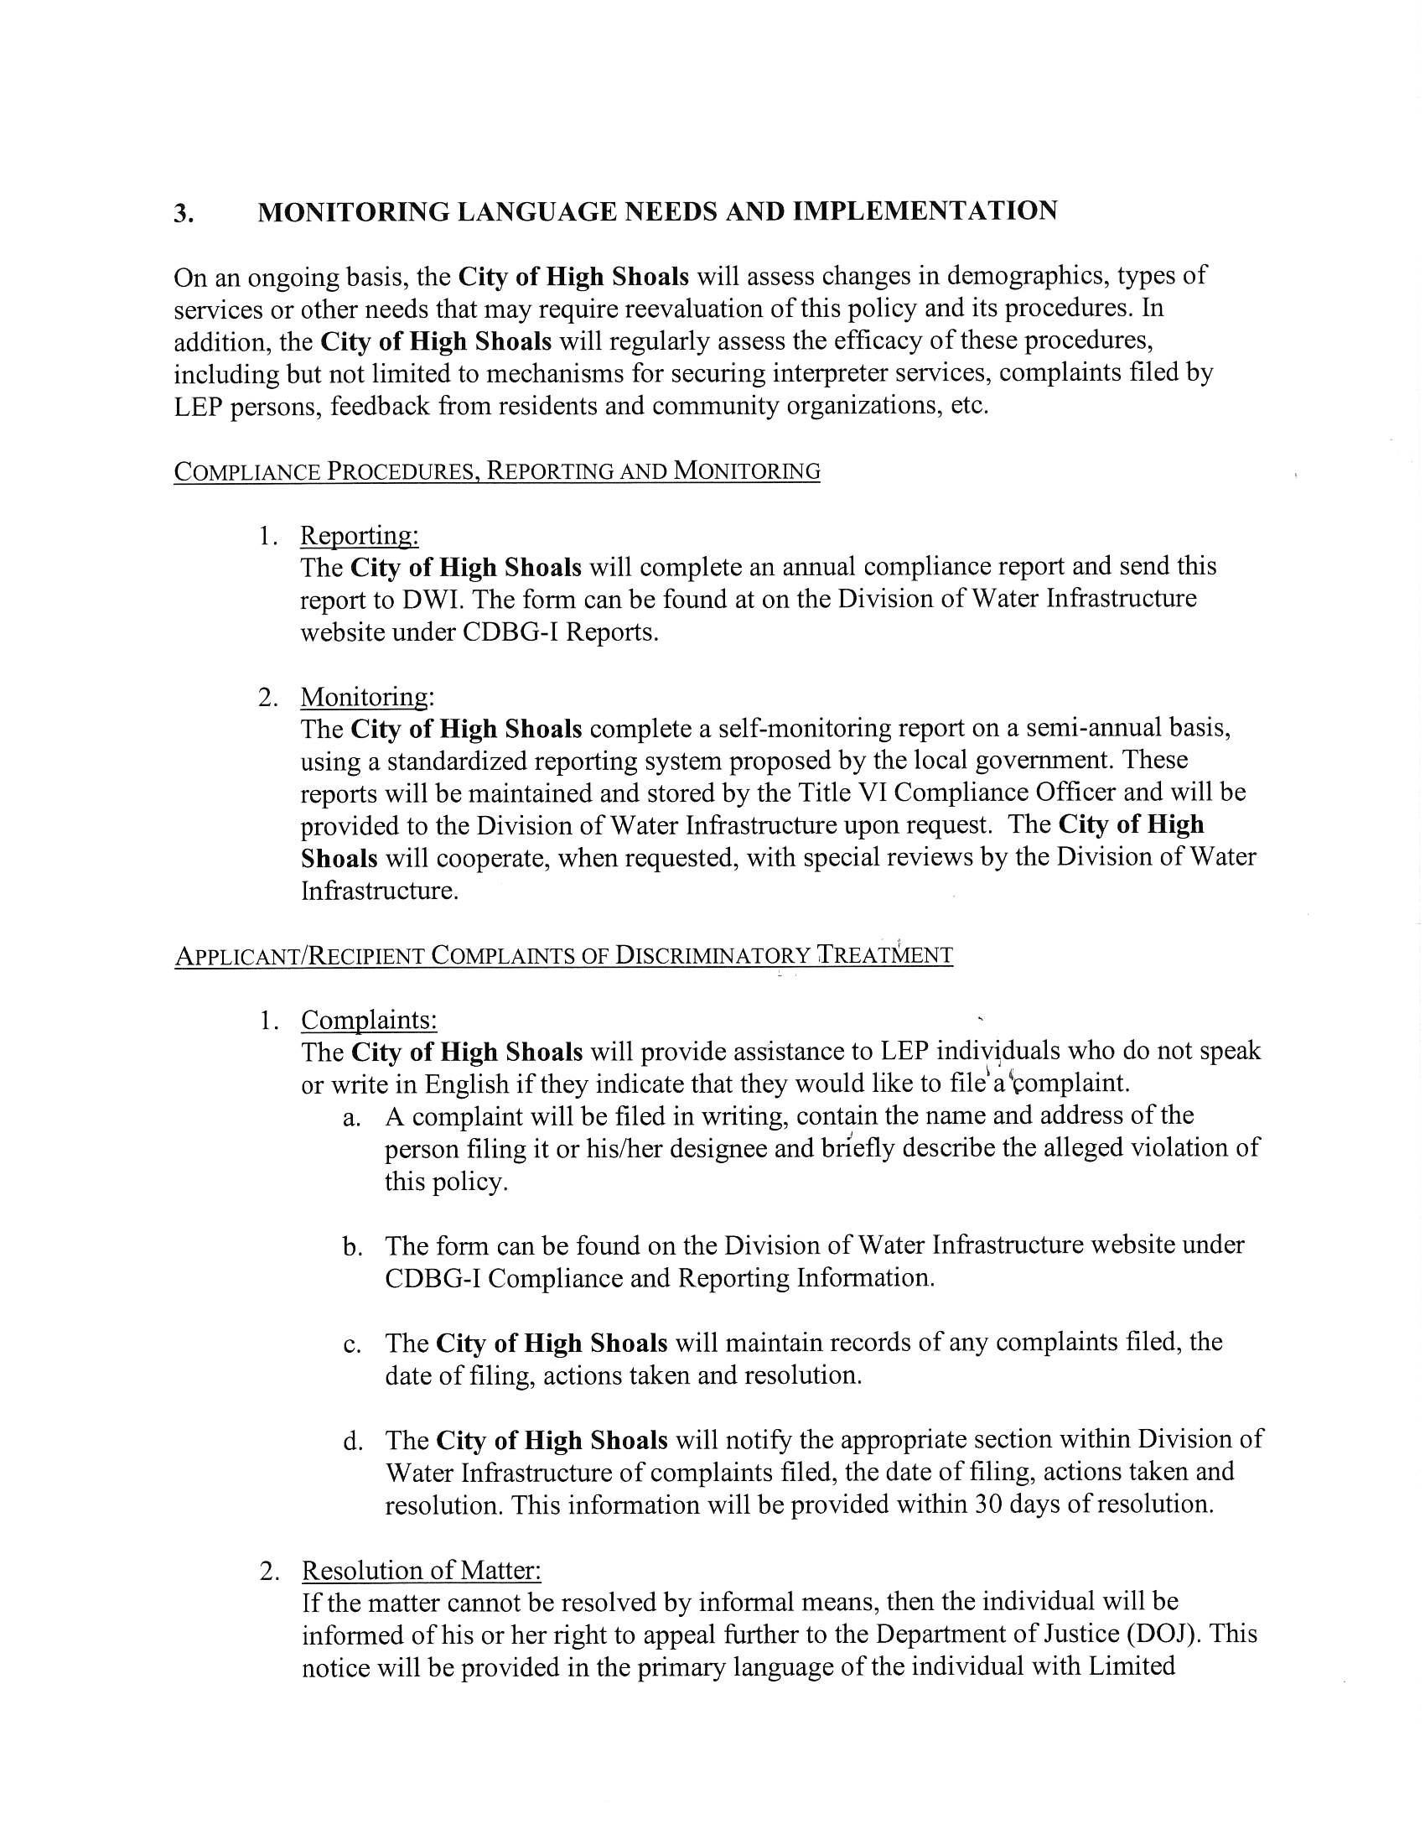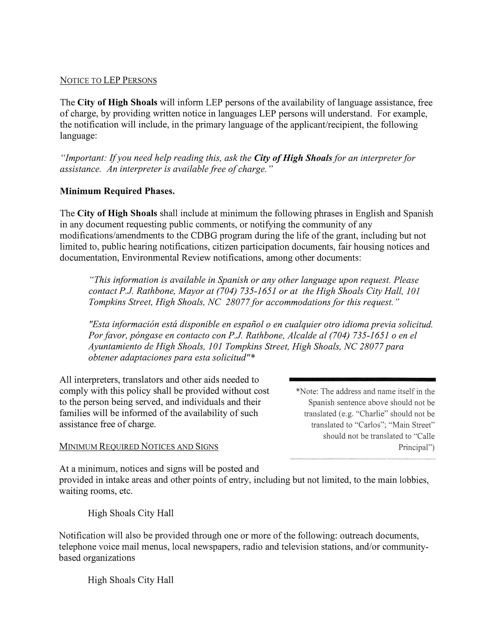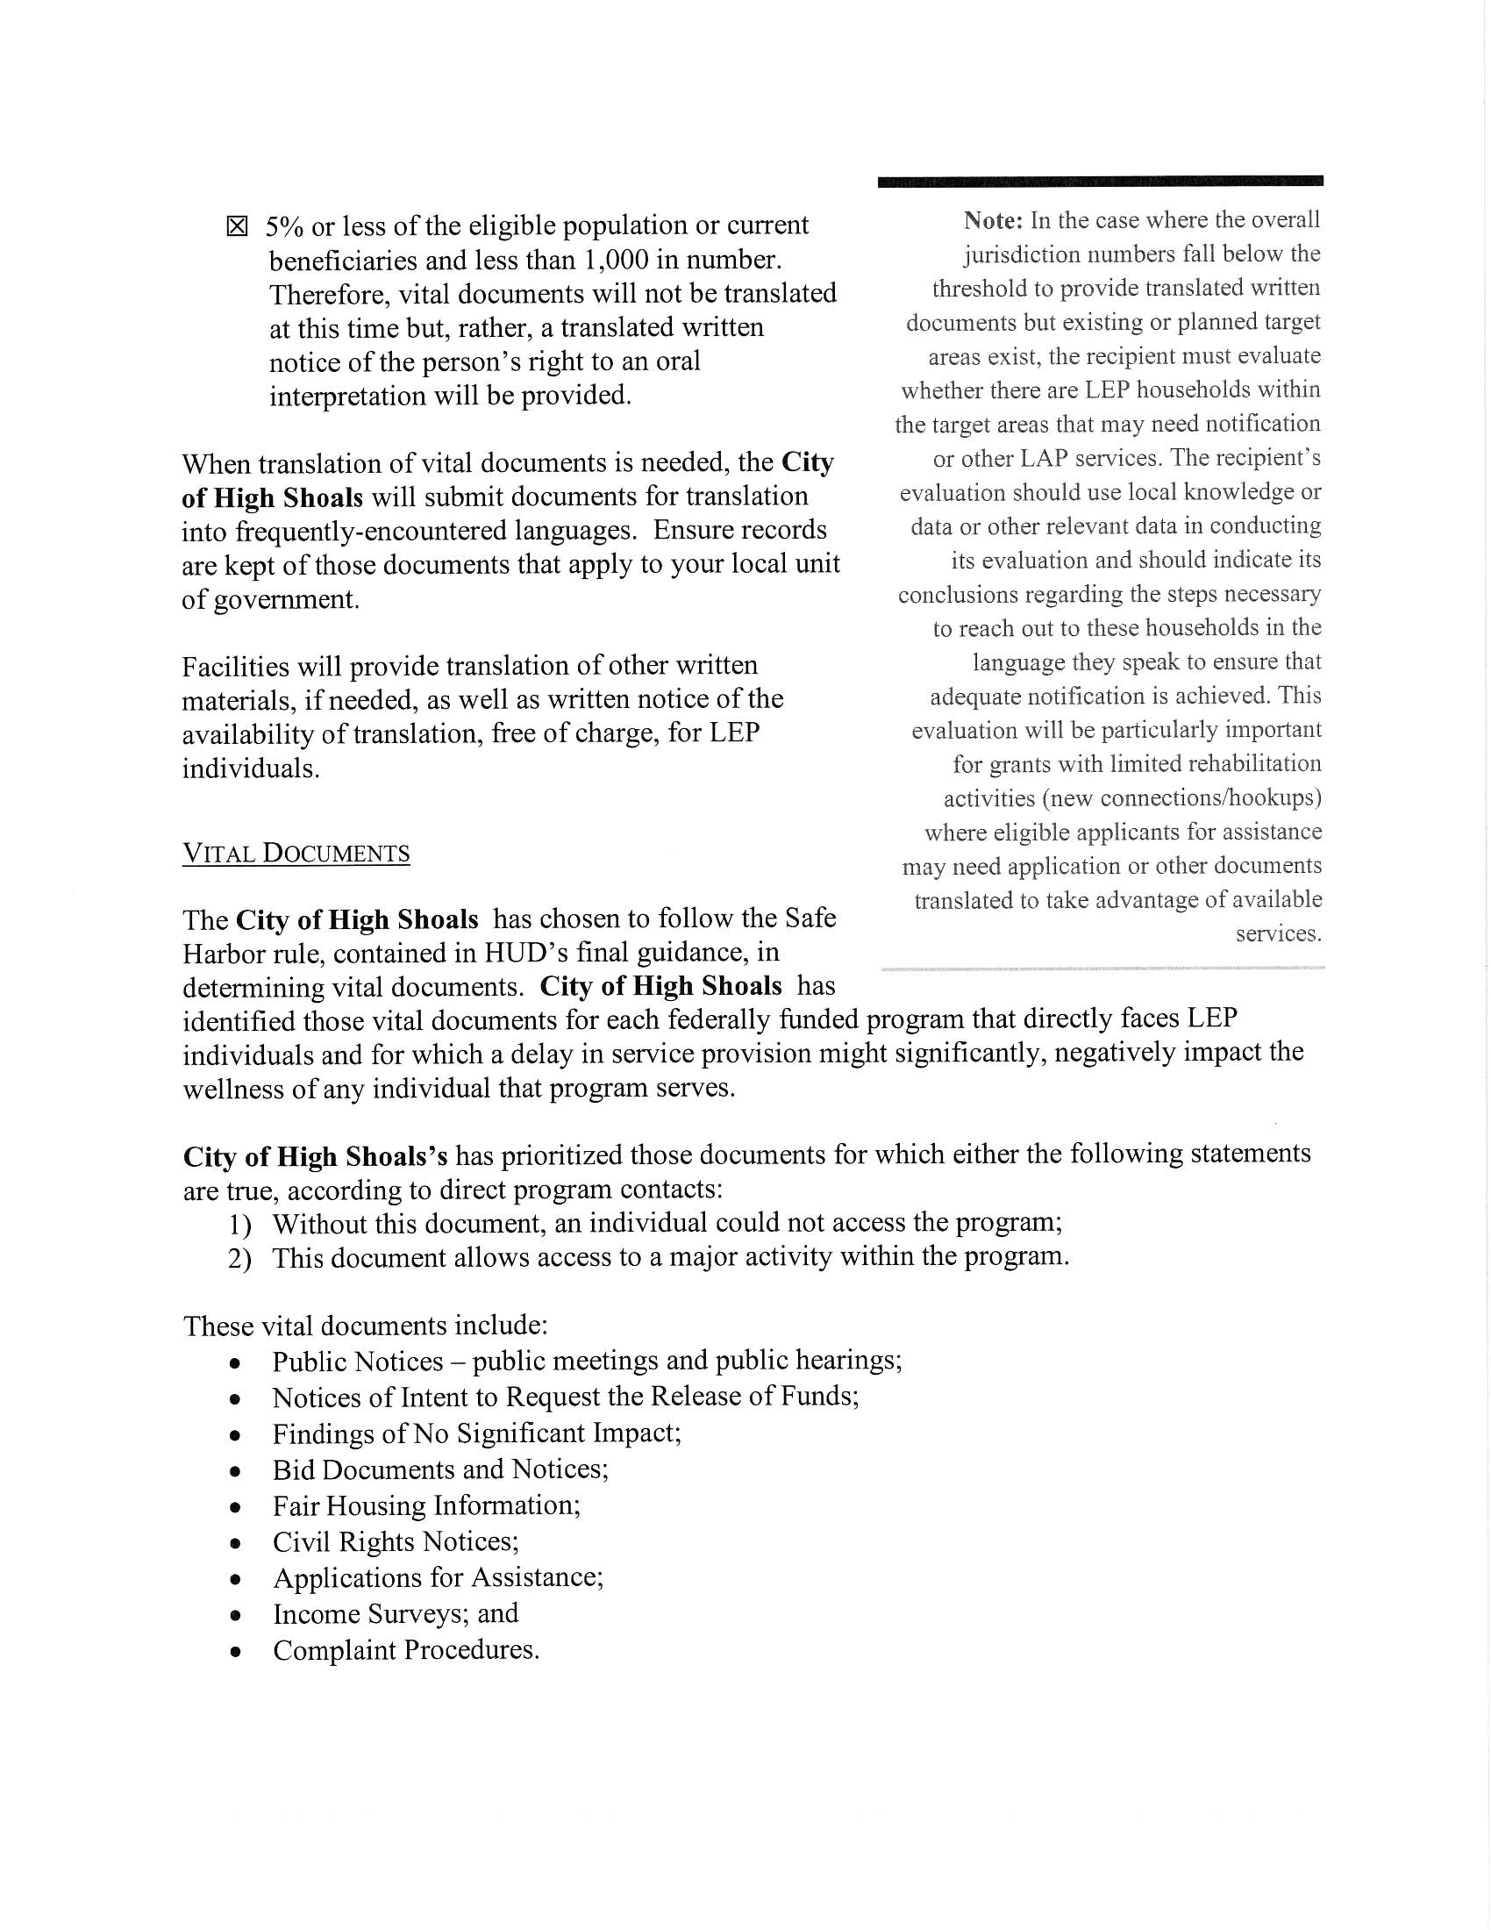
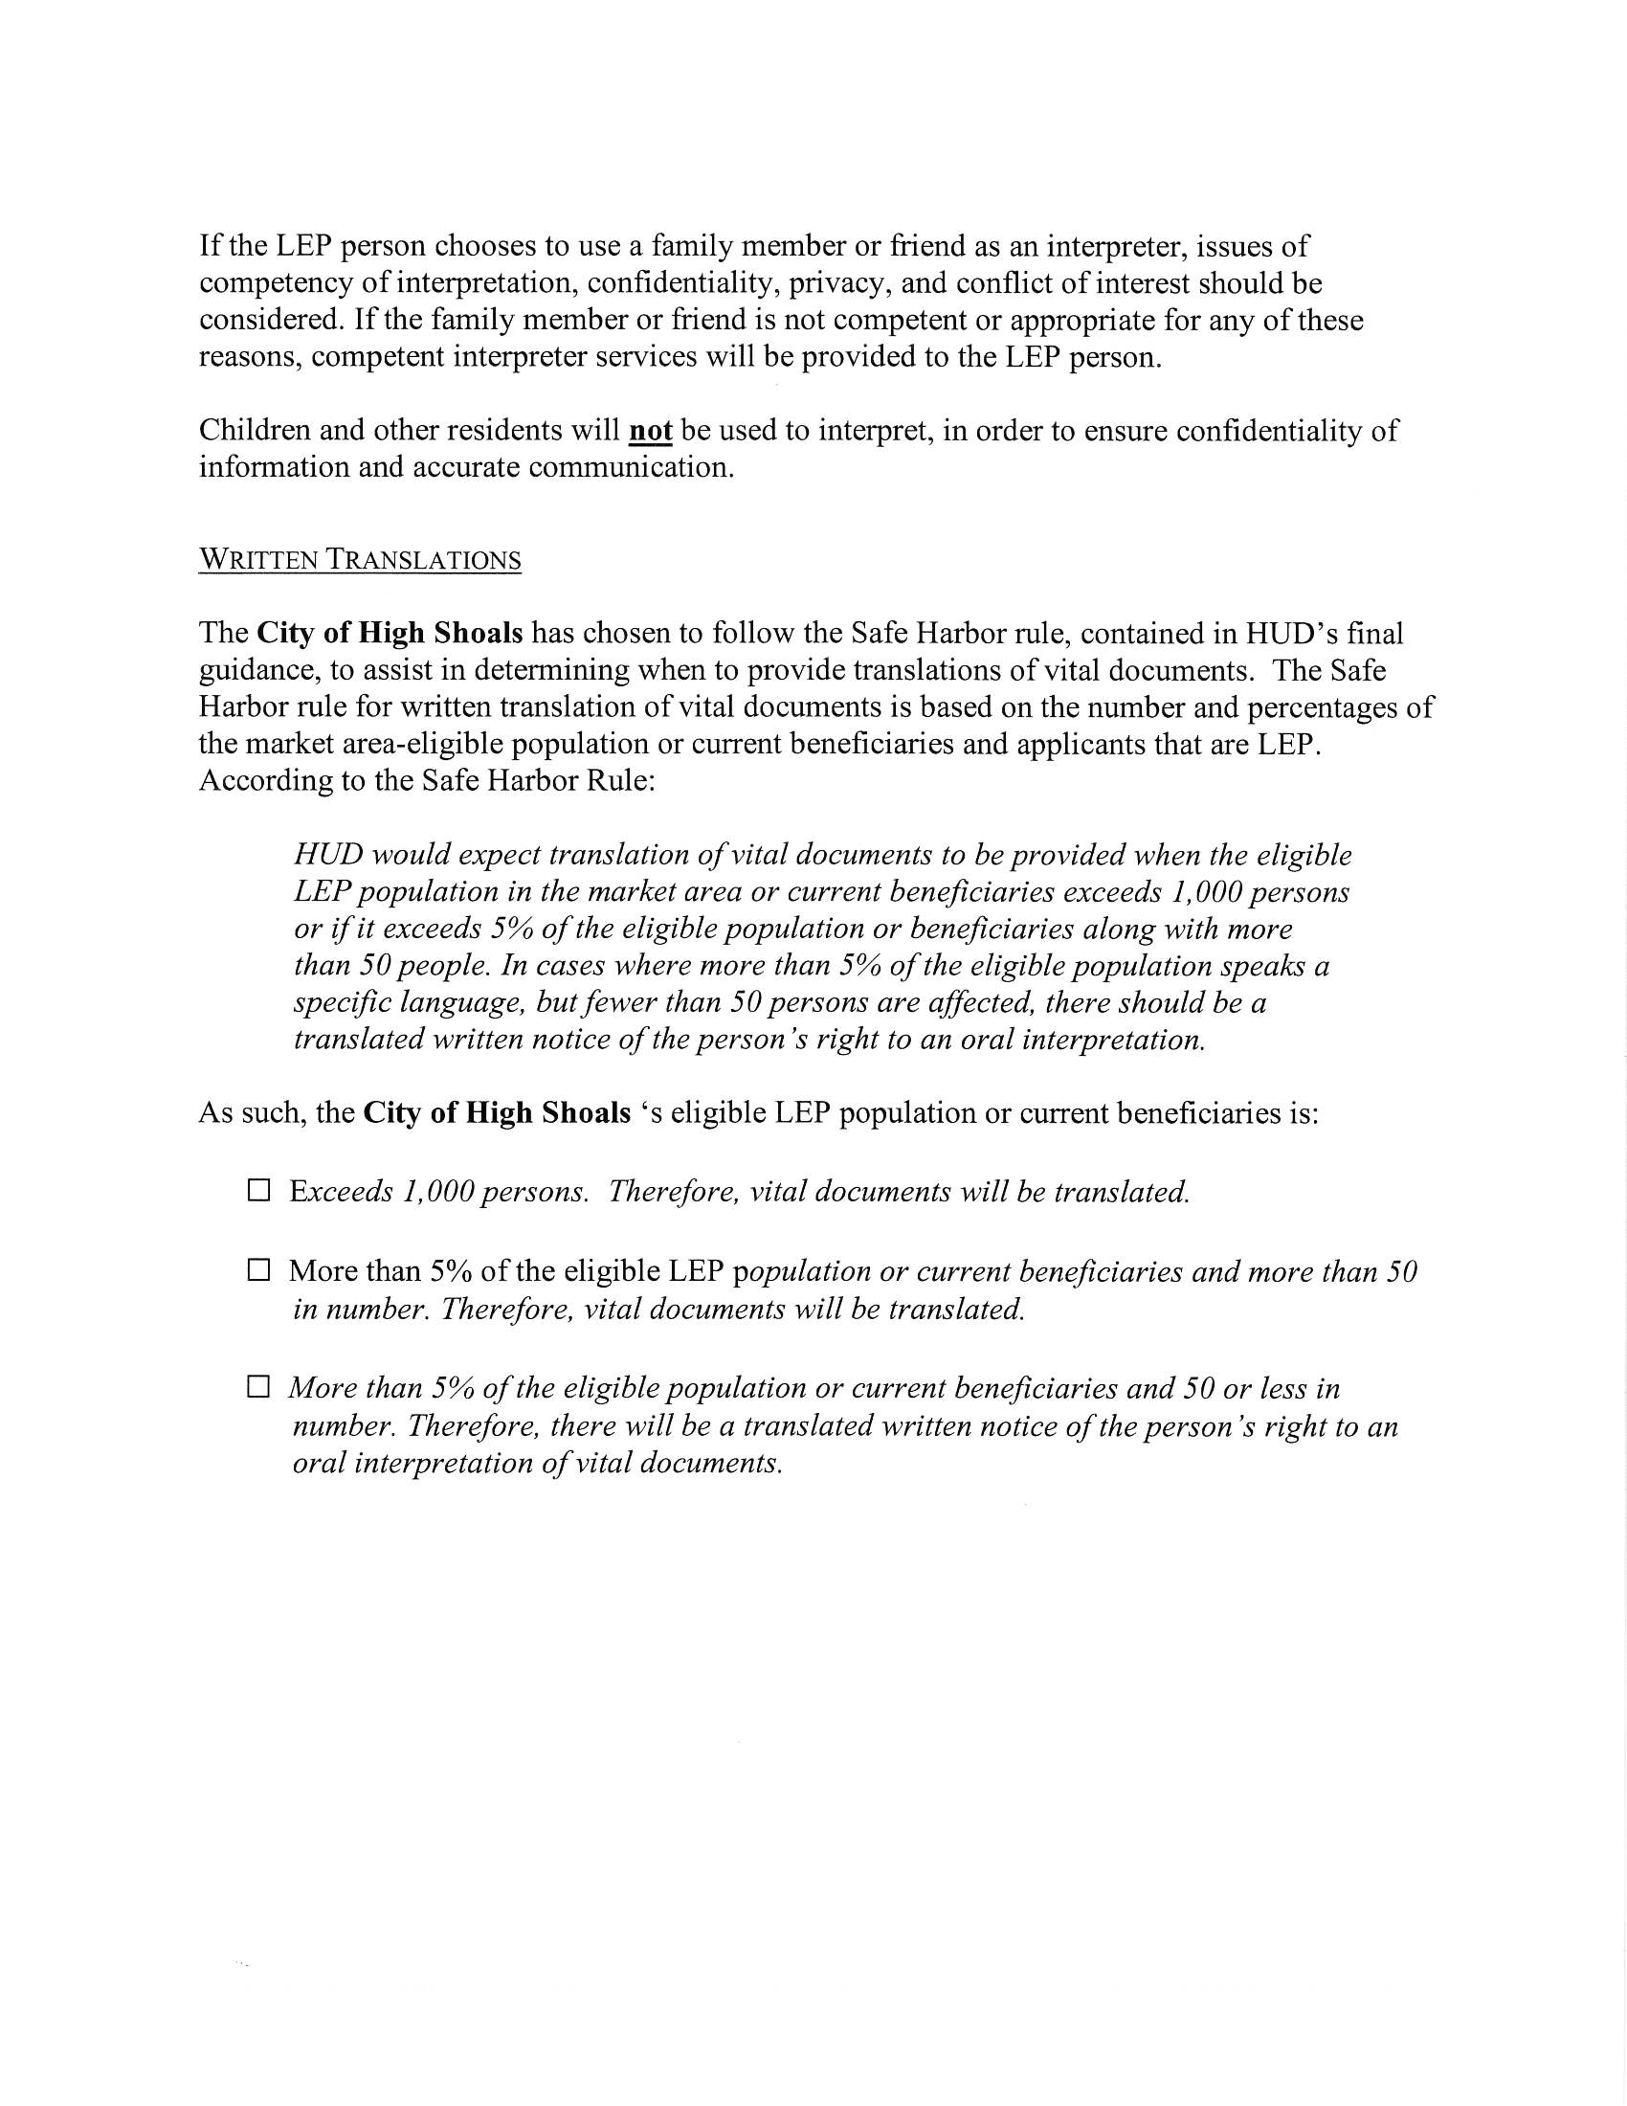
- Discussion/Action: Water lines (when repairs needed) response
  - No action needed.
- Discussion/Action: Personnel—Closed Session Closed session §NCGS 143-13.11(a)(6) Employee writeups/grievances
  - Motion to enter closed session made by Denese Cook, seconded by Bobby Vassey. All in favor.
  - Motion made by Denese Cook to close closed session & resume regular session, seconded by Bobby Vassey, all in favor.
- Discussion/Action: Sell HS1
  - Tim thinks the next time it breaks down, it can be sold. He wants to get his money out of it.
- Discussion/Action: Speed bumps on Holly Ridge Road & North Street
  - Tim got a price on a 6-7 foot wide, 16-foot-long asphalt $650 apiece. Is asking for 3 on Holly Ridge.
  - Make motion to install speed bumps on Holly Ridge Rd., Church St. North Street made by Denese Cook, seconded by Bobby Vassey. All in favor.
- Discussion/Action: Sewer Right of Way
  - Two estimates to bushhog the sewer right of way. One is Ed Wallace Construction $9500, or Ironside Bo Rhyne made motion to go with the $4000 quote, seconded by Bo Rhyne. All in favor.
- Action: Motion to adjourn
  - Motion to adjourn made by Denese Cook, seconded by Bo Rhyne. All in favor.

