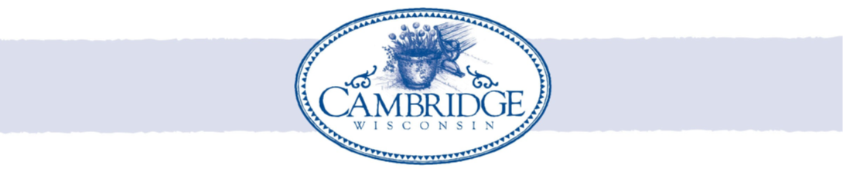
NOTICE IS HEREBY GIVEN that the Village Board will meet at 7:00 PM or as soon as possible thereafter
for a Meeting on Wednesday, November 19, 2025, in the Amundson Community Center, 200 Spring St. to
consider and act on the following:

- CALL TO ORDER/ ROLL CALL

- PLEDGE OF ALLEGIANCE

- PROOF OF POSTING

- PUBLIC COMMENT **

- CONSENT AGENDA
ALL ITEMS LISTED UNDER THE CONSENT AGENDA are considered routine and will be enacted by one motion. There will be no separate discussion of these items unless a motion to amend is passed in which event the item will be removed from the Consent Agenda and considered separately.
- APPROVAL OF MINUTES
  - Village Board Meeting – October 14, 2025
  - Village Board Meeting – October 28, 2025

- COMMITTEE REPORTS
  - Fire/EMS Commission
  - Audit/Finance Committee
  - Water/Sewer Committee

- UNFINISHED BUSINESS – ACTION REQUIRED
  - Discussion and Possible Action Rockdale Regionalization Agreement
  - Discussion and Possible Action 4th Qtr. Fire/EMS Commission Invoice
  - Discussion and Possible Action Budget Line Items.

- NEW BUSINESS – ACTION REQUIRED
  - Discussion and Possible Action Committee Assignments – Cable Commission
  - Discussion and Possible Action Deputy Clerk/Utility Clerk Position
  - Discussion and Possible Action PFP Resolution
  - Discussion and Possible Action Extraterritorial CSM LOT 1 OF CERTIFIED SURVEY MAP NO.685, RECORDED IN VOLUME 3, PAGE 44 OF CERTIFIED SURVEY MAPS OF JEFFERSON COUNTY, WISCONSIN AS DOCUMENT NO.725537 AND LOCATED IN NE 1/4 OF SECTION 7, T.6N., R.13E. OF THE 4TH P.M., TOWN OF OAKLAND, JEFFERSON COUNTY, WISCONSIN.
  - Discussion and Possible Action Extraterritorial CSM Part of the Fractional NW 1/4 of the NW 1/4 & the Fractional SW 1/4 of the NW 1/4 of Section 31, Township 7 North, Range 13 East, Town of Lake Mills, Jefferson County, Wisconsin.
  - Discussion and Possible Action Cambridge Foundation Grant Request

- CORRESPONDENCE

- PUBLIC COMMENT **

- QUESTIONS, REFERRALS TO STAFF OR FUTURE AGENDA ITEMS

- UPCOMING MEETINGS
- Economic Development Committee – December 1, 2025. 5:30pm
- Budget Public Hearing - December 5, 2025, 6:00pm
- Plan Commission – December 8, 2025, 6:30pm
- Joint Law Enforcement Committee – December 9, 2025, 5:30pm
- Village Board Meeting – December 9, 2025, 6:30pm
- Library Board Meeting – December 10, 2025, 6:30pm
- Water/Sewer Committee – December 16, 2025, 6:30pm

- ADJOURNMENT

** The Village of Cambridge Board opts to allow a period of public comment to receive information from members of the public. Wis. Stat. § 19.84(2). The Wisconsin Attorney General advises that a governmental body should defer Board discussion on an item until specific notice of the subject matter and proposed action can be given. (Wisconsin Department of Justice, Wisconsin Open Meetings Law: A Compliance Guide (2009).)

Note:
- Persons Needing Special Accommodations Should Call 423-3712 At Least 24 Hours Prior To The Meeting.
- More Specific Information About Agenda Items May Be Obtained By Calling 423-3712.
- Final Agendas Are Typically Posted By 4 Pm On The Friday Preceding The Regular Meeting At The Amundson Community Center, Cambridge Post Office, Badger Bank and the Village Website

Lucy Peterson Administrator/Treasurer/Deputy Clerk

Posted: November 16, 2025

