Original Goals:
- Allow electronic window signs, but cap their size?
  - Electronic window signs are permitted as accessory signs in nonresidential districts.
  - They shall not be the sole sign identifying a business.
  - They shall count toward the total window sign area.
- Do not allow electronic window signs to be the sole business-identification sign?
- Require static messages and instant transitions only?
  - Electronic signs shall go dark or freeze on a static image upon malfunction.
- Add nighttime dimming and brightness limits?
  - Automatic dimming is required.
  - Nighttime brightness shall be reduced to prevent glare, light trespass, or distraction.
  - Lake-facing and residential-facing electronic signs shall be subject to stricter brightness and operating-hour limits.
- Create a special lake-facing standard
- Ban uplighting for signs?
- Decide whether portable electronic signs should be allowed - currently they are under the temporary sign section
- Treat interior screens visible from outside as signs?
- Consider operating-hour limits?
- Add a “dark background” rule
- Add additional pictures
- Strike out-dated language

ORDINANCE 14-003
TO ADOPT A NEW SIGN ORDINANCE THAT WILL REPLACE THE SIGN ORDINANCE IN ITS ENTIRETY. THE PROPOSED SIGN ORDINANCE EMPLOYS A MORE LOGICAL ORGANIZATIONAL STRUCTURE AND CONTAINS ADDITIONAL GRAPHIC REPRESENTATIONS OF SIGN REGULATIONS, DESIGNED TO MAKE THE SIGN ORDINANCE EASIER TO UNDERSTAND AND MORE USER-FRIENDLY.

ADOPTED, APPROVED AND PASSED
By the City Council of the City of Belleville, this 6th day of October 2014.
_________________________________
Kerreen Conley, Mayor
_________________________________
Lisa Long, CMC
City Clerk/Treasurer

VERIFICATION OF PUBLICATION
I further certify that the foregoing was published in the Belleville Area Independent, a newspaper of general circulation in the City of Belleville, on the 16th day of October 2014.
_________________________________
Lisa Long, CMC
City Clerk/Treasurer
INTRODUCED: 07/21/14
PUBLIC HEARING: 08/18/14
ADOPTED: 10/06/14
PUBLISHED: 10/16/14
EFFECTIVE: 10/17/14

Chapter 66
City of Belleville
Sign Ordinance
Effective OCTOBER 17, 2014

Will be updated when changes have been made or by Municode

Table of Contents
Table of Contents with Sections _____________ ii
Article 1.0 Purpose and Introduction ______ 1-1
Article 2.0 Definitions __________________ 2-1
Article 3.0 Sign Standards ______________ 3-1
Article 4.0 Review Procedures ___________ 4-1
Article 5.0 Administration, Appeals and
Enforcement ______________ 5-1

Table of Contents with Sections
How to Use this Ordinance ______________________________________________ iii
1. Symbols and User Notes ______________________________________________ iii
2. Reading the Ordinance ______________________________________________ iii
Article 1.0 Purpose and Introduction __________________________________ 1-1
Sec. 1.1 Intent __________________________________________________ 1-3
Article 2.0 Definitions ______________________________________________ 2-1
Sec. 2.1 Definitions ______________________________________________ 2-3
Article 3.0 Sign Standards ____________________________________________ 3-1
Sec. 3.1 General Conditions__________________________________________ 3-3
Sec. 3.2 Ground Signs______________________________________________ 3-5
Sec. 3.3 Building Signs_____________________________________________ 3-7
Sec. 3.4 Computations______________________________________________ 3-8
Sec. 3.5 Temporary Signs ___________________________________________ 3-8
Sec. 3.6 Window Signs _____________________________________________ 3-9
Sec. 3.7 Signs in the Public Right-of-Way_________________________________ 3-9
Sec. 3.8 Non-Conforming Signs_______________________________________ 3-9
Sec. 3.9 Construction Specifications___________________________________ 3-10
Sec. 3.10 Construction of Signs, Auxiliary Specifications _________________ 3-10
Article 4.0 Review Procedures _________________________________________ 4-1
Sec. 4.1 Permits _________________________________________________ 4-3
Article 5.0 Administration, Appeals and Enforcement ___________________ 5-1
Sec. 5.1 Authorized Sign Contractors___________________________________ 5-3
Sec. 5.2 Liability for Damages________________________________________ 5-3
Sec. 5.3 Removal of Signs___________________________________________ 5-3
Sec. 5.4 Violations________________________________________________ 5-3
Sec. 5.5 Enforcement______________________________________________ 5-3
Sec. 5.6 Appeal Procedures__________________________________________ 5-4
Sec. 5.7 Powers of the Zoning Board of Appeals________________________ 5-4

How to Use This Ordinance
1. SYMBOLS AND USER NOTES
The following symbols are used throughout the Sign Ordinance:
📖 indicates the term is defined in Article 2, Definitions. (Note: Not every defined term is designated with a 📖 symbol. Consult Article 2, Definitions, for a list of all defined terms.)
📐 indicates there is a graphic that illustrates the standard or requirement.
2. READING THE ORDINANCE
Rules have been established to assist with interpreting the ordinance. Below are some rules to keep in mind when reading this document:
☑ Sometimes there may be general and specific regulations that pertain to one particular aspect of site design. In such instances, the specific regulations must be followed.
☑ Discrepancies between text and an illustration (including its caption) may occur. In the case of such discrepancies, the text is considered the accurate source of information.
☑ The use of the word shall carries significant meaning. Shall regulations must be followed. Requirements that use the word may are discretionary, meaning that the requirement is at the discretion of the Planning Commission or Zoning Board of Appeals.
☑ Article 2, Definitions, contains many terms. If a term is not listed in this section, it will carry the meaning customarily assigned to it.
☑ Conjunctions are often used and must be read accurately:
■ AND indicates that all connected items, conditions, provisions or events shall apply.
■ OR indicates that the connected items, conditions, provisions or events may apply singly or in any combination. (OR may also be read "and/or")
■ EITHER ... OR indicates that the connected items, conditions, provisions or events shall apply singly, but not in combination.

💻 Digital User Note:

What is a link?
A link allows for quick reference to a relevant section. By 'clicking' a link, the user is taken directly to a page in the Ordinance or another reference document. The user may return to the original page by clicking the 'previous view' button in Adobe Acrobat Reader.
🌐 If you do not see the 'previous view' button on your Adobe Acrobat Reader screen, you can add it by turning on your 'page navigation toolbar'. For assistance, refer to the 'Help' menu in your version of Acrobat Reader.

What information is linked?
All blue text is linked to either another page within the Ordinance, a separate City ordinance or document, or an external website.
In addition, several other features of the document are linked to allow users to navigate through the ordinance. Click on any of the following features to quickly locate another section:
Article tabs located on the side of each page are linked to the Contents page of each Article.
Icons located at the bottom of each page are linked to the 'How to Use This Ordinance' section, the main Table of Contents, and the Zoning Map.
[OCR Error: PAGE 8] Failed to extract image(s): No images found in response

Article 1.0 Purpose and Introduction
1.1 Intent
1.0 Purpose and Introduction

1.1 INTENT
It is the intent of this section to ensure the effective use of signs as a means of communication in the City; to maintain and enhance the aesthetic environment; to improve pedestrian and traffic safety; to minimize the adverse effect of signs on nearby public and private property; and to enable the fair and consistent enforcement of these sign restrictions.
It is the further intent of this section to allow a variety of types of signs in commercial and industrial zones, a limited variety of signs in other zones and other incidental signs.
The execution of these regulations recognizes that the purpose of this chapter is to protect the dual interest of the public health, safety and welfare and to ensure the maintenance of an attractive physical environment while satisfying the needs of sign users for adequate identification, communication, and advertising. In order that such purposes can be achieved, the following objectives shall be applied for this chapter and any future additions, deletions and amendments:
1. General. Ensure that signs are located, designed, constructed, installed and maintained in a way that protects life, health, property and the public welfare;

2. Public Safety. Protect public safety by prohibiting signs that are structurally unsafe or poorly maintained; that cause unsafe traffic conditions through distraction of motorists, confusion with traffic signs, or hindrance of vision; and that impede safe movement of pedestrians or safe ingress and egress from buildings or sites;

3. Protect Aesthetic Quality of Districts and Neighborhoods. Prevent blight and protect aesthetic qualities by preventing visual clutter and protecting views; preventing intrusion of commercial messages into non-commercial areas; and eliminating signs and sign structures on unused commercial properties. Also, to avoid glare, light trespass, and skyglow through selection of fixture type and location, lighting technology, and control of light levels. Prevent signs from creating a nuisance to persons or occupancy of nearby properties;

4. Free Speech. Ensure that the constitutionally guaranteed right of free speech is protected and to allow signs as a means of communication;

5. Reduce Conflict. Reduce conflict among signs and light and between public and private information systems;

6. Business Identification. Allow for reasonable and effective signage for business identification and other commercial speech, non-commercial speech, and dissemination of public information, including but not limited to, public safety information and notification as may be required by law;

7. Foster Economic Development. Ensure that signs are located in a manner that does not cause visual clutter, blight, and distraction, but rather promotes identification and communication necessary for sustaining and expanding economic development in the City;

8. Recognize Unique Areas. Acknowledge the unique character of certain districts, e.g., the B-2 Central Business District, and establish special time, place and manner regulations that reflect the unique aesthetic, historical, and/or cultural characteristics of these areas.
[OCR Error: PAGE 12] Failed to extract image(s): No images found in response

Article 2.0 Definitions
2.1 Definitions
1. Abandoned Sign
2. Animated Sign, Digital Sign, or Electronic Sign
3. Awning Sign
4. Banner
5. Beacon
#. Box, Panel, or Capsule Sign
6. Building Sign
7. Business Center Sign
8. Changeable Copy Sign
9. Code of Ordinances
10. Commercial Message
11. Flag, Feather Flag, or Sail Flag
12. Ground Sign
13. Incidental Sign
# Inflatable Sign

15. Integral Sign
16. Mansard Roof Sign
17. Moving Sign
18. Non-conforming Sign
19. Off-site Sign (off-premises sign)
20. On-site Sign (on-premises sign)
21. Pennant
22. Permanent Sign
23. Pole Sign
24. Portable Sign
25. Projecting Sign
26. Residential Development Sign
27. Roof Sign
28. Suspended Sign
29. Temporary Sign
30. Three-dimensional Sign
31. Wall Sign
32. Window Sign
33. Zone Lot

2.0 Definitions

2.1 DEFINITIONS
SIGN: Any device, fixture, placard, or structure that uses any color, form, graphic, illumination, symbol or writing to advertise, announce the purpose of or identify the purpose of a person or entity, or to communicate information of any kind to the public. For the purpose of this Chapter, the term "sign" shall also include the following terms:
1. Abandoned Sign: A sign which no longer directs or exhorts any person, or advertises a bona fide business, lessee, owner, product or activity conducted or product available on the premises where such sign is displayed.
2. Animated Sign, Digital Sign, or Electronic Sign: Any sign that uses movement or change of lighting to depict action or create a special effect or scene, including signs containing flashing, intermittent or moving lights or with moving or revolving parts.add picture 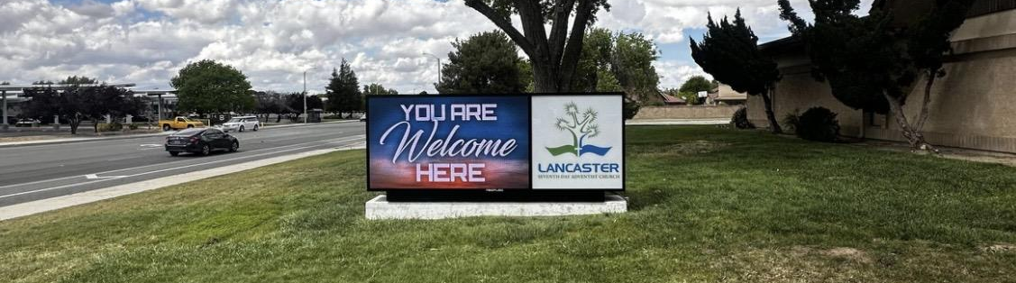

3. Awning Sign: Any sign that is part of or attached to an awning, canopy, or other fabric, plastic, or structural protective cover.add picture 

4. Banner: Any sign of lightweight fabric or similar material that is attached to a pole or a building at one or more edges. National flags, state or municipal flags, or the official flag of any institution or business shall not be considered banners. 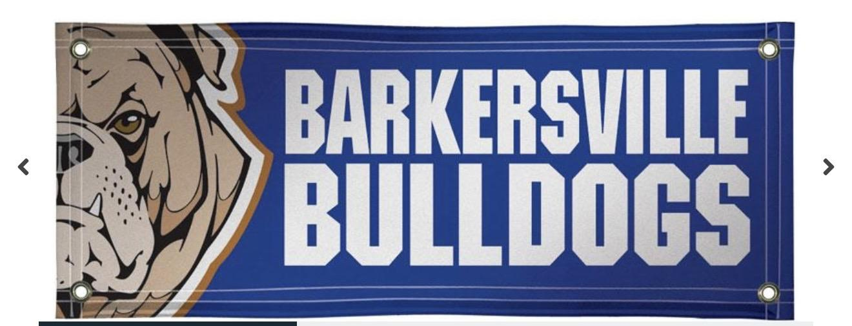

5. Beacon: Any light with one or more beams directed into the atmosphere or directed at one or more points not on the same zone lot as the light source; also, any light with one or more beams that rotate or move.

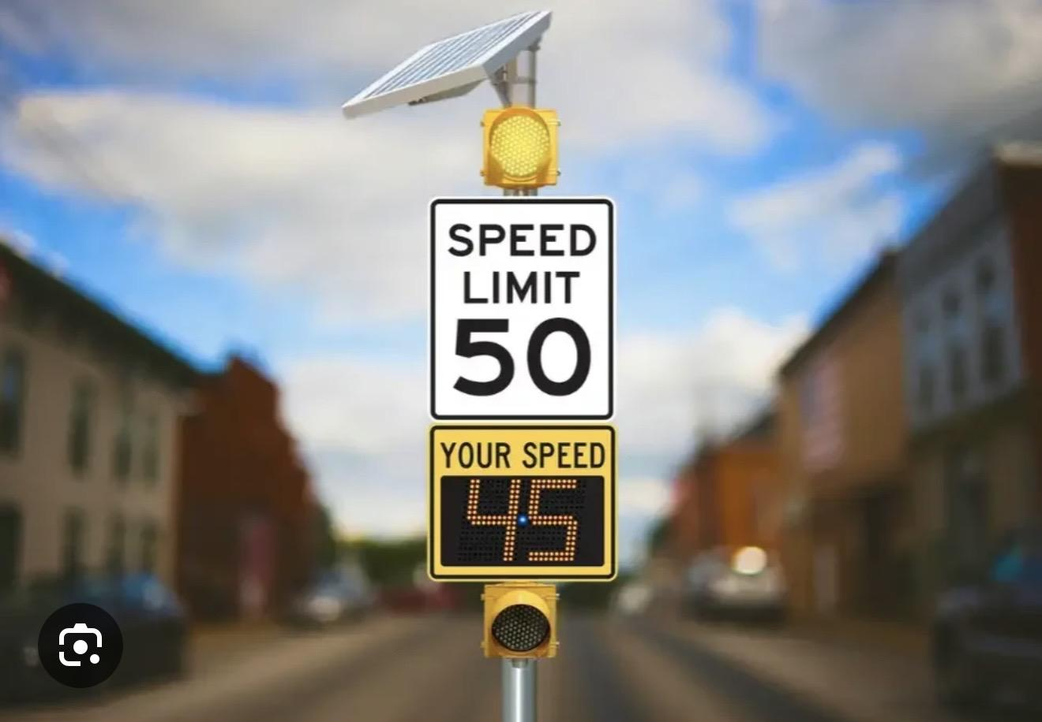

XX. Box, Capsule, or Panel Sign: A rectangular, square, or geometric enclosed metal cabinet containing a single or double translucent face plate. Internally or externally illuminated (typically via LEDs or fluorescent lamps).

6. Building Sign: Any sign attached to any part of a building, as contrasted to a ground sign. Building signs shall include the following types of signs as defined in this section: Banner, Awning, Projecting and Wall.


7. Business Center Sign: A sign which identifies a group of two (2) or more stores, offices, research facilities, or manufacturing facilities which collectively have a name different than the name of the individual establishments and which have common parking facilities, or which is a platted business subdivision.

8. Changeable Copy Sign: A sign or portion thereof with characters, letters, or illustrations that can be changed or rearranged without altering the face or the surface of the sign. A sign on which the only copy that changes is an electronic or mechanical indication of time or temperature shall be considered a 'time and temperature' portion of a sign and not a changeable copy sign for purposes of this Chapter.

9. Code of Ordinances: The Code of Ordinances of the City of Belleville, Michigan.

10. Commercial Message: Any sign wording, logo, or other representation that, directly or indirectly, names, advertises, or calls attention to a business, product, service, or other commercial activity.

11. Flag, Feather Flag, Sail Flag: Any fabric or banner containing distinctive colors, patterns, or symbols, used as a symbol of a government, political subdivision, or other entity.


12. Ground Sign: Any sign supported by structures or supports that are placed on, or anchored in, the ground and that are independent from any building or other structure.
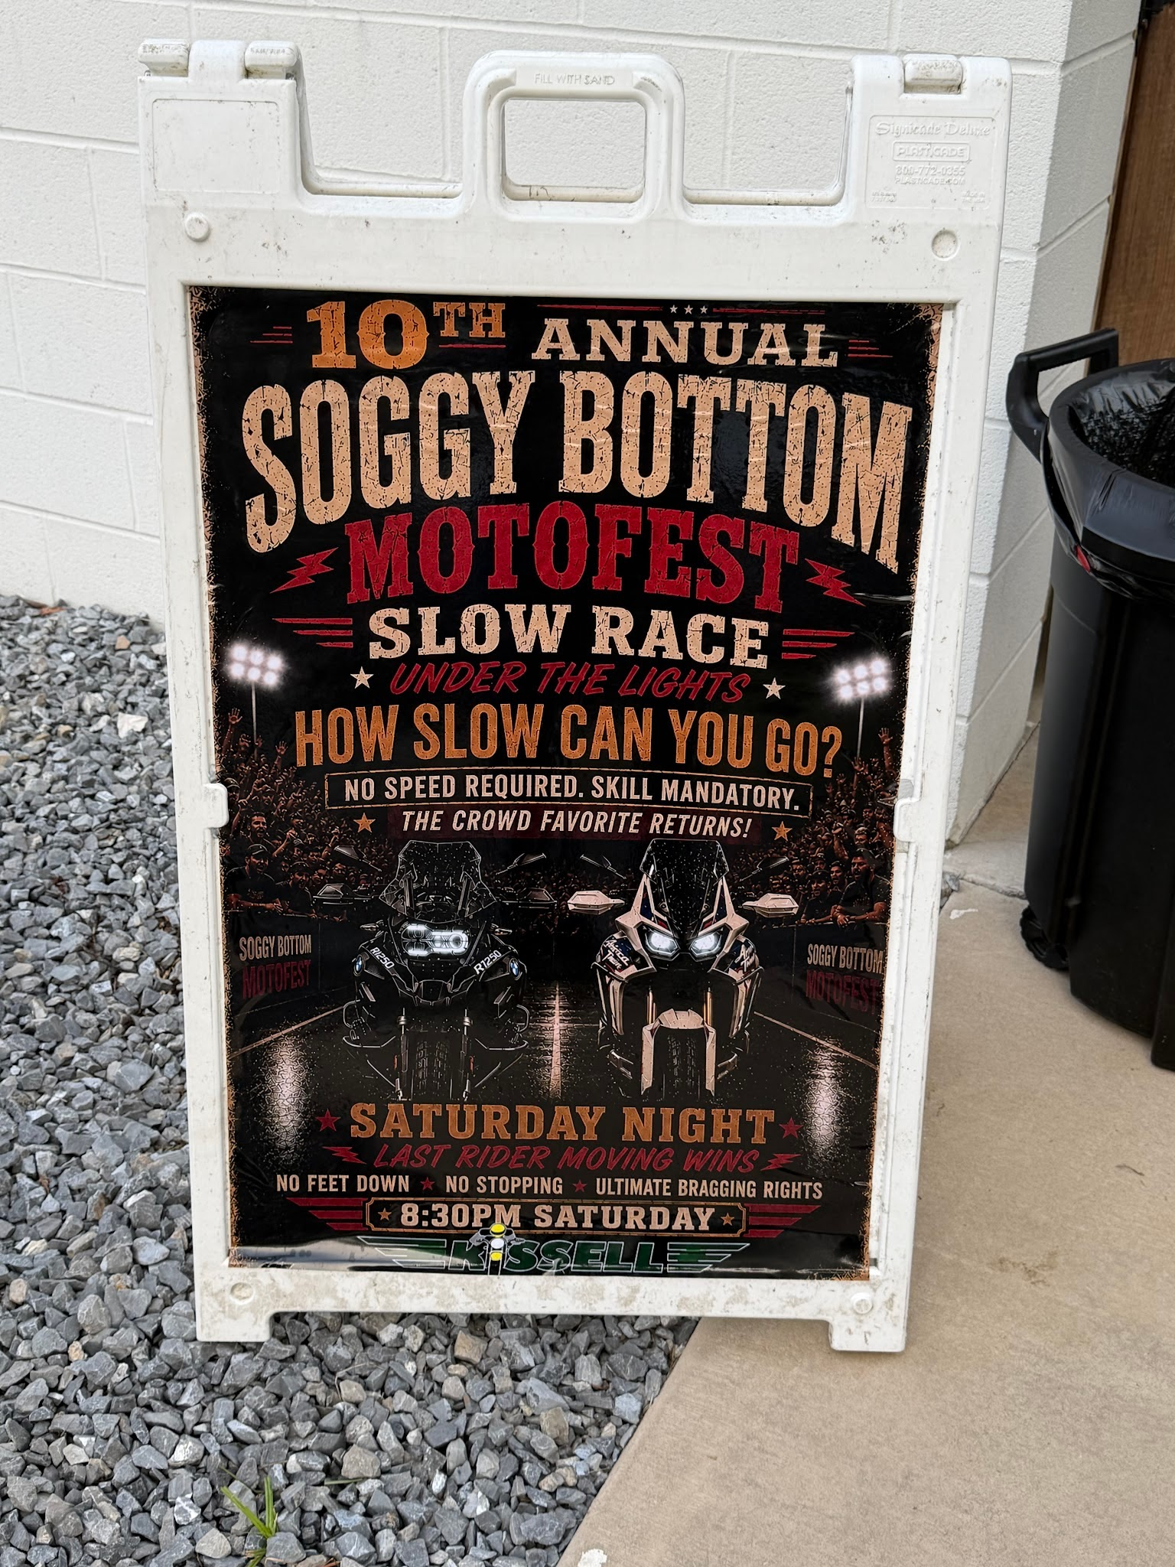
13. Incidental Sign: A sign, generally informational, that has a purpose secondary to the use of the zone lot on which it is located, such as "no parking," "entrance," "loading only," "telephone," "restrooms", "ATM", "handicap," "no hunting," "no trespassing" and other similar directives. No commercial message shall be considered incidental.


XX. Inflatable Sign: An inflatable sign is a temporary, three-dimensional advertising display that is expanded and supported by air or gas pressure.

14. Integral Sign: Integral signs are names and addresses of buildings, dates of erection, monument citations, commemorative tablets and the like, when carved into stone, concrete or similar material or made of metal or other permanent material, and which are intended to be a permanent part of the building regardless of the occupant or use.
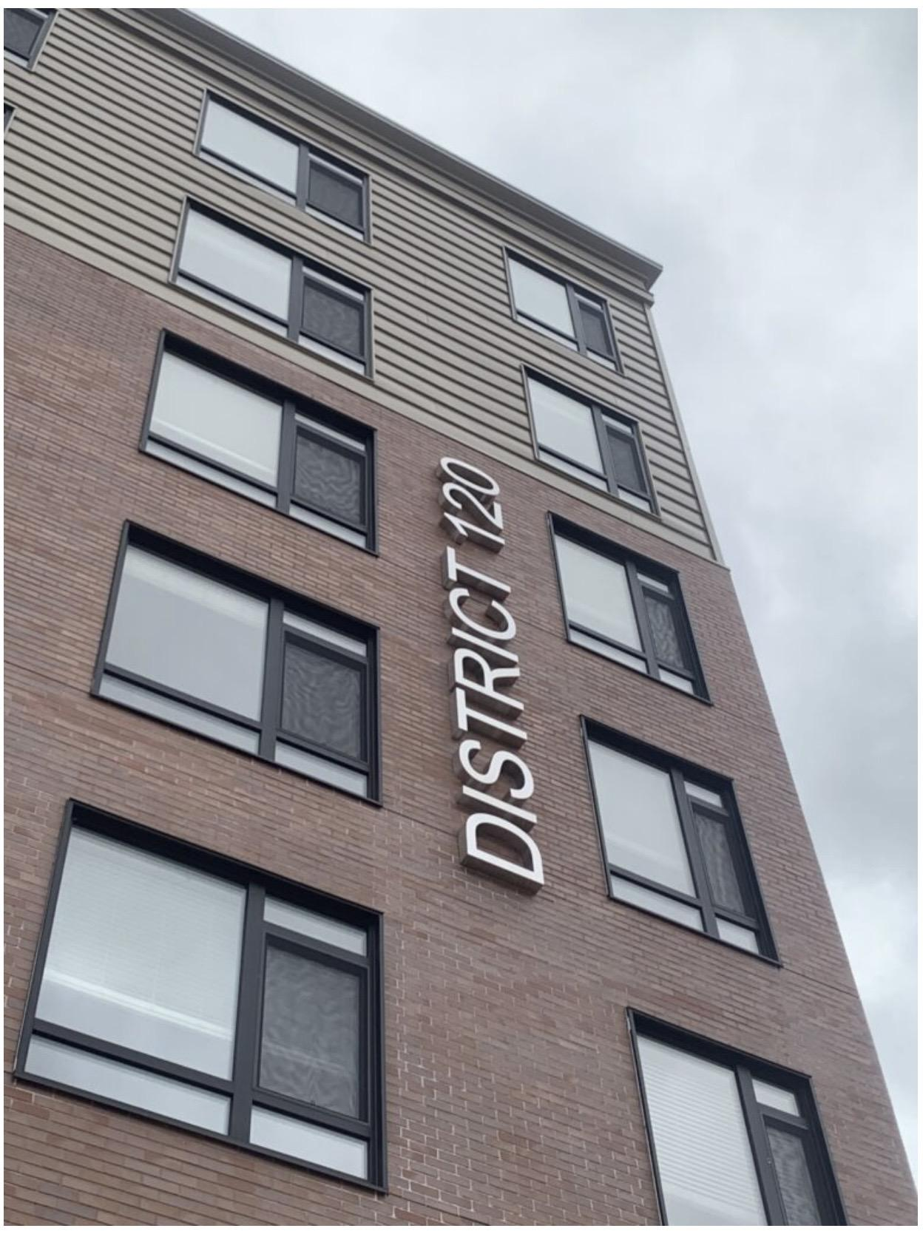

15. Mansard Roof Sign: A sign erected or constructed as an integral or essentially integral part of a normal roof structure of any design, such that no part of the sign extends vertically above the highest portion of the roof and such that no part of the sign is separated from the rest of the roof by a space of more than six inches.
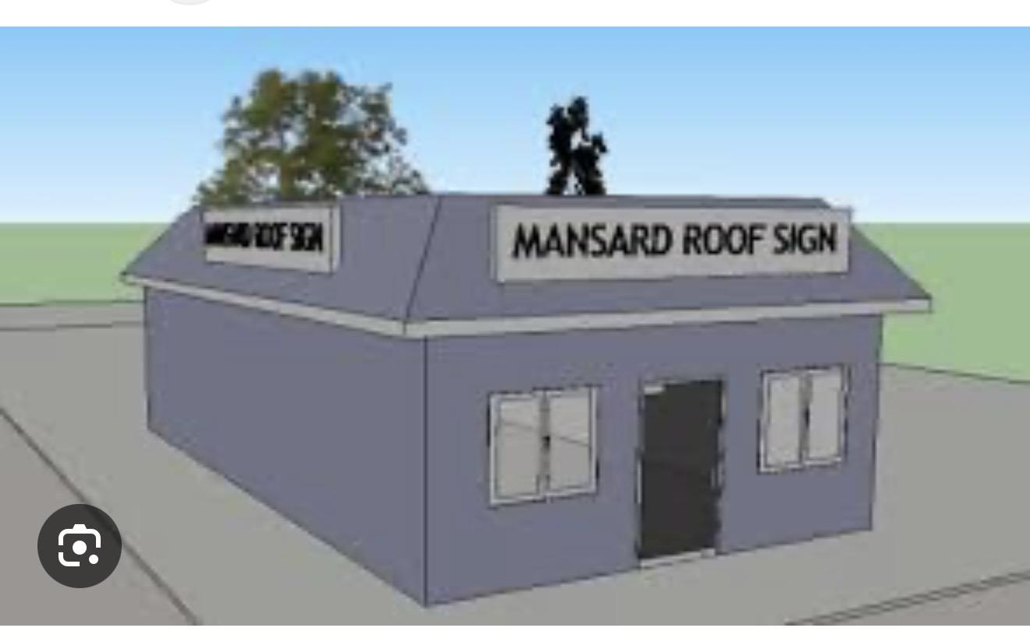
16. Moving Sign: Any sign, or any portion thereof, which moves or assumes any motion constituting a non-stationary or fixed condition except for the rotation of barber poles, and except currently licensed and operable vehicles and trailers which have painted upon them in a permanent manner the name of the product which they deliver and/or the name and address of the business which actively uses such vehicle or trailer for transporting employees, equipment and materials related to the business.add picture
17. Non-conforming Sign: Any sign that does not conform to the requirements of this Chapter.
XX. Obsolete Sign: An obsolete sign is a physical advertising, directional, or informational sign that promotes a business, product, service, or activity that no longer exists or operates at that location.
18. Occupancy: Shall mean a change of ownership; change of business/user; or a change of occupancy.
19. Off-Site Sign (off-premises sign): A sign not strictly related to goods, activities or services rendered on the premises where the sign is located or affixed
20. On-Site Sign (on-premises sign): A sign which advertises or identifies only goods, services, facilities, events or attractions on the premises where located.

21. Pennant: Any lightweight plastic, fabric, or other material, whether or not containing a message of any kind, suspended from a rope, wire, or string, usually in series, designed to move in the wind.


22. Permanent Sign: Any sign hardwired or anchored/attached to a structure.
23. Pole Sign: A sign with one or more poles as its support or base that is not attached to a building but relates to the business located in the building.


24. Portable Sign: Any sign not permanently attached to the ground or other permanent structure, or a sign designed to be transported, including, but not limited to, signs designed to be transported by means of wheels; signs converted to A- or T-frames; menu and sandwich board signs; outside benches; balloons used as signs; and signs attached to or painted on vehicles or trailers parked and visible from the public right-of- way, except currently licensed and operable vehicles and trailers which have painted upon them in a permanent manner the name of the product which they deliver and/or the name and address of the business which actively uses such vehicle or trailer for transporting employees, equipment and materials related to the business.
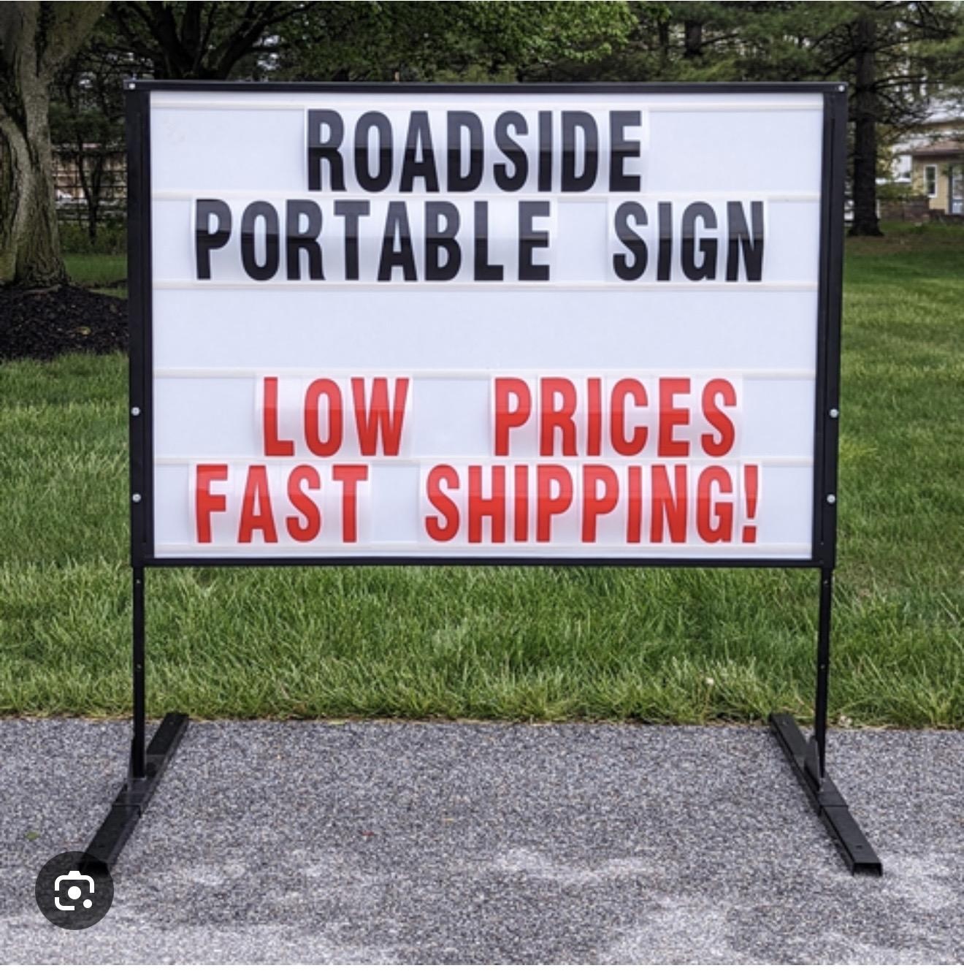
25. Projecting Sign: Any sign affixed perpendicular to a building or wall in such a manner that its leading edge extends more than twelve (12) inches beyond the surface of such building or wall.

26. Residential Development Sign: A sign at the entrance of a residential development for the purposes of identifying a subdivision, site condominium, multiple family development, or mobile home park.
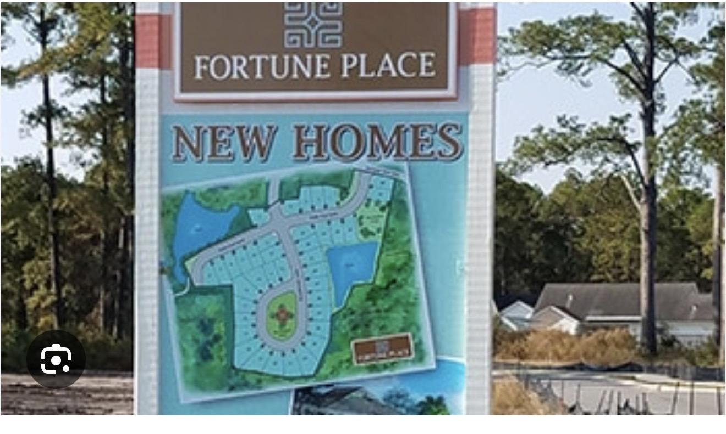
27. Roof Sign: Any sign erected and constructed wholly on and over the roof of a building, supported by the roof structure, and extending vertically above the highest portion of the roof.add picture Add picture
28. Suspended Sign: A sign that is suspended from the underside of a horizontal plane surface and is supported by such surface.

29. Temporary Sign: A sign that is intended to display commercial or noncommercial messages for a limited period of time.

30. Three-dimensional Sign: A sign which is designed to look like a three-dimensional object, or which has a part which is designed to look like a three-dimensional object or create a three-dimensional impression.

##. Vehicle Sign: Signs attached to parked vehicles or trailers used primarily to promote a business or product rather than for daily transportation.

31. Wall Sign: Any sign attached parallel to, but within six inches of, a wall, painted on the wall surface of, or erected and confined within the limits of an outside wall of any building or structure, which is supported by such wall or building, and which displays only one sign surface.


32. Window Sign: Any interior sign that is placed inside a window or door or within three feet of the windows or doors, including vinyl letters eight or more inches in height.


33. Zone Lot: A parcel of land in single ownership that is of sufficient size to meet minimum zoning requirements for area, coverage and use, and that can provide such yards and other open spaces as required by the zoning regulations.

Article 3.0 Sign Standards
CHANGES ADOPTED BY CITY COUNCIL ON AUGUST 15, 2016
City of Belleville Sign Ordinance
Add reference/link to Food Truck Ordinance 24-003

Article 3.0 Sign Standards
3.1 General Conditions
3.2 Computations
3.3 Ground Signs
3.4 Building Signs
3.5 Temporary Special Purpose Signs
3.6 Window Signs
3.7 Signs in the Public Right-of-Way
3.8 Non-Conforming Signs
3.9 Construction Specifications
3.10 Construction of Signs, Auxiliary Specifications
1. Definitions
2. Sign Standards
3. Review/Permit
4. Admin and Enforcement
5. Zoning Ordinance

3.1 GENERAL CONDITIONS
1. Location: No sign shall be erected or maintained so as to obstruct free and clear vision or to hide, obstruct, or otherwise interfere with the effectiveness of any official traffic sign or signal, or so as to prevent ready observation of traffic by pedestrians or by operators of vehicles on any street or highway. No sign shall be placed in such a position as to endanger pedestrians, bicyclists, or traffic on a street by obscuring the view or by interfering with official street signs or signals by virtue of position, brightness, size, or color.

2. Illumination:
A. No sign shall be illuminated by other than electrical means.

B. The light from illuminated signs shall be directed in a manner that will not interfere with vehicular traffic or with the enjoyment or use of adjacent properties, nor directly shine onto adjacent or abutting properties. Illuminated signs adjacent to residentially zoned or used property shall be designed and maintained such that illumination levels do not exceed one-tenth (0.1) footcandle along the adjacent property lines.
It is strongly recommended that all signs with interior illumination provide a darker colored background with lighter colored letters and graphics, or a sufficiently opaque colored background to reduce glare. An interior illuminated sign with a dominant white background will generally exceed the maximum allowable brightness and create a glare for traffic at night.
C. No sign shall have blinking, flashing, or fluttering lights or other illuminating devices which have a changing light intensity, brightness or color, or which are so constructed and operated as to create an appearance or illusion of writing or printing; provided, that such movement showing the date, the time and/or the temperature exclusively may be permitted.
D. No exposed reflective type bulbs and no strobe lights or incandescent lamps shall be used on the exterior surface of any sign so as to expose the face of the bulb, light or lamp to any public street or adjacent property.
E. The illumination provisions above shall not apply to sign lighting systems owned or controlled by any public agency for the purpose of directing traffic.
F. Nighttime brightness shall be reduced to prevent glare, light trespass, or distraction through the use of automatic dimming or other dimmable functions.
3. Prohibited Signs: All signs not expressly permitted under this Chapter are prohibited in the City. Such prohibited signs include, but are not limited to, the following:
A. Beacons.

C. Portable Signs, except as specifically permitted in this Chapter. D. Roof signs.
E. Inflatable signs and tethered balloons.
F. Animated, digital, or electronic signs, except those signs which give the date, time and/or temperature, provided no other animated messages are displayed.
G. Signs affixed to trees, rocks, shrubs or natural features, except signs authorized by the City which denote a site of historic significance.
H. Signs which imitate traffic signals, traffic direction signs, or similar traffic control devices or signs which make use of words such as "Stop", "Look", "Danger", or any other words, phrases, symbols or characters, in such a manner as to interfere with, mislead or confuse traffic.
I. Permanent signs (other than those erected by a public agency) which are located within or overhang the public right-of-way or other public property unless specified elsewhere in these regulations.
J. Any strobe, flashing, or oscillating lights either from the interior or exterior of a building.
K. Moving signs.
L. Abandoned or obselete signs.
M. Signs which emit audible sound, odor or visible matter.
N. Exterior string lights used for advertising
O. Any sign erected on a tree, utility pole or other pole used for another purpose, except for signs of any political subdivision of this state.

5. Signs and Activities Permitted In All Districts Without a Permit:
A. Incidental signs, which shall not exceed two (2) square feet in area per side and four feet (4) in height.
B. Signs erected for traffic safety purposes by public road agencies.
C. Federal, State, County or Local required signs on private property.
E. Flags bearing the official design of a nation, state, municipality, educational institution, church or fraternal organization. Flags bearing the official seal or emblem of a company or corporation including related slogans, messages or graphics. Each zone lot shall be limited to not more than four (4) of the above flags.
F. Permanent signs applied to the surfaces of vending machines or ice containers indicating only the contents of such devices and not exceeding the surface area of the device; provided, that such devices must be located within ten (10) feet of the building.
H. Changing of advertising copy or message on a theater marquee or similar approved signs which are specifically designed for the use of replaceable copy.
I. Painting, repainting, cleaning, and other normal maintenance and repair of a sign or any sign structure, unless a structural change is made.
J. Temporary signs not exceeding a total of nine (9) square feet in area per side and three (3) feet in height in residential districts, and thirty-six (36) square feet in area per side and four (4) feet in height in non-residential districts. Such temporary signs shall be limited in duration to two (2) thirty (30) day periods or sixty (60) days in a calendar year. Electrical permits are required if illuminated.

3.2 COMPUTATIONS
The following principles shall control the computation of sign area and sign height:
1. Computation of Area: The area of a sign face (which is also the sign area of a wall sign or other sign with only one face) shall be computed by means of the smallest square, rectangle, or combination thereof that will encompass the extreme limits of the writing, representation, emblem, or other display, together with any material or color forming an integral part of the background of the display or used to differentiate the sign from the backdrop or structure against which it is placed, but not including any supporting framework, bracing, or decorative fence or wall when such fence or wall otherwise meets zoning regulations and is clearly incidental to the display itself. Where a sign has two or more faces, the area of all faces shall be included in determining the total area of the sign. The outer edges of all neon tubing on a sign shall be included in the calculation of the area of the sign face, even if it is outside of the supporting frame of the sign.
2. Computation of Height: The height of a sign shall be computed as the distance from the base of the sign at normal grade to the top of the highest attached component of the sign. Normal grade shall be construed to be exclusive of any filling, berming, mounding, or excavating solely for the purpose of locating the sign. In cases where the normal grade cannot reasonably be determined, sign height shall be computed on the assumption that the elevation of the normal grade at the base of the sign is equal to the elevation of the nearest point of the crown of a public street or the grade of the land at the principal entrance to the principal structure on the zone lot, whichever is lower.

3. Computation of Setback: The distance that a sign is set back from the front lot line, street right-of-way or other location as specified in this Chapter, shall be determined based on the following:
A. the specified line shall be considered as a plane extending vertically and perpendicularly from the ground to a point above the highest part of the sign; and
B. the distance shall be measured as a horizontal straight line running from the point on the sign closest to the plane to the point where the line intersects the plane.
Graphic: Sign Computations (see section 3.2.1)
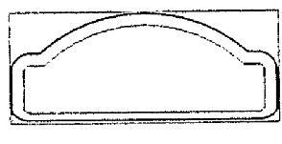
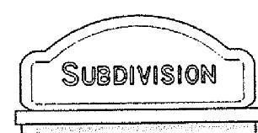

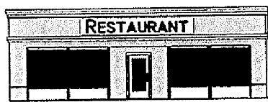
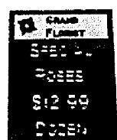
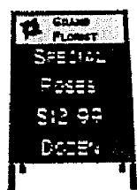
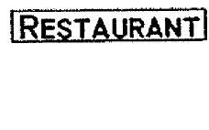

3.3 GROUND SIGNS
1. General Requirements:
A. Within all non-residential zoning districts except for the B-2 District, only one (1) ground sign shall be permitted per zone lot; provided, that if a zone lot has more than seven hundred fifty (750) feet of frontage on a single street, then one (1) additional ground sign shall be permitted which shall be positioned as determined during site plan review or as a part of a sign application review.
B. Within the B-2 District:
i. A ground sign shall not be permitted if the existing building is located at the front lot line, or the building proposed to be constructed will be located at the front lot line.
ii. A ground sign may be approved by the Planning Commission if the existing building is set back from the front lot line a sufficient distance to provide space for the ground sign to be installed; provided, that such ground sign shall be set back at least two (2) feet from the front lot line. C. Residential zoning districts.
i. Only one (1) ground sign shall be permitted at the primary entrance of a subdivision, site condominium, multiple family development or mobile home park. One (1) additional ground sign may be permitted at a secondary entrance if it is not located on the same street as the primary entrance. Size and location shall be determined during site plan review or as part of a sign application review. Maximum sign area is provided in Table 3.3.2 Ground Signs—Standard Area.
ii. Within all residential zoning districts, only one (1) ground sign shall be permitted per zone lot. One (1) additional ground sign may be permitted at a secondary entrance if it is not located on the same street as the primary entrance, or if the zone lot has more than fifteen hundred (1,500) feet of frontage on a single street. Size and location shall be determined during site plan review or as part of a sign application review. Maximum area is provided in Table 3.3.2 Ground Signs—Standard Area.
D. One ground sign may be erected for a shopping center, office park, industrial park or other integrated group of stores, commercial buildings, office buildings or industrial buildings. The sign area shall not exceed one (1) square foot per three (3) front feet of building or buildings for which it is erected; however, such signs shall not exceed one hundred

3.3.2 Ground Signs - Standard Area
District | Minimum Front Yard Setback (a) | Maximum Height in Feet | Maximum Area Per Side in Square Feet (b) | Maximum Total Area in Square Feet
R-1, R-2, R-3, R-M, B-1, B-3, O-1, P-1, L1, L-2, LP | 10 | 7 | 32 | 64
B-2 | 2 | 5 | 32 | 64
Bus Center (c) | 10 | 15 | 150 | 300
(a) If a site is in two overlapping districts, the smaller setback shall apply
(b) For zone lots with street frontage in excess of two hundred (200) feet, the Maximum Area shall be in accordance with Table 3.3.2 Ground Signs– Maximum Area
(c) Business Center Sign: see Section 3.3.1.D
fifty (150) square feet in area. Such signs may be up to fifteen (15) feet in height. If the lot fronts on two (2) or more collector or arterial streets, then one such sign may be permitted for each frontage.
E. Within all PUD Districts, the number and size and location of ground signs shall be determined by the intended use of the premises, subject to the review and approval of the City Planning Commission during PUD plan review.
F. The supporting structure for a ground sign shall not be included in the calculation of the sign area, subject to the following provisions:
i. If an area of the supporting structure includes a message, logo or symbol which is other than decorative, that area shall be included in the calculation of the total sign area.
ii. The supporting structure of a sign shall not extend more than one (1) foot beyond each side of the sign, nor more than one (1) foot above the top of the sign; and the top of the supporting structure shall be within the height limit specified for the sign in table 3.3.2: provided, that the planning Commission may approve a sign which exceeds these limits if in its opinion, the unique shape, size and design of the proposed sign meets the purposes of this Chapter as described in Section 1.1.
iii. The supporting structure of a sign shall conform to one of the following design standards:
a. A solid supporting base constructed of natural or man-made materials including but not limited to wood, stone, brick, or concrete.

b. One or more supporting posts positioned under the sign, which shall be covered by a shroud made of metal or other suitable material designed to complement the sign's material and design, and which shroud shall be at least sixty percent (60%) of the width of the sign and solid from the ground to the bottom of the sign; provided, that the Planning Commission may approve a reduced shroud if this requirement would limit vision and create a safety hazard.
c. Two decorative supporting posts, one on each side of the sign, made of a material designed to complement the sign's material and design. The space below the sign and between the posts shall contain an opaque decorative filler which complements the materials and design of the sign, or a raised planting bed with planting materials which provide a year-round visual barrier.
d. Individual letters or other appropriate sign material placed on a decorative wall made of natural or man-made materials including but not limited to wood, stone, brick, or concrete, which would be constructed by itself under the Zoning Regulations in

3.3.2 Ground Signs - Maximum Area for Zone Lots with Frontage of 200 ft. or More
Zone Lot Street Frontage | Maximum Area per Side in Square Feet |  |  | Maximum Total Area in Square Feet
Sign Height | 0-5 ft | 5.1—6 ft. | 6.1—7 ft | 0-5 ft | 5.1—6 ft. | 6.1—7 ft
200—499 feet | 60 | 50 | 40 | 120 | 100 | 80
500-999 feet | 70 | 60 | 50 | 140 | 120 | 100
1,000 feet or more | 80 | 70 | 60 | 160 | 140 | 120

Chapter 106. The area of the sign material on the wall shall be considered a ground sign for purposes of this Chapter.
2. Maximum height and area requirements for ground signs shall be applied within each zoning district according the schedule in Table 3.3.2 Ground Signs—Standard Area, provided, that if a specific size limitation is provided elsewhere in this Chapter, it shall supersede this table. The maximum height and area for ground signs within business centers are pursuant to paragraph d above.

3. Portable A-Frame signs
A. In all non-residential zoning districts, each business shall be permitted one (1) portable A-frame sign.

B. The maximum size of the portable sign is four (4) feet in height and two (2) feet in width.

C. The portable sign shall be located on the inside or outside edge of the sidewalk in such a manner that a pedestrian travel area width of at least four (4) feet is maintained between the sign and either the building wall or the curb.
D. The portable sign shall not unreasonably interfere with the view, access to, or use of adjacent property.
E. A sign permit is required for each portable sign, which permit shall be valid for a period of one (1) year.
F. A portable sign shall be removed during the hours the business is closed.
G. A distance of twenty (20) feet is to be maintained between portable signs.

3.4 BUILDING SIGNS

1. General Requirements

A. Within all non-residential zoning districts, a combination of building signs may be established not to exceed the maximum area provided in Table 3.4.2 Building Signs.

B. For businesses with frontage on more than one public street, each frontage is allowed signage, as regulated in Table 3.4.2 Building Signs.

C. Within all PUD districts, the number and size of wall signs shall be determined by the intended use of the premises, subject to the review and approval of the City Planning Commission during the PUD plan process.

D. One (1) projecting sign shall be permitted for each exterior pedestrian entrance in a building which is within any non-residential district, subject to the following provisions:
i. The area of the projecting sign shall not exceed six (6) square feet in area per side, which sign area shall be included in the total sign area permitted for the subject building. The projecting sign shall fit within a two (2) foot by three (3) foot rectangle. The projecting sign shall not be thicker than four (4) inches between the two (2) faces of the sign.

ii. When more than one projecting sign could be installed on the same building for multiple tenants, all such projecting signs shall be identical in the pattern of placement on the building and in the design of the supporting brackets.

iii. A projecting sign shall be suspended below an ornamental metal bracket so that the inside edge of the sign is six (6) inches from the wall on which the supporting bracket is attached. The bracket shall be painted to complement the color scheme of the sign. The sign shall be installed at a right angle to the supporting wall and shall not be installed at the corner of a building.

iv. Changeable copy, reflective material and interior illumination shall not be permitted as a part of projecting signs.

v. A projecting sign may extend over an abutting sidewalk but shall not extend over public or private roadways or parking areas The bottom edge of a projecting sign shall provide a clear distance of eight (8) feet from the sidewalk, and six (6) inches from the top of an entryway which is below the sign. The outside edge of a projecting sign shall not extend more than forty-two (42) inches from the face of the building that it is attached to.
2. Maximum area requirements for building signs shall be applied within each zoning district
3.4.2 Building Signs
Zoning Districts | Area Basis in Sq Ft of Lineal Foot of Building | Maximum Area in Sq Ft
provided, that if a facade area limitation is
B-1, B-2, B-3, O-1, P-1, I-1, I-2, I-P | 2 | 150

provided elsewhere in this Chapter, it shall supersede this table.

3.5 TEMPORARY SPECIAL PURPOSE SIGNS
1. Temporary special purpose signs in nonresidential districts.
A. A temporary special purpose sign, displaying a
may be erected in a non-residential district for a period of not more than thirty (30) days, not to exceed three (3) thirty (30) day periods or ninety (90) days per year. Only one (1) special event purpose sign may be placed on a lot. A special purpose sign shall be a portable sign, freestanding sign, or banner sign (affixed to a wall) and shall be no greater than 36 square feet in area and no taller than 6 feet. The sign may be illuminated as provided in this Chapter. Electrical permits are required if illuminated. A temporary sign permit is required.
B. Special purpose signs shall have an appearance in keeping with permanent signs in the City. In the case of nonelectronic signs, they shall be professionally prepared and supported by wood or metal posts or similar support frames that are black, dark, or otherwise solid neutral color in color.
In the case of a portable electronic message sign, they shall be encased in a black or other solid neutral color frame with matching base.
C. Signs on a chassis are prohibited unless the wheels and chassis are fully screened by a black, dark, or otherwise solid neutral color skirting that matches or complements the color of the frame and is professionally fabricated.

D. Permit required: Unless specified elsewhere in this Chapter, a permit shall be required to display any temporary special purpose sign described by these regulations. The permit number shall be clearly displayed on the sign.

3.6 WINDOW SIGNS
Window signs, including permanent and temporary decals, static vinyl clings, and digital or electronic signs, may cover no more than 35% of the entire window surface of the building frontage, allowing for businesses to communicate with the public but maintain clear views into businesses for safety as well as to encourage views of activity inside. Such signs shall be calculated on the full extent of the graphic representation, regardless of its opacity.

3.7 SIGNS IN THE PUBLIC RIGHT-OF-WAY
No signs shall be allowed in the public right-of-way, except for the following:
1. Signs erected by or on behalf of a governmental or other public agency to post legal notices, identify public property, convey public information, and direct or regulate pedestrian or vehicular traffic.

2. Projecting signs pursuant to the provisions of

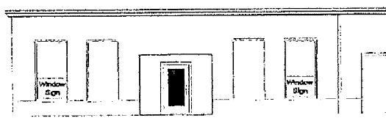
Signage limited to 35% of window surface
these regulations.
3. Portable signs pursuant to the provisions of these regulations.
4.

3.8 NON-CONFORMING SIGNS
1. Subject to the provisions of this section, nonconforming signs that were otherwise lawful on the effective date of this section may be continued.

2. A nonconforming sign shall not be moved, replaced, enlarged or altered, except to bring the sign into complete conformity with this section. A message panel may be replaced provided that it does not change the character or area of the sign and does not increase the non-conforming aspects of the sign.

3. No illumination shall be added to a nonconforming sign.

ARTICLE 4.0
REVIEW PROCEDURES

4.0 Review Procedures

4.1 PERMITS
Permits Required: It shall be unlawful for any person to erect, alter or relocate within the City of Belleville, any sign or other advertising structure as defined herein, except where specifically exempted or permitted by this Chapter, without first obtaining a permit therefore issued by the Building Official after payment of any fees required by this Chapter and approved by the Planning Commission.
1. Application for Permit: Application for permits shall be made upon forms provided by the Building Official, and shall contain or have attached thereto, the following information:
A. Name, address and telephone number of the applicant.
B. Location of building, structure or lot to which the sign is to be attached or erected.
C. Position of the sign in relation to nearby buildings, structures or property lines.
D. Five (5) sets of drawings of the plans and specifications and method of construction and attachment to the building or in the ground. Copy of stress sheets and calculations, if deemed necessary, showing the structure as designed for dead load and wind pressure in accordance with regulations adopted by the Planning Commission.
E. Name and address and phone numbers of the person, firm, corporation or association erecting the structure.
F. Any electrical permit required and issued for said sign.
G. Such other information as the Planning Commission and /or Building Official may require to show full compliance with this and all other applicable laws of the City of Belleville and State of Michigan.
H. In the discretion of said Planning Commission, when in its opinion the public safety requires it, the application containing the aforesaid material shall, in addition, bear the certificate or seal of a registered architect or engineer as a condition to the issuance of a permit.

2. Permit Fee: A permit fee shall be paid to the City for each permanent permit and each temporary permit required by this Chapter as shall be set by resolution of the City Council of the City of Belleville.
3. Routine Maintenance: Every sign shall be maintained so as to retain its original appearance and structural integrity. Elements of the sign which are missing, damaged, deteriorated or destroyed shall be repaired or replaced to maintain the original appearance of the sign.
The following routine maintenance may be done without a sign permit, provided that such work is done in conformance with the provisions of this Chapter:
A. Routine maintenance as follows:
i. The ordinary servicing or repainting of an existing sign structure or message without changes in the design or message, the cleaning of a sign and the maintenance of a sign's electrical system, but not including the items in subsection (ii);
ii. Routine maintenance shall not include the replacement of sign inserts, awning signs and canopy signs, and the addition of advertising material or other changes to existing signs or sign structures, which items shall require a sign permit.
B. The changing of the message on a sign specifically designed for frequent changes of such message, such as a billboard, bulletin board, changeable copy sign or similar type of sign; and
C. The changing of the message for an individual tenant on a tenant directory sign which has a uniform design for all tenants.
Section 3.8 Non-Conforming Signs shall also apply.

Article 5.0

Administration, Appeals and Enforcement

Article 5.0 Administration, Appeals and Enforcement
5.1 Authorized Sign Contractors
5.2 Liability for Damages
5.3 Removal of Signs
5.4 Violations
5.5 Enforcement
5.6 Appeal Procedures
5.7 Powers of the Zoning Board of Appeal

5.0 Administration, Appeals, and Enforcement

5.1 AUTHORIZED SIGN CONTRACTORS
Every person, before engaging or continuing in the business of erecting or repairing signs in the City of Belleville, shall obtain an annual sign contractor permit. To obtain said permit, the contractor shall first furnish the city a public liability insurance policy in the amount of Fifty Thousand Dollars ($50,000.00) for injury to one person and One Million Dollars ($1,000,000.00) for injury to more than one person and property damage insurance in the amount of Twenty-five Thousand Dollars ($25,000.00) for damage to property. Said permit shall terminate upon the expiration of the insurance policy unless evidence of renewal is filed with the city clerk.

5.2 LIABILITY FOR DAMAGES
The provisions of this Chapter shall not be construed to relieve or limit in any way the responsibility or liability of any firm, person or corporation which erects or owns any sign for personal injury or property damage caused by the sign; nor shall the provisions of this Chapter be construed to impose upon the City of Belleville, its officers or its employees any responsibility or liability by reason of the approval of any sign under the provisions of this Chapter.

5.3 REMOVAL OF SIGNS
1. The Building Official shall order the removal of any sign erected or maintained in violation of this Chapter except for legal non-conforming signs. Notice in writing shall be given to the owner of such sign or of the building, structure, or premises on which such sign is located, to remove the sign or bring it into compliance with the Chapter. Failure to remove the sign or to comply with this notice shall be a misdemeanor. The city shall also remove the sign immediately and without notice, if it reasonably appears that the condition of the sign is such as to present an immediate threat to the safety of the public. Any cost of removal incurred by the city shall be assessed to the owner of the property on which such sign is located and may be collected in the manner of Chapter debt or in the manner of taxes and such charge shall be a lien on the property.

2. A sign shall be removed by the owner or lessee of the premises upon which the sign is located within thirty (30) days after the business which it advertises is no longer conducted on the premises. If the sign is in compliance with this Chapter and is usable by a future tenant, then a blank sign face, painted-out face or blank cover is sufficient to meet this requirement. If the owner or lessee fails to remove the sign, the city shall remove it in accordance with the provisions stated in Sub-section 1 preceding. These removal provisions shall not apply where a subsequent owner or lessee conducts the same type of business and agrees to maintain the signs to advertise the type of business being conducted on the premises, and provided the signs comply with the other provisions of this Chapter.

5.4 VIOLATIONS
1. Any of the following shall be a violation of this Chapter:
A. To install, create, erect, or maintain any sign in a way inconsistent with the terms of this Chapter or that is inconsistent with any plan or permit governing such sign or the zone lot on which the sign is located;
B. To install create, erect, or maintain any sign requiring a permit without such a permit.

2. A.. Each sign installed, created, erected, or maintained in violation of this Chapter shall be considered a separate violation.

3. Unless specified elsewhere in this Chapter any signs placed within a road right-of-way or on utility poles will be considered a violation of this Chapter and may be removed by the City at the expense of the owner.

5.5 ENFORCEMENT
Knowing and willful violation of the provisions of this Chapter shall be a misdemeanor. Enforcement of this Chapter may proceed by criminal prosecution, or by civil suit in circuit court seeking court ordered and supervised compliance, or by both such criminal and civil proceedings. Each day that such violation continues after receipt of written notice to remove a sign shall be deemed a separate offense. Violation of these regulations shall result in a revocation of the subject sign permit.

5.6 APPEAL PROCEDURE
1. Appeals shall be commenced by a person filing a notice of appeal with the office of the City Clerk, accompanied by a fee as may be established by City Council by resolution from time to time. The notice of appeal shall specify the particular grounds upon which the appeal is based and shall be signed. It shall also specify the requirements from which a variance is sought and the nature and extent of such variance.

2. The City Clerk shall fix a reasonable time for the hearing of appeals before the Zoning Board of Appeals and shall give due notice thereof by publishing a notice in the newspaper of record in the City at least ten (10) days prior to the date of hearing and giving notice to persons to whom real property is assessed within three hundred (300) feet of the premises in question and to occupants of single and two-family dwellings within 300 feet. Notice may be given by personal delivery or by first class mail at the address given in the last assessment roll.

3. Standards. Each case before the Zoning Board of Appeals shall be considered as an individual case and shall apply the following standards in a manner appropriate to the particular circumstances of such case. When granting variance, the Zoning Board of Appeals must find:
A. The strict application of the terms of this Chapter would impose an undue and not self-imposed hardship upon the applicant, and
B. Granting the applicant's request would not adversely affect adjoining properties, and
C. Granting the applicant's request would not endanger the safety and good public order of the City of Belleville by creating a traffic or other safety hazard, and
D. Granting the applicant's request would be in keeping with the intent and purpose of this Chapter.

5.7 POWERS OF THE ZONING BOARD OF APPEALS
1. The Zoning Board of Appeals shall not have the power to alter or change the terms of this Chapter but does have the power to engage in administrative review, interpretation and to grant or deny variances as provided for, in this Chapter.

2. The Zoning Board of Appeals shall hear and decide appeals where it is alleged by the applicant that there is an error in any order, requirement, permit, decision or refusal made by the Building Official or any other administrative official in carrying out or enforcing any provision of this Chapter.

3. The Zoning Board of Appeals may authorize, upon an appeal, a variance from the strict application of the provisions of this Chapter where the reasons for the exception satisfy the standards of Section 5.6.3 of this Chapter. In granting variance, the Zoning Board of Appeals may attach thereto such conditions regarding the location, character, and other features of the proposed sign as it may deem reasonable in furtherance of the purpose of this Chapter. In granting a variance, the Zoning Board of Appeals shall state the grounds upon which it justifies the granting of the variance.

4. The Building Official may authorize temporary special approval permits in situations where, as a result of municipal or highway construction projects, access to business establishments or their signage is either blocked or significantly obstructed. Emergency special approval permits may also be authorized by the Building Official for a period not to exceed thirty (30) days where as a result of storm, fire or other disaster, the signage of a business establishment is damaged. Special approval permits may authorize the erection of temporary signs which would otherwise be prohibited within that area. Applications for special approval permits shall be in writing in a form substantially similar to an application for renewal sign permits. All applications must specify the length of time the permit is to be required. All temporary special approval permits must be approved by the Building Official and state the expiration date of said permit. A temporary special approval permit shall cause any existing Emergency special approval permits for the same location to expire. All Sign Variances are temporary and will expire with occupancy change

