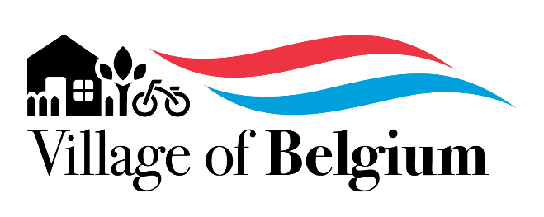
AGENDA
Village Board Meeting
7:00 pm – Monday, November 11, 2024
Village Hall, 104 Peter Thein Ave

Zoom Link:

CALL TO ORDER AND SILENCE CELL PHONES

ROLL CALL OF OFFICERS

OPEN MEETING LAW COMPLIANCE CHECK

PLEDGE OF ALLEGIANCE AND A MOMENT OF SILENCE

PUBLIC INPUT - Speaker must be recognized by the Chair, stand, and state their name. (2 minutes/person - 10 minutes total time)

BELGIUM AREA CHAMBER OF COMMERCE REPORT

REPORTS OF STAFF AND COMMITTEES - No Action required.

Village Marshal Report

Staff Reports: Ozaukee County Sheriff, Belgium Fire Department, Treasurer, Financial Reports, DPW, Wastewater, Clerk, Administrative Assistant

Committee Reports

Financial Reports

CONSENT AGENDA ITEMS - Any of these items may be moved to New Business for further discussion upon request.

Approve Minutes: October 13, 2024

UNFINISHED BUSINESS - Consideration, discussion, and possible action regarding:

NEW BUSINESS - Consideration, discussion, & possible action regarding:
  - Approve Committee of the Whole recommendation for employee wage increases
  - Approve 2025 General Fund Budget
  - Approve 2025 Water Fund & Sewer Fund Budgets
  - Approve 2025 Debt Service Fund & Capital Projects Fund Budgets

ADJOURNMENT

